Guidelines for Producing Accessible 3D Prints
May 2024

edited by Leona Holloway


Round Table on Information Access
for People with Print Disabilities Inc.
Guidelines for Producing Accessible 3D Prints
Copyright © 2024 Round Table on Information Access for People with Print Disabilities
This work is licensed under the Creative Commons
Attribution-Noncommercial-NoDerivs 3.0 Unported License.
To view a copy of this license, visit Creative Commons: http://creativecommons.org/licenses/by-nc-nd/3.0/
or send a letter to Creative Commons, 171 Second Street, Suite 300, San Francisco, California 94105, USA.
Published by Round Table on Information Access for People with Print Disabilities Inc.
3C 2 Distillery Drive
Pyrmont, NSW 2009
Australia
Email: admin@printdisability.org
Web address: Round Table (Information Access for People with Print Disabilities): http://printdisability.org/
National Library of Australia Cataloguing-in-Publication entry
Title: Guidelines for Producing Accessible 3D Prints / Round Table on Information Access for People with Print Disabilities Inc.
ISBN: 978-1-7635539-2-7 (pbk.)
Subjects: People with visual disabilities -- Services for.
Models and modelmaking -- equipment and supplies.
Three-dimensional printing.
Other Authors/Contributors: Round Table on Information Access for People with Print Disabilities Inc.
Dewey Number: 362.41

About these guidelines
The Guidelines for Producing Accessible 3D Prints are published by the Round Table on Information Access for People with Print Disabilities Inc. Round Table is an umbrella organisation that brings together producers, distributors and consumers of information in alternative formats to print, blindness agencies, tertiary institutions and government departments in Australia and New Zealand.
These guidelines are available from Round Table in accessible formats at Round Table (Information Access for People with Print Disabilities): https://printdisability.org/guidelines/.

Acknowledgements
These guidelines are the result of an Australian Research Council Linkage Project (LP170100026) led by Monash University in partnership with Round Table, Department of Education Victoria, Guide Dogs Victoria, NextSense and SeeDifferently. Financial support was also provided by the South Pacific Educators in Vision Impairment, VisAbility and Blind Low Vision New Zealand.
The guidelines were first published to the Round Table website in sections, where they will continue to grow as a living document at 3D printing for people who are blind or have low vision – overview: https://printdisability.org/about-us/accessible-graphics/3d-printing/. Thanks are extended to members of the Australia and New Zealand Accessible Graphics Group (ANZAGG) 3D Printing Group for their many contributions to the guidelines in the form of ideas, expert knowledge, writing, example images and editing. Special thanks to Jim Allan (Texas School for the Blind and Visually Impaired), Sam Boswell and Nikhil D’Souza (NextSense), Sarah Hayman (Statewide Vision Resource Centre), Ka Li (National Network for Equitable Library Service), Ian Matty (Mountain Lakes Public Library), and Navrakan Virdi (Braille and Large Print Services, NSW Department of Education).

This published version of the guidelines was prepared by a small working group of experts in accessible format production: Leona Holloway (Monash University), Debra Lewis (Statewide Vision Resource Centre, Department of Education Victoria), Debra Murphy (Vision Australia), and Yin Yin Htay (Blind & Low Vision Education Network, New Zealand).

Disclaimer
This document has been prepared from the collective knowledge and experience of the working groups and sources believed to be accurate and complete at the time of compilation. While every effort has been made to ensure accuracy, the accessibility of the websites and the references, Round Table does not accept any responsibility for omissions or inaccuracies.

Contents

About these guidelines 1
Acknowledgements 1
Disclaimer 2
Contents 3
Introduction to these guidelines 7
What is 3D printing? 7
Why is 3D printing important for people with print disabilities? 7
Why are separate guidelines needed for accessible 3D prints? 8
3D printing by people with print disabilities 8
Who are these guidelines for? 9
Terminology used in these guidelines 10
1. Organisational support for 3D printing as an accessible format 12
1.1 Cost and equipment 12
1.2 Staff training and support 12
1.3 Access to 3D model files 13
1.4 Design and production of 3D printed models 13
1.5 Storage and distribution 13
2. When to use 3D printing for touch readers 14
2.1 3D printed objects are ideal: 14
2.2 3D printing is NOT recommended when: 15
2.3 Considerations when choosing to use 3D prints 16
3. Where to find 3D printing designs 17
3.1 Generalist 3D model repositories 17
3.2 3D model repositories for people with print disabilities 17
3.3 3D model repositories for education, STEM and specialist areas 18
4. 3D printing design software 20
4.1 Automated 3D mapping software 20
4.2 Converting from 2D 21
4.3 3D Scanning 22
4.4 3D Design software 23
5. Design considerations 28
5.1 Design for understanding through touch 29
5.2 Design for inclusion 39
5.3 Design for engagement 42
5.4 Consider the 3D printing process 43
5.5 Iterative design based on touch testing 46
5.6 Models with moving parts 47
5.7 Maps 49
5.8 Icons 51
5.9 Art 52
5.10 Architecture 54
6. The 3D printing process 56
6.1 3D printing services 56
6.2 3D printers 57
6.3 3D printing filament and materials 59
6.4 Slicing 60
6.5 3D printing and troubleshooting 64
7. Other methods for creating 3D models 67
7.1 Hand Crafting 68
7.2 Ceramics 69
7.3 Laser Cutting 69
7.4 CNC Milling 70
7.5 Moulding and Casting 71
7.6 Thermoforming 72
8. Labelling 3D prints 73
8.1 Print labels 75
8.2 Braille labels 76
8.3 Basement – a base plate or tactile graphic 79
8.4 3D symbols or icons 80
8.5 Audio labels 82
9. Finishing – Preparing 3D prints for touch readers 84
9.1 Smoothing 84
9.2 Adding textures or colours 87
9.3 Construction 89
10. Understanding 3D prints through touch 90
10.1 Know what to expect 90
10.2 Gain an overview first 92
10.3 Use appropriate touch 93
10.4 Use reference points 93
10.5 Explore the detail 94
11. 3D Printing on Paper for Tactile Graphics 95
12. Blind makers: 3D model selection, design and printing by people with print disabilities 98
12.1 Selecting a 3D model 98
12.2 Designing a 3D model 98
12.3 Using a 3D printer 100
References 103
Appendix A: Useful Web Links 106
When to use 3D Printing 106
Where to find 3D printing designs 106
3D printing design software 107
The 3D printing process 108
Blind makers 109

Introduction to these guidelines

What is 3D printing?
3D printing is a consumer-level technology with the potential to revolutionise accessible formats production through the creation of tactile models that are more inclusive, engaging and easier to understand.
3D printers operate by printing one thin layer on top of another to create a 3-dimensional object. There are many types of printers and materials, but the most common and affordable use a heated nozzle to print with plastic. 3D printers are available for use in some universities, schools and public libraries. Anyone can use a 3D printer if they have a moderate level of confidence tinkering with equipment and have the time to build up their knowledge through experimentation and seeking help from the 3D printing community. Alternatively, there are many commercial 3D printing services and accessible format producers are increasingly offering 3D printing as an option.
While these guidelines focus on 3D printing as the mechanism for creating accessible 3D models, much of the advice given is applicable to 3D models made by other means, and indeed Section 7 covers methods other than 3D printing for the creation of accessible 3D models.

Why is 3D printing important for people with print disabilities?
People with a print disability are those who cannot access information in a print format because they:
- Are blind or have low vision.
- Have physical disabilities which limit their ability to hold or manipulate information in a printed form.
- Have perceptual or other disabilities which limit their ability to follow a line of print or which affect their concentration.
Because 3D printed models can be understood through both vision and touch, they can be used by most people with print disabilities and have several advantages over other formats for accessible graphics provision:
- 3D models are often more intuitive and easier to understand than 2.5D tactile graphics [8], meaning that they can be successfully used by people who are not trained in touch reading.
- 3D printed models can be cheaper or easier to obtain than other options such as commercial products or real objects [6, 12].
- 3D models can provide touch access to objects that are otherwise too small, too large, too dangerous, too precious, too rare or not available to be touched.
- 3D models can be used together with sighted peers, for example in a mainstream classroom or at a public event, thereby contributing to greater inclusion.
In addition to the creation of 3D models, 3D printers can also be used to create tactile graphics using mainstream equipment, as will be described in Section 11.

Why are separate guidelines needed for accessible 3D prints?
One of the advantages of 3D printed models over tactile graphics is that they can be used by blind, low vision and sighted students together. However, not all models can be understood well through both vision and touch. Instead, thoughtful design, printing and finishing techniques are required to ensure that 3D printed models are optimised for touch reading and inclusion.

3D printing by people with print disabilities
The focus of these guidelines is the production of 3D printed models for use by people with print disabilities. But of course, these same people may themselves be technology students, professional accessible formats producers or DIY/maker enthusiasts wanting to find, design and print 3D models themselves. All sections of these guidelines have therefore been written for use by people with print disabilities. Section 12: Blind Makers provides additional details regarding accessible software, hardware and hacks. It is hoped that strong advocacy combined with a responsive 3D printing industry will mean that such a section is not required in future editions of these guidelines.

Who are these guidelines for?
These guidelines have been produced primarily to help designers of 3D models for use specifically by people with print disabilities. However, given that between 10-15% of the world’s population have a print disability, these guidelines should be considered by anyone creating a 3D model for information and inclusion of a wide audience. Possible users of the guidelines include:
- People with a print disability who may find the guidelines useful in explaining their accessibility requirements or who want to create their own 3D models
- Specialist accessible format production agencies
- Other people wanting to create 3D models for people with a print disability, for example parents, educators, orientation and mobility specialists and occupational therapists
- Sign makers producing accessible maps of public places
- Museums and galleries providing inclusive tactile exhibits
- Commercial companies producing educational models and learning tools

Terminology used in these guidelines
Term | Definition | Related section
2.5D tactile graphic | A tactile graphic, raised line drawing or relief with all picture elements raised to a very low height. Common production techniques include swell paper and embossing. | n/a
3D model | A 3D model, created through any process (not necessarily 3D printing). | n/a
ABS | Acrylonitrile-Butadiene Styrene filament, used in FDM 3D printing for strength or smoothing. | 6.3
adhesion / bed adhesion | How well the 3D model stays stuck to the bed during the FDM 3D printing process. | 6.5.2
ANZAGG | Australia and New Zealand Accessible Graphics Group | n/a
bed / build plate | A flat surface on which a 3D printer builds or prints an object | 6.2
brim | A single layer of printing around the base of a 3D model to assist with bed adhesion. | 6.4.6
chamfers | In 3D modelling, a chamfer creates a bevelled edge or corner by cutting it off at an angle. | 4.4, 5.4.5
CNC milling | A subtractive method for creating 3D models by drilling from a solid block of material, usually wood. | 7.4
extrusion | The process of melting filament and passing it through the nozzle during the FDM 3D printing process. | 6.2
FDM | Fused Deposition Modelling, whereby 3D printing filament is melted and then printed onto the build plate one layer at a time. | 6.2
filament | A strand of 3D printing material used for FDM printing. | 6.2, 6.3
fillets | In 3D modelling, a fillet creates a rounded edge or corner by replacing it with a circular arc. | 4.4, 5.4.5
greyscale image | Image using only black, white, and shades of grey. Each pixel is calculated as an intensity level. | n/a
organic shapes | Non-geometric, curvilinear, irregular shapes such as those found in nature. Organic shapes are generally more difficult to create using 3D modelling software. | n/a
PLA | Polylactic Acid filament, the most common and reliable filament used in FDM 3D printing. | 6.3
raft | A horizontal latticework of filament printed underneath a 3D model to assist with bed adhesion. | 6.4.6
relief model | A flat plane with raised areas. This includes artworks with figures partially raised from the background, as well as topographic maps showing the rise and fall of a portion of the earth’s surface. | n/a
Round Table | Round Table on Information Access for People with Print Disabilities, Inc. | n/a
slicer | Slicing software. | 6.4
slicing | The process of converting a 3D model file into instructions for a 3D printer. | 6.4
.stl | An open-source file format containing the shape information about a 3D model. | n/a
swell paper | Also known as microcapsule, stereocopy, swellform, PIAF or Zychem paper. A method for creating 2.5 tactile graphics using carbon-based ink and heat. | n/a

1. Organisational support for 3D printing as an accessible format
This section provides guidance regarding issues that organisations should consider in order to best support the adoption and sustainability of 3D printing as an accessible format for people with print disabilities.

1.1 Cost and equipment
While the cost of purchasing 3D printing equipment and software may initially seem like a barrier to the adoption of 3D printing, studies have shown that the use of 3D printing actually saves costs compared with the purchase of specialised tactile materials and adaptive equipment [6, 12]. Good quality FDM 3D printers can be purchased for as little as AUD$1,000 and most 3D modelling software is free with an educational licence. Refer to Section 6.2.1 Selecting a 3D printer for advice on choosing a suitable printer.

1.2 Staff training and support
Staff skills and mindset are perhaps the most important factor for the successful adoption of new technologies like 3D printing.
3D printing requires a moderate level of technical skills and willingness to problem solve and tinker with machinery (Section 6 The 3D printing process). Staff must therefore be provided with introductory training followed up with adequate time to build up their skills and confidence through hands-on practice and trial-and-error. If complex 3D models are to be designed, dedicated staff with prior 3D modelling experience may need to be employed for this task.
It is helpful for teachers, O&M professionals and others to be provided with examples of popular and effective 3D printed models so that they understand the potential value of 3D printed models and will start to think about what models would help them in their work. Ideally, sample models should be explicitly connected with learning goals and perhaps even accompanied by lesson plans on how to use them with learners with print disabilities.

1.3 Access to 3D model files
3D models that are suitable for use by people with print disabilities are currently scattered across multiple online sites (Section 3 Where to find 3D printing designs) and vision specialist staff have reported that searching for models can be frustrating. It is helpful to compile an internal catalogue of 3D models that are recommended or held as loanable items within an organisation. This catalogue could be as simple as a Thingiverse collection or an Excel spreadsheet but ideally it would be part of an integrated request system and models would be tagged with labels for recommended uses. For example, a teacher should be able to easily find 3D models relevant for a grade 6 student learning mathematics.
To assist the print accessibility community as a whole, it is important to share any newly created models online, offering free open source access. Tactiles.eu and the BTactile metalibrary are recommended places to share 3D models designed specifically for accessibility.

1.4 Design and production of 3D printed models
Depending on an organisation’s structure, production of 3D models can either be centralised or distributed. A centralised system takes advantage of specialised staff roles but requires efficient methods for transporting 3D models between locations. In a distributed system with 3D printers across multiple sites, it is best to provide the same equipment and set-up at all sites so that pre-sliced files can be shared for plug-and-play 3D printing. A technology team that can provide user training and printer repairs is also valuable for supporting distributed systems.

1.5 Storage and distribution
Consider whether 3D models will be printed on demand or loaned and returned to a centralised location for storage and redistribution. A loan system will require storage space, a system for locating existing prints, and cleaning and repair of returned models.
If a model is damaged when it is returned, consider whether it can be repaired, reprinted, or needs a redesign for greater strength before reprinting (refer to Section 5.4.2 Design for strength).

2. When to use 3D printing for touch readers
3D printed models are one option among many for conveying visual information to people with a print disability.

2.1 3D printed objects are ideal:
- When the original object or concept is three dimensional
- When real objects or models are not available to touch because they are:
  - too small (e.g. molecule)
  - too large (e.g. building)
  - too precious or fragile (e.g. original artworks)
  - too dangerous (e.g. live crocodile)
  - too uncooperative (e.g. live bird)
  - too disgusting (e.g. urinal, dissection)
  - not in proximity (e.g. famous landmarks, planets)
  - theoretical (e.g. 3D graphs)
  - virtual (e.g. story or computer game characters and places)
- When tactile graphics are too difficult to understand because projected or obscured views would be required (e.g. complex block constructions for a maths problem)
- For beginner tactile learners to help understand the relationship between a 3D object and a 2.5D tactile graphic
- When teaching point of view and perspective (using a 3D model in combination with tactile graphics)
- When movable and/or removable parts are incorporated (e.g. model of the eye, anatomy, braille spinner)
- To make learning more fun, engaging or inclusive – 3D models can be used with sighted classmates
- To create customised tools for the classroom (e.g. tactile protractor, braille name stamp for ceramics class, brailler finger guide)
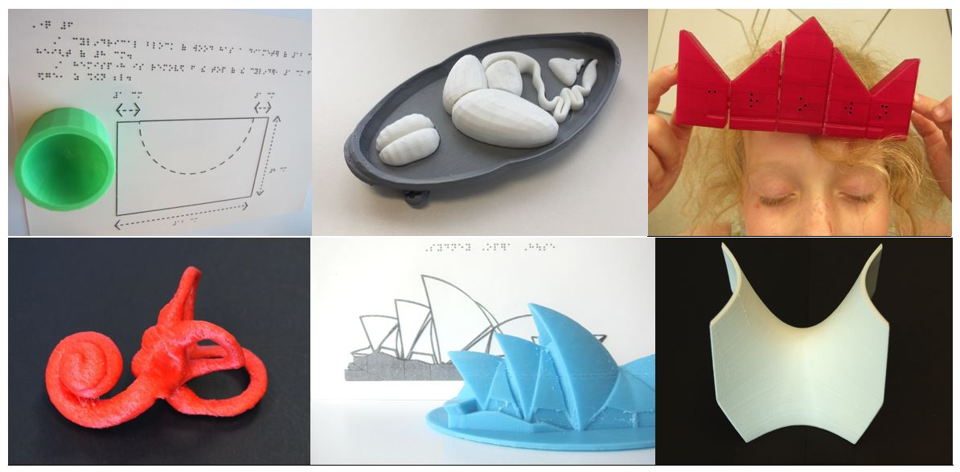
Figure 2a: Example 3D prints for use in the classroom. Images courtesy of Monash University.

2.2 3D printing is NOT recommended when:
- Real objects or models are readily available. It may be possible to source appropriate materials such as:
  - household objects
  - tourist models of famous buildings
  - taxidermy animals
  - anatomy models
  - chemistry models
  - realistic models of animals for the general population (e.g. toy models made by Schleich or the lifesize animal sculptures at Melbourne Zoo)
  - generic accessible tools from blindness agencies
- A large size is required. Most 3D printers are limited to a size of around 20 x 20 x 20cm
- A large number of copies are required (e.g. for the creation of popular tools such as tactile rulers)
- 3D attempts to duplicate a 2D image
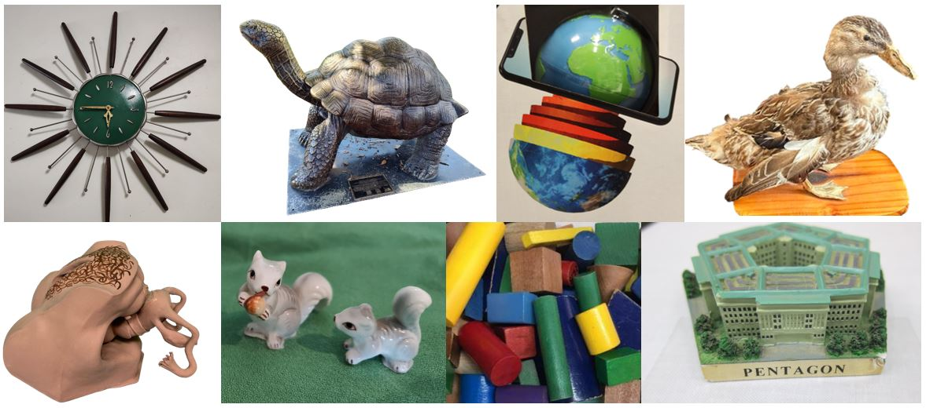
Figure 1b: Readily available 3D models (left to right, top row first): clock with tactile markers, life-size sculpture at Melbourne Zoo, globe, taxidermy duck, Jackson anatomy model, animal ornaments, geometric shapes and tourist’s building model. 3D printing is NOT recommended when other options like these are available. Original images.

2.3 Considerations when choosing to use 3D prints
- While materials for 3D printing are cheap, design and printing time can be lengthy.
- 3D models can rarely be used as a stand-alone solution. They are best accompanied by a description of the details and features (refer to Section 8 Labelling 3D Prints) and additional accessible formats (refer to the Accessible Formats Decision Forest in Appendix A).
- 3D models have a uniform texture and weight. Information about the texture, weight and size of the real object should be provided with the model.
- If the whole object is not shown or it is in a fixed position, this needs to be explained to the learner.

3. Where to find 3D printing designs
Millions of 3D models are available for download online, most of them free. It is always worthwhile to search or browse for an existing 3D model before designing something brand new. Adapting an existing model is another option.
The websites listed below are recommended for educational purposes and touch readers. Another quick way to find 3D models is to conduct a Google image search with a description of the desired model and .stl, for example “human brain .stl”.

3.1 Generalist 3D model repositories
- Pinshape – A generalist collection of 3D models with a mix of free and paid designs.
- Printables – A quickly-growing repository of free models, with categories for educational materials.
- STLFinder – A dedicated search engine for millions of 3D printable models, with links to the original site where the model is hosted. It is possible to create an account to bookmark favourite designs.
- Thingiverse – By far the biggest selection of 3D models available, with millions of designs. It has a huge selection across many areas and all models are free. Includes a number of collections by designers for touch readers, including ANZAGG, Braille & Large Print Services from the NSW Department of Education, NextSense, SVRC and See3D
- YouMagine – A generalist site with thousands of free 3D printable models.

3.2 3D model repositories for people with print disabilities
  - 3D Opal – 3D objects for accessible education in physics, chemistry and astronomy.
  - BTactile – A metalibrary (collating resources from other repositories) for easy searching of tactile graphics and 3D prints designed/selected for touch readers. Note that some of the models include braille in European languages.
  - Fittle – 3D jigsaw pieces with braille letters to support early tactile literacy.
  - ImageShare – A metalibrary (collating resources from other repositories) of accessible format materials including 3D models.
  - Medien Augenbit – A German site with mainly mathematical and scientific models designed specifically for touch readers. Includes lots of rulers and accessible tools. Note that some models include braille in German.
  - Microbiology for the Blind and Visually Impaired – 3D printing models with associated lessons
  - Nonscriptum – Geometry lesson plans for students with print disabilities with accompanying 3D printable models.
  - Star Coins Project 3D printable tactile constellations – A large collection of constellations, each on a disk with a threading hole, along with related lesson plans.
  - Tactile Universe – 3D astronomy models with accompanying lesson plans.
  - Tactiles.eu – 3D printing repository designed specifically for accessibility, featuring the top 20 models requested by touch readers and vision specialist teachers. Accessible format producers are encouraged to contribute their own designs.
  - A Touch of the Universe – Tactile astronomy kits for children with print disabilities.

3.3 3D model repositories for education, STEM and specialist areas
- African Fossils – Archaeological finds from up to 25 million years ago.
- 3D Printing the X-ray Universe – 3D models created using data from the Chandra X-ray Observatory.
- Dremel DigiLabs Lesson Plans – A curated collection of free 3D printable models accompanied by lesson plans for hands-on education.
- hhmi Biointeractive – Models of diseases, viruses and cancers.
- MiniWorld3D – A collection of detailed 3D models of landmarks & famous buildings of the world, designed explicitly for 3D printing. There is a mix of free and paid models.
- NASA 3D Resources – Space-related models from NASA, including tools, rockets, landing sites, asteroids, etc. Some models include braille labels.
- NIH 3D Print Exchange – The NIH 3D Print Exchange is designed for sharing scientifically accurate 3D models with the STEM community. Collections include neuroscience, the heart library and molecule of the month.
- Polar Cloud – An online social platform for sharing 3D print designs and curriculum for education. Sign-in is required, with free accounts for schools and universities.
- Scan the World – Artworks, statues, artefacts, etc. from museums and galleries around the world.

4. 3D printing design software
There are many 3D design software packages and web services available. Here, we have listed only those that are used and recommended by practitioners who are producing 3D printed materials for touch readers in Australia and New Zealand.

4.1 Automated 3D mapping software

4.1.1 Touch Mapper
Touchmapper is free online software. It can be used to create a customised tactile graphic or 3D model of a map with streets and major buildings based on OpenStreetMap data. The user can select the location, scale, and whether to print borders. A small cone will be added at the point of interest, i.e. the address entered to generate the map.
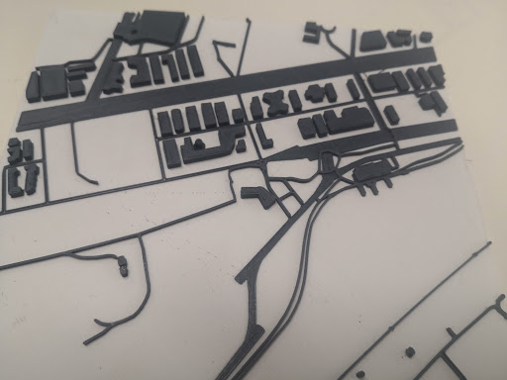
Figure 4a: Map created using Touchmapper. The filament colour was changed during printing from white for the base to black for the raised roads and buildings for high contrast. Image courtesy of Monash University.

4.1.2 Terrain2STL
Terrain2STL is a free online tool. Specify longitude and latitude or find the area on a world map to generate a 3D model of terrain in that location. It is usually necessary to exaggerate the height to create a model that is tactually distinct. Note also that peaks may be rough and require some sanding after printing.
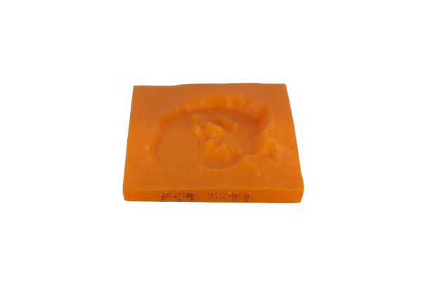
Figure 4b: Terrain model of Tower Hill volcanic crater (Thingiverse thing 4649677). Braille labels were added using OpenSCAD. Image courtesy of Monash University.

4.2 Converting from 2D
It is possible to convert a colour or black and white image to a 3D model based on greyscale. However, this technique very often results in an image that looks reasonable but does not make sense when accessed by touch. The original 2D image must be designed very carefully, with dark areas to be raised and light areas to be flat (or vice versa). It is helpful to simplify the image and remove background clutter before conversion.
Image to Lithophane is a free online service to quickly convert any image to a 3D relief. As an added bonus, the relief can be wrapped onto a variety of shapes, such as a dome or curved rectangle.
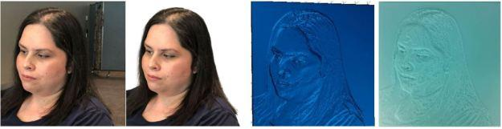
Figure 4c: Photograph with background removed and conversion to a lithophane model and 3D print. Image produced with permission from the subject.
Alternatively, drawing software like Inkscape (free), Adobe Illustrator or CorelDRAW can be used to save a 2D image as .svg format. The .svg file can then be imported directly into many 3D design software packages or slicers.
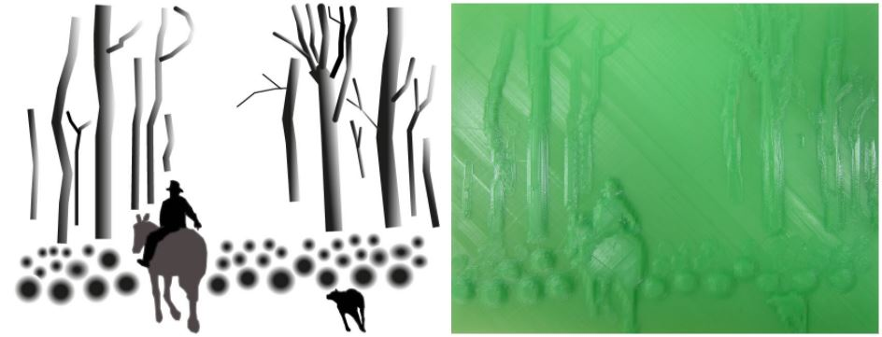
Figure 4d: Greyscale image and 3D conversion for “The Drover” by Walter Withers.
Images courtesy of Monash University.

4.3 3D Scanning
3D scanning involves taking a series of images of an object from all angles. These images are then used to construct a 3D model. 3D scanning can be achieved using an app for a smartphone, an add-on such as Structure Sensor, or a professional 3D scanner that comes with its own software. The resultant 3D file will need to be manually adjusted to prepare it for 3D printing.
Requirements for 3D scanning:
- Access to the original object
- Access to the object from all angles
- Not suitable for moving objects or thin objects
- Difficult for uniform, shiny or transparent objects.
Recommended uses of 3D scanning: Complex objects that cannot easily be modelled.
Tips for successful 3D scanning:
- Use bright light spread evenly over the object.
- Keep an equal distance away from the object, making sure that the whole object fits in the screen.
- Use a plain background if possible.

4.4 3D Design software

4.4.1 OpenSCAD and OpenJSCAD
OpenSCAD and OpenJSCAD are free software using text programming input to create and combine 3D models. OpenSCAD for use on Linux/UNIX, Mac or Windows. OpenJSCAD is very similar to OpenSCAD except that it uses Javascript syntax.
Advantages of OpenSCAD and OpenJSCAD:
- Good for precision.
- Accessible for people who are blind or have low vision.
- Easy to learn.
Disadvantages of OpenSCAD and OpenJSCAD:
- Not suitable for generating non-geometric, organic shapes.
Recommended uses for OpenSCAD and OpenJSCAD:
- Modelling by people with print disabilities (for more details, see Section 12 Blind makers).
- Generating braille labels using the template provided at Thingiverse and adding braille labels onto pre-existing models.
- Precision for mathematical shapes.
Cost of OpenSCAD and OpenJSCAD: Free
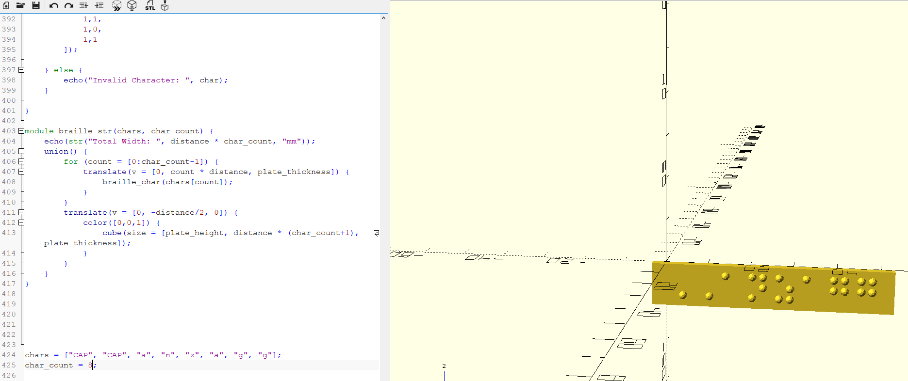
Figure 4e: OpenSCAD for creating braille labels. Original image.

4.4.2 TinkerCAD
TinkerCAD is a free online 3D modelling software, based on adding and subtracting geometric shapes, that is easy and intuitive to learn. It is recommended as a first introduction to 3D modelling.
Advantages of TinkerCAD:
- Easy to learn.
- Has a large library of predefined shapes, including connectors.
- Solid modelling (i.e. all designs are 3D printable).
Disadvantages of TinkerCAD:
- Tracing from 2D graphics is not possible.
- Operations can become slow as the models become more complex.
- Working models are stored online and cannot be shared easily.
- Stable internet connection is required.
- Not accessible.
Recommended uses for TinkerCAD: Basic models built from components.
Cost of TinkerCAD: Free.

4.4.3 Shapr3D
Shapr3D is much more lightweight than other professional options such as Fusion360, making it easier to learn and use. It enables models to be created using shape building (like TinkerCAD) but also via moulding: using touch access on an iPad to push and pull the model to create more non-geometric, organic shapes.
Cost of Shapr3D: Available for free using an educational licence

4.4.4 OnShape
OnShape is an easy next step after learning to use TinkerCAD. It takes a more “engineering” approach to computer aided design.
Advantages of OnShape:
- Very easy method for adding “fillets” and “chamfers” for rounded corners
- Ability to organise projects with multiple parts
- Ability to create schematics of a project
- Cloud-based app that runs very fast
Disadvantages of OnShape: Steep learning curve
Recommended uses of OnShape:
- Converting from a 2D profile sketch to an extruded 3D model or importing a .jpg photograph to trace.
- Any block-based resource, because it is easy to add “fillets” and “chamfers” for smoothing corners. The project can be exported from OnShape to TinkerCAD and finalised there.
Cost of OnShape: OnShape for Education is free for students and educators.

4.4.5 Fusion 360
Fusion 360 is a powerful tool for creating 3D designs from scratch. It has a steeper learning curve than the above software packages but still easy enough to be taught to secondary school students.
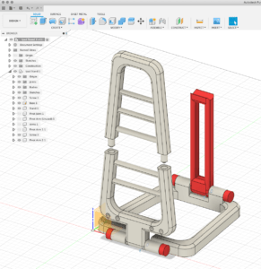
Figure 4f: Fusion 360 modelling. Original image.
Advantages of Fusion 360:
- A more powerful design program.
- Parametric design, meaning that any component can easily be changed.
- Precision: Allows the designer to be very precise about measurements and tolerances of parts.
- Timeline to see and change every step made during the design.
- Ability to import sketches and reference images to create accurate 3D models.
- Assembly features to create and test interactive designs before printing.
Disadvantages of Fusion 360:
- Not suitable for sculpting organic shapes.
- May initially be difficult to learn, as it takes a different approach to modelling using sketches. However, Fusion 360 shares some methods from other modelling software such as addition and subtraction functions (Boolean).
- Not ideal for editing existing STL files.
Recommended uses for Fusion 360:
- Move on to Fusion 360 once TinkerCAD has been learned and to overcome some of its limitations.
- Can be used for applying braille to curved surfaces (one dot at a time).
- Best when paired with a mesh editing software such as Netfabb.
Cost of Fusion 360:
- Free for educational use.
- Free for 1 year but limited functionality for personal and non-commercial use.
- For the fully-featured version, there is an annual fee.
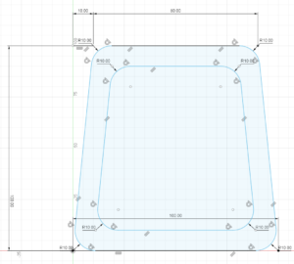
Figure 4g: Fusion 360 sketching. Original image.

5. Design considerations
These guidelines provide recommendations on design considerations for 3D models that will be used by people with print disability. Given that good design is an art as well as a science, these guidelines cannot be entirely prescriptive. As explained in Section 5.5 Iterative design based on touch testing, printing and touch testing is always necessary to ensure that designs are effective and meaningful through touch.
Table 5a: Design guidelines at a glance
3D printing design element | Recommendations — minimum (min) and maximum (max) dimensions | Section
Base | Min 0.8mm thick.  1.5mm is recommended. | 5.4.2
Stalks/stems/poles | Min 3mm diameter. | 5.4.2
Lines | Height min 0.5mm for faint lines; 1mm for definite lines.  Width 1.1-3mm.  Distance between lines min 2mm for double lines; min 5mm for separate lines. | 5.1.5
Arrows | Raise the arrow head 0.5-1mm from the line. | 5.1.5
Heights | Min 0.5mm height for detection.  Min 1mm height for important features. | 5.1.3, 5.15
Indents | Min 5mm wide for detection.  0.5mm depth is sufficient.  Indented print < 2mm wide. | 5.1.3, 8.1
Corners | Radius of 0.6 in TinkerCAD. | 5.4.5
Roads (on maps) | If indented, min 7mm wide; 20mm wide recommended. | 5.7.1
Walls (on floorplans) | 1-5mm height above the floor. | 5.7.2
Moving parts | 0.3mm spacing between parts. | 5.6.2
This section provides five main principles for the design of 3D models for touch readers (Sections 5.1 - 5.5), which can be applied to any 3D model. This is followed by a series of guidelines for specific types of 3D models (Sections 5.6 - 5.10).

5.1 Design for understanding through touch
Just as tactile graphics need to be modified from the print diagram rather than presented as a direct replica, so too 3D models need to be a well-considered re-interpretation of the original object to best support understanding through touch. Touch differs from vision in that very fine details cannot be distinguished and an understanding of the whole must be built up through sequential active exploration of the parts through direct contact with the body – mainly the finger pads and perhaps also the fingers and palms. To allow for these considerations, objects designed for understanding through touch should be simplified to remove distracting tactile details, allow access with the fingers, and provide tactual distinction between elements.
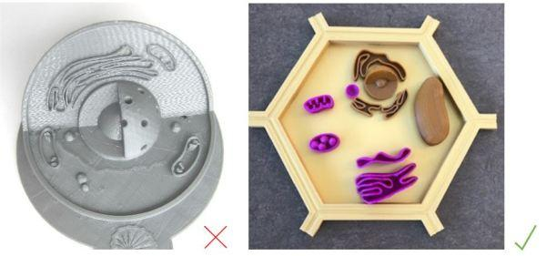
Figure 5a: Two 3D printed cells. The model on the left has all features at the same height with crowding. It is not suitable for touch readers. The model on the right is better suited for touch readers as it is larger and uses variable heights, more distinct shapes and wider spacing. Images courtesy of Monash University (left) and Texas School for the Blind and Visually Impaired (right).
In addition to following these design principles, understanding through touch requires accompanying information – context, a title and a detailed description – as described in Section 10 Understanding 3D prints through touch.

5.1.1 Simplify
Omit any redundant or distracting details that could otherwise confuse or distract the touch reader.
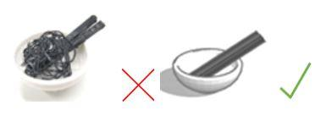
Figure 5b: Simplify models to include only the most important information. Removal of the noodles makes a bowl with utensils easier to interpret. Images courtesy of Monash University.

5.1.2 Spacing
Adequate spacing is required to distinguish between details and to allow space for the fingers to explore all surfaces of a 3D model.
As per tactile graphics guidelines, lines or similar details should be at least 2mm apart to allow distinction by touch.
Consider the spacing between taller elements, ensuring that there is enough space between them for the fingers to feel the sides and base of the elements.
For two objects of similar height, a minimum of 5mm is required between them [16]. If elements have a height difference of more than 1.5mm, then they should be separated by at least 15mm.
Consider the width of (adult or children’s) fingers when designing paths that should be followed or gaps that should be explored. Indented pathways work well for large maps but should be more than 7mm wide. If fingers must reach between two elements, they should be separated by:
- 1 finger width (20mm) if they are a similar height,
- 3 finger widths (60mm) if they differ in height by more than 1.5mm.
Tunnels and holes should be large enough for the fingers to enter. If this is not possible, consider outlining the hole so that it is more salient.
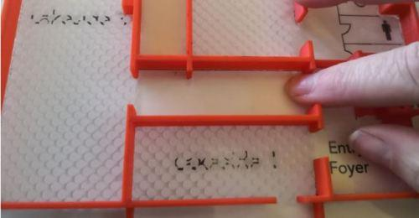
Figure 5c: Gaps and paths must be wide enough for the finger to explore. Image courtesy of Monash University.

5.1.3 Heights
It is acceptable to distort heights and distances in order to enhance tactile distinction [10, 11].
Height differences need to be adequate so that elements can easily be perceived.
0.5mm is the minimum height for features that must be detectable but not prominent [16], however if this is less than the printer layer height the lines may be ignored. Therefore, a minimum height of 1mm is recommended for lines and other raised features.
Note that indents are much more difficult to perceive than raised features. At times, this can be advantageous, for example to insert print labels without disturbing the touch reading experience. Conversely, if indents are important they need to be wide enough for the finger pad to perceive. Alternatively, consider outlining a small but important indent with a raised line.
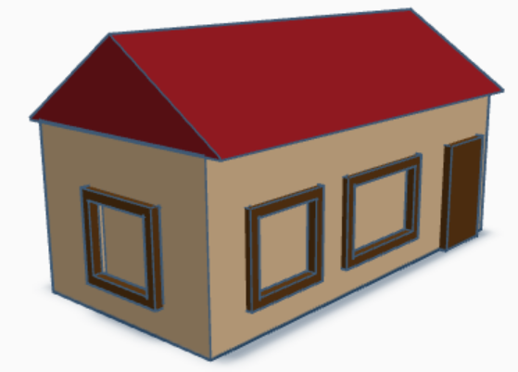
Figure 5d: Add raised outlines around indented features that are otherwise too small for the finger pad to perceive. Original image.
As described in Section 5.7.4, exaggeration of the vertical scale is useful for topographic maps to enable detection of details in the landscape that would otherwise not be possible.
Keep in mind that tall objects can obstruct lateral hand movements for searching. Taller features need more space around them so that lower objects can be found and felt. Do not exceed ¾ finger length or 40mm in height for objects placed on a base with surrounding material, so that fingers can reach to the base.

5.1.4 Scale
Larger models are generally preferred [19]. However, an exception is when objects can be replicated at actual size, which is easier to recognise than enlargements [17].
If the 3D printed model differs in size from the original object, provide an indication of scale [2, 7]. Some strategies may include:
- Adding ridge lines on multi-storey buildings to indicate each storey.
- Adding a raised line to indicate the scale of an ant, 1cm, 1m or 100m, etc. as best suits the model.
- Include an object of well-known size as part of the model, for example an ant, a dog, a person, a bus or a building.
- If a small object has been enlarged for tactual exploration and understanding, print a companion copy that shows the actual size.
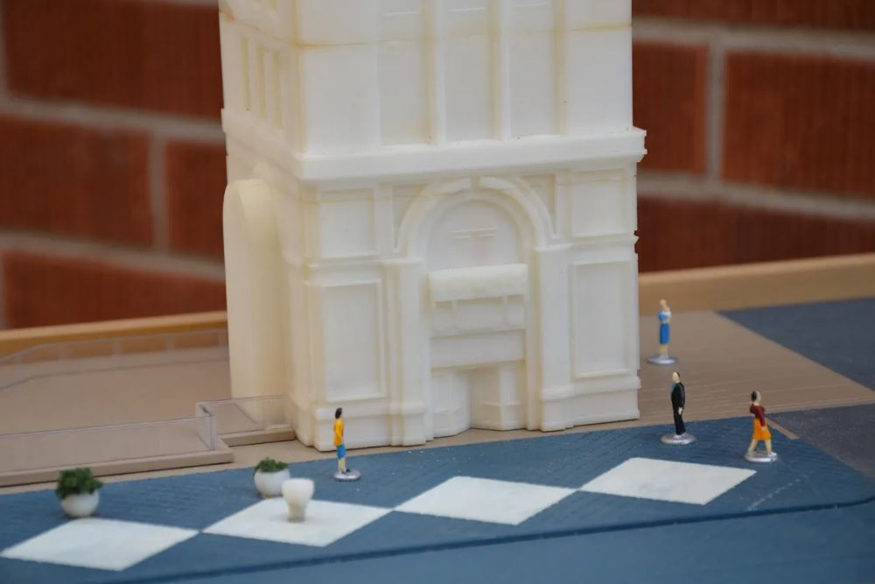
Figure 5e: Provide figures or other well-known objects alongside a 3D printed model of a real object to indicate scale. Image courtesy of Matthew Gesualdi, Tact-Ed.
If very small details are important for understanding, consider providing a separate model, relief model or tactile graphic showing that section in more detail. For example, split the model into an overview to show the general shape and enlarged sections to illustrate the small details.
Given that 3D printer beds are usually quite small, it is possible to make larger 3D models by joining flat surfaces with glue (PLA) or acetone (ABS) or to incorporate joins into the design. Alternatively, multiple pieces can be printed separately and then affixed to a large base. The overall size of a model should not exceed the length of the user’s arm [15]. Also consider the space where the model is likely to be used.

5.1.5 Lines
Lines can be printed flat (with a square top) for a smooth finish and easy tracking.
0.5mm is the minimum width for detection of lines. However, 1-3mm thickness is recommended for reliable lines that can easily be detected.
As per guidance regarding heights (Section 5.1.3), lines can be detected at 0.5mm but may not always be printed depending on printer settings. A minimum height of 1mm is therefore recommended.
Arrow heads can be printed 1mm higher than the lines so that they stand out. As with tactile graphics, arrow heads are easier to distinguish when presented as lines rather than a filled triangle. A length of 5mm is sufficient for the arrowhead lines.

Figure 5f: Arrow heads should be 5mm long lines (not filled). They can be 1mm higher than lines to stand out. Original image.
The distance between lines should be a minimum of 2mm for double lines; or a minimum of 5mm for separate lines.
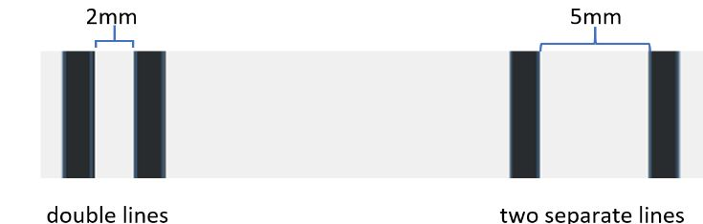
Figure 5g: Use a minimum distance of 2mm between double lines and 5mm between separate lines. Original image.

5.1.6 Make the most important features easy to find
The most important or distinctive features of a model should be easy to find tactually.
For handheld models, this may mean making the most important features protrude.
For complex models such as anatomy, it may be helpful to print the model as removable so the most important details can be explored individually.
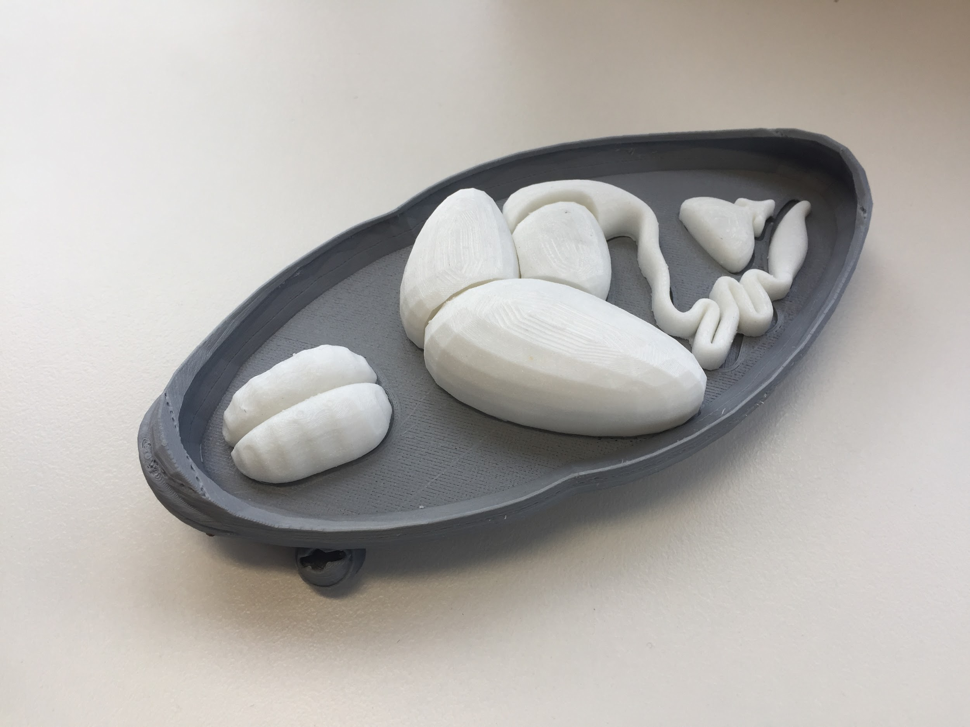
Figure 5h: 3D printed frog dissection with organs that can be removed for full tactual exploration (Thingiverse thing 258112). Image courtesy of Monash University.
For models that will be fixed to a base, the most important features should ideally be near the top of the model where they are easiest to find.

5.1.7 Don’t obscure the whole or obstruct hand movements
Enclosure using the whole hand(s) is an important method for gaining an understanding of a whole object through touch. Similarly, tracing along an edge or route is an important technique for gaining an understanding of the parts in relation to each other and the whole.
Unnecessarily tall or large features on a 3D model may obstruct such hand movements [18] and should therefore be minimised.
Permanent fixture of a model on a base restricts touch access to the lower parts of the model. If the whole shape is important for understanding, consider providing a detachable base plate or cradle rather than fixing the model to a base.
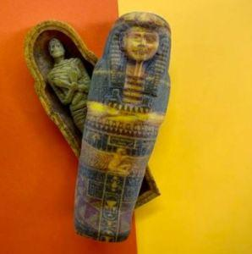
Figure 5i: 3D printed Egyptian mummy in a sarcophagus (Thingiverse thing 6090239). The mummy can be removed to allow tactile exploration from all angles. Image courtesy of Braille and Large Print Services, NSW Department of Education.

5.1.8 Use textures and material properties for meaning
A variety of textures or surfaces helps users to differentiate parts of the model. These textures can be integrated into the 3D printed model either as a surface pattern within the model itself, or through the addition of textured materials after printing (refer to Section 9 Finishing).
Shapes with a flat top (e.g. cylinders) are best for a smoother finish when printed top-down; curved shapes (e.g. half sphere) are best if printed on the side.
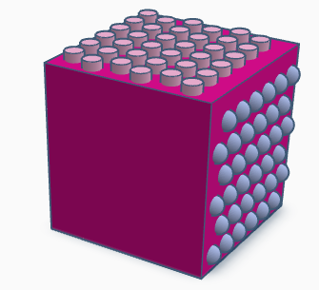
Figure 5j: Curved textures are best for printing on the side of a shape whereas flat-topped textures are best for printing on a horizontal surface. Original image.
Cura slicing software provides the option of “fuzzy skin” to give a slightly textured feel on the sides of a model. To access the fuzzy skin options, on the top toolbar go to Settings > Configure Setting Visibility and search for “fuzzy”. The settings can be adjusted for thickness and density. Fuzzy skin will be applied to the whole model. If a flat texture is needed on parts of the model, they should be oriented to the top or base of the print or two models can be combined. This feature is not suitable for models with small important details or braille, as they can be obscured by the texture. 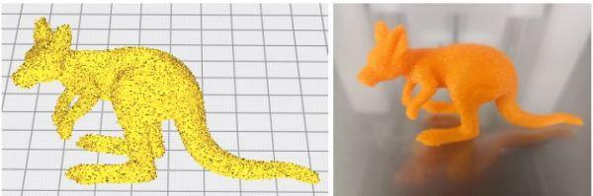
Figure 5k: 3D model of a kangaroo with “fuzzy” settings in Cura and as a finished print.
Original images.

5.1.9 Indicate orientation
When exploring 3D objects not attached to a base, touch readers tend to pick up the 3D model and rotate it in their hands. This is an important process for understanding the overall shape. However, it does mean that the orientation of the object can become confused.
When designing 3D models for touch reading it may be helpful to add a feature to indicate the bottom (flat), front (with braille label) or top (a dot or point) of a model that can be explained in accompanying information.

5.1.10 Stability for touch exploration
Tactile reading is a dynamic process, relying on movement of the hands and fingers over the surface of an object. For 3D printed pieces that can be combined in a variety of ways, ensure that once they are positioned, they can be kept steady while being touched.
Some suggested methods for providing stability:
- Create grid boards or frames in which 3D printed pieces can be placed. Laser cutting is a quick and easy technique for creating grid boards.
- Glue magnetic sheeting onto the back of 3D printed pieces then place them onto a white board or magnetic board.
- Glue non-slip matting onto the base of 3D models, or provide non-slip matting when the models are being used.
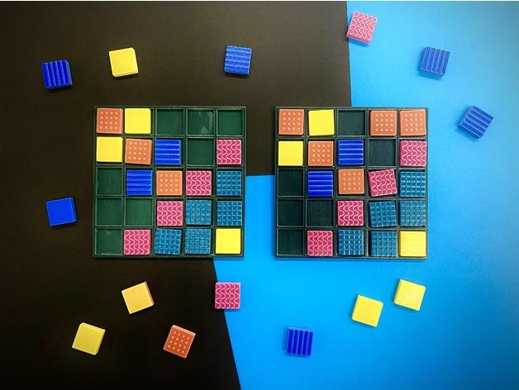
Figure 5l: 3D printed or laser cut grid boards will keep 3D printed pieces in place while being explored by touch. Image courtesy of Braille & Large Print Services, Department of Education NSW.

5.2 Design for inclusion
While touch reading should be the first consideration for accessible 3D models, it is helpful to incorporate features that will ensure the models can also be used by people who are sighted or have low vision.

5.2.1 Colour
If possible, print in colours that are meaningful in relation to the subject matter.
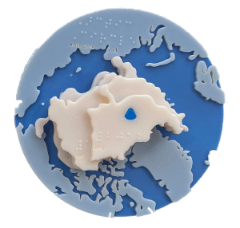
Figure 5m: 3D printed arctic ice shelves through the years (Thingiverse thing 6090079), printed in meaningful colours. Image courtesy of Braille and Large Print Services, NSW Department of Education.
If a whole model will be printed in a single colour, avoid very dark colours and black, as these are more difficult to distinguish visually because the shadows are less visible.
Refer to Section 9 Finishing for advice on adding colour after printing.

5.2.2 Contrast
Use contrasting colours to highlight important features. Colour variation helps learners with low vision to distinguish and recognise components of a 3D printed object.
To print in two colours with a standard FDM printer, the design needs to be made in two parts (1 per colour) and the printer needs to have dual printing nozzles.
It is also possible to stop a print part way and change the filament so that the base and top of the model are in contrasting colours.
Alternatively, colour can be added after printing using permanent markers, nail polish or automotive paint.

Recommended colour combinations for high contrast include:
- Yellow / Royal blue
- White on black
- Black on white
- Lime green on black
- Yellow on black
- Yellow on fire engine red (better for children with CVI)
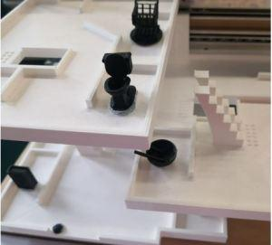
Figure 5n: 3D printed map with tactile icons in a contrasting colour.
Image courtesy of Monash University.
Refer to Section 9 Finishing for further advice on adding colour.

5.2.3 Supplement with print images
It may be helpful to supplement 3D models with print images, particularly if the model does not have high colour contrast and will be used by students with low vision. For example, models by Tactile Universe are supplied with a reverse image on the base, so that the user can hold the model in front of them to look at the print while feeling the tactile model on the back.

5.2.4 Labelling
Incorporate print labels in addition to braille and, if possible, audio. Refer to Section 8 Labelling 3D Prints for further guidance.

5.3 Design for engagement
3D printing offers an opportunity to create durable tactile learning tools with movement or multiple parts to provide active learning opportunities through interaction, play and reflection.

5.3.1 Manipulatives
3D prints are more engaging when they can be manipulated to create meaning. This may include:
- Spinners
- Multiple parts that can come apart and be put back together
- Multiple pieces that can be positioned in different ways to create meaning
- Hinges or other motions to explain physics concepts, show movement, or create flaps
- Bisections of models to show internal details, e.g. the internal cavities of the heart, or measurement lines inside a 3D shape
Refer to Section 5.6 Models with moving parts for tips on how to design these features.

5.3.2 Inserts for sound or weight
For engagement for younger children, consider adding objects inside a hollow 3D print so that it makes a noise when moved. Suggested objects include bells, dried lentils, dried beans or peppercorns. Larger and more expensive options include groan tubes or animal noise tins.
Inserts such as sand can also be used to increase the weight of a 3D printed object.
To insert an object inside a 3D print, include an empty space inside the model and then pause the printer when it is near the end of the space.

5.4 Consider the 3D printing process
Design models with the printing process in mind.

5.4.1 Avoid overhangs
Avoid overhanging areas as these will either fail to print or require support structures that result in a rough finish. This issue is explained in more detail in Section 6.4 Slicing.

5.4.2 Design for strength
Avoid very thin structures that are likely to break.
Bases should be a minimum of 0.8mm thick for strength, however beware of bending if the print is removed from the bed while it is still warm. For a more stable base, 1.5mm thickness is sufficient for objects unlikely to be under stress, or 2mm thickness for stronger bases. Models with a very thick base use more plastic and take longer to print.
Stalks or poles should be a minimum of 3mm thickness if short; or thicker if they are long.
When strength is of particular concern, also consider using a stronger printing filament such as ABS or tough PLA (refer to Section 6.3 3D printing filament and materials).
Refer also to Sections 6.4.4 Orientation and 6.4.5 Fill for tips on how to add strength through slicing decisions.

5.4.3 Design for economy
Reducing the thickness of a base (to a recommended minimum of 0.8mm) or eliminating the base entirely can greatly reduce the amount of filament and time required for printing.
As a further strategy to reduce printing time, braille labels can be printed separately – upright for smoothness and at a slow speed to reduce the chances of errors – allowing the main model to be printed more quickly and efficiently in a flat position.
When loading a model into the slicing software, orient the model to reduce the need for supports. This will help speed up the printing process, reduce plastic wastage and also minimise rough surfaces that are unpleasant to touch.

5.4.4 Design for re-use
Due to the printing time and space requirements for storage of 3D prints, it is wise to design models so that they can be reused for multiple teaching purposes. For example, if kept to the basics, a single topographic map can be augmented with Wikki Stix to show rivers, highways or state/country borders and with Blu-tack or plasticine to show cities, towns or other features.
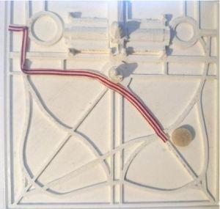
Figure 5o: 3D printed map with sticky-backed tape added to indicate a walking route to a point of interest marked with a fuzzy dot. Image courtesy of Monash University.

5.4.5 Safety considerations
Please note that 3D printed models are not considered food-safe because they are porous.
Corners and sharp points should be rounded for touch readers to avoid potential injury or harm and reduce the sharp plastic feel. Rounding the corners of flat bases also makes it much easier to remove the model from the print bed.
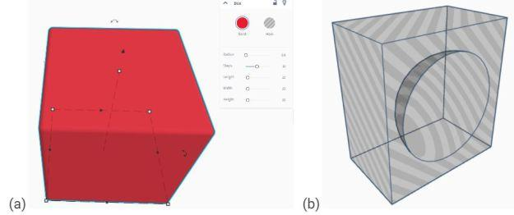
Figure 5p: Two methods to create rounded corners in TinkerCAD: (a) cube with radius 0.6 (b) customised shape for subtracting from corners. Original images.
To round corners in Onshape, Fusion360 and other more advanced 3D modelling software, use fillets and chamfers.
To round corners in the code-based OpenSCAD 3D modelling software, use the hull() function with cylinders or spheres at each of the corners of the shape.
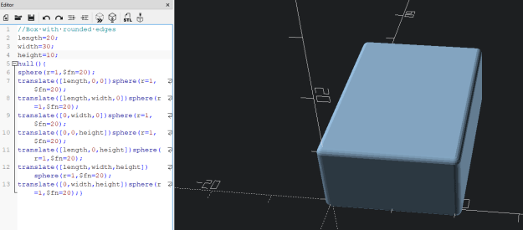
Figure 5q: Rounding corners in OpenSCAD using the hull() function with spheres on the corners. Original image.
Prints should also be checked for sharp corners and points after printing, when they can be smoothed manually, as per the guidelines on Section 9 Finishing.

5.5 Iterative design based on touch testing
Even when following guiding principles, design is an art as well as a science, and it is difficult to predict how something will feel when designing it visually on a computer screen. It is therefore important to touch test 3D printed designs and make adjustments according to the feedback.
It is helpful to print small portions of a design to quickly and efficiently conduct the first stage of touch testing a new 3D model.
Ideally, touch testing should be conducted with:
- People who are congenitally blind, to make sure that the concepts being used are familiar to them.
- People who are novice touch readers, to make sure that the model is tactually distinct for people who are unskilled in touch reading.
- People either of a similar age to the target audience, or spanning a large range of ages if the model will be used by a broad population. This is because finger/hand size is an important consideration for design, and tactile acuity generally declines with age.

5.6 Models with moving parts
Manipulatives are 3D models with moving parts or multiple pieces that the user can arrange in relation to each other.
Before printing parts that need to fit together or move, ensure that the printer is well calibrated to be as dimensionally accurate as possible on the X and Y axis. Each filament’s properties can behave differently in the printing process, shrinking at different rates for different geometries (especially in printing holes). Print and measure prints for calibration and adjust the printer settings as required.

5.6.1 Connections between pieces
Magnets provide an easy and effective way of joining pieces that are intended to be manipulated by the user, for example to add objects to a map or to join the cross-sections of a 3D shape.
To join two 3D printed pieces, the use of small neodymium magnets is suggested. Ensure that the magnets are positioned so that they attract rather than repel.
To enclose magnets inside a model:
- Design a hole inside the model with a little extra height to allow for inaccuracies.
- Stop the print just before the hole is covered. This can either be done manually or by adjusting the .gcode. In Cura, after slicing the model go to extensions > post processing > modify g-code. Select “add a script” and choose “pause at height” then enter the height for the top of the hole.
- Insert some superglue and the magnet into the hole.
- Wait for the superglue to act before resuming the print and watch carefully until the hole is covered to make sure the magnet does not lift out onto the metal print head.
It is also possible to place a hole at the base of the model and affix the model with superglue after printing, however this method is not recommended for use with young children, as swallowing magnets can cause severe internal injuries.

5.6.2 Moving parts
Strong tape such as duct tape can be used to join bisected halves of a model that needs to be unfolded to show the internal space [1].
Some models can be created with “print in place” connections for spinning. The easiest method for designing such models is to find an existing model with the desired moving parts then make modifications. However, “print in place” hinges tend to stick or break, so it is best to only use them where minimal force is likely to be applied.
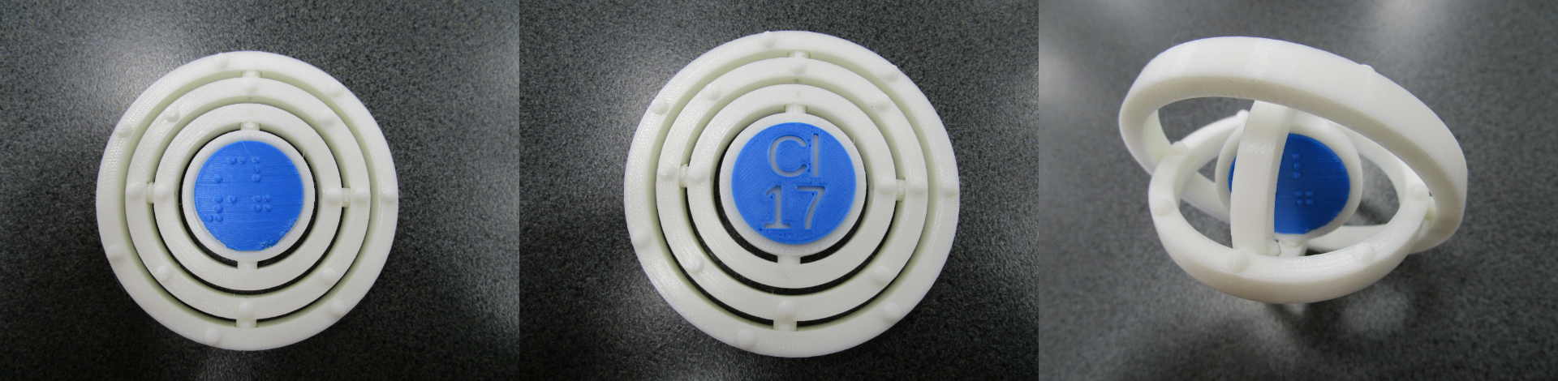
Figure 5r: A chemistry model with spinning electron shells, with print and braille labelling added. Image courtesy of SVRC, Victorian Department of Education.
When more strength is required, a better option for hinges is to 3D print a channel then insert a bolt or metal rod for greater strength [1]. It is also a good idea to increase infill for greater strength when printing the parts with the bolt hole.
Another mechanism for movement is tracks that 3D printed pieces can be attached to using 3D printed rods or a nut and bolt.
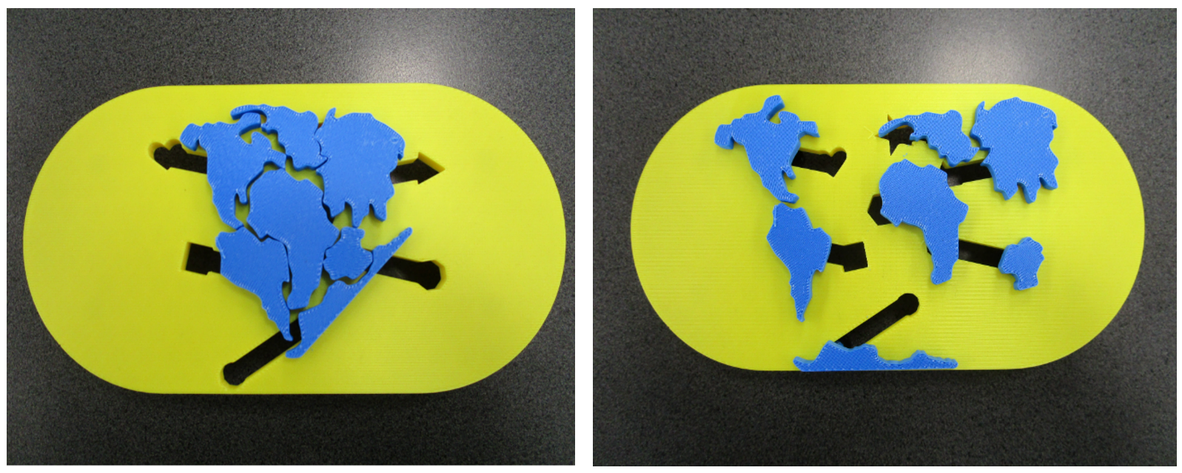
Figure 5s: 3D model showing tectonic plate movement. Each continent has a threaded rod at the back that stays in place in the channels for movement (Thingiverse thing 5996134). Image courtesy of SVRC, Victorian Department of Education.

5.7 Maps

5.7.1 Spacing
On outdoor maps, consider widening streets and gaps between buildings so that the fingers can feel the sides of buildings and easily trace along routes. 7mm is sufficient but wider streets may be better.
On indoor maps, ensure that doorways are wide enough for the finger to pass through.

5.7.2 Heights
The height of buildings and walls should represent their relative height but the vertical scale can differ from the horizontal scale. Heights should be low enough for the fingers to easily reach the base.
On street maps, consider adding ridge lines on multi-storey buildings to indicate each storey. If space permits for roads and paths to be wide enough for the fingertip, they should be lower than surrounding features to reflect the act of stepping down from the curb.
On indoor maps or floorplans, walls should be higher than floors and pathways so that they can be understood as walls. A height difference of 1-3mm between pathways and walls is sufficient [10] and up to 5mm is acceptable.

5.7.3 Realism
Where possible, indicate features with (simplified) realism rather than abstract symbols. For example, stairs and trees can be represented realistically and are easy to understand without reference to a key. Refer to Section 5.8 Icons for further suggestions.
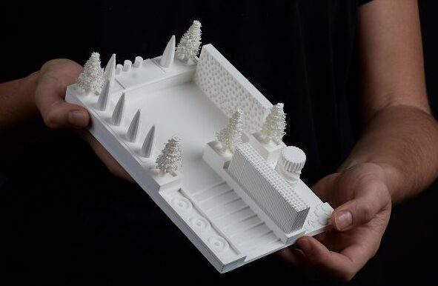
Figure 5t: Map of a sensory garden with simplified realism to represent trees.
Image courtesy of SensiLab, Monash University.

5.7.4 Topographic maps
Topographic maps of a chosen region can easily be created using the free Terrain2STL website.
Super-elevation, i.e. an exaggeration of the vertical scale, is useful for topographic maps to enable detection of details in the landscape. As a general guideline, a super-elevation factor of 3 is recommended, whereby the z values (heights) are represented three times as high as the scale in the horizontal plane would actually require [1]. Accompanying information should explain the super-elevation to the touch reader.

5.8 Icons
3D icons for maps can be recognised more easily than 2.5D icons, reducing the need to rely on a key and making tactile maps easier to understand [9].
A selection of pre-tested icons for maps of shopping districts, parks and playgrounds are available for free download from Thingiverse (thing 5841775). These icons should be printed at a minimum size of 20mm³. If space permits, larger icons are generally easier to recognise.
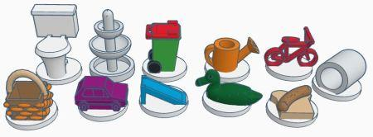
Figure 5u: A selection of 3D icons for use on tactile maps of parks and playgrounds, available for free download from Thingiverse (thing 5841775). Image courtesy of Monash University.
The existing icons are provided on a circular base so that they can be securely fixed to the map base. Alternatively, they can be embedded into a map model and printed all in one piece. Icons must be spaced apart to allow adequate access for tactile exploration from all sides.
Further icons can be designed based on the following guidelines:
- Use objects that are a distinctive shape. Objects that are regular shapes such as rectangular prisms and rounded objects cannot easily be distinguished unless they have very distinctive additional features.
- Common objects that are hand-held are ideal for icon representations because they are most likely to be familiar to people who are congenitally blind.
- The most important and distinctive features should be near the top of the icon, where they can be more easily accessed by touch. It may be necessary to position the object so that the distinctive features can be felt.
- Simplify the object to its bare essentials removing any extraneous details.
- Exaggerate features that are distinctive. For example, a dog or cat’s ears should be exaggerated to assist with identification. However, this exaggeration of features should not be based on stylistic visual conventions that would be unfamiliar to a touch reader who has been blind since birth.
- Flatter icons are more difficult for novice touch readers to recognise than those that are more 3-dimensional. Consider rotating the object to an upright position so that it is easier to feel.
- Corners and edges should be square or round in accordance with the original object to assist with interpretation. Often this means square corners for man-made objects and rounded corners for organic objects.

5.9 Art

5.9.1 Sculptures and museum objects
In general, for the representation of sculptures, 3D models are preferred to tactile reliefs, which are in turn preferred over tactile graphics [5].
A large range of 3D models for famous artworks are available through the Scan The World project. However, when selecting models from this collection keep in mind that the original artworks were not designed for 3D printing, so many of the models may be too complex for FDM printing, require a lot of supports, or include delicate structures.
Materiality is important to make objects like museum artefacts authentic. For tips on adjusting the surface feel and weight of a 3D print, refer to Sections 6.4 Slicing and Section 9 Finishing. However, keep in mind that 3D printing may not be the best technique to represent objects with very different material properties. For example, to represent a jellyfish it would be much better to 3D print a mould and then fill it with jelly or a similarly soft, wobbly substance.

5.9.2 Paintings
Paintings are much more difficult to render successfully as 3D prints because the original format is flat, they often rely heavily on colour and the scene being depicted may be very complex.
The first option for representing a painting using 3D printing is to create a relief model with partially raised forms emerging from the canvas. A successful depiction will simplify down to the most important details. Scenery in the background can either be omitted or shown very flat, with foreground objects much more raised.
A second option for representing a painting using 3D printing is to create a tactile graphic showing the basic composition then accompany this with 3D printed models (and other artefacts) of the most important elements within the painting.
Lastly, an abstract or semi-abstract painting can potentially be represented by converting greyscale to heights in a relief model. This method may be suitable for showing broad brush strokes and abstract shapes but should NOT be used for complex representational artworks.
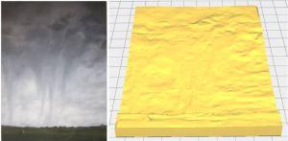
Figure 5v: The Last Bale oil painting by Margaret Holloway (left) and conversion to 3D relief using greyscale (right). Image courtesy of the artist.

5.9.3 Accompanying information
Perhaps even more so than other 3D artefacts, 3D printed models of artworks need to be accompanied by descriptions and other modalities in order to convey not just the subject matter but also the colour, lighting, shadow, materials, scale, context, aesthetics and emotional response. Art concepts may also need to be explained.
As an example, a 3D model of a sculpture may be supplemented with a sample of the type of stone from which the original was carved, or a painting of sheep may be accompanied by a sample of unwashed wool and the sound of a bleating sheep.

5.10 Architecture
When representing buildings and architectural models using 3D printing, adjust the level of detail according to the scale and purpose of the model.
For a small building on a large map, simply provide the basic shape to convey the form, scale and position of the building.
For a tall building on a large map, provide the basic shape with an indication of the number of storeys. This can be conveyed with indented windows on a smaller building, or with ridges for each level on a skyscraper.
When the building and its architecture is the main topic of a 3D model, identify the key architectural features for inclusion and ensure that they are able to be felt tactually. This may require some distortion of scale, for example exaggerating offsets, widening columns and chimneys [4], bringing doorways forward or adding a raised outline around windows and other indented features. Ornate architectural details are best conveyed as enlarged tactile graphics or 3D printed relief models rather than trying to include them on a 3D model.
To show internal details of a building, consider making the roof and upper levels removable. Internal walls do not need to be full height, so that the finger can easily reach to the floor where braille labels and travel routes may be marked. The removable parts must be designed so that they are easy to remove and return to the correct position.
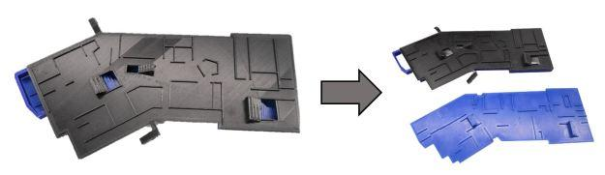
Figure 5w: Building models with removable roof and/or floors allows the overall building shape and internal floorplan to be shown along with how the levels connect. Image courtesy of Monash University.

6. The 3D printing process
The 3D printing process involves slicing a 3D model (Section 6.4) then using a 3D printer (Section 6.2) to print the model (Section 6.5) with the selected filament (Section 6.3). 3D printing services are available for those who do not have access to their own 3D printer (Section 6.1).

6.1 3D printing services
There are many options for 3D printing for those who do not have direct access to a printer.
- Commercial 3D printing services: For example, CraftCloud provides quotes from a global network of providers; Hubs is a high quality service with worldwide professional printing providers; and PrusaPrinters has a community website to connect with individuals who can provide a print-on-demand service. The advantage of these services is that they give choice in terms of the type of printing process, materials and colours. Prints can be ordered online either from their catalogue or by supplying a 3D model file.
- Education departments: Most accessible format production teams within education departments are also able to design, produce and loan 3D printed models for students who are blind or have low vision.
- Schools: Many schools have 3D printers. It may be possible for teachers to use the printer or ask school staff to provide 3D prints for students with print disabilities. It may even be possible to set a class project for students to design and produce 3D models for accessibility.
- Public libraries: Some public libraries have 3D printers available for public use, charging by the hour. Library staff will do the printing based on individual requirements. Check local council websites for availability.
- Blindness agencies: The advantage of ordering through a blindness agency is that they will be able to assist with design and provide advice on the suitability of 3D models for people with print disabilities. In Australia, NextSense provides FDM 3D printing and laser cutting services at cost via NDIS funding. Vision Australia can produce FDM 3D prints and commercial quality UV printed reliefs for their clients or as a commercial product.
- Community groups: See3D is a not-for-profit organisation providing volunteer 3D design and printing for touch readers. They are based in the US but can post to Australia or New Zealand. They are hoping to establish these services with local providers in the future.

6.2 3D printers
FDM printers are the most common type of 3D printer for home and school use. As illustrated in Figure 6a, a reel of plastic filament is fed into the print head where it is melted and extruded through a nozzle. The print head can move back and forth and side to side. Either the print bed or print head can also move up and down so that the filament can be extruded one thin layer at a time.

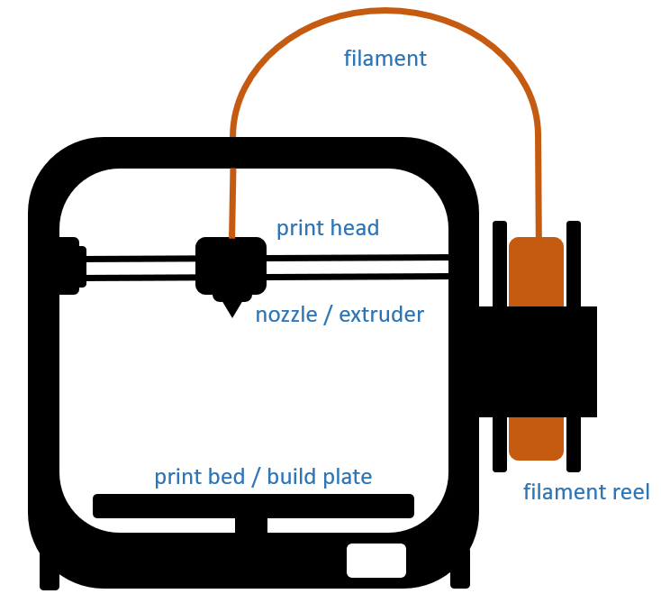
Figure 6a: The basic parts on an FDM 3D printer. Original image.

6.2.1 Selecting a 3D printer

When choosing a printer, consider the following factors:
- Printer type: FDM printers are the easiest, cheapest and most commonly used printers in education. SLA printers use resin and can produce models with a finer level of detail, however the end product can be brittle and the production process is messy and more time-consuming, requiring UV curing and clean-up of liquid resin.
- Maximum print size: This is determined by the bed size and printer height. A build size of 20cm³ is sufficient for most hand-held models.
- Bed heating: A heated bed assists with adhesion, which is particularly important if using ABS filament or if printing large models with a flat base.
- Nozzles: a single nozzle is sufficient for most prints, however two nozzles are required for soluble supports or multi-colour prints
- Filament: 1.75mm filament is the standard size and allows a somewhat wider choice of colours and materials. Some specialist filaments such as those containing metal can only be used with certain printers.
- Location of the filament feeding motor: Select a printer with the filament feeding motor close to the print head (direct feed) if using flexible materials such as TPU or nylon. Direct feed printers are generally also easier to use for people with print disabilities.
- Automation: Some more expensive 3D printers have cameras to monitor a print remotely. They can automatically sense when the filament is blocked or empty, etc. These features are more important for printing very large models or multiple copies overnight.
- Community support for solving printing problems: Online communities, support and troubleshooting are likely to be better for more well-known and established 3D printing companies.
- Accessibility: Consider whether the printer gives audible feedback and whether it can be operated remotely using command lines or an accessible slicer. Further details on 3D printing accessibility are given in Section 12 Blind makers.
Some printers recommended by the ANZAGG 3D printing group members include Bambu, Prusa and Ultimaker.

6.3 3D printing filament and materials
PLA: A corn-based plastic filament (more environmentally friendly) that prints reliably and is good for fine detail. The melting point is relatively low, so objects printed in PLA are likely to warp in a hot car or hot water. PLA filament should be stored in a plastic bag with desiccant to prevent it from absorbing atmospheric humidity and becoming brittle. Tough PLA is a slightly stronger option for models that must withstand tension or rough treatment. Silk PLA provides a smoother finish that may be more pleasant to the touch.
ABS: A plastic filament that is very good for strength and durability. ABS prints at a high temperature (giving off unpleasant fumes) and it can therefore be used as a master for thermoform copies. It is not good for fine detail and adhesion and shrinkage can be problematic during printing. Excellent smoothing can be achieved after printing using an acetone bath (Section 9.1.3 Chemical smoothing), however this process involves handling of hazardous chemicals.
PET-G: This filament has the same advantages as PLA (it prints reliably and gives fine detail) but it is stronger and is more resistant to heat.
PVA: Filament used to create dissolvable supports with a two-headed printer. After printing, the model can be soaked in water to dissolve and remove the supports, leaving a smoother finish. Beware of moisture absorption during storage and if necessary, place the reel on a hot printer bed to remove any moisture.
Conductive filament: Can be used to seamlessly integrate electronic components within a model, providing a connection between a touch point on the model’s surface to electronics underneath or inside the model to allow for features such as audio touch points.
TPU and Nylon: These filaments are slightly stretchy and can be used to create “squishy” models, for example for anatomical parts. When printing with TPU and nylon it is best to use a 3D printer with the filament motor near the print head to reduce errors caused by stretching and warping between the motor and the nozzle.
Carbon fibre filaments: Metal filaments are excellent for strength, stiffness and finish. However, they can only be used with printers that are designed for that purpose (with enclosed printing and higher temperatures), and it is best to use steel printing nozzles.
Speciality filaments: Filaments containing wood or other materials can be used to give a slightly different texture, feel or smell. However, they can cause printing problems as they tend to clog or abrade nozzles.
Resin: This material is used with a specialised SLA printer. It is the best option for achieving very fine detail, however a clean-up process and UV curing are required, which can be messy and time-consuming. The cost of materials is significantly higher than most FDM filaments and the finished models can be brittle and break easily.

6.4 Slicing
Slicing is the process of setting instructions for the 3D printer on how it should print a model. Printers come with their own slicing software and there are other slicers that can be used with a range of printer brands. The slicing process involves opening a 3D model file in the slicing software, selecting settings such as size, orientation, print quality, etc., then slicing the model to obtain a .gcode file that can be sent to the printer.
Thoughtful slicing is an invaluable step for reducing printer errors and achieving a smooth, touch-friendly finish.

6.4.1 Layer height
Thinner layers have better adhesion to a heated bed and give more fine definition, reducing ridges between layers. However, thinner layers take much longer to print.
Sometimes, thick layers can help convey meaning for the 3D object, such as a model of a striped animal or of a sedimentary landform.

6.4.2 Size
In general, touch readers prefer larger models [19]. Within reason, bigger is better for the user but takes much longer to print and consumes more material. Models should not exceed arm’s length.
Do not resize models with braille labels included on them, as braille must be read at a standard size.

6.4.3 Supports
Supports are additional structures added during slicing to hold up overhanging structures on a 3D model.
Supports are generally needed if the overhang is greater than 45 degrees. They are always needed if a separate part of the model starts above the base, such as the horse’s nose and belly in Figure 6b.
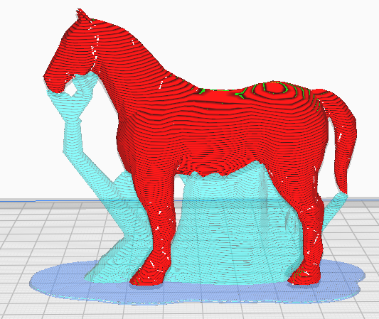
Figure 6b: Tree supports (in blue) to provide a temporary base for overhanging parts on a 3D model of a horse. The supports are removed after printing. Original image.
Tree supports are the recommended type of support structure when printing for touch readers as they are easier to remove and leave less residue.
PVA supports can give a good finish but a two-headed printer is required and the process of dissolving and removing them is messy and time consuming.

6.4.4 Orientation
The orientation or rotational position of a 3D model is important in terms of stability, supports and strength.
Stability: Tall thin models are likely to move during printing, which can cause printing problems such as mis-aligned layers or falling. If possible, orient the model so it has a wide flat base and height is minimised.
Supports: As described in Section 6.4.3 Supports, try to orient the model to minimise overhangs and the need for supports. Also consider printing the model in two parts if it has too many overhangs. Prusa Slicer and its variants have a built-in function to automatically split models and create pegs and peg holes to join the model, while Cura has a “banana split” plug-in.
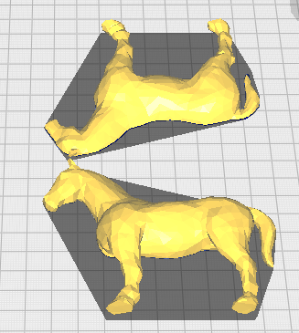
Figure 6c: 3D model of a horse divided into two parts using the banana split plug-in to achieve better adhesion and reduce supports. The halves will need to be joined after printing. Original image.
Strength: A 3D print is most likely to break along the horizontal printing plane, where the printing layers join. Long parts that need strength should be laid flat, parallel with the printing plate.
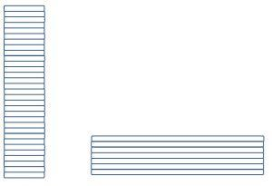
Figure 6d: A long thin structure is weaker when printed upright (left) because the short horizontal layers can easily be broken. Original image.

6.4.5 Fill
Fill refers to the pattern and amount of 3D printed structure inside a 3D printed model to give it strength. The amount of fill will usually range between 15%-50%.
It is possible to add weight and strength to a model simply by increasing the fill but it also adds to the print time and uses significantly more material.
Lightning fill is a fill pattern available in Cura for very quick printing when strength is not required.

6.4.6 Adhesion
As described below in Section 6.5.2, adhesion to the build plate is the most important and often difficult requirement for successful 3D printing. Adhesion can be assisted by the addition of filament at the base, selected through the slicer settings. This is most often required when using ABS filament, when the model is very large, or when the model will be printed upright with a small base.
A brim is a thin single layer of filament forming extending the base of the model. After printing, use a deburring tool (available from hardware and 3D printing stores) to remove the brim and achieve a smooth edge.
A raft is a latticework of filament that is printed underneath the model. Rafts can consume a lot of material, add significantly to the printing time and be difficult to remove, but it can be an effective solution when adhesion is particularly problematic.
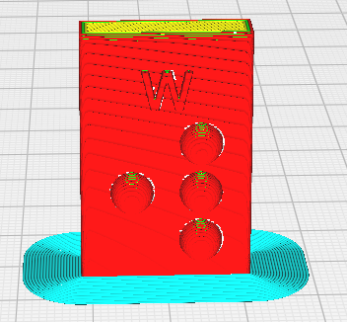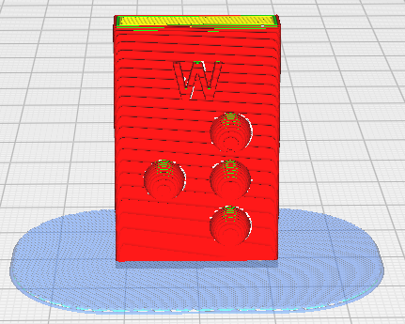
Figure 6e: A brim (left) is a single thin layer of filament added around the base of a model. A raft (right) is a thicker latticework of filament. Original images.

6.4.7 Printing speed
Slow down the printer for stability when printing a model that might be liable to tipping (tall with a small base).

6.5 3D printing and troubleshooting
The 3D printing process involves a lot of moving parts and melted plastic, and is therefore prone to errors. The key to becoming skilled at 3D printing is to take a tinkering approach: look up resources online, use trial and error, and be willing to pull the printer apart. Most 3D printers are designed to be fixable by home users and it is easy to purchase and install replacement parts.

6.5.1 Placement of the printer
3D printers and 3D printing filament are susceptible to errors caused by the environment.
Do not place the 3D printer on the same benchtop as another piece of equipment that is likely to cause vibrations.
Do place the 3D printer in a position where it is protected from air drafts and humidity. If the 3D printer has open sides, it may be necessary to add protective shields from drafts. These can either be homemade hacks or commercial options such as the Wham HotBox.

6.5.2 Adhesion
Adhesion refers to how well the 3D print sticks to the build plate. Good adhesion is required to prevent the 3D models from moving or falling during the printing process, after which time the printer will have nothing to build on and create a “spaghetti” mess of extruded filament strands. There are a number of strategies that can assist in achieving good adhesion.
Levelling the bed: Levelling the bed is the most important step for successful printing. Level the bed after moving the printer and any time that there are problems with adhesion. Use the printer’s automated levelling method then print just the first one or two layers of a large model to check that it sticks without dragging. Make fine adjustments as necessary.
Glue stick: Glass printing plates can benefit from a very thin layer of glue. Smear the plate with a glue stick and then wipe it with a wet paper towel. Alternatively, dissolve a glue stick in water and smear the liquid on the plate. Always let the glue dry before printing. Clean the plate and repeat the process as necessary.

6.5.3 Extrusion
Extrusion refers to the process whereby filament is melted and passed through the nozzle in an FDM 3D printer. Poor extrusion will result in problems with adhesion, 3D models that appear porous with small holes in them, and layers that break. Poor or blocked extrusion can be caused by problems in the print head or the filament feed. The following strategies are effective for identifying and fixing most problems with extrusion.
- Check the filament reel. Is there sufficient filament on the reel? Has the filament become tangled?
- Remove the filament using the printer’s feed mechanism. Did the filament come out or was it stuck? If stuck, did the feed motor turn? Has the filament ground down where it is in contact with the feed motor?
- Heat up the nozzle and then manually remove the filament from the printing head. If there is a blockage inside the nozzle, this can usually be cleaned by sticking a clean piece of filament into the nozzle and pulling it out while the nozzle is still hot. Finally, manually push some filament through the nozzle to ensure that it goes through cleanly.
- Reload the filament and run some filament through the nozzle using the printer’s automated mechanism to check that everything is working properly.

6.5.4 Stringing
Stringing refers to tiny strings of filament pulled out from the 3D model where the printing head has lifted up and moved from one part of the model to another. Strings can be very sharp, therefore it is important to address this problem when creating 3D models for touch readers.
Stringing may be caused by any of the following issues. More detailed advice for specific printers and slicers is available online.
- Retraction refers to pulling the filament back after each extrusion to prevent it from oozing out as strings or blobs. It is the most effective method for reducing stringing. Retraction can usually be selected as an option in the slicer settings.
- Stringing can be caused by a temperature setting that is too high for the filament, which will ooze out when too hot.
- A very fast print speed can cause stringing. Conversely, a fast travel speed (between parts of the model) will reduce stringing. These settings can be adjusted in the slicer.
- Cleaning the nozzle is a simple solution that may reduce oozing due to increased pressure inside the nozzle.
- Swollen filament can likewise cause oozing due to increased pressure. Filaments must be kept in a dry environment. If they have been exposed to a humid environment, they may be dried by exposure to a warm temperature.

7. Other methods for creating 3D models
3D printing is, of course, not the only method for creating 3D models. Other options should also be considered, depending on the desired model features, the availability of necessary equipment and how the model will be used.
Table 7a: Overview of methods for creating 3D models.
Method | Specialist Equipment | Materials | Other Considerations
Hand Crafting  (7.1) | Various e.g. hot glue gun, wire cutters, scissors, etc | Various e.g. wire, polystyrene, pipe cleaners, papier mache, modelling clay, fabric | For one-off models that have good material properties. Can be created by people who are blind or have low vision.
Ceramics  (7.2) | Kiln | Clay, glaze | Can be created by people who are blind or have low vision.
Laser Cutting  (7.3) | Laser cutter | Cardboard, wood or acrylic | Creates flat layers that can then be constructed or stacked. Etch if a textured surface is required.
CNC Milling  (7.4) | Milling machine | Polystyrene or wood | Subtractive process with high accuracy. Best for relatively flat shapes with a large base.
Moulding and Casting (7.5) | None | Silicone, plaster, resin, expanding foam, clay or other | Good for creating multiple copies of fully 3D models.
Thermoform (7.6) | Thermoform machine | Plastic sheets | Quick and cheap way of making multiple copies, but only suitable for shapes with a broader base and no overhangs.

7.1 Hand Crafting
Hand crafting is a good option for creating one-off models with meaningful material and textural properties. Suggested materials include foil or polystyrene and wire for internal structure, covered with plasticine, air-drying or oven bake clay, papier-mâché, fabric, and/or a wide array of craft materials. Hand-crafted models can be created by people with a print disability.
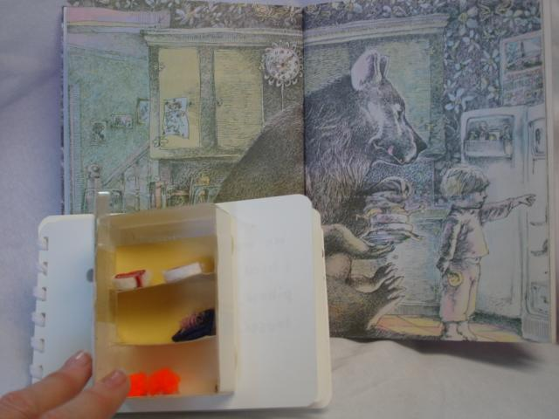
Figure 7a: Small 3D fridge made with scrap supplies to illustrate “The Bear’s Toothache” by David McPhail. Image courtesy of Feelix Library, Vision Australia.
If making a model using sewing, knit or crochet, stuff it very firmly so that it retains its shape under pressure from touch. Ensure that buttons and other features are well-attached and don’t pose a choking hazard to younger users.

7.2 Ceramics
Ceramics uses clay as the starting material and requires a kiln and glaze to produce a smooth durable product. It may be practical in schools where there is a kiln and a knowledgeable staff member. Models can easily be created by people with a print disability. Slip clay is also an option for creating cast copies with moulds.

7.3 Laser Cutting
CO₂ laser cutters use a computer image to cut or etch into sheets or boards of cardboard, fabric, wood, acrylic or other non-metal materials. They can be used to create 3D models in three different ways:
- Cutting a flat sheet, perhaps with some etching for tactile textures or braille, to serve as a base for models made using another method. This method uses simple image files.
- Constructing forms from flat sheets. For example, boxes can be created to serve as a base holding electronics and audio components, or to create 3D buildings. Free software such as MakerCase is available to customise boxes of any size with interlocking edges.
- Cutting multiple layers that will then be stacked, glued and perhaps sanded. This method uses the same 3D model files as 3D prints. It is well suited for creating topographic maps with layers.

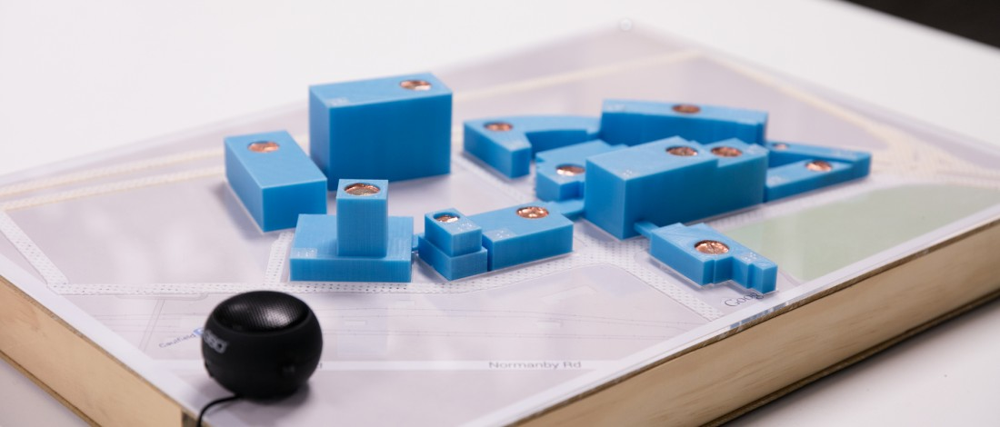
Figure 7b: Laser cut box as a base for 3D printed buildings, with etching to indicate roads and a box to house electronic components. Image courtesy of SensiLab, Monash University.

7.4 CNC Milling
CNC Milling is a process beginning with a 3D model file and a block of raw material called stock (such as foam, wood, metal, plastics or resin) that is milled to remove any unwanted material. While it is a faster process than 3D printing, CNC milling requires monitoring and manual intervention. First use a large milling bit to remove the majority of the stock material, followed by smaller and finer bits until the desired level of detail or smoothness is achieved. The first time that a file is milled, it needs to be watched closely in case of errors, and in general the machine should not be left unsupervised for long periods of time. After completion, a lot of clean is required for the removed materials. For touch readers, milled pieces will also require smoothing with sandpaper and perhaps application of a top coat. The finished model will feel superior to 3D printed models, with less distractions caused by the production process. It also allows for models of a bigger size and a wider range of materials. If using wood, note that MDF is very cheap but its milling poses serious health risks and it cannot be sanitised easily, whereas hardwood is more expensive but safer and easier to clean.
As it is a subtractive process, milling is best suited to relatively flat shapes with a large base, such as maps and landforms. Less advanced machines cannot produce overhanging parts.
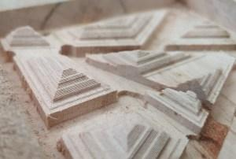
Figure 7c: CNC milling with wood. Image courtesy of NextSense.

7.5 Moulding and Casting
Moulding is helpful to create a large number of the same 3D model. The process begins with a master model, which could be a real object or made using 3D printing or any of the methods listed above. Models with a flat base are easiest for creating a mould, which can be used to cast multiple copies. Some clean-up of the copies is usually required.
A range of different materials can be used for moulding and casting. The golden rule is never like-with-like, i.e. the mould and cast must be made from different materials. Common options for the mould include:
- silicone (easiest to work with but most expensive);
- silicone with plaster bandage supports;
- latex (cheaper than silicone but harder to work with);
- or two-part plaster moulds.
The cast can be made using anything that easily transforms from a liquid to a solid, such as urethane plastic, resin (very durable but best for small models), plaster, expanding foam, slip clay, wax or melted candles, soap, etc.

7.6 Thermoforming
Thermoforming, also known as vacuum forming, is a fast process of moulding a plastic sheet over a raised shape using a combination of heat and vacuum. The original 3D model could be made using any of the above methods, then quickly and cheaply reproduced using thermoforming. Accessible format producers will be familiar with American Thermoform Corporation machines designed specifically for braille-size pages. Many other thermoform machines are also available, ranging from industrial packaging machines to home office and DIY contraptions that connect to a domestic vacuum cleaner.
Thermoforming is only suitable for objects without overhanging features or tall vertical walls.
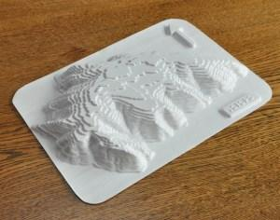
Figure 7d: Thermoform copy of a laser cut model of Uluru. Image courtesy of ChildsPly Vision.

8. Labelling 3D prints
3D models will almost always need to be accompanied by some supporting information including verbal, written or electronic. Important information to include:
- Overview: A title for the model and enough information to know what to expect.
- Orientation. Which way is up? Where is the front?
- Scale. Is the model to scale? If not, what is the scale? It can help to provide a reference line to indicate the relative size of a person, ant or other relevant object with a well-known size.
- Important features.
Much of this information is often provided by a teacher, classroom aide or museum/gallery guide. However, labelling is still important to enable independent exploration.
Table 8a: Overview of the methods and technologies available for labelling 3D prints.
Labelling method | Minimum size | Additional requirements | Considerations
Basement (8.3) | Must be larger than the 3D model | Tactile graphic | Can give detailed information about specific parts of the model.  Also assists with orientation of the model.
Braille label (8.2) | 6.4mm high × variable width | None | Information is given on the model without the need for external systems or a key.  Not suitable for complex models.  User must know braille.
Braille symbol  (2-3 cells)  (8.2) | 6.4mm high × 12.4mm wide | Key | Can give detailed information about specific parts of the model.  Can be confusing if orientation (which way up) is not clear.  User must know braille.
UBIS symbol  (8.4) | 16.5mm high × 16mm wide | Key | Also indicates which way is up.  Quite large.
3D symbol or icon  (8.4) | variable | Key | Can be intuitive, reducing the need to refer to the key.
QR code with tactile indicator  (8.5.2) | 25 × 25mm minimum;  30 × 30mm for 1,000 characters or more | QR code reader on phone or tablet | Can provide a large amount of text or other other media.  Free, using mainstream technology.  Quite large.
NFC tag  (8.5.3) | 25-38mm² | Smartphone (iPhone 6 or higher; many newer Android phones) | Limited to one label per model.  Allows for a detailed audio description.  Needs specialised equipment.
Penfriend (or similar)  (8.5.1) | Variable | Penfriend device and labels.  Tactile indicator around the label. | Easy to use.  Uses an individual device (not distributable).  Expensive.
Touch triggered electronics  (8.5.4) | Variable | Conductive material, microcontroller board, speaker or headphones, and power source. | Familiar touch-based interaction (e.g. single-tap & double-tap).  Creation requires expertise.  Expensive.

8.1 Print labels
The addition of print labels makes an accessible tactile model inclusive, so that it can be used together by people with any level of vision.
Small print labels should be added using thin indents, as these will not interfere with touch reading. If placing print and braille labels together, position the print label above the braille so that it can still be seen while fingers are touching the braille.
Add visual contrast to the print label by colouring inside the indented letters with a permanent marker or similar.
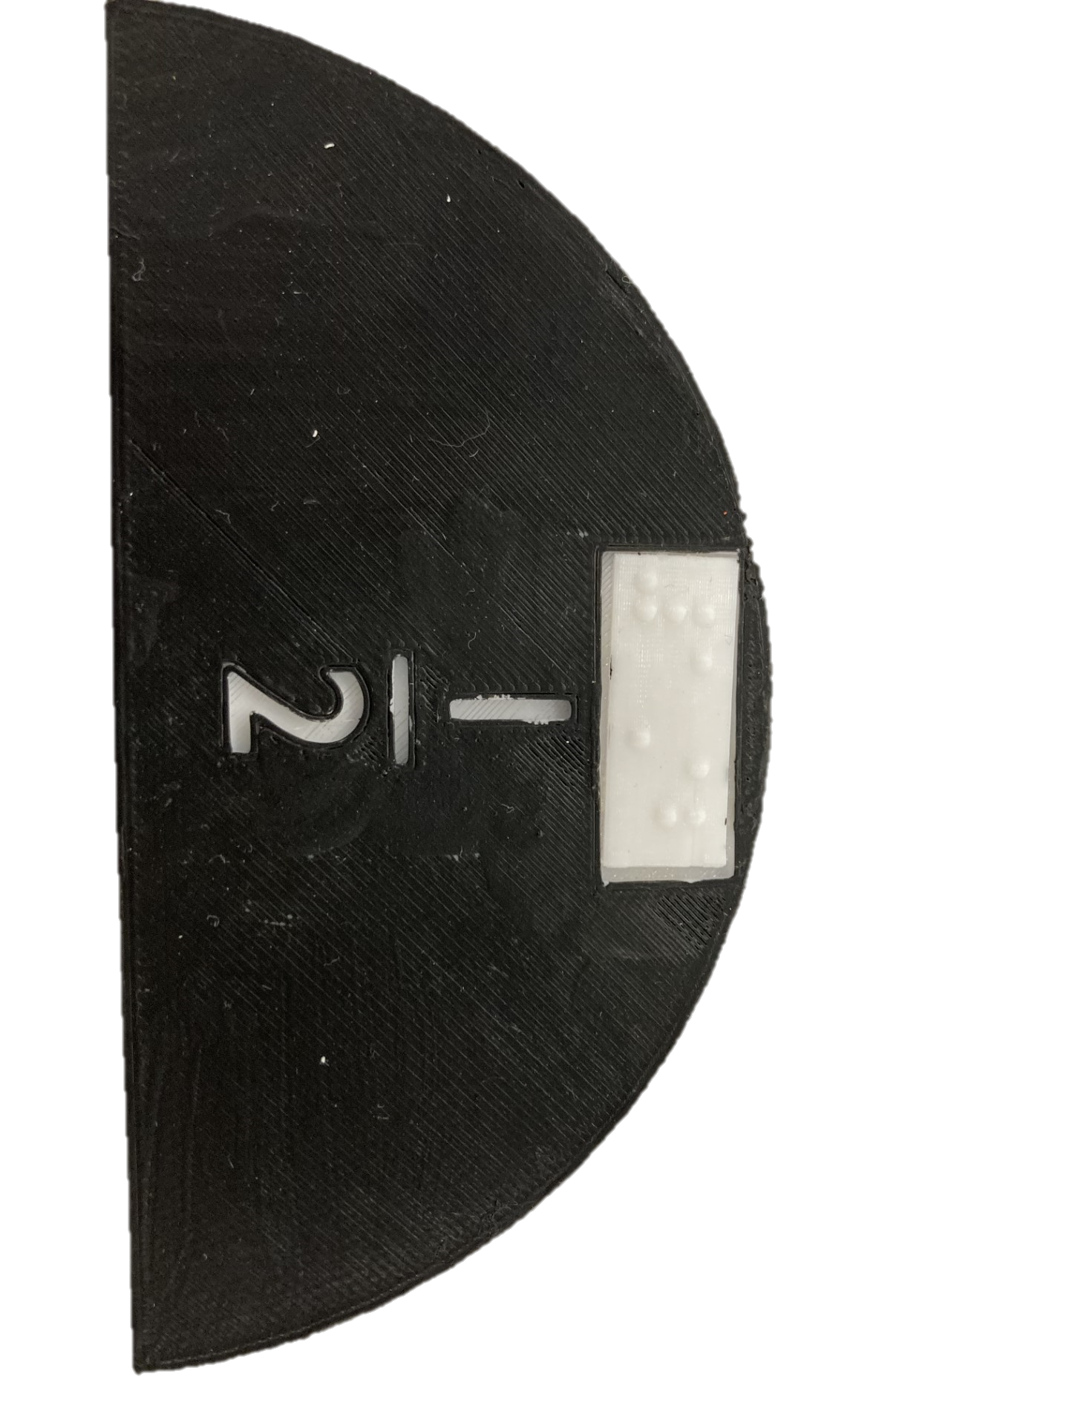
Figure 8a: Fraction half with braille and print labels. Indenting the print means that it will not interfere with touch reading, and a contrasting colour can be added inside the indented print for use by students with low vision. Image courtesy of the Statewide Vision Resource Centre.

8.2 Braille labels
Braille labels provide an immediate way to recognise the title or parts of a 3D print by touch. They must be placed on a smooth surface and the user must be able to read braille. As braille requires a lot of space, only short braille labels can fit onto 3D models. If the orientation of the braille is not clearly evident, add a tactual indicator such as cutting off the top right corner of the label.
If possible, place braille labels at the front of a model as a tactile indication of which way it should face.

8.2.1 3D printed braille labels
As braille must be given at a standard size, do not incorporate braille labels on models that are likely to be printed at a variety of scales.
Braille labels can cause confusion when trying to interpret complex models and alternative methods for labelling should be used in these instances.
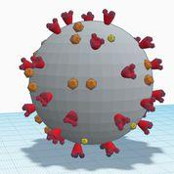
Figure 8b: Coronavirus model with a complex surface not suitable for braille labels. Original image.
If using an FDM printer, braille should be printed upright (at a 90% angle from the printing plate) to achieve optimal tactile quality and readability [1, 14]. Models with flat surfaces on the side are ideal candidates for braille labels. If the braille needs to be placed on the top or base of a model, either print the whole model on its side or print the braille labels separately then insert them after printing.
It is possible to wrap braille on curved surfaces, however the process is time-consuming. A short braille symbol is advised with a key provided on an accompanying basement, braille page or electronic document.
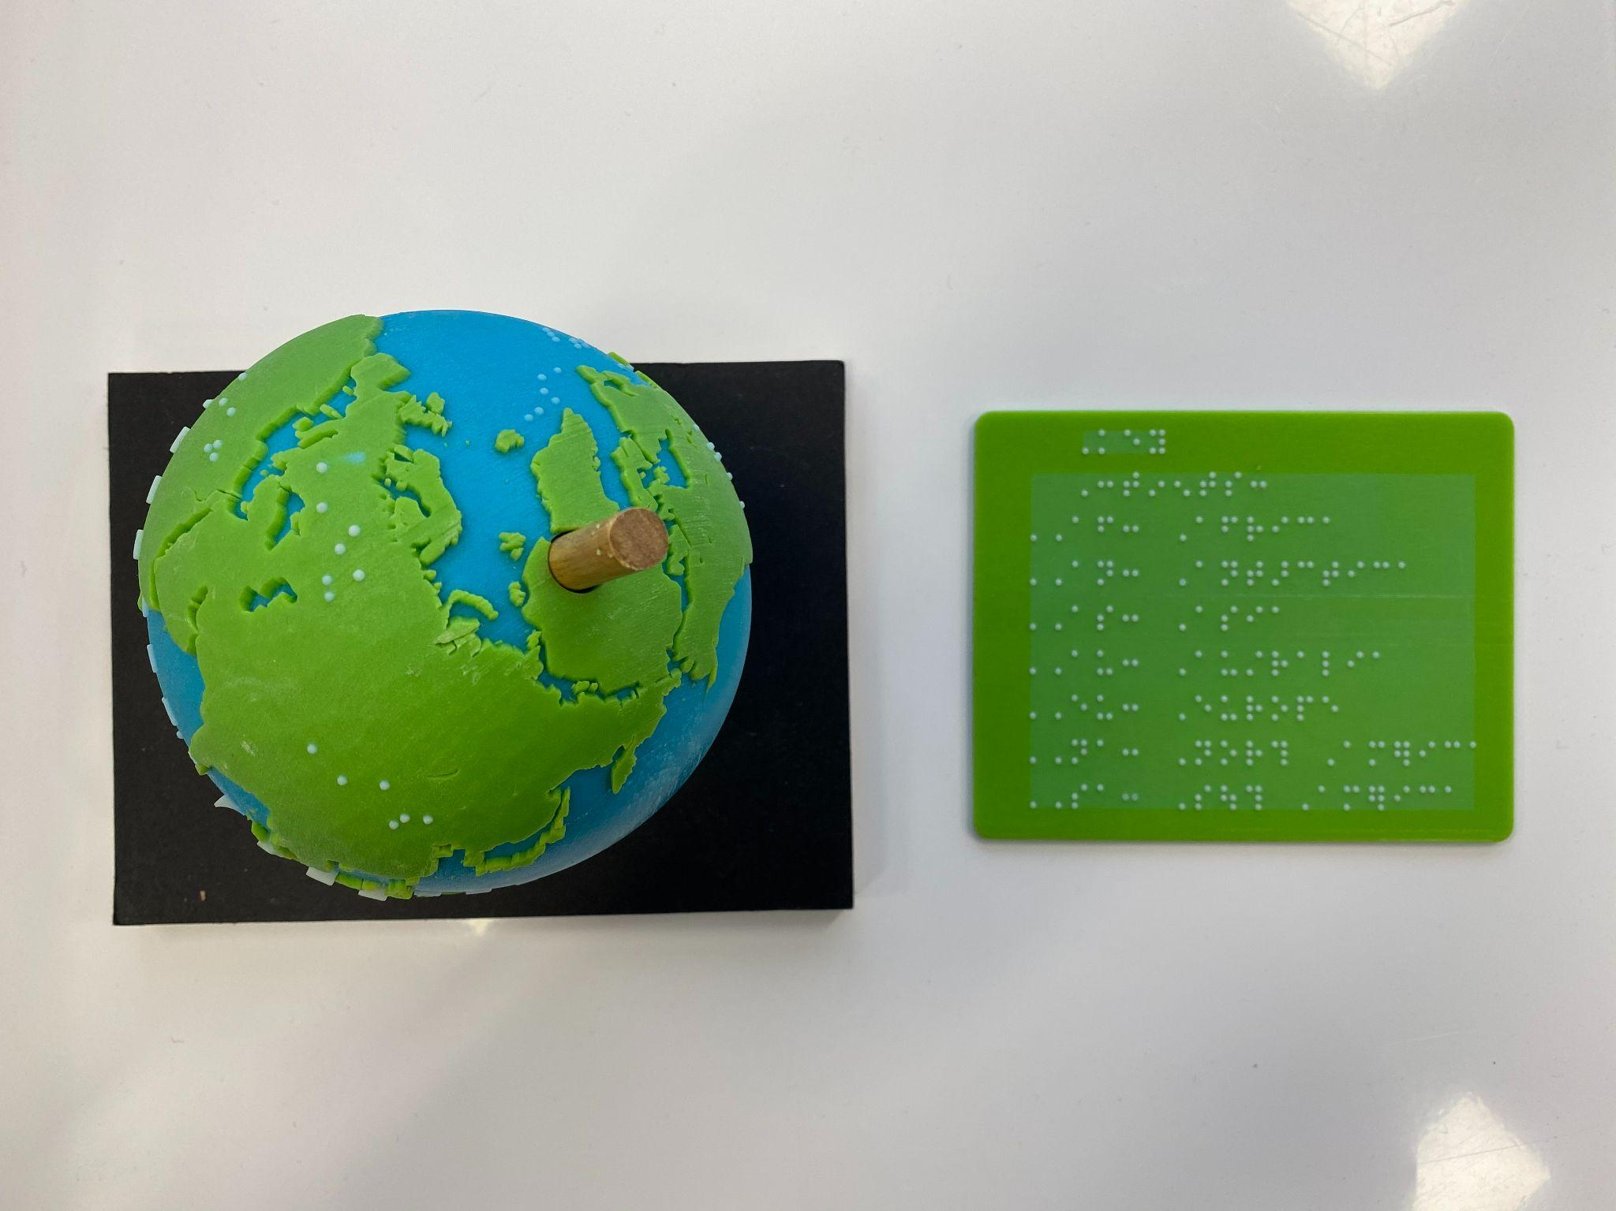
Figure 8c: 3D printed globe with short braille symbols on curved flat surfaces. Image courtesy Braille & Large Print Service, NSW Department of Education.
A suggested process to place braille on curved surfaces:
- Open the model file in Fusion 360.
- Write the braille as text and import into Fusion 360 as an .svg file.
- Make hemispheres for one complete braille cell, copy and paste across as needed, then delete the hemispheres that are not needed.
There are several options for generating 3D braille:
- Good quality braille on a flat surface, including contractions, can be custom created using the OpenSCAD file available from Thingiverse (thing 4167866). The resulting .stl file can then be incorporated with any model using most 3D software.
- TouchSee is an online converter from print text to braille labels, and can be used by people without any knowledge of braille. Note that Unified English (contracted) braille is not the default translation code and must be selected. The braille dots quality is good, however the base is very thin. A thicker base is needed to print the braille on its side.

8.2.2 Alternative methods to provide braille labels on 3D models
When braille labels are not suitable for any of the reasons above, adhesive braille labels can be added onto the model after printing is complete. Clear adhesive glue may be needed for a strong bond on curved surfaces.
Consider adding sticky braille labels underneath a model with a flat base, such as a map.
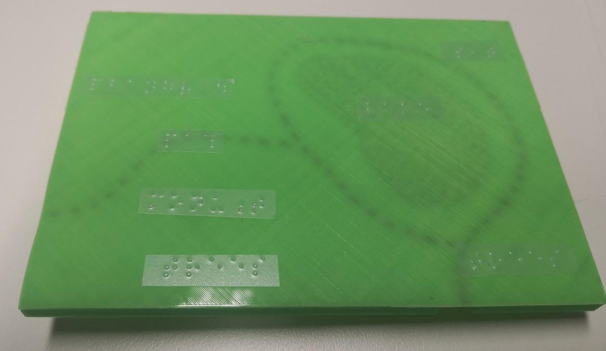
Figure 8d: Sticky braille labels placed under key features on a flat-based 3D model. Image courtesy of Monash University.

8.3 Basement – a base plate or tactile graphic
A base plate with an outline or slot for the model will give an indication of orientation (which way up) and can include labelling. This is the recommended approach for complex models with substantial labelling requirements.
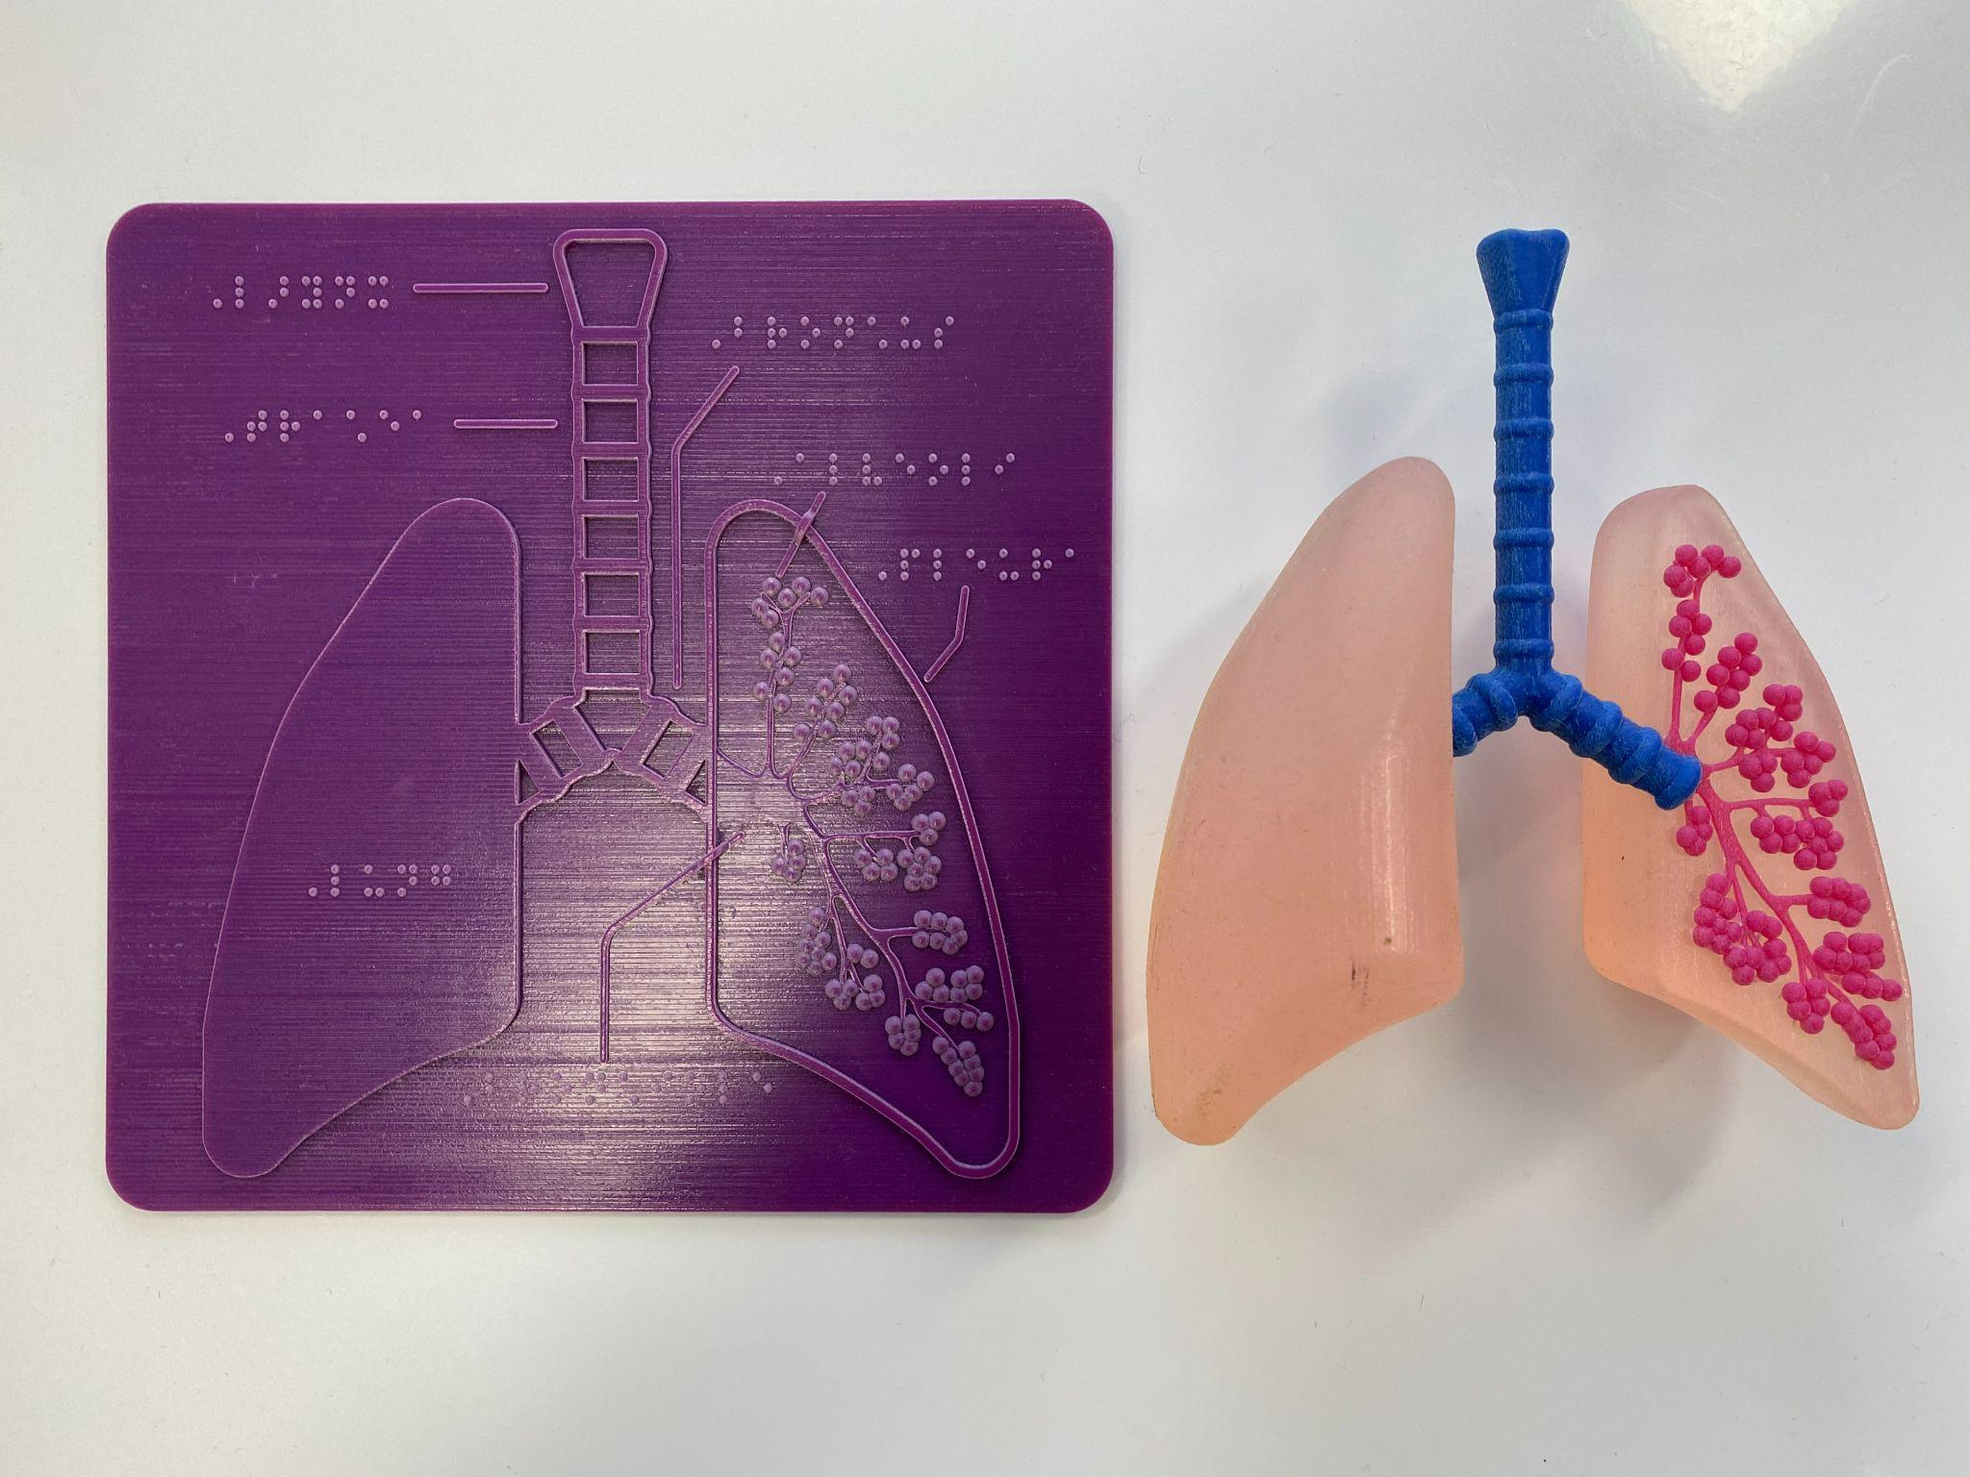
Figure 8e: 3D printed lungs and base plate with labels. Image courtesy of Braille and Large Print Services, NSW Department of Education.
Alternatively, a tactile graphic can be created with a tactile outline for placement of the model (which way up and which way forward). This tactile graphic should include a title and can also include a written description, braille labels, a key and/or a QR code for further information.

8.4 3D symbols or icons
If the base model is sufficiently simple, 3D symbols or icons may be preferred over braille because they are scalable, they can be read regardless of orientation, and the user does not need to know braille.
As illustrated in Figure 8f, a V symbol with dots can both serve as a symbol linked with a key, and indicate which way is up [1]. The 3D files for the V symbol can be downloaded from the tactiles.eu website. Always place the V pointing downwards and use the simplest symbols first.
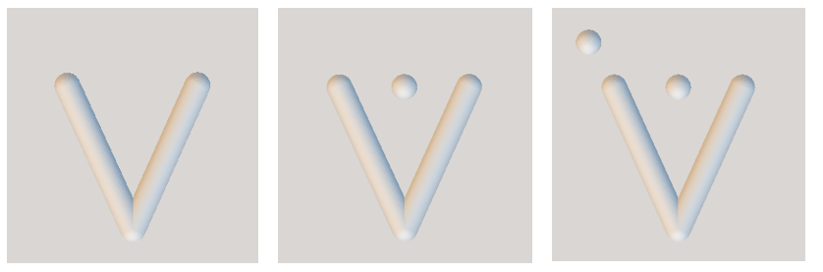
Figure 8f: Two of the 3D4VIP V symbols. Original image.
Alternatively, it may be appropriate to design new tactile symbols (abstract) or icons (representational).
In order to be distinctive, icons should adhere to the following guidelines:
- Distinctive features should be located on the top – not on the sides or base, where they are less likely to be felt. For example, a cone can be felt more easily with the wide end at the base and the pointed tip at the top.
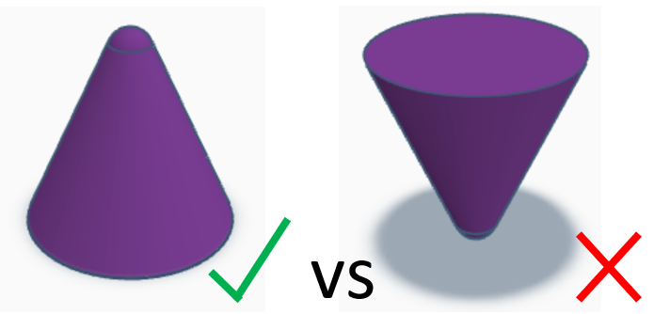
- The symbol or icon should be tactually distinct. For example, a plate with a knife and fork is not tactually distinct at a small size.
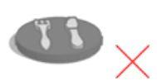
- The symbol or icon should be a unique shape that cannot easily be confused with other objects. For example, a hamburger could easily be confused with a bush or cushion.
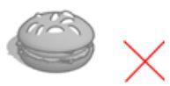
- Icons should be representative of the concept being conveyed so that they can be interpreted without ambiguity. For example, stairs can be instantly recognised.
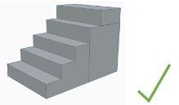
By contrast, a human figure is not a good icon on a general purpose map because it could be interpreted as representing “you are here”, “information/assistance” or “toilets”.
- Icons should be based on well-recognised symbols or objects that can be touched in real life. For example, the floppy disk icon to represent “store” or “save” is unlikely to be well known by touch readers, nor would it be tactually distinct.
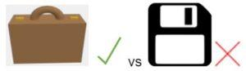
- Simple shapes are best, without extra details that would require extra time for examination and recognition. For example, a bowl with chopsticks is quicker to identify than a bowl with chopsticks and noodles.
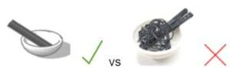

8.5 Audio labels
Audio labels are a good option when lengthy explanations are needed and the model will be explored independently. They also promote inclusion, as they can provide useful information to everyone, regardless of whether they have a print disability.

8.5.1 Penfriend and other audio label stickers
PenFriend and similar products use small adhesive labels that can be added to objects and programmed with customised audio. To record labels using PenFriend, the tip of the pen is placed on the label, the record button is pressed, the user speaks into the microphone at the top of the PenFriend and presses the record button again once finished. The recording is stored and played back when the same PenFriend is placed on the label. The stickers vary in size and can be placed on components of a complex 3D model to provide annotations.
Audio label stickers provide the easiest approach for creating multiple audio labels on a single 3D model, so that important parts can be labelled and identified independently by the user. However, these systems are designed for personal use, with customised pairing between the label and the device. Cost begins at around AUD$200.

8.5.2 QR codes
QR codes can be generated using free online sites, printed on standard paper or swell paper and stuck to the base of a model, at multiple points on a larger model, or on an accompanying basement. The user will then need to scan the code using a free app on any mobile device. If a lot of materials are labelled with QR codes, the mobile device can be mounted on a stand so that the user does not need to hold it.
A tactile indicator, such as a raised outline, must be given so that it is obvious where the QR code is located for easier scanning.

8.5.3 NFC tags
NFC tags are able to communicate wirelessly with smartphones at a distance of 10cm. Tags can be attached to the outside of the model or inserted inside the model during printing. The user will just need to tap their phone against the model. Because tags are read from 10cm away, only one NFC tag can be used per model, limiting their use to the provision of overall information about the whole model.
NFC tags work with iPhone 6 or higher and many newer android phones. NFC may need to be enabled in the phone’s settings.

8.5.4 Touch-triggered electronics
Audio trigger points connected to a microcontroller board can provide audio labels when the touch point is pressed. Microcontroller boards such as Bare Conductive boards (easy to set up) or Raspberry Pi (requiring more programming) can be connected to the trigger points with conductive material such as wires, conductive filament or conductive paint. Headphones or an external speaker are also required for the audio output.
This method of creating audio labels for 3D models is only recommended for high-use items. A moderate level of electronics and technical know-how is required to build the system, and controller boards begin at a cost of around AUD$70.

9. Finishing – Preparing 3D prints for touch readers
3D models created for people with a print disability require particular attention at the finishing stages to ensure that they are smooth to touch, provide high contrast, and perhaps even provide textural details.

9.1 Smoothing
Smoothing is important to ensure that 3D prints are not potentially damaging to the skin, given that reading by touch involves movement across the surface. Don’t just rely on vision – carefully check the 3D prints with the hands for any sharp or jagged points, rough surfaces or distracting tactual artefacts that require smoothing.
The FDM 3D printing process can easily result in sharp points on a 3D print. In particular, any point where the printing head has lifted off the print (usually over the top of a curved surface) may feel rough due to tiny sharp strands of plastic. This problem can be minimised through careful adjustment of the 3D printing settings, as described in Section 6.5.4 Stringing. There may also be sharp or unwanted remnants where supports have been removed, and a sharp edge where a skirt has been removed from the base.
Note that any method for smoothing a 3D print is also likely to result in some loss of fine detail.

9.1.1 Tools for removing supports and sharp remnants
If rafts and supports have been printed using the same filament as the model, remove them as soon as possible after printing, while there is still some flexibility.
Remove rafts using a spatula or sharp paint scraper. Remove supports using needle nosed pliers.
To smooth small rough areas after removal of supports, mini needle files or a dremel tool are recommended. Unless the model will be finished with paint, avoid using sandpaper as it is likely to scrape a large area and change the appearance of the print surface.
Brims can usually be removed by hand but may leave a thin sharp edge at the base of the print. This is best removed with a deburring tool.

9.1.2 PVA rafts and supports
If using a dual-head FDM printer, PVA filament can be used for rafts and supports for a smoother finish, however their removal is a more time-consuming process.
Submerge the model in lukewarm water (less than 50°C). After soaking for ten minutes, remove the main supports by hand then continue soaking and changing the water until all remnants have dissolved. At least 3 buckets of water are usually required.

9.1.3 Chemical smoothing
Chemical treatment not only gives a smooth glossy surface for a pleasant tactile experience, it also strengthens the model by fusing the layers together and makes it easier to clean by creating a non-porous surface. However, chemical smoothing will obscure fine details.
Epoxies such as XTC-3D can be used on either PLA or ABS. The epoxy needs to be mixed before being applied in a thin layer over a foil tray. Curing takes around 3.5 hours but can be sped up with a light heat source. The resultant print will be smooth, glossy and very strong.
3D Gloop! is a solvent designed specifically for 3D printing plastics, available for PLA, PET or ABS. While it is primarily sold as an adhesive for strong joins between two 3D printed parts, it can also be applied in small quantities to create a smooth surface.
Exposure to acetone can be used to achieve a very smooth finish, however it is only recommended when chemical safety procedures can be strictly followed. This technique works only on ABS and PET (not PLA). The cold vapour method is the safest. Line the floor and walls of a sealable container with paper towel or cloth soaked in acetone. If using a metal container (e.g. an old paint tin), use magnets to fix the cloth to the sides. Place the 3D print in the centre on a plinth/aluminium foil so it is not touching the acetone. Seal immediately (with a clear lid if possible). Leave for approximately 1 hour, remembering that some further smoothing will continue after the print is removed. The model will be soft to touch and needs to dry thoroughly for at least a day. Only use acetone in a well-ventilated area and always use disposable latex gloves or nitrile gloves for protection. Do not use vinyl gloves as they will be dissolved by the acetone.

9.1.4 Heat
Heat is a quick way to smooth the surface of a 3D print. However, this technique is not suitable for models with small peaks that could become charred, discoloured or distorted with heat. Practice on a failed print first to ensure that the technique and level of heat will not cause damage. Some methods for smoothing with heat include:
- A wood burning tool with a flat tip. Run the flat end of the tool lightly over the surface of the 3D print.
- A few seconds with a gas lighter should be sufficient to slightly melt and smooth the surface without distortion.
- If using a heat gun, use a low heat and keep the gun moving quickly along the surface.

9.1.5 Sanding and painting
If an extremely smooth and professional finish is required for high use items, start by smoothing the whole model using a rasp and then sandpaper (beginning with rough, and getting successively finer). When sanding is finished, improve the appearance by spray painting with any of the following products. Several layers may be needed:
- Rust-oleum Triple Thick Glaze
- a polish such as Brasso
- automotive spray paint
This technique can be very time-consuming and is only recommended for multi-use display items, such as in an art gallery.

9.2 Adding textures or colours

9.2.1 Textures
Textures are useful for better replicating the properties of the object being represented, for distinguishing between different parts of the model, or for highlighting key areas. Textures may be incorporated into the 3D printed model itself or added after printing.
Fine-grained textures such as sand or model-makers’ grass can be added to the surface of a 3D model. First, evenly spread a layer of craft glue using a spatula or piece of card. Then, spread the material on top. After drying, removing any excess materials that did not adhere properly. Be aware that some mending may be necessary for high-use items. Alternatively, paint with sand mixed in has long been used to give the feel of stone to handmade models for blind students [13].
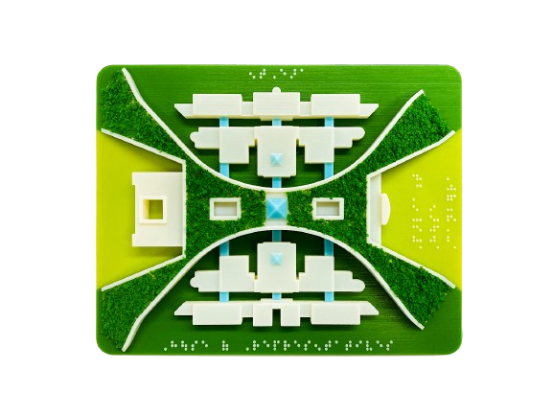
Figure 9a: 3D printed model of Parliament House in Canberra with model-makers’ grass added. Image courtesy of Braille and Large Print Services, NSW Department of Education.
Fabrics such as felt, fleece or hessian can also be glued to a 3D model.
A 3D printing pen can be used to add textured patterns or lines directly onto a 3D print. This method may be quicker and easier than incorporating textures and lines into the CAD model for a shape with curved surfaces. Select a contrasting colour for the 3D printing pen filament if adding features that are visually important. 3D printing pens are relatively cheap and most can use the same PLA or ABS filament as 3D printers. Some come with a low temperature nozzle, allowing safe handling by touch readers. However, 3D pens tend to block easily and practice is required to achieve a good result.

9.2.2 Colours
Colour contrast is important for people with low vision, and also for models that will be used in an inclusive public environment. Some 3D printers, including dual-head printers, enable full or dual colour printing. Colour can also be added after printing is complete, as described in this section.
For outward structures, water-proof paint pens (such as Posca brand) are recommended as they are convenient and effective. Nail polish and modelling paint also work well. If using water-based paints such as acrylics, an additional layer of varnish or matte finishing spray will be needed as a sealant. Oil paint adheres well but can take days to dry.
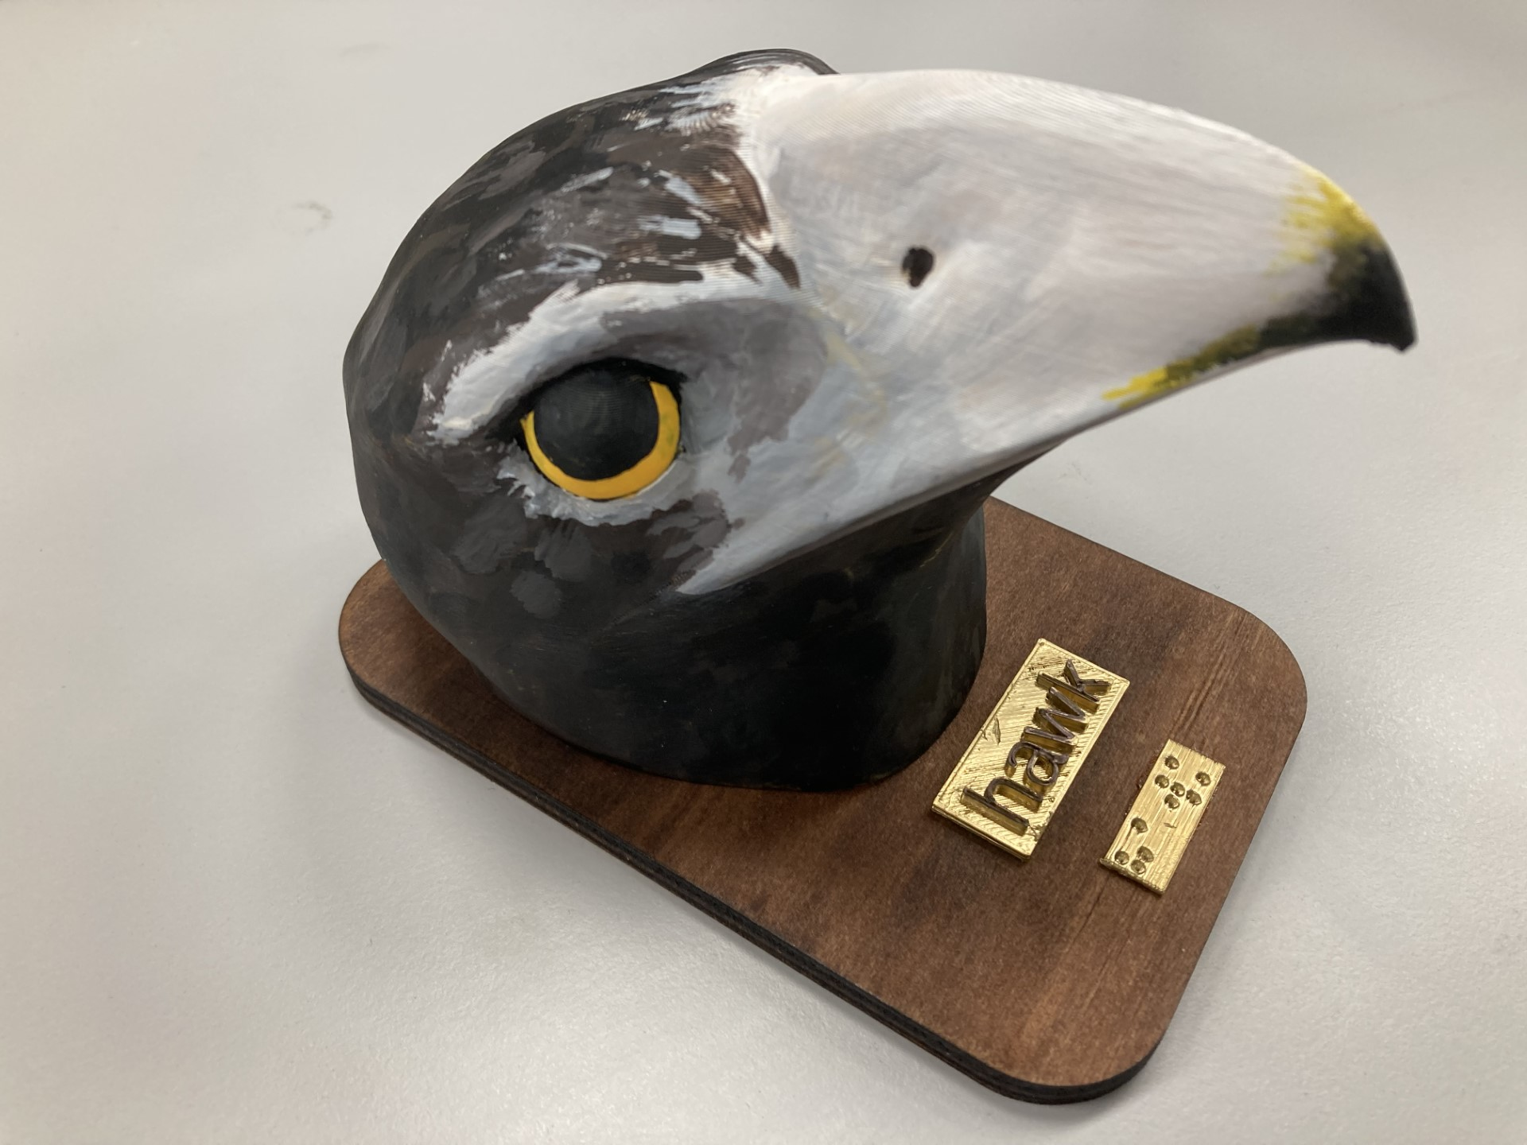
Figure 9b: 3D printed hawk head with acrylic paint for realism and contrast. Image courtesy of the Statewide Vision Resource Centre.
Markers are generally not recommended for use on FDM 3D prints as they will run along the printing line, however fine liners or thin pens may be a good option for adding contrast inside indented lettering.

9.3 Construction

9.3.1 Joining
3D Gloop! is a solvent designed specifically to provide strong adhesion between two 3D printed parts. It is available for use with PLA or ABS.
Acetone can be used to join two pieces of ABS. Make sure the surfaces are flat first, then apply the acetone with a brush or cloth. Clamp the pieces together until the model has dried.
Superglue may also be sufficient for joining pieces that will not be under pressure.
PLA welding can give seamless joins when there is a small surface area, or to repair cracks in poorly printed parts. Use a short straight piece of PLA filament in a power drill or dremel tool. With the drill on medium speed and held at a 45 degree angle, drag over the seam from right to left. The friction should melt the plastic together. For a strong seam or a deep channel, the weld may need to be created in several layers. Let each layer cool before starting the next. After welding, some smoothing is likely to be required (refer to Section 9.1 Smoothing).

9.3.2 Applying a base
Often, it is more efficient to attach a 3D print to a base after it has been printed rather than 3D printing the base as part of the model. The base should be a solid material (not flexible) for example, acrylic or wood. If adding textures to the base (such as sand, fake grass or fabric), it is best to attach the 3D print to the base first, then add the textures to the remaining base area.
Superglue should be sufficient to fix the 3D print to the base.

10. Understanding 3D prints through touch
This section presents five overarching principles for presenting and reading 3D models by touch.

10.1 Know what to expect
Context is essential to understanding. Provide information about 3D printing, the model title, a description of the model and, if necessary, a key.
The touch reader should be provided with a title and broad overview of the object when a 3D printed model is first presented to them. For example:
“This is a model of the peak of Mount Everest. A braille label is given near the base, facing south. The model shows an area of approximately 25 kilometres along each side. Mount Everest is 8.8km above sea level; this model shows the very top portion.”
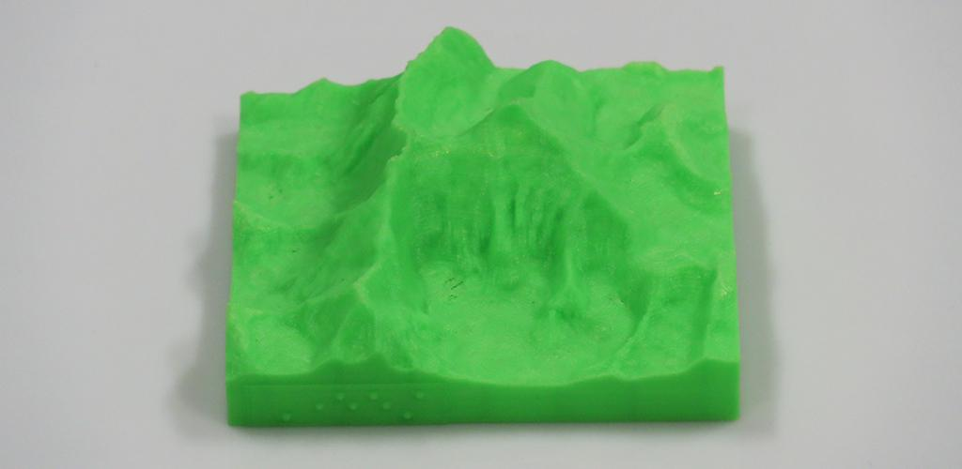
Figure 10a: 3D printed terrain showing the peak of Mount Everest. Image courtesy of Monash University.
It is also important to specify how the properties of the model differ from the real object. For example:
- Is the real object more soft, flexible, smooth, rough, heavy or solid?
- Does it have a particular temperature?
- What is it made from?
- What is its scale?
As always when supporting concept development, point out relationships with objects that the student already knows or that are available on hand to touch.
If it is the first time the person has handled a 3D printed object, it may be helpful to give a brief explanation of the printing process and how it affects the feel of the model. Most common 3D printers use melted plastic, which is printed in layers. This means that the base of the object will be very smooth, the sides may have small ridge lines, and any overhanging pieces may be rough on the underside where supports have been removed or melted plastic was left dangling in mid-air.
While young children will benefit from verbal guidance from a teacher, parent or peer, accompanying text will provide older touch readers the opportunity to explore the 3D printed object independently. Consider the reader’s preferred labelling technique, i.e. verbal explanation, braille, electronic text, or interactive audio labels.
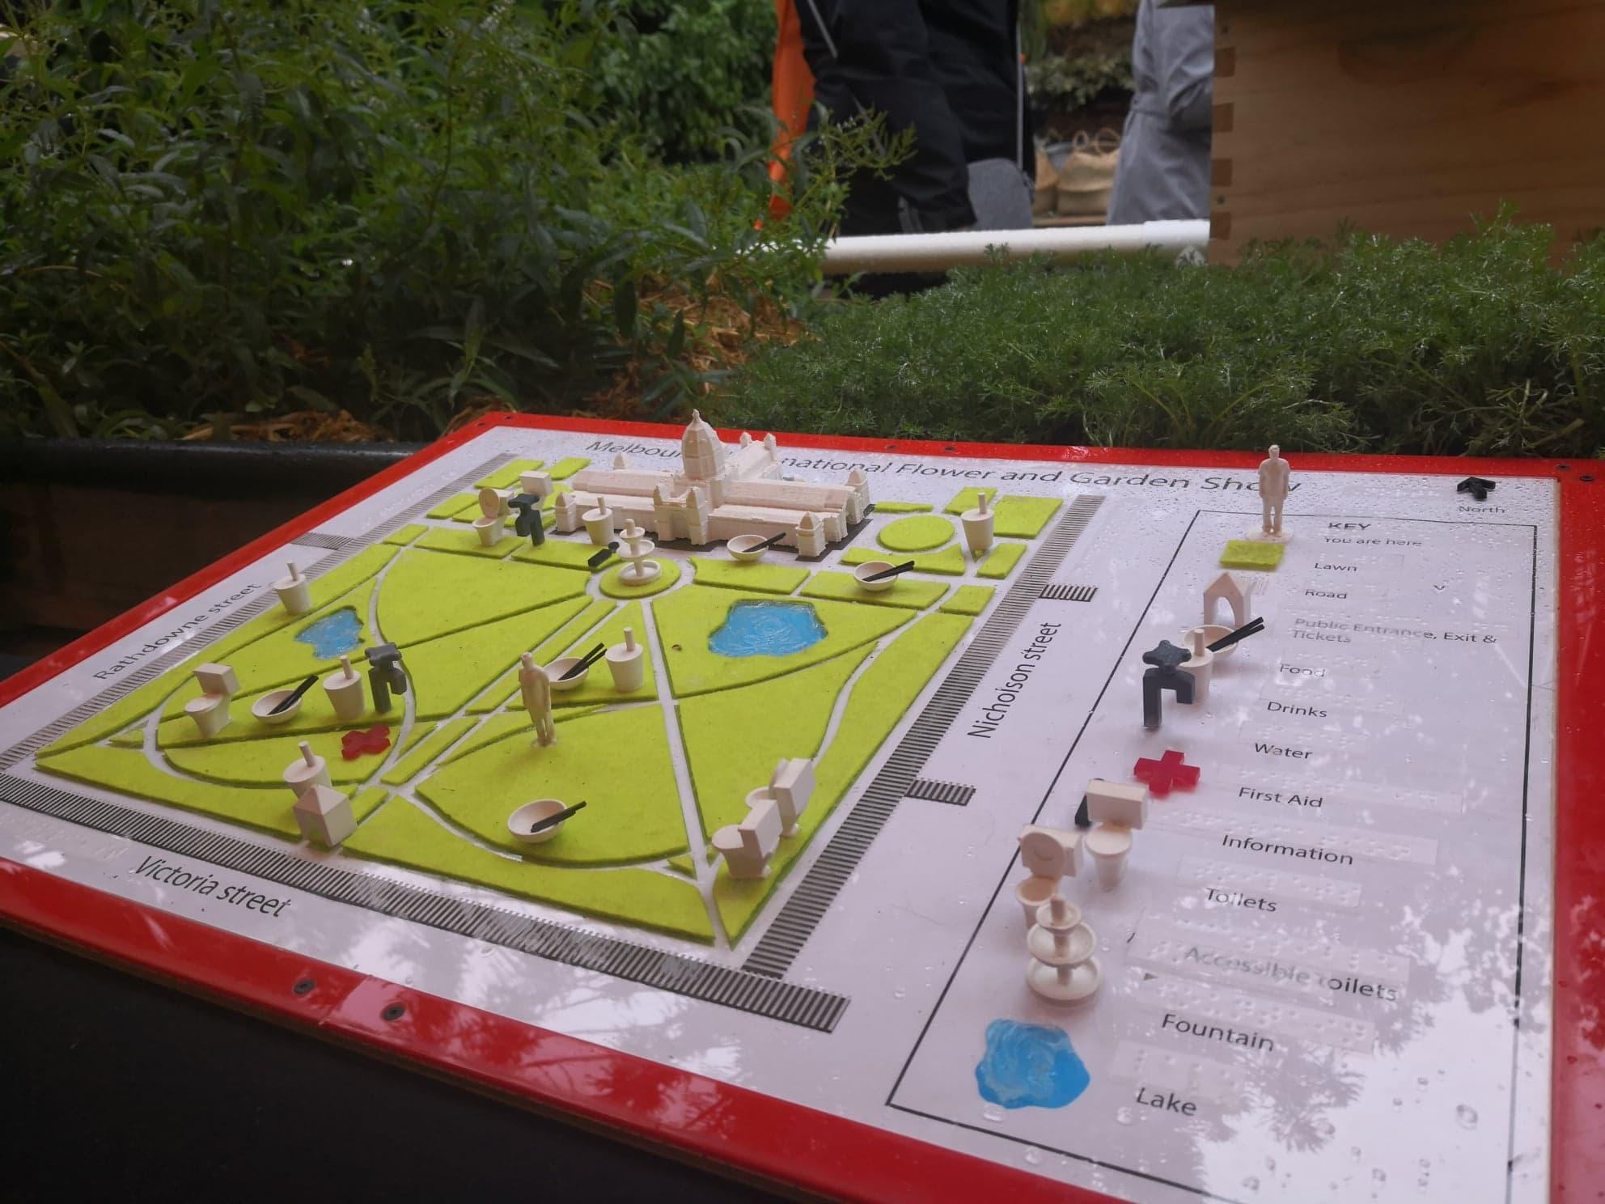
Figure 10b: Add a key to explain the use of lines, textures and symbols. Image courtesy of SensiLab, Monash University.

10.2 Gain an overview first
For any media read by touch, understanding is greatly aided by gaining an overview before examining the detail.
The first step to gaining an overview of a 3D printed model is accessing the title and description, as outlined above. The second step is a quick tactile search.
For tactile graphics, students are taught methods to gain a quick view of the whole page before beginning to read detail, for example using a perimeter search (move clockwise around the edges of the diagram and then into the middle) or the waterfall technique (spread both hands across the top of the diagram and move down). These methods rely on a flat palm and quick motion, meaning that they cannot be used on rounded forms or 3D printed models with protruding features that block movement.
To gain an overview of 3D models by touch, the two hands can be spread and placed carefully on the top and sides of the model. Use the palms and full length of the fingers of both hands to gain an overall understanding of the model. Smaller models can be picked up and rotated in the hand to gain an understanding of the basic shape. If the model is too large to hold or feel at once, conduct a systematic search from left to right, top to bottom or move around the model to explore it from every angle.
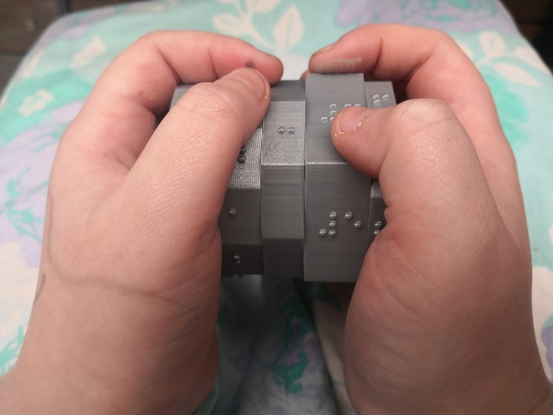
Figure 10c: Use two hands to enclose the object to gain an overview of the whole shape. Image courtesy of Monash University.

10.3 Use appropriate touch
Whereas the hand and fingers are held fairly flat to read tactile graphics, curved fingers are required for exploring 3D models. The whole hand can be used to understand the overall shape.
It is important not to have clammy or sweaty hands/fingers because they will stick and grip when trying to move smoothly along a surface.
A light touch allows for moving up and over things easily without getting snagged or hurt on protruding parts.
If a student needs encouragement to tactually explore the model, then hand-over-hand or hand-under-hand techniques may be considered.

10.4 Use reference points
Reference points are required for orientation and when exploring detail.
It is natural for the touch reader to turn a 3D model in their hands during exploration. The object should be in its correct orientation when it is first presented to the touch reader. It is helpful to identify a prominent feature on the top, bottom or front of the model so that the correct orientation can be found again once the model has been turned. This should be included in the model description.
Using two hands simultaneously allows the touch reader to get an understanding of the symmetry of the object and the spatial relationship of individual parts.
To gain a better understanding of the relative dimensions and positions, the touch reader may use a point of reference by keeping one finger on a point while tracing a line, pathway or edge. This is especially useful if the line traced goes around the object, for example from front to back. It is also useful to allow repeated movement between two components on a 3D model to build up an understanding of how the parts relate to one another in space and distance.

10.5 Explore the detail
Provide ample time for tactile exploration of 3D models.
When exploring a 3D model, features are first felt from the top or outside of the model. It is important to conduct a more thorough search with the fingertips to explore all of the important features. Encourage the touch reader to move inside the structure of the model, touching the sides and around the base of protruding features and feeling for holes, different levels, significant features and special markers.

11. 3D Printing on Paper for Tactile Graphics
As an alternative to swell paper and heat fuser to generate tactile graphics, computer-generated tactile graphics can be produced using 3D printing methods. 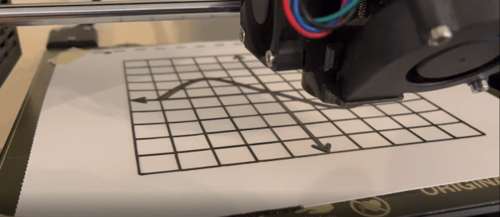
Figure 11a: 3D printing a graph directly onto paper using contrasting colour filament. Image courtesy of Texas School for the Blind and Visually Impaired.
These instructions enable creation of a single layer tactile graphic (all one height) using an FDM 3D printer. Refer to [3] for further technical details.
- Prepare the image file. Any drawing software can be used.
- Set the size of the image to match the size of the printing area.
- Design the image in a similar manner to a swell paper diagram:
  - Standard line thickness 2.25 point or between 0.8 to 1.2mm in width
  - Rounded corners
  - Braille font size approximately 24 point
- Save as PNG format. If the software does not provide the option to save as PNG, convert it using a free tool like Inkscape.
- Prepare the paper. Cellulose-based paper should be between 120-180gsm so it is thick enough to reduce bending but thin enough that the bed does not need to be re-levelled.
- If adding print labels for sighted/low vision users, do this now.
- Cut the paper to the size of the build plate.
- Secure the paper to the build plate.
- Bulldog clips are a quick and easy method for securing the paper to the build plate and they do not cause damage. The more the better!
- If the paper is thicker than 180gsm, the build plate height may need to be adjusted.
- Convert the 2D .png image to a 3D .stl file.
OPTION 1: Import the .png file directly into Cura or another slicer.
- Specify that black areas should be raised
- Choose a maximum height that is equal to the initial layer height. 0.25mm is recommended, and 0.4mm is the maximum height to maintain adherence if the paper bends.
- Set the base height at 0 so that the image will print directly onto the paper
OPTION 2: If the slicer does not accept image files, use the Cowlicks automated tool.
- Go to https://cowlicks.github.io/.
- Upload the .png image.
- Check and download the resultant .stl file.
- Slice.
- Ensure that the print size is the same as the original image size.
- Check the maximum height of the initial layer in the slicer. 0.25mm is recommended.
- Build plate adhesion type should be set to “none”.

- Print.
- For best results, use a flexible filament that will not peel off the page when it is bent. TPU filament works well. PET-G and nylon are other good options. However, note that flexible filaments work best on printers with a feed mechanism close to the print head. Ultimaker printers are not recommended for this type of filament.
- Use clear filament if 3D printing on top of an ink printed image, otherwise use a high contrast colour to assist users who have low vision.

12. Blind makers: 3D model selection, design and printing by people with print disabilities
Most 3D printing software and equipment has been designed without accessibility in mind. However, there are some options for people with a print disability and who want to print or create their own 3D models. The 3D-Printing-Access listserv on groups.io is highly recommended as a place to ask questions and learn more about all aspects of 3D printing by people with print disabilities.

12.1 Selecting a 3D model
When selecting existing models to print, databases of 3D models specifically for touch readers are the best place to search, as listed in Section 3.2 3D model repositories for people with print disabilities. If available, it is always advisable to read any comments from the maker and people who have printed the model to help determine whether the model is suitable.

12.2 Designing a 3D model

12.2.1 3D design software for use by people with low vision
Makers Empire is a 3D design software from an Australian company who have incorporated suggestions to make their software more accessible. Text-to-speech is incorporated and a limited braille font is included. Makers Empire has been used successfully by the South Australian School & Services for Vision Impaired (SASSVI) to run a 3D design program with students with low vision.

12.2.2 3D design software for use by people who are blind
OpenSCAD is a free open source online software for creating 3D designs. It is accessible because it is script-based, however this also means that some basic programming knowledge is required for its use. NVDA is the most compatible screen reading tool to use with OpenSCAD. Alternatively, the code can be written in a more familiar environment such as Notepad, with OpenSCAD used simply for rendering:
- Write the code and copy the text to the clipboard.
- Open OpenSCAD and press Ctrl-N to open a new editor.
- Paste the text into the editor.
- Press F6 to render the file. The program will chime if rendering was successful.
- Press F7 to export the model as an STL file.
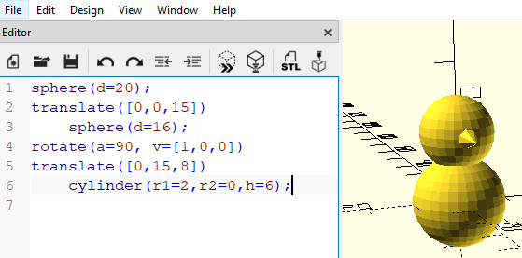
Figure 12a: OpenSCAD coding editor and rendered preview of the 3D model being designed. Original image.
OpenJSCAD is essentially the same as OpenSCAD but it uses JavaScript programming syntax. Furthermore, OpenJSCAD can be used online.

12.2.3 Checking a 3D design
Regardless of the method of production, checking the model before printing is an important step. Some suggested methods are:
- Take a screenshot and produce it as a tactile graphic, for example using swell paper, embossing or a refreshable tactile display.
- 3D print just a single layer (a slice through the model).
- Take a picture of the design and have it described by AI such as ChatGPT or Seeing AI.
- ShapeShift is a dynamic pin display that can be paired with OpenSCAD to preview models as they are being created, allowing users who are blind to check and modify their designs before printing.
- Open source software paired with OpenJSCAD and a Falcon Haptic Device to provide audio and haptic feedback for blind 3D modelers.

12.2.4 Conversion of a drawing or clay model into a digital 3D model
Another option is to convert from drawings or models created by a person with a print disability into a 3D computer model that can be 3D printed at any size and with durable materials. Some options include:
- Students with a print disability draw the object from four sides and a sighted teacher manually translates their drawing into a 3D printable model.
- Converting a greyscale picture to 3D, as described in Section 4.2 Converting from 2D.
- 3D scanning is a more complex process. Begin with a physical sculpture created by the blind maker using modelling clay, blocks or similar. Smartphone apps are available to take a series of images of the sculpture from all angles. This is best done in even light, keeping the camera an equal distance from the object and making sure that the whole object fits in the frame. Note that the resultant 3D file may need further editing before it is able to be 3D printed. Sighted assistance is likely to be needed for the processes of scanning and editing, which may not be accessible for people with print disabilities.

12.3 Using a 3D printer
Most 3D printers use an LCD display for operation, however some allow remote printing, making them more accessible for blind makers.

12.3.1 Slicing and Printing
The following software were recommended at the time of writing:
- Simplify3d (paid) is the most highly recommended slicer as it is much more accessible than other options. Many of the controls and labelled and rotating models, resizing, etc. can be achieved by typing values.
- Slic3r is a free option with some functions accessible using a screen reader, including orienting the 3D model on the print bed by typing in values.
- Octoprint is an open source web interface that can be used with most 3D printers. It can be used as a slicer; to monitor, start, pause and stop prints; and to control other printer functions such as temperature, changing filaments, levelling the bed, etc.
When slicing, it is recommended to always use supports in case of unexpected overhangs. Select a support type using organic or tree-like structures that are obvious to feel and easy to break away.
The following 3D printers have been used successfully by blind makers:
- Prusa 3D printers have a sound assist mode that plays a beep for each item and a higher pitched beep to indicate the top and bottom of a menu as a physical click knob is turned. It is possible to memorise the menu items (or list them beside the printer) and then count to select the desired item using the physical click knob. Prusa Connect is a cloud service for controlling the printer, including uploading and starting prints.
- AnkerMake 3D printers have a touchscreen that can be used by adding a template over the screen. The printer beeps with every action on the touchscreen and the printer beeps when it is ready and when it is finished. The iOS app is mostly accessible but the desktop software is not.
- The Bambu P1P and P1S have buttons rather than a touchscreen and are compatible with Simplify3D slicing software.

12.3.2 Monitoring a 3D Print
FDM prints in progress can be supervised non-visually by sound or touch:
- Loose filament tends to move around on the plate, making a high-pitched ticking sound that indicates a printing error.
- Raised corners due to adhesion problems cause a scraping sound when the nozzle passes over that area.
- Depending on the printer, the filament spool may make a noise as it turns, confirming that that there is no blockage.
- The filament can be touched as it enters the feed tube to check that it is moving.
- It is safe to pause the print and touch the partially completed model. If well familiarised with the printer, adults may check a print in progress by using one hand to track where the print head is working and the other hand to gently touch a part of the model that is not currently being printed. However, it is generally best not to touch the printing area as the nozzle is extremely hot, the printing head can be easily moved and oils on the skin can interfere with adhesion.

References
[1] 3D4VIP (2023) Tactiles 3D Printing for VI Guidelines https://tactiles.eu/guidelines/
[2] Ania, M.-J. (2020). Art Nouveau & Ecology. VIP action: How to make heritage accessible for blind & visually impaired people. https://artnouveau-net.eu/wp-content/uploads/2020/04/VIPactinenglwebff63-1.pdf
[3] Barros, G., Correia, W., & Teixeira, J. M. (2023). Towards the Effectiveness of 3D Printing on Tactile Content Creation for Visually Impaired Users. Polymers, 15(9), 2180. https://doi.org/10.3390/polym15092180
[4] Barvir, R., Brus, J., & Vondrakova, A. (2021). 3D-printed models of Czech architectural monuments for people with severe visual impairment. 30th International Cartographic Conference (ICC 2021), Florence, Italy. https://doi.org/10.5194/ica-abs-3-23-2021
[5] Fuller, R., & Watkins, W. R. (2011). Exhibit Design Relating to Low Vision and Blindness: Research on Effective Use of Tactile Exhibits with Touch Activated Audio Description for the Blind and Low Vision Audience. https://hdl.handle.net/2022/28993
[6] Gallup, N., & Pearce, J. M. (2020). The Economics of Classroom 3-D Printing of Open-Source Digital Designs of Learning Aids. Designs, 4(4), 50. https://doi.org/10.3390/designs4040050
[7] Gesualdi, M., & Griner, D. (2022). Getting in touch: a practicum of solutions for tactile experience in the built environment. Design for All Institute of India, 17(6), 36-50. https://www.academia.edu/82434892
[8] Holloway, L., Butler, M., & Marriott, K. (2018). Accessible Maps for the Blind: Comparing 3D Printed Models with Tactile Graphics. CHI Conference on Human Factors in Computing Systems, Montreal, Canada. https://doi.org.10.1145/3173574.3173772
[9] Holloway, L., Butler, M., & Marriott, K. (2023). TactIcons: Designing 3D Printed Map Icons for People who are Blind or have Low Vision. CHI Conference on Human Factors in Computing Systems, Hamburg, Germany. https://doi.org/10.1145/3544548.3581359
[10] Kaplan, H., & Pyayt, A. (2022). Development of User Feedback-Based Optimized Encoding System for 3D-Printed Tactile Maps. Disabilities, 2(3), 379-397. https://doi.org/10.3390/disabilities2030027
[11] Kłopotowska, A., & Magdziak, M. (2021). Tactile Architectural Drawings - Practical Application and Potential of Architectural Typhlographics. Sustainability, 13(11), 1-19. https://doi.org/10.3390/su13116216
[12] McMenamin, P. G., Quayle, M. R., McHenry, C. R., & Adams, J. W. (2014). The Production of Anatomical Teaching Resources Using Three-Dimensional (3D) Printing Technology, Anatomical Sciences Education, 7(6), 479-486. https://doi.org/10.1002/ase.1475
[13] The Ohio Writers' Program. (1941). Models for the Blind. Ohio, USA: Ohio State School for the Blind.
[14] Puerta, E., Crnovrsanin, T., South, L., & Dunne, C. (2024). The Effect of Orientation on the Readability and Comfort of 3D-Printed Braille. CHI Conference on Human Factors in Computing Systems, Honolulu, HI, USA. https://doi.org/10.1145/3613904.3642719
[15] Sanches, E. C. P., Bueno, J., & Okimoto, M. L. L. R. (2021). Designing 3D Printed Audio-Tactile Graphics: Recommendations from Prior Research. CHI International Conference on Human-Computer Interaction. https://doi.org/10.1007/978-3-030-78092-0_31
[16] Simonnet, M., Morvan, S., Marques, D., Ducruix, O., Grancher, A., & Kerouedan, S. (2018). Maritime Buoyage on 3D-Printed Tactile Maps. ASSETS '18: International ACM SIGACCESS Conference on Computers and Accessibility, Galway, Ireland, UK. https://doi.org/10.1145/3234695.3241007
[17] Tu, Y.-H., Wu, C.-F., & Yeh, I.-T. (2002). Evaluation of recognizing tactile pictures in different size display in sighted and blind people. 6th Asian Design International Conference. https://www.researchgate.net/publication/237570266
[18] Wang, X., Kayukawa, S., Takagi, H., & Asakawa, C. (2022). BentoMuseum: 3D and Layered Interactive Museum Map for Blind Visitors. ASSETS International ACM SIGACCESS Conference on Computers and Accessibility, Athens, Greece. https://doi.org/10.1145/3517428.3544811
[19] Watanabe, T., & Sato, K. (2019). Suitable Size of 3D Printing Architecture Models for Tactile Exploration. Journal on Technology & Persons with Disabilities, 7. http://hdl.handle.net/10211.3/210389

Appendix A: Useful Web Links

When to use 3D Printing
Accessible graphics decision forest https://printdisability.org/about-us/accessible-graphics/graphics-guidelines/decision-forest/

Where to find 3D printing designs

Generalist 3D model repositories
Pinshape https://pinshape.com
Printables www.printables.com/model
STLFinder www.stlfinder.com/
Thingiverse www.thingiverse.com/
YouMagine www.youmagine.com/

3D model repositories for touch readers
3D Opal http://sahyun.net/projects/3Dprint/objects.php
BTactile https://btactile.com/
Fittle www.lvpei.tech/fittle
ImageShare https://imageshare.benetech.org/
Medien Augenbit https://medien.augenbit.de/category/modelle/
Microbiology for the Blind and Visually Impaired https://sites.google.com/view/microbiologyfortheblind
Nonscriptum LLC www.nonscriptum.com/geometry
Star Coins www.rovingbits.com/StarCoins/
Tactile Universe https://tactileuniverse.org/models/
Tactiles.eu https://tactiles.eu/database/
Thingiverse www.thingiverse.com/
Touch of the Universe www.uv.es/astrokit/

3D model repositories for education, STEM and specialist areas
African Fossils https://africanfossils.org/search
3D Printing the X-ray Universe https://chandra.harvard.edu/resources/illustrations/3d_files.html
Dremel DigiLabs Lesson Plans https://digilab.dremel.com/resources/lesson-plans
hhmi Biointeractive www.biointeractive.org/classroom-resources?keyword=3d
MiniWorld3D www.myminifactory.com/users/MiniWorld
NASA 3D Resources https://nasa3d.arc.nasa.gov/
NIH 3D Print Exchange https://3dprint.nih.gov/
Polar Cloud https://polar3d.com/index.html
Scan the World www.myminifactory.com/category/scan-the-world
Lesson plans for printing and using 3D printed geometry, written for vision specialist teachers working with students who are BLV, by Joan Horvath and Rich Cameron of Nonscriptum LLC https://www.nonscriptum.com/geometry

3D printing design software
Touchmapper free online software for automated tactile maps https://touch-mapper.org/.
Terrain2STL free online tool for topographic maps http://jthatch.com/Terrain2STL/.
Image to Lithophane free online service for converting from 2D greyscale images https://3dp.rocks/lithophane/
OpenSCAD open source code-based 3D design software www.openscad.org/
“OpenSCAD Tutorial for Beginners” by Ken Douglas, published by All3DP https://all3dp.com/2/openscad-tutorial-beginner/
“Mastering OpenSCAD” by Jochen Kerdels https://mastering-openscad.eu/buch/introduction/
OpenJSCAD https://openjscad.xyz/
TinkerCAD free online shape-based 3D design software www.tinkercad.com/
Fusion 360 www.autodesk.com.au/products/fusion-360/overview
TouchSee free online converter from print to braille labels https://touchsee.me/

The 3D printing process

3D printing services
CraftCloud https://craftcloud3d.com/
Hubs www.hubs.com/
PrusaPrinters www.prusaprinters.org/world
NextSense www.nextsense.org.au
Vision Australia www.visionaustralia.org/business-consulting/print-accessibility
See3D https://see3d.org/

Slicing
Cura slicer https://ultimaker.com/software/ultimaker-cura
Video showing how to calibrate a 3D printer when using Cura. https://www.youtube.com/watch?v=-jsBI3OeUJQ
This article further explains the process https://the3dprinterbee.com/cura-horizontal-expansion/
Banana split plug-in for dividing models in half in Cura https://marketplace.ultimaker.com/app/cura/plugins/jarrrgh/BananaSplit

Blind makers
3D-printing-Access listserv https://groups.io/g/3d-Printing-Access/
Makers Empire software with accessibility for people with low vision www.makersempire.com
Accessible STEM Programming and STEM Lessons for students who are blind and visually impaired. Includes step-by-step lessons on using OpenSCAD and Prusa printers and slicing. https://www.accessiblestem.org/lessons/
Aishwarya Pillai, a blind artist, describes her techniques for creating tactile paintings with 3D features at https://www.youtube.com/watch?v=4NKs8lfTMJ0
Instructions on how to create a shapeShift device to check a 3D design https://github.com/ShapeLab/shapeShift.
Software downloads and instructions on how to pair OpenSCAD with a Falcon Haptic Device to check a 3D design are provided at https://www.uni-marburg.de/en/fb12/research-groups/grafikmultimedia/research/haptic_mesh_inspection.
A VSC extension to modify OpenSCAD to overcome some of its accessibility issues https://github.com/alexasiu/shapeCAD-Extension
Simplify3D accessible slicer www.simplify3d.com
Slic3r free slicer with some accessible functions https://slic3r.org
Octoprint open source web interface https://octoprint.org

