ANZAGG 3D Meeting Minutes
Wednesday 15 June 2022

1. Roll call with self-introductions
Meeting chaired by Leona Holloway, Monash University
13 attendees from Monash University, See3D, TSBVI, Victorian Department of Education, NextSense, SPEVI, NNELS, BLENNZ, SASVI, NSW Department of Education

2. Guest Speaker: Caroline Karbowski, See3D
https://see3d.org/
Caroline learned braille as a child so that she could read in the car without getting car sick. Then in high school for a tech competition she pitched an idea to 3D print models for people who are blind. This led to the formation of See3D, a non-profit organisation utilising funding from OSU, donations, free filament from IC3D, and volunteer assistance to design, print and distribute 3D models for people who are blind.
Since 2017, See3D have distributed over 1,400 models sent to 29 states, 17 countries and 21 organisations. For individuals, payment is not required but donations are accepted. With labour and time included, costing is estimated at around $40 for a 6” model and $100 for a model with printed braille description.
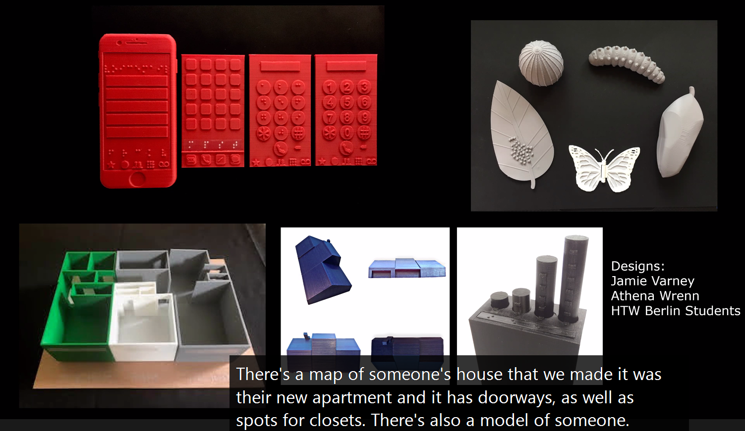
In a recent project, See3D made accompanying objects to illustrate the classic Ugandan story book “the very tall man”. Ian Matty is assisting with designing models and Clovernook made braille books. Eventually, there will be 10 books and Clovernook will visit Africa to get direct feedback from blind students there.
At first, people were receiving models but not sure what they were touching. So, See3D started to provide accompanying description. Learning guides are available on the See3D website.
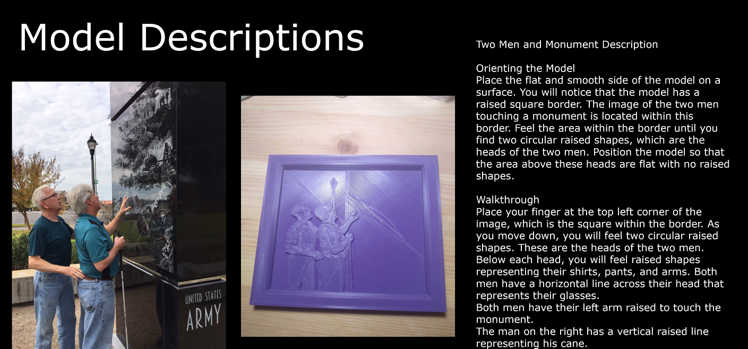
Then decided to create kits with themes. So far, there are kits for anatomy and American history. The next kit will address Ancient world civilisations, with the Sphinx, a pyramid, terracotta warriors, etc.
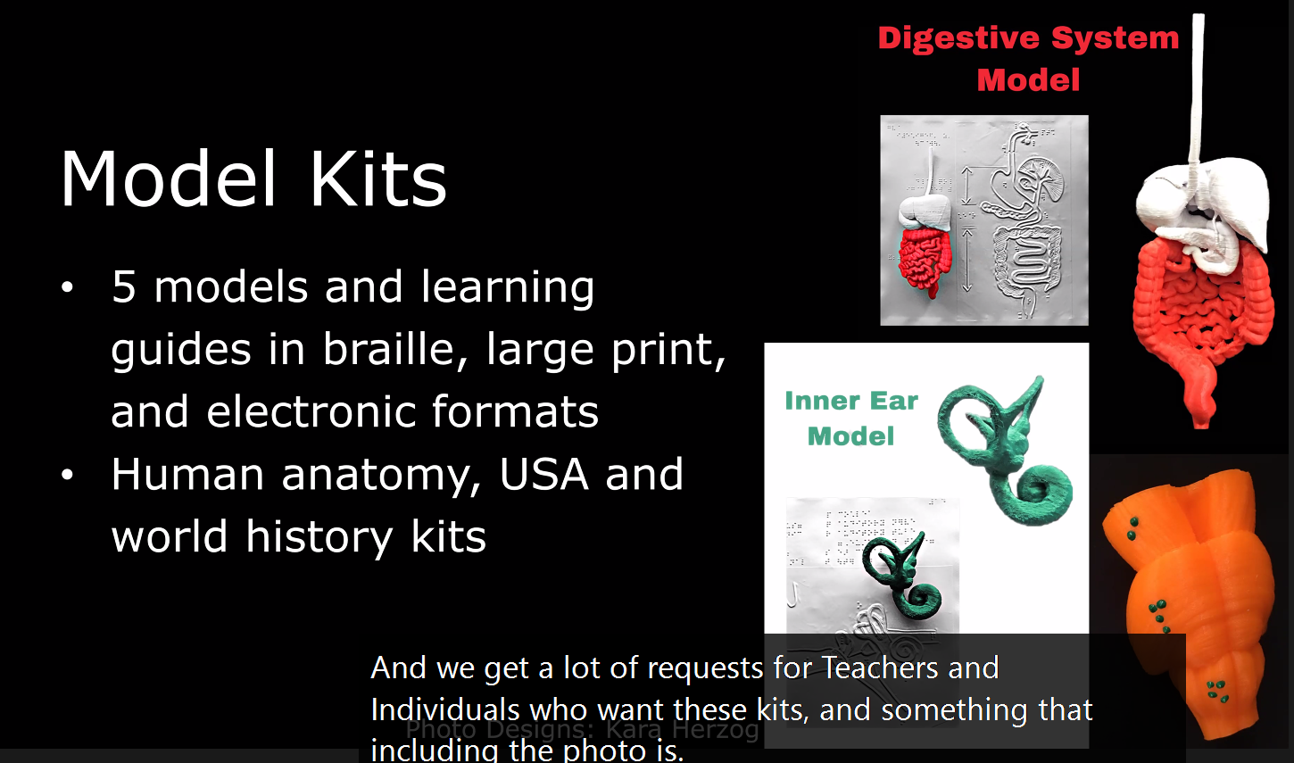
For curved surfaces they will often use puff paint to add braille, which is easier to incorporate but sometimes falls off.
The Ohio State School for the Blind (OSSB) runs a Model Club for their students. They conduct field trips including a visit to IC3D, where they create printers, filament and models.
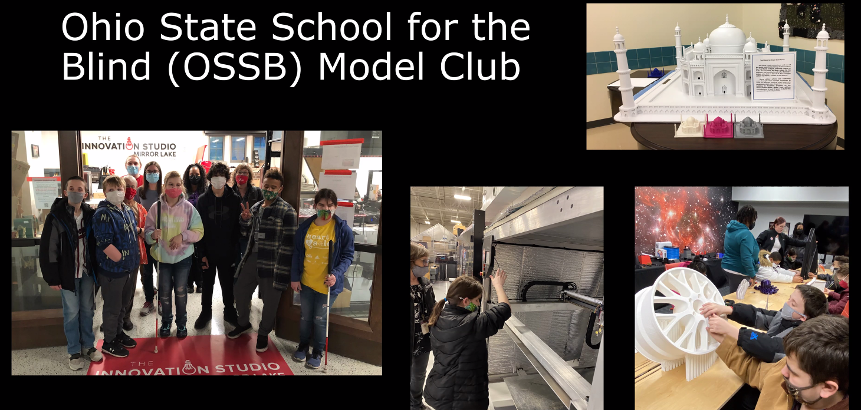
See3D want to do more advocacy for making printers and slicers accessible. They have had some initial conversations with IC3D.
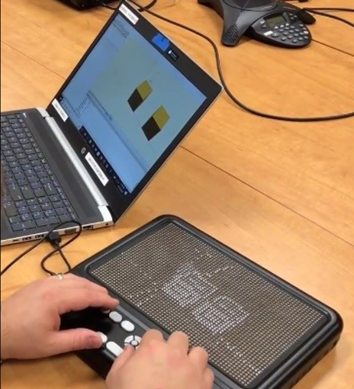
Image from Neil Mckenzie using OpenSCAD with a Graphiti refreshable pin display
Working with Direct Dimensions, a professional scanning company, to get professional scans of objects. The usual cost is around $3000.
See3D are always looking for more volunteers, e.g. volunteers overseas who can print and send models locally.
For more information, contact Caroline Karbowski at info@see3d.org or visit https://see3d.org/.
A list of resources is also provided at https://docs.google.com/document/d/1Ekve3--tgHBMiGwsmR2Ggb5vXSn6Ch9ifRSRerGwrgE/edit#heading=h.y7r5wzx3kykd
The slides from Caroline’s presentation will be available on the ANZAGG Teams page under files > meeting minutes and agendas.
Member question: what 3D printers are they using? Answer: They have mainly been using Ender3, Ultimaker and Flashforge.
Blind students at OSSB are using OpenSCAD. A member suggested that Narrator works well with OpenSCAD. Often sighted assistance is needed to get the file out and onto the printer. OpenSCAD has been improved, e.g. menu item to get to different windows (editing, compiling and errors). Chancey Fleet and Amanda Rodda teach accessible 3D modelling. Chancey Fleet recommends Simplify3D for slicing.
We also discussed Lidar scanning with the latest iPhone. A teacher has been doing Lidar scanning with an iPhone to generate classroom maps. They scan the room in 3D then trace it to a simple outline that he 3D prints as a single layer on paper. It takes around 1.5 hours from scan to print.
See3D have been working with high schools, getting sighted students to design models for touch readers as part of their schoolwork.

3. Guidelines

3.1 3D Printing on Paper
Chris Correll from TSBVI has been working on a method for 3D printing tactile diagrams on paper. This is documented at https://github.com/tactile-graphics/guides/wiki and makes use of a tool created to convert from .png to .stl at https://cowlicks.github.io/.
Leona is experimenting with the process, as it is a little different using Cura, and will incorporate the instructions into the ANZAGG 3D printing guidelines.

3.2 Design Guidelines
Still in (slow!) progress.

3.3 Updates
Updates made to sections on “sources of 3D models” and “3D printing by people who are blind – using a 3D printer” (thanks to discussion on the BLV 3D Printing Facebook page. The Simplify3d slicer was recommended as excellent for accessibility, but is not free).

4. Other Business

4.1 Tactile rulers
The tactile rulers produced by Visio have arrived. They were designed using 3D printing then injection moulded for mass production. Leona will distribute them to ANZAGG members to assess.
ACTION: Please contact Leona if you were not at the meeting but would like to receive a ruler. Three more are available.

5. Next Meeting
20 July 2022

