ANZAGG 3D Meeting Minutes

Wednesday 20 April 2022

1. Roll call with self-introductions
Meeting chaired by Leona Holloway, Monash University
7 attendees from Monash University, NextSense, SPEVI, NNELS,

2. Icebreaker – What have you been designing/printing in the last month?
We discussed whether tactile markings could be used on Lego. This is not usually practical but it may be important to indicate colour. You can use a colour identifier but this adds to cognitive load and the overall difficulty of the task.
Leona’s paper on 3D printed street crossings received a best paper award at CHI. This is in large part thanks to the input of O&M specialists in the conception, development and testing of the materials. Leona’s presentation on the topic is available at https://programs.sigchi.org/chi/2022/program/content/68945
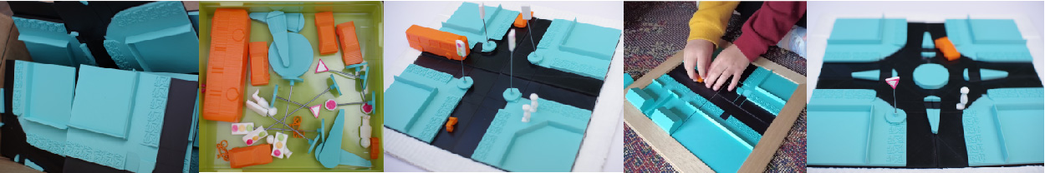

3. Research updates from Monash University

3.1 Multi-level Floorplans – Ruth Nagassa
Ruth has completed touch testing of her 3D printed multi-level shopping centre maps with 9 adult touch readers. The 3-storey maps were presented as 3 flat floors or stacked on a rotating or sliding mechanism. A lot of measures were taken in terms of accuracy, understanding, engagement, usability, etc. All presentation modes performed approximately the same, however there was a clear user preference for the stacked presentations and they were thought to be useful for real-life implementation.
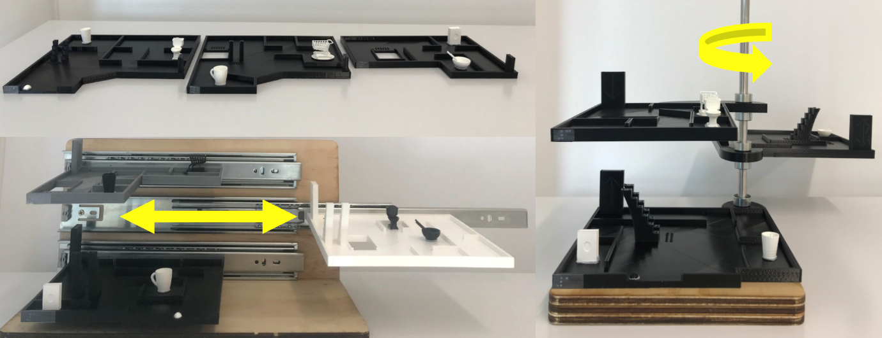
Question: how many of the touch testers were congenitally blind? It was suggested that people who are congenitally blind tend to think of routes as steps between landmarks. Whereas those with visual experience are more likely to have a Euclidian sense of space. A group member who is congenitally blind said that growing up, they used a lot of models made of cardboard, toy cars, etc to understand spatial layout but it was hard to conceptualise things like subways and train stations. A multi-level model would have been very helpful. As an adult, they use structured discovery (rather than memorising routes) and keep track of directions to develop a 3D mental model.

3.2 3D Printing for Education
We have been doing a great job in the adoption of 3D printing for accessibility in Australia and New Zealand. Leona is conducting surveys and interviews with the aim of taping into your collective knowledge to share with others. The questions mainly related to what sort of models are most popular/successful, and what are the supports and barriers to implementation.
Leona will be following up with respondents for interviews in the next month.

4. Events

4.1 Community Care Smart Assistive Technology Collaborative Webinar, 23 March
Leona Holloway and Sarah Hayman presented a webinar on the ARC 3D printing project for the Community Care Smart Assistive Technology Collaborative in Queensland. You must be a member of the collective to access the recording but it is free to join.

4.2 Access Elvis, Bendigo Art Gallery, 23 April & 20 May 2022
Monash University has been working with the Bendigo Art Gallery for two special tours of the Elvis: Direct from Graceland exhibition for people who are blind or have low vision. Ruth has created a 3D printed model of Elvis’ childhood home in Tupelo, to which she will be adding some balsa wood for a more realistic texture. Erica Tandori, who is a legally blind artist, has created an enormous tactile diorama with a model of Graceland. The labels have been laser etched with large print, a QR code and braille.
A member has made QR codes tactile by placing them on a raised piece of cardboard.

4.3 Melbourne Knowledge Week, 11 May 2022
The Monash University Inclusive Technologies group will be presenting 3D printed materials for touch readers at Melbourne Knowledge Week with a “come and try” collection of materials and a braille bombing event on Wednesday 11 May.

4.4 Round Table Conference, 16-18 May 2022
We will not hold a 3D Printing meeting next month as it clashes with the Round Table conference. Leona and Ruth will be presenting on the ARC 3D Printing project. Leona will also be running an ANZAGG workshop on accessible graphics production techniques.

5. Other Business

5.1 Tactile rulers
Tactile rulers from Visio are in the mail! Leona will distribute them locally once they arrive. Please let her know if you would like one.

5.2 3D Printing Guidelines
Work continues on the ANZAGG 3D Printing Guidelines with thanks to members who have contributed a number of comments to the draft document. Leona will work on this and contact individuals for assistance. The main section for completion is Design Guidelines.

5.3 Braille Lego
In April and May, The LEGO Foundation will be in Australia facilitating workshops for educators and service providers who have been using LEGO®️ Braille Bricks in the classroom or in their practice.
These workshops are taking place in Melbourne, Sydney and Brisbane, but can also be attended online via ZOOM.
A member was originally sceptical about Braille Lego because the braille is too large, but it was more useful than expected, using their suggested activities. There are also social advantages to the braille Lego, as it can be used by blind, low vision and sighted children together. They have mainly been using it as 2.5D with one layer of braille Lego on a base plate.
It was agreed that learning to read with large braille can lead to bad reading habits because you need to scrub up and down to feel the whole braille cell.

6. Next Meeting
Wednesday 15 June 2022

