ANZAGG 3D Meeting Minutes

Wednesday 20 October 2021

1. Roll call
Meeting chaired by Leona Holloway, Monash University
11 attendees from Monash University, NSW Department of Education, ACT Department of Education, Victorian Department of Education, Build-a-Better Book Project, NNELS, BLENNZ, NextSense, Maple Glass Printing

2. Icebreaker - What have you been designing/printing in the last month?
Most of us have been in lockdown with limited access to 3D printers.
One member was inspired by another member and has been looking through the humanities curriculum. They have created the Nile delta and the Pompeii volcano using the Terrain2STL website.
Focusing on kindergarten to grade 2 level curriculum. They have created 2D to 3D shapes for prisms (for maths) and are looking at creating book bags that would include 3D prints and other tactile resources related to a book. Ideas wanted for which books are most popular. At a higher level, Captain Underpants, Diary of a Wimpy Kid and Harry Potter are most popular. For younger children, Eric Carle books are very popular. Another member is also making story boxes, e.g. for Goldilocks and the Three Bears they can 3D print 3 bowls, 3 chairs, 3 beds at 3 different sizes. They are also using 3D printing for objects in counting books that can’t easily be bought. A third member said that all kids get a pack of 4 free books when they start school in their state. They were planning on adding a 3D printed braille stamp with the child’s name but hadn’t thought about other objects. The main problem is production time, as the book titles are kept a secret until the last minute.
Leona has been creating 3D icons for shops to go on tactile maps. Each icon is a maximum of 20mm wide and 25mm high. Initial testing has begun. Members suggested websites to get ideas for simple icons: the Noun Project and SVG repo.
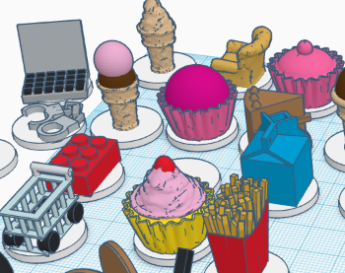
A small selection of the icons being trialled. Not all have been successful! The object needs to be simple, tactually distinct, unique in shape, without important features near the base, and something that you touch in real life.

3. Draft Guidelines
Published guidelines: http://printdisability.org/about-us/accessible-graphics/3d-printing/
No major updates to the guidelines to report.

4. Guest Speaker: Kathryn Penzhover (University of Colorado) on Build-A-Better-Book Project
See https://www.colorado.edu/project/bbb/ for a gallery of designs. Please do use them, modify and re-upload.
Build-A-Better-Book is a science outreach organisation. They wanted to teach 3D printing and maker technology but with a meaningful outcome for the students.
They first started with tactile images of story books but it has now gone well beyond books. BLV people asked for games.
Tactile enhancement is achieved using a variety of techniques:
- Swell paper
- Slate and stylus to write braille
- Wikki Stix or 3D pen to outline images on a print book
- Memory game made using laser cut wooden cards and Wiki Stix
- 3D printing.
  - Sometimes add other materials onto the print to add a variety of textures, e.g. the planets 3D printed with Wikki Stix to show the orbits.
- Craft materials, e.g. paddle pop sticks with wool to create spider webs.
- Structure Sensor to go from real object or a play-do sculpture to 3D printing. The device attaches to an iPad to scan and create a 3D printing file. You need to walk around the object. The object needs to be within a certain size range. It outputs as an .obj file that you can import to TinkerCAD to clean up and convert to .stl. They were able to do good quality scans of their team members.
Books:
- Eric Carle very popular author
- Animals shown in profile, with half in relief.
- “Have you seen her?” book with 3D printed owls that move through the book.
Games:
- Connect 4 with tactile pieces
- Chess board with low profile pieces and tall outlines for each square.
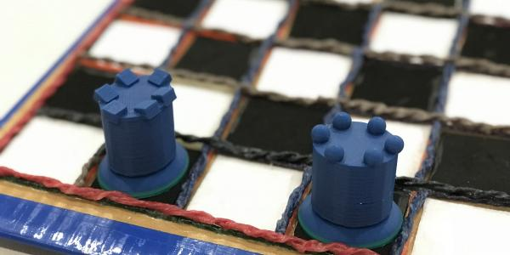
Maths:
- adjustable tactile pie chart
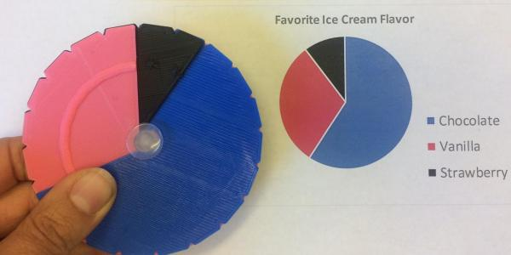
A member asked about participation by people who are blind or have low vision:
- Build-A-Better-Book co-design with BLV participants whenever possible. While 3D printing has accessibility hurdles, BLV students are able to use 3D pens.
- Another member uses OpenSCAD to create their own models and also creates relief versions of images. A third member recommended lithograph printing to create relief versions of 2D images. A fourth member has been trialling printing directly on paper and is able to convert directly from 2D to 3D in Cura.
- recommended http://fullcontrolgcode.com/ for creating models with only a few lines of code.

5. Discussion topic: Using complementary formats
A member led a discussion around when it is appropriate, or even necessary, to use both 3D printing and tactile graphics together as complementary formats.
Sometimes, particularly in maths, swell paper and 3D printing are not effective on their own but a combination works well. E.g. question with orthographic views of a stack of blocks, when the student is asked to show the face or calculate the area. But you also need to be careful not to give away the answer to blind students.
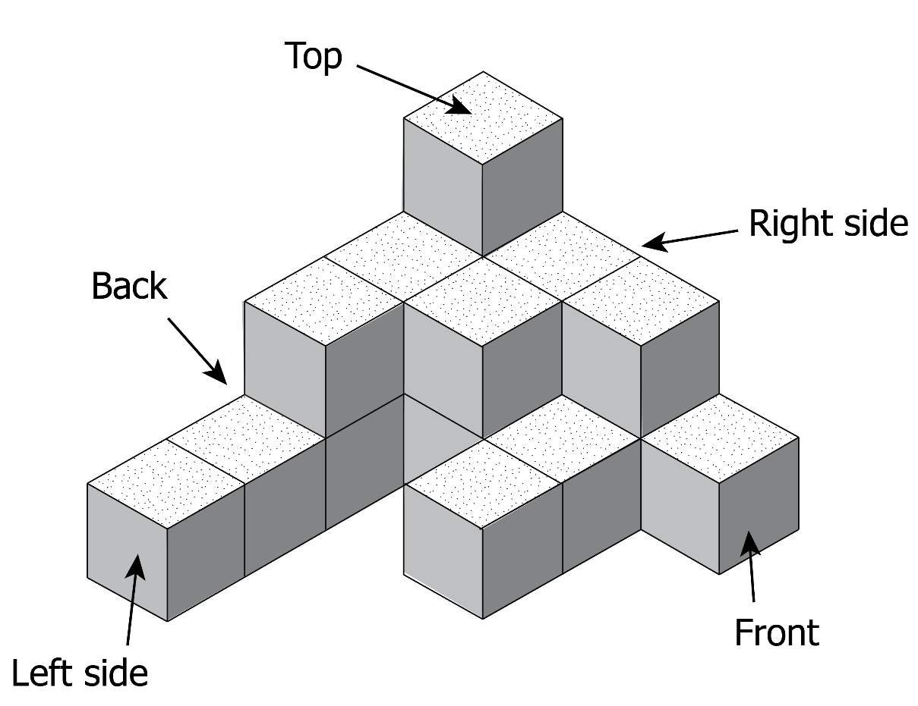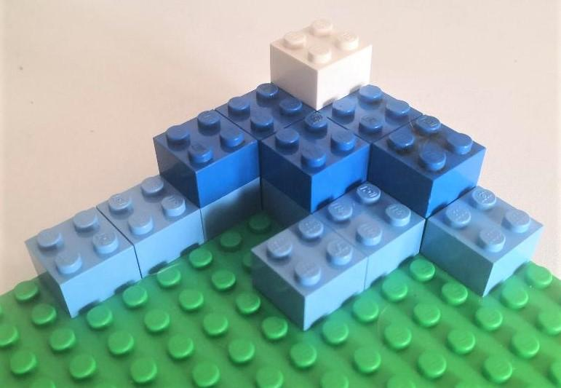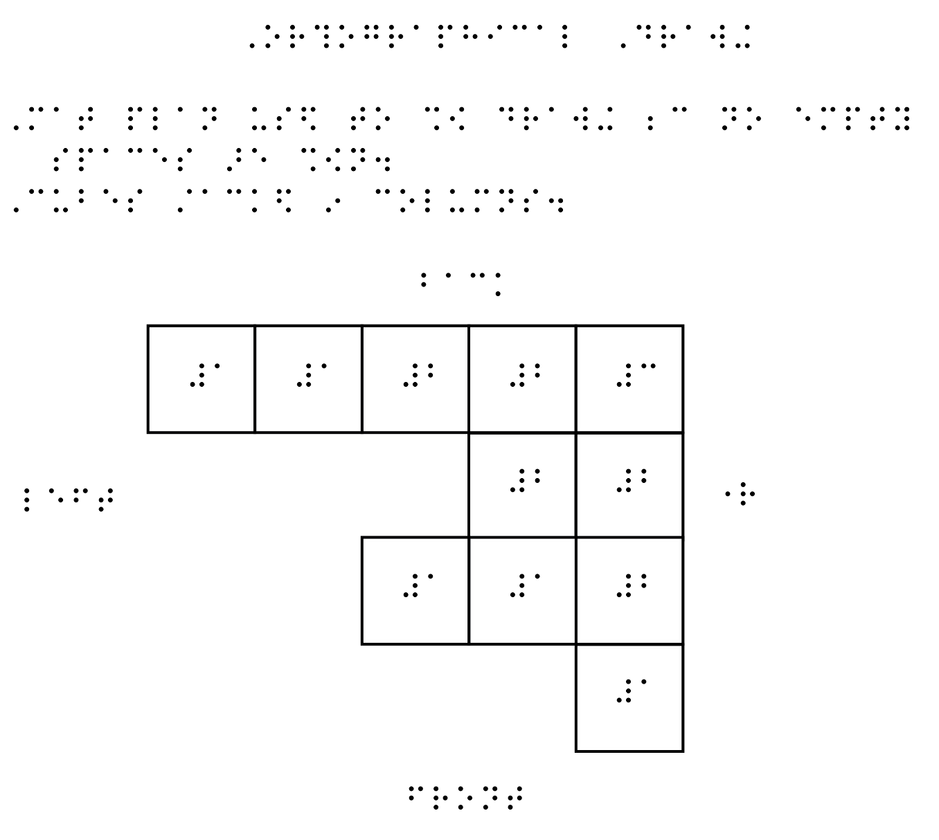
Another member has found a similar issue with castle diagrams and has wrestled with this issue too. As a maths teacher in a mainstream classroom, they would get kids in early high school to make the picture themselves using attachable blocks. But your approach depends on the learning objective: is the student learning how to interpret 3D diagrams or how to calculate area? Most schools already have the unit cubes or Lego that they can use themselves to create the shapes.
The orthographic diagrams come up in NAPLAN tests. In previous years, they would be replaced with an alternative question, but NAPLAN does not want to do that anymore. This means that we need to teach the concepts in the classroom in the same way that they will be tested.
A blind member remembers encountering those sorts of questions, e.g. 2D version of 3D cube, and struggling to understand. Having a 3D model or foldable model would be very helpful. Another example is giving a front view of a building in 2.5D versus 3D model of whole building. A lot of kids don’t have exposure to tactile graphics, and teaching concepts of perspective could be helped by combining 2D and 3D models.
All education is about going from concrete to abstract. But the student needs to be old enough to make the cognitive leap.

6. Other Business
To be held over until next meeting.

7. Next Meeting
Wednesday 17 November 2021 11.30am AEST
Guest speaker: Tony from Maple Glass Printing on glass printing and non-planar printing

