ANZAGG 3D Meeting Minutes

Wednesday 18 August 2021

1. Roll call
Meeting chaired by Leona Holloway, Monash University
15 attendees from Monash University, ACT Department of Education, Mountain Lakes Library, BLENNZ, NSW Department of Education, BLENNZ, NNELS, Victorian Department of Education, NextSense, SASVI

2. Icebreaker - What have you been designing/printing in the last month?

2.1 Braille stamps
Made a jumbo braille stamp for playdo, which a colleague is trialling with her kids at home. The original design is on Thingiverse at https://www.thingiverse.com/thing:4919848. Some years ago, Leona similarly made a set of customised braille name stamps for blind school students to label their pottery projects.
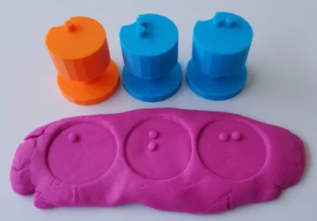

2.2 Lithopane
Experimenting with a lithopane 3D print of a famous face. Started with a black & white image and used lithopane software. Has anyone else had tried this and how successful was it? One member tried converting from a black and white image in Fusion360. It worked well with maps and geography but not for humans. There is a large 3D rendering of a photograph at the Andy Warhol museum in Pittsburgh. Tactually, you could discern the eyes, nose and mouth but not much else.

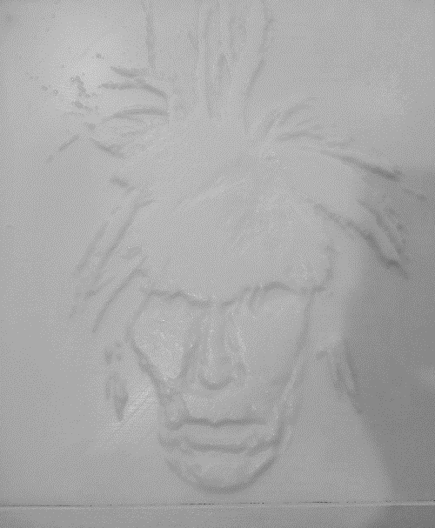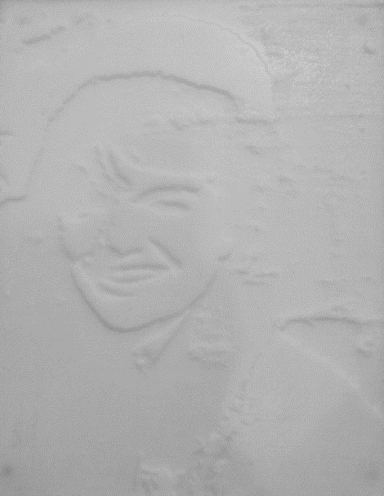

2.3 3D pens
A member asked about using a 3D pen to fix very small areas, as they are missing some pieces on a 3D world globe. Another member has tried them. It is quite tricky to draw in mid-air but useful. They can be bought quite cheaply. The type that use standard 3D printing filament are recommended. Another member has unsuccessfully tried a 3D pen that requires UV curing.

2.4 student-made pictograms
A member has been 3D printing some of the pictograms from the Tokyo Olympics and Paralympics. Their blind and low vision students are designing their own pictograms with some success. They are using using a raft to hold the pieces together. Another member suggested using a plastic welding gun to create a backing piece. Or a third member suggested using a 3D printing pen to stick things together.

2.5 multi-level maps
Ruth Nagassa showed her 3-level shopping centre map with floors that spin or slide out of the way. The base is plywood and she used a threaded rod, shaft collars and washers (all available at hardware stores) to hold it together. She has also designed 3D printed icons to designate the bookstore (a book), supermarket (a trolley), food court (bowl with chopsticks), juice bar (cup with straw) and coffee shop (mug).
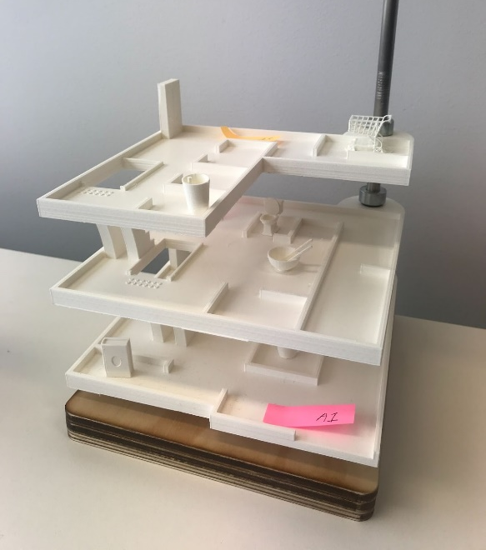

2.6 tactile rulers and outsourcing
A member has been printing a lot of 2-colour tactile rulers. Teachers want up to 30cm but it won’t fit on the printer. They have been looking for a third party to outsource the 3D printing but hasn’t found anywhere suitable yet. Another member has looked at 3D printing services in the USA and said it is too expensive. It is better to simply buy a 3D printer with a larger bed. But it is harder to find a printer with both a large bed and dual colour printing. A member suggested using a dovetail connection to print the ruler in two parts. Another member suggested using resin moulding.

2.7 tactile clock
Printing the Perkins brailler finger guides and a tactile clock.
ACTION: The files for the tactile clock to be shared in Teams.

2.8 CNC machine
NextSense have purchased a CNC machine. Before lockdown, they carved a small landscape and a larger topographical map out of MDF. The CNC is faster than 3D printing – it took approximately 2 hours for a 120mm x 60mm x 20mm piece. Not a lot of post-work required, just 5 minutes of sanding. The machine cuts the piece to size. It is very messy with the sawdust, so it needs to be in a room where you can clean easily. You can use the same 3D files as with a 3D printer, but there can’t be any overhanging areas. The cutting area much larger then 3D printer.
The Inclusive Tech group at Monash Uni are getting a milling machine for their new makerspace in Clayton later this year.

3. Draft Guidelines
Published guidelines: http://printdisability.org/about-us/accessible-graphics/3d-printing/
Over the last month, links have been added to other sections and resources in When to use 3D printing.

4. Discussion topic: cataloguing and distribution
There are two types of catalogues:
- Internal catalogues for people requesting from their accessible formats supplier
- Open repositories for people printing for themselves.

4.1 Internal catalogues
SVRC have catalogued models that have been tested (and approved). The catalogue is a Word document published on the SVRC website at https://www.svrc.vic.edu.au/alternative-format-catalog. It includes a photograph, description, why it might be useful, and subject area.
The NSW State Braille and Large Print Services catalogue is available only from within the department. The 3D prints have been added to the Oliver inter-library loan system. Category searching is possible. There is also a PDF catalogue for people who prefer, updated every 6 months. It has been advertised through quick presentations to subject-matter experts.
BLENNZ are also using their library catalogue to include 3D prints.
NextSense are using their intranet. The most commonly requested 3D printed models are listed on Sharepoint, which has a 3D viewer. They advertise to departments in Zoom meetings.

4.2 Open repositories
A member said that they want to know what settings to use when they prints other people’s models.
Another member agreed that as a blind person, they needs details on how to print because they can’t inspect the model visually. Which should it be oriented? Are supports needed?
A member is working on an idea in this space. To be continued …
Leona uploads her designs to Leona’s Thingiverse account and has collections in the ANZAGG Thingiverse account. These models were added to BTactile some years ago, but it has not been updated since then.

5. Other Business

5.1 Accessible Graphics Format Decision Tree
Now available for download from the Round Table website (but not yet advertised):
- Decision Forest - print version (PDF)
- Decision Forest - text description (.docx)

5.2 Pasadena 3D Printing Meeting
The next Pasadena 3D printing meetup will be on the topic of non-planar printing, to avoid "steps" in curved surfaces. Thursday 23 September at 12pm AEST. https://www.meetup.com/Pasadena-3D-printing-meetup/events/279813353/

5.3 64oz Games Store
Accessibility games store with 3D printed game pieces such as dice, Catan, braille snap blocks, See https://64ozgames.com/.
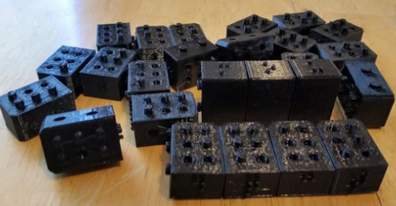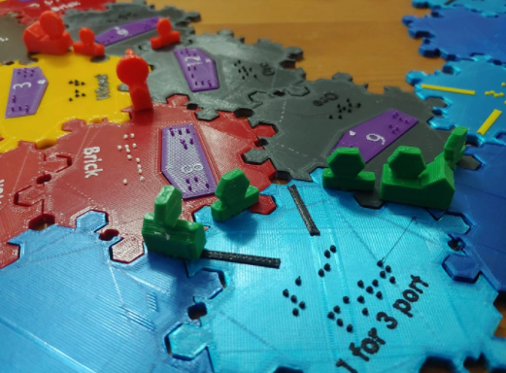

5.4 Blind Bargains Podcast by AT Guys
Ian Matty was a guest speaker along with See3D. The podcast is available at https://www.blindbargains.com/bargains.php?m=22127&

6. Next Meeting
Wednesday 15 September 2021 11.30am AEST

