ANZAGG 3D Meeting Minutes

Wednesday 21 July 2021

1. Roll call
Meeting chaired by Leona Holloway, Monash University
13 attendees from Monash University, Victorian Department of Education, NextSense, SPEVI, Tactile Universe, NNELS, BLENNZ, SASVI

2. Icebreaker - What have you been designing/printing in the last month?
To celebrate Maori culture week, BLENNZ have designed a 3D print of a constellation with 9 stars that is important to Maori culture (Matariki, which signals the start of the Maori New Year?)
Cataloguing 3D prints so that their teachers can easily make requests. They have been adding colour to some of the prints for high contrast (using a sharpie) and taking photographs.
Creating 3D prints of multi-level buildings. She showed a model with 3 levels attached to a backboard with drawer slides, so that you can have the layers stacked or move them independently to get better access by touch. Another model is displayed on a retort stand, so that the layers can be rotated.
Released models for braille/print boggle cubes and a 4 × 4 tray on Thingiverse at https://www.thingiverse.com/thing:4908196. While a 3D version is not strictly necessary (you either need to use a tactile version then get sighted players to write down the letters; or use the standard print version and get the braille reader to write down the letters), it is appealing and has already been requested by 4 adult touch readers.
Working on a collection of texture beads, published on Thingiverse at https://www.thingiverse.com/thing:4914161. The beads are designed for concept development for young children. They have a wide threading hole and come in four shapes (sphere, cylinder, rectangular prism or cube) and three textures (plain, striped or dotted. A number of different textures were tested. Those chosen are very distinct tactually and can easily be identified/named.

3. Draft Guidelines
Published guidelines: http://printdisability.org/about-us/accessible-graphics/3d-printing/

3.1 Audio labels
http://printdisability.org/about-us/accessible-graphics/3d-printing/labelling/
Monash Uni 3D printed resin models of poses for the Mary Quant exhibition, testing out three different methods for audio labels: QR code, NFC tags, and inbuilt electronics with speaker. The QR code was the most problematic, because some people did not have a QR reader loaded on their phone and it was tricky to capture the code at a small scale. The capacitive touch button was preferred because it was the easiest to trigger and you didn’t need to also be holding your phone.
For the capacitive touch button, they used a Bare Conductive board. It is more expensive than an Arduinio or Raspberry Pi but it comes loaded with code and 12 capacitive touch points. You just need to wire it up and load numbered audio files. If you know your Arduino programming, you can also modify the code to do double taps, long taps, etc.
Another member built something with laser cutting and capacitive touch points but they tried to DIY and the wiring was a nightmare.

3.2 Lines
Preliminary testing with lines. Anything that can be sliced and printed can be felt. Lines less than 0.5mm high were not printed.
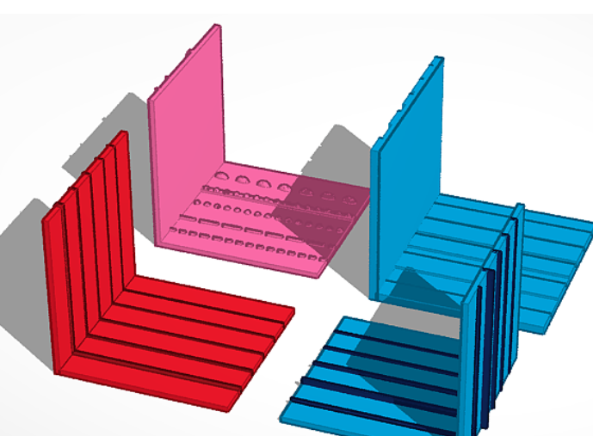

4. Guest Speaker – Nicolas Bonne, Tactile Universe
Nic was a student at SVRC and at Monsah University, where he studied galaxies. He is now working as an astronomer in the UK. He initiated the Tactile Universe project.
When Nic graduated and moved to the UK, he was looking for work as an astronomer. He was asked how he could have accessed the telescope images more easily as a student. To turn images into tactile analogues, they transform from a black and white telescope image to a 3D tactile image using Blender. The models are printed standing on their edge for a smoother finish. In the example shown below, you can feel the spiral arms and the bright blob in the middle easily.
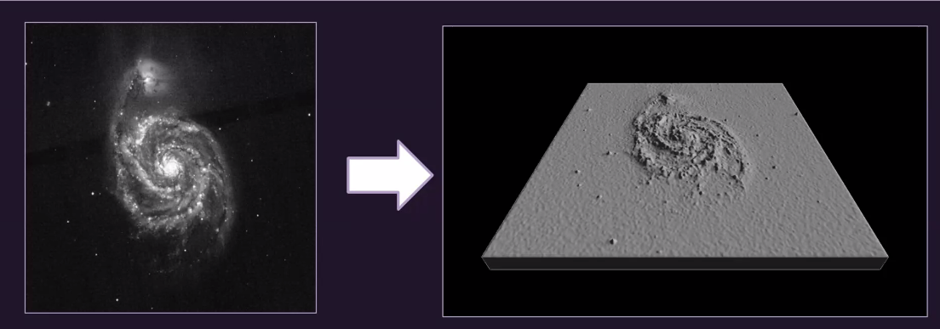
They realised that what works for Nic, who is an expert in astronomy and has his own tactile preferences, will not necessarily work for other people with vision impairment. To test this, they printed a lot of models with different heights, sizes, and other parameters. They then found a local VI support group in Portsmouth, talked them through the models, and they helped select the preferred parameters:
- Size 112 x 112mm (similar to a postcard) because it is easy to hold in one or two hands or can be put on the table. They were also constrained by the size of the 3D printing bed.
- From the base to the tallest peak is 3mm in height. That is enough to feel the difference, without the model becoming spiky and uncomfortable to touch.
- Resolution of 2 features per mm.
- Black and white image placed on the back of the model so that people with low vision can use both their vision and their touch in parallel.
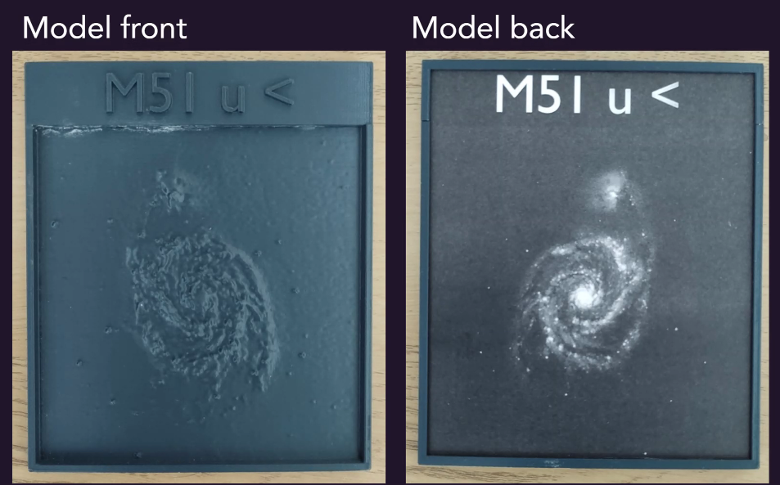
- Name plate on top for quick identification and orientation.
All of these developments were thanks to consultation with the VI community.
They then put together lessons for students around the country. In the UK there aren’t many specialist schools for VI students. Instead, they are integrated into mainstream schools. The lessons therefore needed to be usable for sighted peers as well.
In the lessons, they start by talking about the sizes of planets in our solar system. Then the children make a tactile map of the planets in relation to the sun using rhinestone stickers.
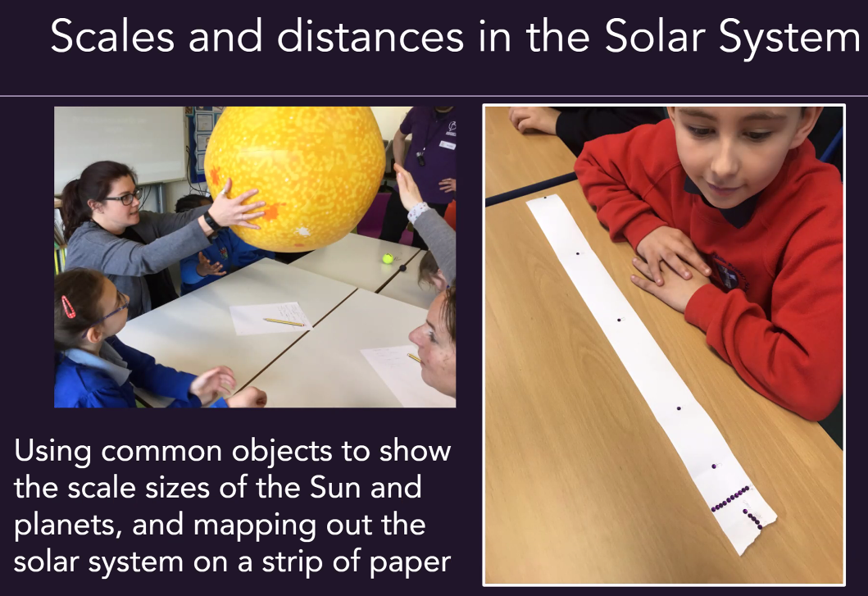
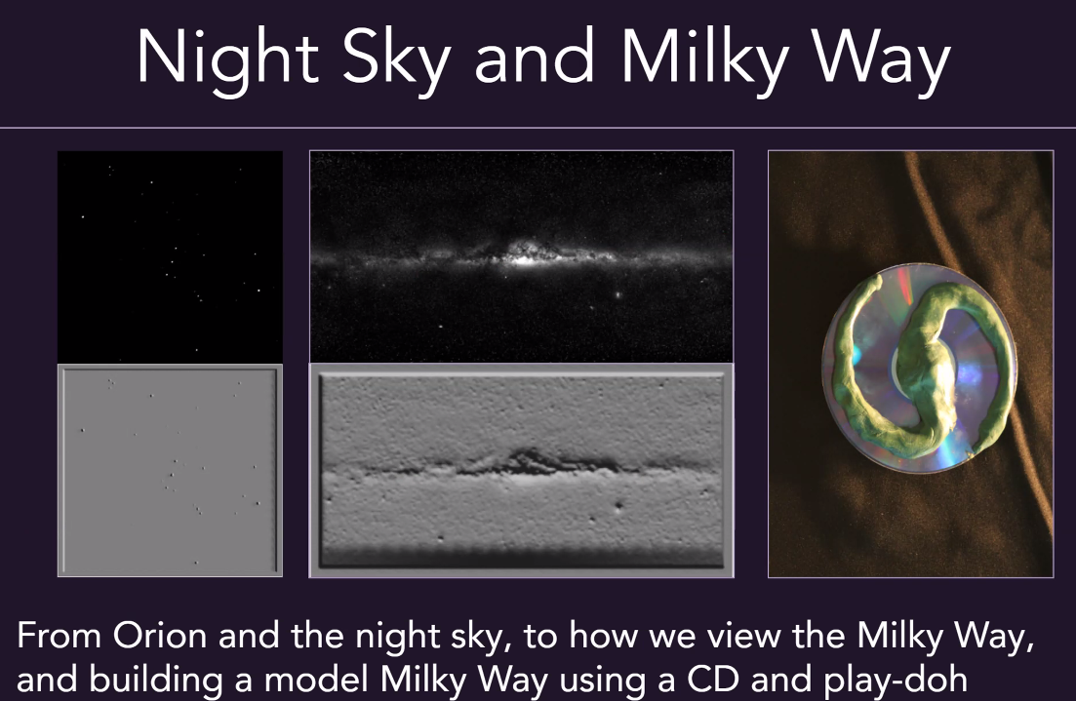
Students are shown ten different galaxies and work out their own way of organising or categorising them.
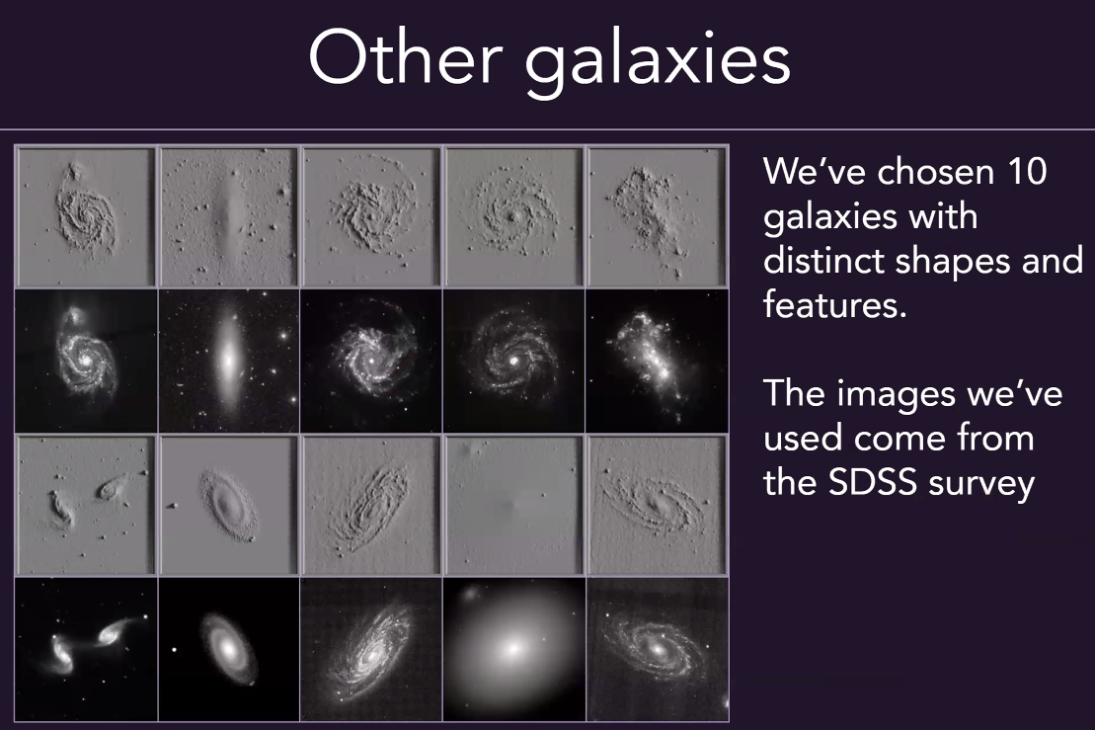
Astronomers put a colour filter on the telescope to indicate temperature, gas, etc.
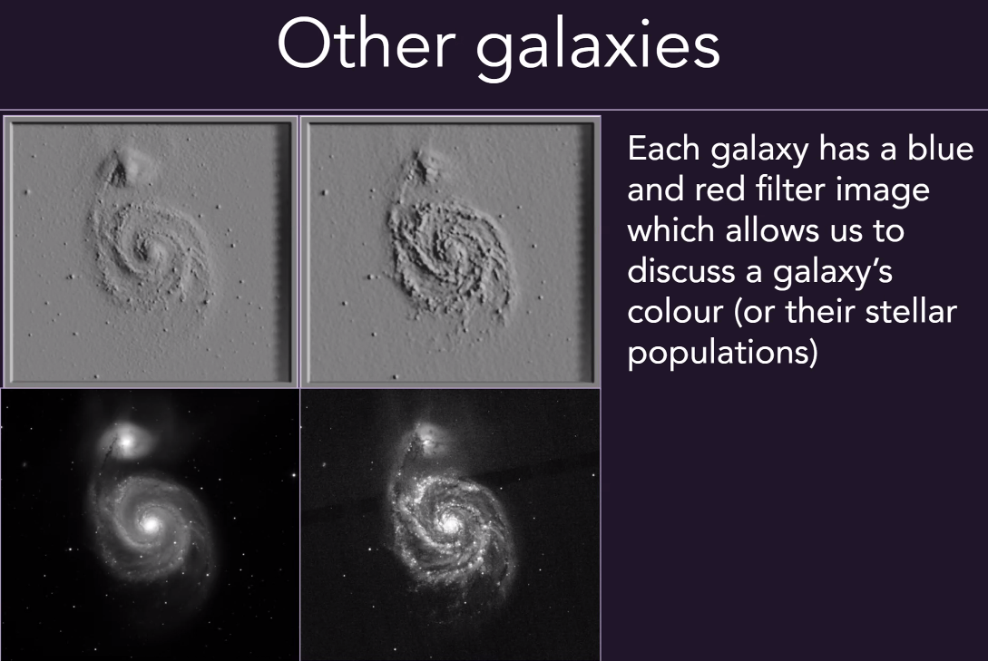
The lesson plans, .stl files and list of other materials needed are all available on the Tactile Universe website:
- 24 STL files for the galaxy models and name plates and a holder
- Lesson plans and presentations
- A list of materials needed to run all three lessons
Tactile Universe have trained people who go out to the schools to run the lessons. The teacher usually just observes, but this had been good because the teacher has then been able to learn from it and share their observations. Fully sighted students are getting a lot out of the models as well as the BLV students. Having something to hold in their hands keeps all students more engaged and interested for longer. They also found that keeping the images raw, with some anomalies and inconsistencies, prompts questions and further learning.
Tactile Universe have released a plug-in in Blender so that you can make your own image, with options to customise the print. Some groups around the UK and internationally have been using and adapting the code.
- Blender install files
- Custom Blender plugin used to create all the STL files
Nic uses a Prusa FDM 3D printer, which is relatively inexpensive. He adjusted the print speed to prevent “wobble” while printing on the side, especially at the top. He also uses a raft to make sure the model doesn’t fall over. Each tactile universe takes around 4-5 hours to print, therefore 3D printing is not really useful for quick research or looking at hundreds of galaxies. Hopefully refreshable braille displays will be able to fill that need. He doesn’t do any post-finishing. They have also tried printing with resin, which works well (but is more expensive) and powder injection, which feels quite grainy.
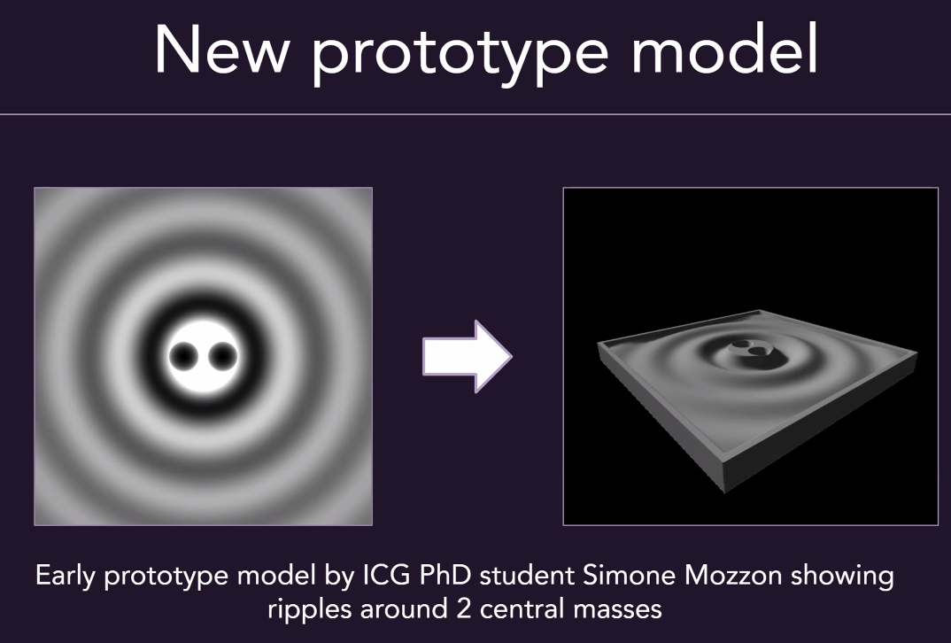
For more information or to contact Nic, please go to:
- tactileuniverse@gmail.com
- www.tactileuniverse.org
- @TactileUniverse on Twitter or Facebook

5. Other Business

5.1 Accessible Graphics Format Decision Tree
Nothing to report.

5.2 (ex-DIAGRAM) 3D Printing Meeting
A meeting was held yesterday 20 June.
Some free online tools for repairing 3D models that were not originally designed for 3D printing:
- https://tools3d.azurewebsites.net/
- https://www.formware.co/onlinestlrepair
ACTION: add these to the software guidelines.
Recommended free tools for reducing vertices (mesh size), which significantly reduces printing time. https://3dless.com/ or Meshmixer: Choose the ‘Select’ tool from the menu on the right, then double-click on your model (this will select your entire mesh). Then click on the ‘Edit…’ option and select ‘Reduce’.
Cura automatically does compression so that there is less instruction going to the printer and it is not doing processing.
UPDATE: The following links give information about Arc Welder, a GCode compression tool to simplify models and thereby reduce printing time.
- https://hackaday.com/2020/11/03/this-gcode-post-processor-squeezes-lines-into-arcs/
- https://plugins.octoprint.org/plugins/arc_welder/
- https://www.youtube.com/watch?v=18uYYXecH5g

5.3 Pasadena 3D Printing Meeting
Next meeting (bring a project) scheduled for Thursday July 29, 12pm AEST. This is a good opportunity to get some technical or design advice. To sign up, see https://www.meetup.com/Pasadena-3D-printing-meetup/

5.4 Getting a good fit for joins
A member has been working hard on trying to design good joints. Another member has tested their DNA pieces, which worked well. A third member tested the hex game but the joints were very stiff and when the designer adjusted the joints there was no discernible difference in the end result. The general guideline is to leave a minimum of 0.3mm between joints but it is very difficult to get joints right because sizing depends on a lot of factors, including
- Slicing
- Printing
- Spread at the base of the print
- Type of filament
- Moisture content in the filament
Another member advised looking at horizontal expansion. You need to print a 20mm x 20mm cube, measure it with calipers, then adjust the setting. Their printer was out by 0.15mm when they tested it. See https://www.youtube.com/watch?v=-jsBI3OeUJQ

6. Next Meeting
Wednesday 18 August 2021 11.30am AEST

