ANZAGG 3D Meeting Minutes

Wednesday 17 June 2021

1. Roll call
Meeting chaired by Leona Holloway, Monash University
12 members in attendance from Monash University, Victorian Department of Education, SPEVI, ACT Department of Education, BLENNZ, Mountain Lakes Library, NNELS, NSW Department of Education, SASVI

2. Icebreaker - What have you been designing/printing in the last month?
- Jim Allan made a braille writer guide for the smart brailler. It will be posted on Youmagine after testing.
- Spanish food vocabulary cards https://www.thingiverse.com/thing:4885508/files. The first prototype is complete. They worked with a blind Spanish teacher and art students creating raised graphics in TinkerCAD. Each card has a tactile image, print in Spanish and English, braille and a QR code on back linking to a video for deafblind students. That’s 5 communication methods on one card. The teacher has put Velcro on the back for interaction, for example the students can make a food pyramid. The next version will have icons that are more 3D.
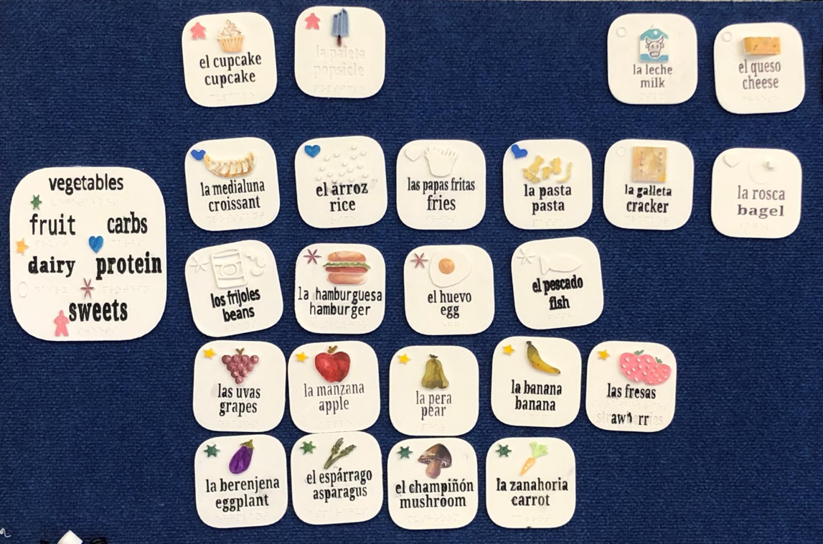
- braille/print letter beads https://www.thingiverse.com/thing:4875770
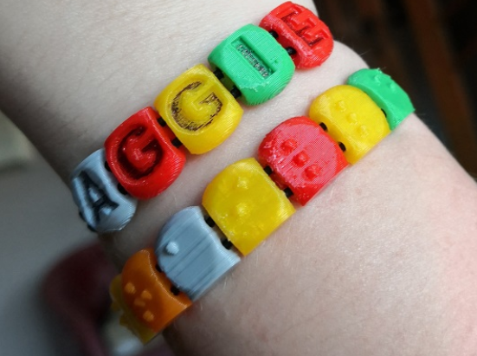
- Ballylanders in big and small size. They were coloured by spray painting the base, spray painting individual colours (with masking), then adding detail with permanent markers. It was time-consuming but gave a great finish.
- Working with one of the teachers to create 3D prints of aboriginal symbols for meeting place, etc. with colour contrast. The first model was printed with flat tops but rounded tops feel better.
- Received requests for reproductive system, Pompei (rooms, shops, overall map), Roman empire (buildings, overall map of the empire to provide context). There are always lots of requests for swing cells and brailler finger guides.
- To make a map, a member finds a clear print map, converts it to svg in Illustrator, then imports to Fusion 360. This gives lines and shapes that you can manipulate.
- Experimenting with terrain2STL to create test prints for vacuuform.
- Printed a Baby Yoda just for fun.

3. Draft Guidelines
Published guidelines: http://printdisability.org/about-us/accessible-graphics/3d-printing/

3.1 Finishing
http://printdisability.org/about-us/accessible-graphics/3d-printing/finishing/
Updated with tip regarding varnish as a sealant over water-based paints.

3.2 Labelling
http://printdisability.org/about-us/accessible-graphics/3d-printing/labelling/
Checked and released this month. It does not include computer vision or pairing with touchscreens, which will be added at a later date.

3.3 Lines
A member will be running some experiments to use as the basis for guidelines on 3D printed line thickness, type, etc. Lines can be used on 3D models for for label leader lines, as roads on maps, dividers between sections, to emphasise outlines, etc.
Another member used the tactile graphics guidelines for lines and teachers said they were fine.
ACTION: Try to identify minimum thickness, minimum height (or depth for indented roads), which lines can be distinguished from one another, etc.
Design is also important in deciding what lines to use. For example, an outline should be thickest, interior lines are thinner, labels are the least prominent.

4. Reports

4.1 DIAGRAM working group
Only one DIAGRAM meeting has been held since our last ANZAGG 3D meeting. Not much to report.

5. Other Business

5.1 Accessible Graphics Format Decision Tree
Work on a revised decision tree to be included in the upcoming Round Table Guidelines on Producing Accessible Graphics. A draft was supplied with the agenda.
A member said that the tree is helpful as there is a lack of understanding of accessible graphics options.
Another member has sent some suggestions via email.
A third organisation had produced a decision tree for 3D printing but most teachers did not use it.
Can the tree be provided as an interactive electronic document? It was agreed that this would be helpful.
All agreed that it should not be a decision about which one format to use; often it is helpful to have a range of formats, for example a tactile graphic with a 3D model to assist with tactile literacy; or a detailed description to accompany complicated graphics. This suggestion will be incorporated with more “and” options or by making a decision forest rather than a decision tree.

5.2 Tiny 3D prints for the mouth
https://www.smithsonianmag.com/science-nature/gummy-candies-help-students-blindness-study-chemistry-180977853/
In a recent study, tiny 3D models of chemistry molecules, as small as a grain of rice, were able to be identified more accurately (by sighted students) using the mouth compared with the fingers. They printed using a non-toxic resin used for dentistry.
There was some scepticism about how useful this might be, as only global shapes can be communicated using tiny models. Also, placing graphics in the mouth might not be taken seriously for older students or adults.

5.3 Students from HTW in Berlin
A member was invited to work with students from HTW in Berlin, who have been creating 3D printed textures using Rhino software. For example, they created textures for reptile skin, turtle skin, “panic”, and a model of the Giant’s Causeway in Ireland.
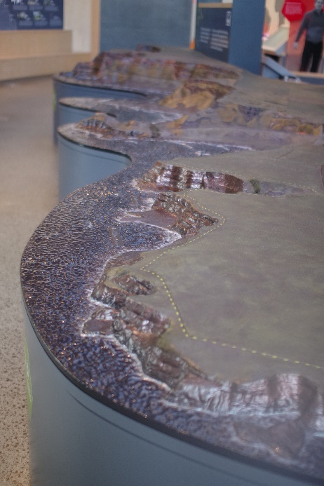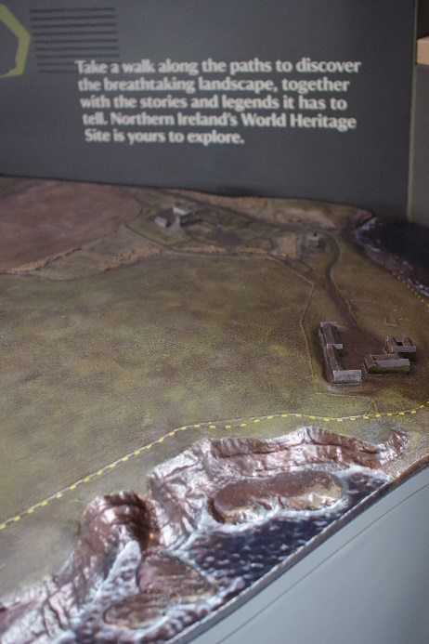
Table-top model of the Giant’s Causeway in Ireland
A member has used Rhino in the past and is thinking about going back to it for textures because in other programs you need to add each block individually, which is very time-consuming. Once the textures are developed, they could be provided as parts on TinkerCAD to collage together.
UPDATE: A free alternative to Rhino/Rhino/Grasshopper - using Blender with the Sverchok Plugin. http://nikitron.cc.ua/sverchok_en.html

6. Next Meeting
Wednesday 21 July 2021 5pm AEST with guest speaker, Nicolas (Nick) Bonne. He is a vision impaired astronomer who studied at Monash University and is now working on the Tactile Universe project in the UK.

