ANZAGG 3D Meeting Minutes

Wednesday 26 May 2021

1. Roll call
Meeting chaired by Leona Holloway, Monash University

In attendance
11 members in attendance from Monash University, TSBVI, SPEVI, BLENNZ, Victorian Department of Education, NNELS, ACT Department of Education, NextSense, Mountain Lakes Library

2. Icebreaker - What have you been designing/printing in the last month?
Designed a 3D model of the Shrine of Remembrance in Victoria during lockdown. Printed it this week (it took 18 hours!) and showed to blind teachers, who think it will be a useful resource. There are quite a few accessible monuments and artworks near the Shrine of Remembrance, as documented at http://printdisability.org/about-us/accessible-graphics/publicart/#Vic
Working with a local school for the deaf. Introduced a teacher of younger students to 3D design. They want to design a Ling puzzle cube with six sides for the students to practice the Ling speech sounds with their families.
Received a request for the Dots RPG dice. Jess Dempsey, the founder of the DOTS RPG Project, has recently joined the Blind & Low Vision 3D Printing group on Facebook and is happy to provide more information.
Made the Ballyland ball as a bead for a necklace. So cute! Painted it with acrylic and then covered in varnish.
See also the Tactile Reading Conference presentation from Statped, where they created braille/print 3D printed letter beads - https://www.youtube.com/watch?v=hQ0am_G6NWw.
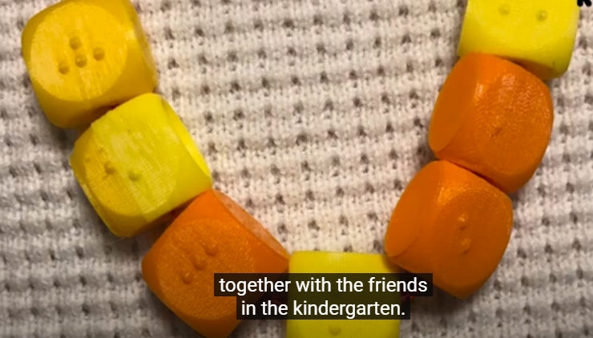

3. Draft Guidelines
Published guidelines: http://printdisability.org/about-us/accessible-graphics/3d-printing/

3.1 Finishing
http://printdisability.org/about-us/accessible-graphics/3d-printing/finishing/
These guidelines have been published and refined based on feedback. Advised against using acetone due to safety concerns and recommended using a “silk” PLA variant for a smoother finish.

3.2 Labelling
The first draft should be ready for checking by the end of the month.

3.3 3D printing design software
http://printdisability.org/about-us/accessible-graphics/3d-printing/design-software/
These guidelines have been updated with additional material from a member and from the MakerBot Educator’s Guidebook. Note that ZBrushCoreMini is a free, simplified program recommended as a starting point for creating sculpted 3D designs for organic shapes.

4. Reports

4.1 Tactile Reading Conference
The Tactile Reading Conference was held from 29-30 April online. Many recordings and all scripts are now freely available. There was a parallel session dedicated to 3D printing. Library of tactile and high contrast images of art historical artworks, by Hoelle Corvest-Morel and Dorine in’t Veld, is also recommended viewing.

4.2 Round Table Conference
Relevant presentations from the Round Table Conference:
- Update on the ARC Linkage project on 3D printing for touch readers, by Kim Marriott (Monash University)
- 3D printing for ecudation, by Nav Virdi (NSW Department of Education)
- UV printing, by Peter Le (Vision Australia)
- Workshop on 3D printing guidelines, by Leona Holloway and Ruth Nagassa
The associated PowerPoint presentations and papers are available from http://printdisability.org/conference/2021-round-table-conference/presentations/.

4.3 DIAGRAM working group

3D models for sex education
We received a query about models that can be used for sex education for BLV students in Scotland and at Visio.
One organisation purchased some Jackson Models last year and they have just become available for short-term loan through our Equipment Library. We've had OTs on placement who've been doing a project on this very topic for the past year. They gave a presentation and created a handbook which included an array of suggestions as to how to teach this topic to students who are blind or have low vision. They can be contacted via cpar0011@student.monash.edu (Claire) and hcha0012@student.monash.edu (Natalie).
Another member conducted an extensive search and found the following models:
https://www.thingiverse.com/thing:4149401 female reproductive system
https://www.flatpyramid.com/3d/genitals/ male penis $30
https://sketchfab.com/store/3d-models?q=male+reproductive+model male reproductive system $80
A member told the story of a school that purchased realistic sex toys for use teaching sex education.
APH have a sex education kit with suggestions of how to create your own models using everyday materials. https://www.aph.org/product/health-education-for-students-with-visual-impairments-a-guidebook-for-teachers-2/

3D printing on paper
3D printing tactile graphics on paper. It works pretty well but sometimes it peels off when the page is bent. Would a more flexible filament be better? An engineer at NASA has been using this method for schematic diagrams for a blind staff member. It is quick and does not require extra specialist equipment. They use 0.1mm diameter for braille dots, which are readable.
Another member likes printing with TPU.
Another member will try printing on paper with nylon filament.

5. Other Business

5.1 non-visual 3D printing
A blind member has been 3D printing found models using a Prusa K3S+ with accessibility mode. It will beep to let you know when you are at the top or bottom of menu. It also plays click sound for each menu item, which you select using a physical knob. They have memorised the menu structure but they are now creating a menu guide, inspired by gaming community who share menu structures as markdown for accessible gaming.
The blind member also uses OctoPrint with NVDA to set printer temperature, monitor print status, etc. The OctoPrint web interface has some buttons that are not well-labelled. The best strategy is to tab to those links with NVDA. The OctoPod iPhone app connects to OctoPrint and is more accessible. They have set up OctoPod with their apple watch.

5.2 Vaquform machines
3D printing not suitable for mass production.
Vaquform machines work similarly to thermoform machine. You can 3D print a model then make a mould. At US$1,500 it is cheaper than the thermoform machine and works with a wider range of materials. You can use any type of plastic sheet but they supply sheets with QR codes that you can scan to automatically give the correct settings.

6. Next Meeting
Wednesday 16 June 2021, 11.30am AEST

