Australia & New Zealand Accessible Graphics Group (ANZAGG)
3D Printing Meeting Minutes

August 2023

1. Roll call with self-introductions
Meeting chaired by Leona Holloway, Monash University
10 people in attendance from Monash University, TSBVI, See3D, Victorian Department of Education, NNELS, BLENNZ

2. Icebreaker: What have you been designing/printing in the last month?
A quadrilateral explorer printed from Thingiverse, which can be used to make different quadrilaterals using 4 sides with channels secured with 3D printed nut and bolt. The nut and bolt worked very well but the channel can be sliced off the top two pieces (next to the nut) as it isn’t required. A triangle explorer is also available.
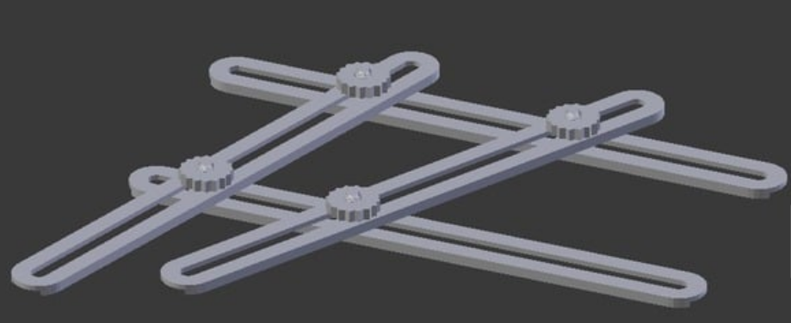
Quadrilateral explorer, thing 3281205
A beautiful map of Australia was made using height to indicate rainfall. It was created using data from the Australian Bureau of Meteorology and one of their staff painted the model using acrylic paint. They plan to make further maps with other data from the Bureau of Meteorology.
Chris Correll from TSBVI has been working on lesson plans for blind and low vision students to create their own 3D models using OpenSCAD and command line to send their files to the 3D printers. He has written up instructions at https://www.accessiblestem.org/.
50 Perkins Brailler finger guides were given away to visiting teachers at a recent event. Another member made some modifications to the finger guide model to improve durability. This file will be shared.
See3D have been successful in obtaining a $5000 grant to assist schools for the blind with 3D printing student clubs. They will be holding their first meeting this Sunday. Please reach out to info@See3D.org if you would like to join, can serve as a mentor, or know of others who are running 3D printing programs for their blind students.
Playing with settings in Cura. Recommended a plugin called “banana split”, which can be downloaded from the Ultimaker Cura Marketplace. It allows you to easily split a model into two parts in Cura, reducing the need for supports when printing a complex model.
Playing with making lithophanes using the Simplify3D slicer. DNA lithophanes are very good. They have also been experimenting with stock images, removing the background first. See https://research.baylor.edu/about/find-researcher/bryan-shaw for Baylor chemistry lithophanes.
You can generate the 3D model for any protein at https://www.centerforbiomolecularmodeling.org/modelingResources/index.php

3. Feature Topic: Draft ANZAGG guidelines on designing 3D printed models for use by touch readers
The draft guidelines are now available for checking (but not for public release) at https://printdisability.org/about-us/accessible-graphics/3d-printing/design/. We discussed the structure and content of the new sections on art and architecture.
Structure:
- The guidelines are very long but it was agreed that they should be kept on one page. The structured headings make it easy to navigate.
- Should references be included? e.g. (Simonnet et al., 2018) with link to academic paper. Yes, these can be retained and show that the guidelines are based on evidence.
- When a topic is relevant to more than one section, it will be explained in full in one section with cross-referencing in the other.
Architecture:
- It is useful to make the roof removable so that you can see the detail underneath
Artworks:
- recommended an expert who could be consulted. Contact details will be shared.
- emphasised the importance of accompanying descriptions. Things like lighting, shadow, colour etc. are all important to an artwork’s aesthetics and meaning but they cannot be conveyed through form alone.
- Art concepts may also need to be provided. Work has been started on a lexicon of art concepts.
- Materiality is important to make objects like museum artefacts feel authentic. This includes smoothness and weight. We were unsure about how best to modify the weight of a print.
ACTION: conduct some experiments with infill and inserts.
UPDATE: Adjusting the infill was more effective and easier than inserting something like sand.
- Consider misconceptions that could be introduced by the use of 3D printing. For example, a hard plastic 3D printed model of a jelly fish would be meaningless – it would be much better to 3D print a mould and then make the jellyfish using jello. “All models are wrong, but some are useful” – George E. P. Box.
A statement is needed on how the guidelines were constructed and why they should be trusted.
ACTION: integrate these further comments then release the guidelines. They will remain a living document. Contact details to be given along with the guidelines with a request for further suggestions or corrections.
Huge thanks are extended to everyone for their help with the guidelines.

4. Other business

4.1 ANZAG meeting minutes
Until now, we have been sharing meeting minutes only with the 3D printing group members. Requests have been made to share and store the minutes more publicly. Those present at the meeting were comfortable with sharing the minutes.
ACTION: circulate this question via email for people not at today’s meeting.

4.2 Other groups and resources
Jim Allan runs a fortnightly meeting on the topic of 3D printing for people who are BLV. It is an opportunity for informal discussion. All welcome. Please contact jimallan@tsbvi.edu if you would like to join.

5. Next Meeting
Next meeting is scheduled for Wednesday 20 September 2023.

