ANZAGG 3D Meeting Minutes

19 April 2023

1. Roll call with self-introductions
Meeting chaired by Leona Holloway, Monash University
8 attendees from Monash University, SPEVI, NextSense, See3D, NNELS, National Science Foundation

2. Icebreaker: What have you been designing/printing in the last month?
Wworking with to make a lesson kit in conjunction with tactile graphics about geometry cross-sections. Embedded magnets.
Symbol slate from Reddit – one line with different shapes to trace with a stylus. Experimenting with different filaments.
Printing out Ian Matty’s coloured crayons.
Attended the New York Public Library Tactile Art Teach-in 3 day workshop with Ann Cunningham on Sensational Blackboard, Chancey Fleet on accessible 3D printing, and more.
Using AI to generate drawings as a first draft. 3D printing braille cells (peg slate with 10 cells). Can reach out to people at APH, who were working on a repository for accessible 3D prints.
Popular model requests available for people to help streamline

3. Guest speaker: Sam Reinders on interactive 3D prints
Sam Reinders (Monash University Inclusive Technologies final year PhD student) spoke about his work embedding electronics and haptics within 3D models, and interfacing with a conversational agent and ChatGPT.
Sam’s slides are available on the Accessible 3D Printing Specialists Team
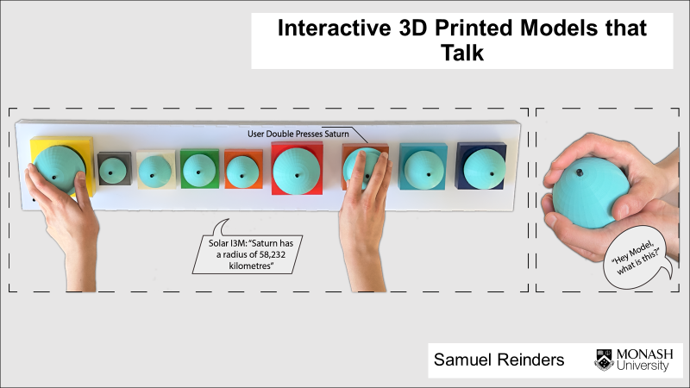
A member asked about scale on Sam’s model of the pyramids of Giza. Can you have the sphinx at both scales to show relative size plus detail? Sam agreed that this is an issue. For example, mercury is the size of a pin head compared with a sun at the size of a basketball. Maybe two sets of models are needed.
The Curiosity Club in Canada talked about ways to understand scale.
Another member asked about what is an educational model versus a toy. There are different legal requirements for toys versus educational materials.
Asked why Sam is using a Raspberry Pi. A member has tried using one himself but ran out of pins. Sam agreed that this can be a problem.
Asked whether the conversational agent can answer questions that are off topic. Sam’s current model is working from customised information. Scaffolding might be more appropriate for educational settings.
Asked about accidental activation of interactions, which is often problematic. Deliberate interactions (rather than a single touch) is usually helpful. Sam uses a half second sustained touch. Touch Graphics uses a one second sustained touch, but that is too long.
Asked about Sam’s plans to integrate ChatGPT. In Sam’s current iteration of the solar system model, he is looking at using ChatGPT instead of a google search result if the conversational agent can’t answer a question with the information it already has.

4. Other business

4.1 3D4VIP project
The European 3D printing 3D4VIP project is now officially complete. Their website has guidelines and a fully functional database with their specially created “top 20” wanted models at https://tactiles.eu/guidelines/. They have invited us to sign up (you need to wait for approval after signing up) then upload our own models and become part of the community.

4.2 ANZAGG guidelines on designing 3D prints
Leona has been updating the guidelines on designing 3D prints, based on feedback from last month’s meeting.

5. Next Meeting
3.30pm AEST Wednesday 17 May 2023

