ANZAGG 3D Meeting Minutes

15 March 2023

1. Roll call with self-introductions
Meeting chaired by Leona Holloway, Monash University.
8 people in attendance from Monash University, Victorian Department of Education, NSW Department of Education, SPEVI, NextSense, BLENNZ, Mountain Lakes Library

2. Icebreaker: What have you been designing/printing in the last month?
Added braille labels to ionic bonding pieces from Thingiverse at https://www.thingiverse.com/thing:5396887. The pieces use something similar to lego studs for positive and negative ions, which fit together very well.
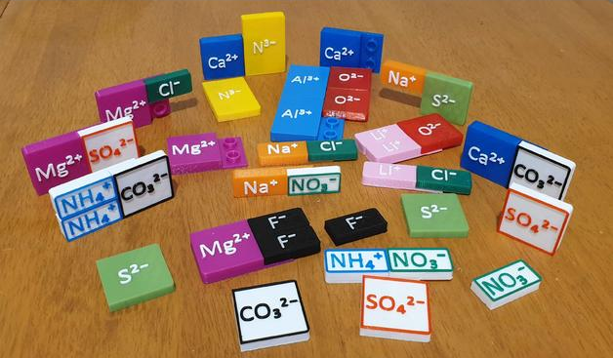
Printed out a DNA model from Thingiverse, which worked well but it was very fiddly to remove the supports and smoothing will also be needed. Another member advised that if you want to avoid using supports, you can try slowing the print speed down to 40 or even 30mm per second. Great tip!
There have been organisational structure changes at NextSense. 3D printing will continue as part of the accessible formats production team.
Worked with Guide Dogs NSW to create a 3D printed smartphone with interchangeable screens to give tactile screen layouts.
Printing galaxies made by Nick Bonne. The prints are available from the Tactile Universe website with lesson plans. They will be used in schools alongside sonification. On the back of the 3D prints, they advise attaching a (reverse) print image to the base so that students with low vision can simultaneously look at the image and feel the universe on the back.
Tactile crayon toppers have been very popular. They help stop the crayon from rolling off the table and could also be helpful for other cylindrical objects like lipstick. They are printing them in TPU flexible filament at a slower speed. The files will be shared and another member would like to try them.
A teacher asked for fraction measuring cups they had seen online. They couldn’t find the STL files but they were easy for a student to redesign.
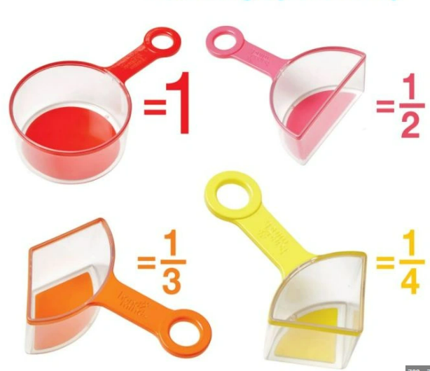
An education department roll-out of 3D printers into schools is going well. They have provided schools with a standard set-up (3D printer, software and filament) and access to files that have been tested using the standard set-up. Accompanying information, training and support are provided by a dedicated team.
Leona has released the components of her 3D printed street crossing corners so that anyone can easily create their own modified corners for different locations. For example, you may want to model a street with no footpath, no grass or no pram ramp. The components are available from https://www.thingiverse.com/thing:5907303v. Thanks to Jim Allan for his work on this project.
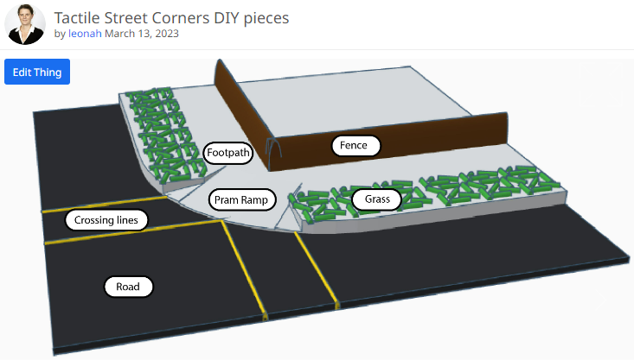

3. Discussion topic: Guidelines for designing 3D prints for touch readers

3.1 3D4VIP guidelines
Partial guidelines now available on the 3D4VIP website at https://tactiles.eu/guidelines/
Two new ideas from the guidelines:
- use duct tape to join two parts of a folding or bisected model
- to add raised lines on the base of a model, incorporate a semi-circular channel then insert a piece of 3D printing filament in the channel after printing

3.2 ANZAGG guidelines
Leona has been working on the draft ANZAGG guidelines. Her first draft outline and recommended measurements are given as an attachment.
Some further suggestions raised at the meeting:
- Measurements: 0.3mm spacing between moving parts
- Measurements: 1mm thick base for braille labels to be added
- Rounded corners: Radius of 0.6 in TinkerCAD for smooth corners and to reduce “elephants foot” spreading at the base of the print
- Prusa Mini + is a good cheap printer for home use
- Design for understanding: Always provide an accompanying description and information with 3D printed models
- Braille labels: It may be necessary to sand a smooth 3D printed surface or use additional glue when adding sticky braille labels onto a 3D printed model
- Design for Inclusion: Adding print images to a 3D model assists with low vision and sighted
- Design for personalisation: 3D printing allows for the creation of one-off objects personalised for the user’s unique needs and preferences
- Design for specific types of models: This section should include moving models.
- Moving models: Print a calibration cube and adjust horizontal expansion before printing models with moving parts for best fit. A member will provide further information.
- Moving models: strong magnets should be encased within the model (safety consideration)
- Consider the 3D printing process: Design for economy. For example, reduce the base thickness or don’t print a base at all. Print braille labels separately (upright) so that the main model can be printed flat, which is quicker and safer.
- Safety consideration: 3D printed materials are not food safe because it is porous.
- Be aware that PLA melts at low temperatures and should not be left in a hot car or cleaned in a dishwasher. ABS has a higher melting point.
ACTIONS: Leona to update the draft guidelines based on our discussion and also add more images as these assist in quick understanding. She will then share with the group members for feedback and further input.

4. Other business
The ANZAGG annual meeting will be held on Tuesday 9 May at the Round Table Conference in Sydney. Nominations are invited for executive committee members. Attendees are also invited to bring along samples for an informal some show-and-tell session when we can learn from each other’s practices. Please contact Leona for more information.

5. Next Meeting
Wednesday 19 April 2023
Guest speaker: In April Sam Reinders (Monash University) will talk about embedding electronics and haptics within 3D models, and interfacing with a conversational agent and ChatGPT.
Upcoming speakers: Florian Lang (Germany) has been invited to speak about a braille learning system created with 3D printing, laser cutting, NFC tags and electronics.

ANZAGG draft guidelines for the design of 3D printed models for touch readers

Measurements at a glance
3D printing design element | Recommendations - minimum (min) and maximum (max)
Base | Min thickness 0.8mm
Lines | Min 1mm high  Min 1.1mm wide  3mm wide is recommended  Min 2mm apart
Arrows | Raise the arrow head 1mm from the line
Heights | Min 0.5mm height for detection  Min 1mm for important features
Roads (on maps) | Indented  Min 7mm wide  2cm wide recommended

Draft structure and guidelines in brief
GENERAL PRINCIPLES
1. Design for understanding by touch
1.1 Simplify
1.2 Spacing – adequate spacing to distinguish between two lines or element; and to allow access into gaps with the fingers
1.3 Heights – distort heights if necessary
1.4 Scale – handheld is best. No bigger than arms length
1.5 Make the most important features easy to find
1.6 Don’t obscure the whole or obstruct hand movements
1.7 Use textures and material properties
1.8 Indicate orientation
1.9 Rounded corners for safety
1.10 Stability for touch
2. Design for inclusion
2.1 Colour
2.2 Contrast
2.3 Print labels
3. Design for engagement
3.1 Creating manipulatives
3.2 Connections between pieces
3.3 Inserts
4. Consider the 3D printing process
4.1 Avoid overhangs
4.2 Design for strength
4.3 Design for re-use
5. Iterative design based on touch testing
DESIGN FOR SPECIFIC TYPES OF MODELS
6. Maps
6.1 Spacing
6.2 Heights
6.3 Streets
6.4 Realism
6.5 Topographic maps
7. Icons
8. Anatomy??
9. Art ???

