ANZAGG 3D Meeting Minutes
Wednesday 14 February 2023

1. Roll call with self-introductions
Meeting chaired by Leona Holloway, Monash University
6 people in attendance from Monash University, NNELS, SASSVI, Victorian Department of Education, NextSense

2. Icebreaker – What have you been designing/printing in the last month?
Training:
- Members from two different organisations met for a tutorial on non-visual 3D printing
- Training of a transcriber to use the 3D printer
Catalogues:
- updated the SVRC catalogue with additional models such as Aztec sculptures and tactile globes. Everything is now tagged according to year level and curriculum area. Teachers and students have been making more requests
Electronics:
- ordered some new electronics to play with, including a wristwatch with proximity sensor that vibrates when you get close, to supplement O&M tools such as the cane. It could be helpful for finding surfaces, gaps, overhangs.
- There is interest in finding out more about Sam Reinder’s work adding interactivity to 3D prints using electronics. ACTION: Leona to invite Sam as a guest speaker to a future meeting.
Game board:
- NextSense made a large board with 100 cutout spaces for students to insert tokens with braille labels. They used it to track soccer matches but it could be used for lots of other things e.g. mathematics, snakes and ladders, etc.
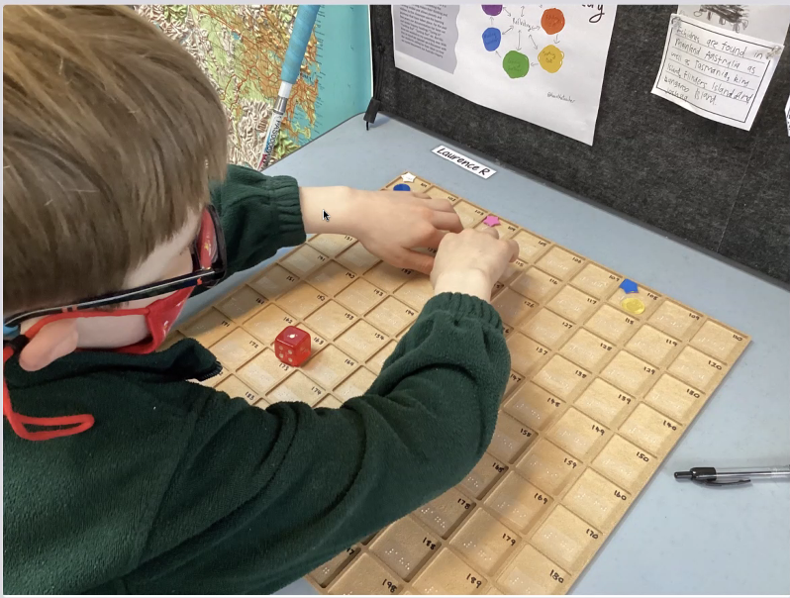
Accessible 3D printing:
- experimenting with Simplify 3DS, a paid slicer with improved accessibility using keyboard commands
- Bambu Lab 3D printers are worth looking at. They aim to address some of the reasons why 3D prints go wrong, as well as allowing multi colour printing.
- blind and low vision students designed their own Christmas decorations for 3D printing. The totally blind students described the decorations and the teacher modelled for them. The students will next be designing their own chocolate moulds.
3D models for concept development:
- attended the workshop with Chancey Fleet and Ann Cunningham on tactile graphics concepts, which addressed how to use 3D models for learning 2D concepts

3. Updates

3.1 Universal Design presentations from Makers Lakers
Student projects website at https://sites.google.com/mlschools.org/makerspaceprojects/home

3.2 Tactile map icons
Now released on Thingiverse at https://www.thingiverse.com/thing:5841775
UPDATE: Paper available at https://dl.acm.org/doi/10.1145/3544548.3581359

3.3 3D4VIP website and catalogue
https://tactiles.eu/
Spinner (in place of a dice) available at https://www.printables.com/.../387221-rotating-braille-dice

4. Next Meeting
15 March 2023
Potential future speakers:
- Sam Reinders on combining 3D prints with conversational agents – April meeting

