ANZAGG 3D Meeting Minutes

Wednesday 21 September 2022

1. Roll call with self-introductions
Meeting chaired by Leona Holloway
12 attendees from Monash University, SPEVI, BLENNZ, Victorian Department of Education, NextSense, NSW Department of Education, SASSVI, NextSense, See3d, NNELS, Yooralla

2. Icebreaker – What have you been designing/printing in the last month?
Printing the universal core communication symbols for a learner with additional meeting. Red triangles with striped texture on side are verbs. Yellow circles with round texture are nouns. Another group member tried making them but was concerned by the size, especially the height. They will ask the teacher what they think. A third group member sent some out a couple of years ago but didn’t hear back from the school. https://www.project-core.com/3d-symbols/
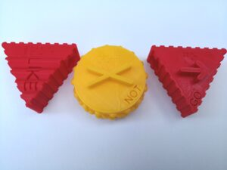
Making a set for goldilocks and the three bears. Chairs, tables and beds in three sizes. They are distributed in a box with the book and a goldilocks doll and felt bears.
Made running tethers for students running in athletics competitions, to regulation. The regulation tethers are difficult to find, with only one manufacturer. The first attempt broke because it was not strong enough in PLA; they will try different printing materials. MakerBot have released a 2022 Guide to 3D Printing Materials: https://pages.makerbot.com/22MaterialsGuide
Had blind students wanting to do coding. Swift playgrounds is the generic coding app by Apple. Lighthouse for the Blind have produced an accessible version – see https://lighthouse-sf.org/2019/01/22/swift-playgrounds-tactile-puzzle-worlds/. Made 3D prints to match the first few tactile graphics so students can step into using the tactile graphics. The student is loving it. Another member has the set of the tactile puzzles, which Vision Australia used to sell. Another group member tried workshop coding with 3x3 grid with Ballyland, which is a good stepping stone towards using Swift Playgrounds.
Bought a FDM Flashforge printer.
Has been making cartoon characters and illustrations from books. They want to see whether students who start with 3D printing continue to use it.
Printing with squishy material (from Bilby 3D Flex, which came with instructions on printing settings). They want to experiment with putting motors, sensors etc inside flexible 3D prints. Another group member said that they tried printing a jellyfish with PLA and it was horrible – they would be interested to try with flexible.
See3D has a project with Clovernook. They printed 500 models relating to 10 African stories (print braille in various languages). Clovernook is now visiting schools for the bind throughout Africa and meeting with teachers and students to find out what they think of the books, which they requested (as opposed to the usual “leftover” books that get donated). All of the books are available as open source online. They are all in uncontracted braille as they are for very young students. E.g. story with elephant, rabbit and pumpkin 3d printed.
Playing with simplified printer settings for accessibility.

3. Guest Speaker – David Harraway, Occupational Therapist @ Yooralla and ComTech assistive tech provision, advice and training
OTs work collaboratively to produce successful solutions with people with disabilities.
Keyguards provide reference points on touch screens. They have square holes. Touchguides have round holes. Keyguides have tactile markers. Keyguards can cost more than $100, but you can 3D print your own for $2. The Volkswitch designer is an online design tool to create keyguards for anything you need – device and holes. https://volksswitch.org/index.php/volks-devices/fully-customizable-3d-printable-aac-keyguard-for-tablets/
Grips, handles and tools are common AT devices:
- Ikea hacks https://ikeahackers.net/category/hacks/3d
- Makers Making Change https://makersmakingchange.com/
David has been making mounts (for easy access and consistency of location) and one-handed gaming controller adaptations (see https://www.printables.com/model/156112-one-handed-xbox-series-xs-controller). There is an accessible gaming collective being set up Australia-wide. Please contact David if you are interested.

4. Guidelines

4.1 3D Guidelines for 3D printing on paper
The guidelines for 3D printing on paper have been adjusted with feedback from one of the group members, who held up some of their 3D printed tactile graphics. They reported that it takes less than 10 minutes to print. They just uses braille paper and cuts it down to the size of the build plate then slips it under the clips on the Ultimaker. There is no need to re-level the bed. They used a bright red filament that contrasts well with the white paper. A member asked how it feels? Another member has tested with touch readers, who have said that it is clear to read but not as pleasant to touch as swell paper. However, it is much cheaper than swell paper and does not require specialist equipment (aside from the 3D printer).

4.2 Icon design guidelines
Guidelines for the creation of 3D tactile maps icons developed by Leona as a result of her most recent research studies have been attached below. Are these useful?
Leona created over 200 prototype icons for parks, playgrounds and shops. These were first tested by sighted people (novice touch readers) to eliminate any icons that were not tactually distinct. The shortlisted icons were then touch tested by 10 sighted and 10 blind people. Successful identification relied on touch perception (including expert use of hand movements), familiarity with the object (which could be affected by congenital blindness, age and cultural factors), and ability to visualise the object (which differed a lot between individuals and also according to mental state). Knowing the context helps to decode the object. The designs were changed and added according to suggestions from touch testers. A total of 33 icons could be identified easily without reference to a key, and a further 34 were selected which could be understood with the aid of a key. Leona will (eventually) release the icons on Thingiverse.
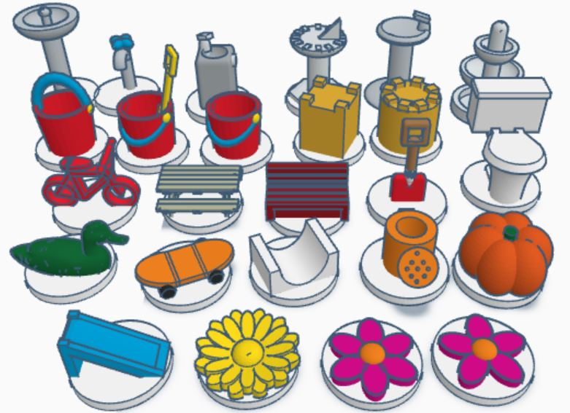

5. Other business
Kimberly Arcand has recently published a book, Stars in your Hand, about 3D printing for astronomy. See https://mitpress.mit.edu/9780262544153/stars-in-your-hand/

6. Next Meeting
The next meeting will be held on Wednesday 16 November.

Design guidelines for the creation of 3D representational tactile map icons
- Icons must be tactually distinct:
- Use objects that are a distinctive shape. Objects that are regular shapes such as rectangular prisms and rounded objects cannot easily be distinguished unless they have very distinctive additional features. For example, a round pizza, domed bicycle bell and rectangular barbeque will be unsuccessful.
- The most important and distinctive features should be near the top of the icon, where they can be more easily accessed by touch. It may be necessary to position the object so that the distinctive features can be felt. For example, a coat hanger is easier to understand when laid flat because the hook is difficult to feel when positioned upright.
- Simplify the object to its bare essentials, removing any extraneous details.
- Exaggerate features that are distinctive. For example, a dog or cat's ears should be exaggerated to assist with identification.
- Flatter icons are more difficult for novice touch readers to recognise than those that are more 3-dimensional in nature.
- Corners and edges should be square or round in accordance with the original object to assist with interpretation. Often this means square corners for man-made objects and rounded corners for organic objects.
- Raised lines and parts are much easier to feel than holes or indents. If an indentation is important, consider outlining it with a raised line.
- Larger icons are easier to feel. 3D representational icons can be succefully identified by touch at a scale of 20mm³, however they can and should be enlarged if space allows, keeping in mind that tactile maps should be no deeper than arm’s length.
- Icons must be spaced apart to allow adequate access for tactile exploration from all sides.
- Icons should be based on concepts that are familiar to people who are congenitally blind:
- Icons should be co-designed with early input from people who are blind.
- Objects that can be hand held are more familiar to people who are congenitally blind than those that are microscopic, too large to reach, rare, dangerous or intangible.
- Do not use visual icons unless they are widely discussed in popular culture.
- When simplifying shapes or exaggerating features, do not use visual stylistic conventions, as these are unlikely to be known by people who are congenitally blind.
- Position icons in their most familiar orientation. For example, a cricket bat should be upright and tilted at an angle as it is held by the batsman.
- Support decoding with context and accompanying information:
- Provide a map title, as knowing the map type reduces the possibilities and assists with association between the object and its meaning.
- If possible, use objects that are all around the same size (hand-held is best) to avoid confusions of scale.
- Provide an accompanying key or legend explaining the meaning of the icons.
- Provide a choice of media, for example incorporate clear print, braille and audio labels alongside the icons.
- Consider the context and user. It is unlikely that a single set of 3D tactile icons can be universally understood. Instead, a range of options may be needed:
- Some icons may need to differ according to culture.
- Consider the expected age of the map users. Some icons differ in their recognition according to generation, for example the typical shape of rubbish bins has changed throughout the years.

