ANZAGG 3D Meeting Minutes

Wednesday 17 November 2021

Roll call
Meeting chair: Leona Holloway
14 people in attendance from Monash University, NextSense, NSW Department of Education, ACT Department of Education, NNELS, Maple Glass Printing, Victorian Department of Education, BLENNZ, SonoKids, Guiding Eyes for the Blind, Mountain Lakes Public Library, Texas School for the Blind and Visually Impaired.

2. Icebreaker - What have you been designing/printing in the last month?
Printer was not working for a week but it was just because it was set for the wrong type of filament. A lot of us have made the same mistake!
Printing models shared at past meetings:
- The milky way from Tactile Universe, where height represents brightness.
- Tactile pie chart from the Build A Better Book Project. Adjusted files are available from the SVRC Thingiverse account.
Using the 3D printer to creating parts for a knitting machine. 3D printing is great for creating parts and tools. Another member printed a Bowden tube clip with a large handle for their Ultimaker because the standard clip keeps falling into the print head.
Designing puzzles for young children with hearing and vision impairments. It has been great getting direct feedback and making puzzles unique for the student.
Printing Leona’s braille and tactile Qwirkle tiles, with separated files for colour printing. (Leona printed them with one colour then used paint pens to add colour).
Planning to focus on 3D printing for STEM content next year, such as the NASA 3D printing models for rockets that come apart. They would also like to look at combining 3D prints with STEM coding kits.
TSBVI students have been using OpenSCAD for last 6 weeks. They are now designing objects like snowmen.

3. Guest Speaker: Tony Koutsonikolas from Maple Glass Printing on glass printing and software solutions for smooth prints.
Maple Glass Printing is a start-up business in Melbourne, where they have created their own process and equipment for 3D printing with glass. See https://www.mapleglassprinting.com/
3D prints are built up in layers. With FDM printers, the layers can be felt. This is not always a good thing, e.g. for braille. Eva commented that “I think for some of our students is that the object and concept need to be clear. So how that translates in the 3D object for blind students can be "textures" need to be clearly distinguishable. Erroneous textures may need to be removed or smoothed.”
Non-planar printing uses layers that are not flat, or printing flat layers with orientation changing. This means that the top surface can be smooth.
Ai Build sell printers with a robotic arm that can change angles to avoid overhangs.
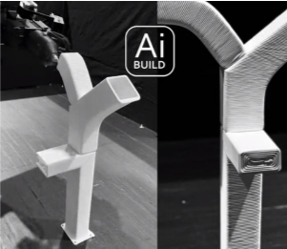
One method of creating non-planar models with a standard printer is using Full Control GCode by Andrew Gleadall. This free software allows you to specify the geometry of the model using direct code. For example, to print a lid you could print the outer wall first then beside the wall, moving inwards slowly.
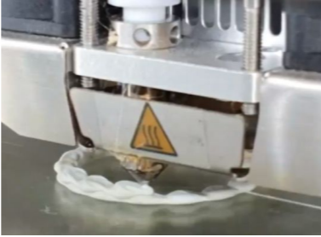
If you want to convert an existing 3D model to non-planar GCode, you can use Slic3r_NonPlanar_Slicing: https://github.com/DrEricEbert/Slic3r_NonPlanar_Slicing Most of the part is printed normally, then the top layer is printed smoothly in a non-planar manner. It could be useful for printing braille top-down?? Any printer can do non-planar printing but you are limited by the space taken by the 3D printing head and carriage. You can buy long nozzles.
Non-direct uses of 3D printing:
- vacuum forming
- mould creation
- part smoothing
For example, Tony 3D printed a jig then used it as a template to cut parts from heat-resistant bricks. Necessary because glass printing requires 900 degrees C.
If your printer is leaving sharp points when it lifts up, you should do a temperature calibration. The temperature may be too high.

4. ANZAGG 3D Printing Guidelines
Published guidelines: http://printdisability.org/about-us/accessible-graphics/3d-printing/

4.1 Updated since last month
- Overview on 3D printing for people who are blind or have low vision – Added a list of 3D printing services and other options if you do not have access to your own printer.
- Labelling 3D prints – Added more details about basements and audio labelling devices.
- Finishing – Preparing 3D prints for touch readers – Added information about 3D printing pens as an option for adding textures, lines and contrasting colour to a 3D print after it is completed; and using 3D Gloop! for joining 3D printed parts.

4.2 Other methods for creating 3D models
New section in progress: “Other methods for creating 3D models”. This section covers handcrafting, ceramics, laser cutting, CNC milling, moulding and casting, and thermoform.
Thanks to members for their contributions to the sections on laser cutting, CNC milling and thermoform. All other members are invited to please take a look and share photographs of your process if you use any of these methods.

5. Other Business

5.1 NASA SSERVI EDI
The NASA SSERVI Equity, Diversity and Inclusion team has been discussing 3D printing, CNC milling and moulding for creation of lunar and space models for inclusive education.

5.2 Pasadena 3D printing meetup
The next Pasadena 3D printing meetup, hosted by Joan Horvath and Rich Cameron, will be held tomorrow, Wednesday 17 November at 7pm Pacific Time / Thursday 18 November at 2pm AEDT. It is an opportunity to bring your projects to share or ask for help with tricky problems. Register at https://www.meetup.com/Pasadena-3D-printing-meetup/events/281602354/

