ANZAGG 3D Meeting Agenda

Wednesday 17 February 2021

1. Roll call
Meeting chaired by Leona Holloway, Monash University
13 people in attendance from Monash Univesity, ACT Department of Education, Victorian Department of Education, TSBVI, BLENNZ, Sonokids, RIDBC and Mountain Lakes Public Library

2. Icebreaker - What have you been designing/printing in the last month?
New designs from members include:
- lots of game pieces to assist with tactile literacy and inclusion, e.g. Catan, boggle cubes, print/braille math tiles, grids for braille tiles. Another member previously made tactile game pieces (indents or bumps) for Connect 4; and a chess set with pegs, however the pieces were difficult to move so a redesign is needed.
- a Perkins Brailler paper feed tray for a one-handed student
- 3D models of castles for history studies. The models were provided alongside tactile graphics.
- A tactile clock printed in two colours for low vision students and has moving clock hands. Bolts, nuts and screws are required for its construction. It is being distributed with a braille book on telling the time with worksheets and tactile graphics.
- a plant cell with removal parts that have been redesigned for touch readers
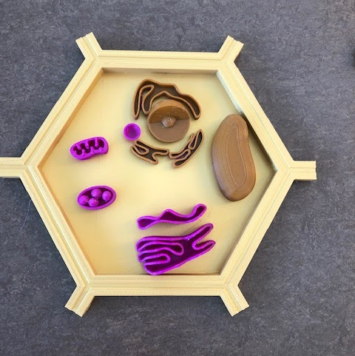

3. Draft Guidelines
Link: http://printdisability.org/about-us/accessible-graphics/3d-printing/
Next section: finishing, i.e. how to prepare your 3D print for blind or low vision users after it comes off the printer. We discussed some initial ideas and experiences:

Smoothing
How do people get rid of sharp edges, for example where there were supports, on top of the model where the nozzle has lifted up, or around the bottom edge where a skirt was removed.
- one member usually picks pieces off with their fingers. They doesn’t usually need sandpaper.
- another member uses pliers to pull pieces off, and a Stanley knife around the base (not recommended!). They also use a rasp or sandpaper when rough parts remain.
- It is not good to use sandpaper because it leaves a visible mark.
- The thin curved blades from Matterhackers were recommended. The full kit is available from https://www.matterhackers.com/store/l/matterhackers-3d-printing-tool-kit-premium/sk/MNUYE0VF. Similar tools can be found by searching for “art knife”.
- Dremel tools were recommended. See Product Categories | Dremel
- For ABS prints, an acetone bath is recommended
- it may make a difference whether supports are removed while the plastic is still warm or after it has hardened. Testing is required!
- Two members use thin craft files for jewellers, also known as mini or needle files.
- A heat gun was suggested but has not been tested.
- Do NOT use an iron (with nonstick paper) as the shape of the model easily becomes warped.
The “iron” setting in Cura runs a hot nozzle over the top layer of the print. This was tested but there was very little difference by touch except that some areas bubbled. It does make the surface less shiny, which is helpful for students with low vision.

Adding colour
Colour contrast is important for students with low vision.
The colour from ink or textas can spread along the printing lines.
For indented print text, you can use a biro or fineliner.
Oil paint is not recommended as it takes days to dry.
Nail polish is good as it adheres well and gives a solid colour.
One member has tried using some paints that she had at home but has not yet tested for water fastness. UPDATE: Acrylic paints look great but they are not water fast.
Waterproof paint pens (with a fine tip) are a very easy, mess-free option.

adding texture
Cura’s “fuzzy” setting is applied to the whole model except the bottom and top layer. It may be useful to indicate organic objects, to distinguish between the top and sides of an object, or for extra grip on handles.
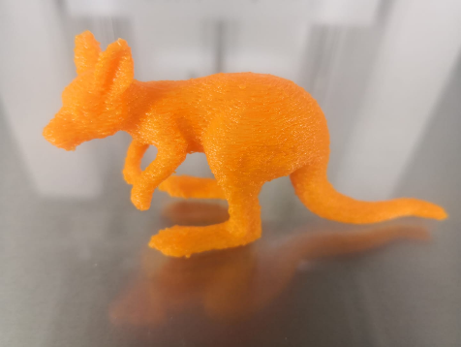
Some members have tried adding textures after printing, for example fake grass for model makers.

4. Guest speaker: Ian Matty, manager of Mountain Lakes Public Library Makerspace
Ian has been using accessibility projects for blind students as a way of teaching sighted students about 3D printing. They have partnered with a school for the blind to help drive design ideas and provide direct feedback on the prototypes. Some of their projects include:
- Pascal’s triangle, bridge puzzle and hex game (to create a marble run). Ian has shared the files for the hex game with us and they have a grant to produce 10 sets for a school for the blind.
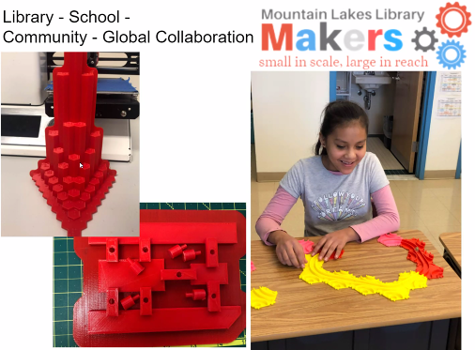
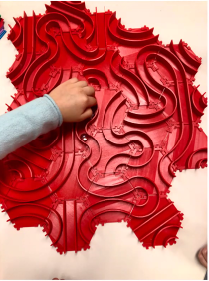
- A maze game that is placed over a touchscreen. After prototyping with 3D printing, they have decided to user laser cutting for faster production.
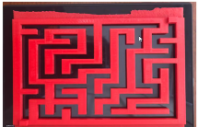
- Tactile books, for example “If you give a mouse a cookie”, “fox in socks” and “brown bear, brown bear, what do you see?”
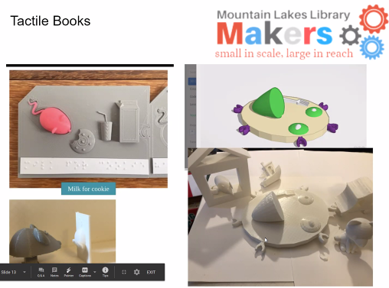
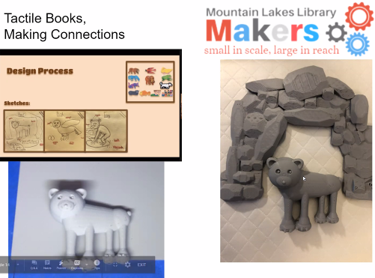
- DNA components (GTAC) that can be connected. They will be used to celebrate DNA Day on April 26.
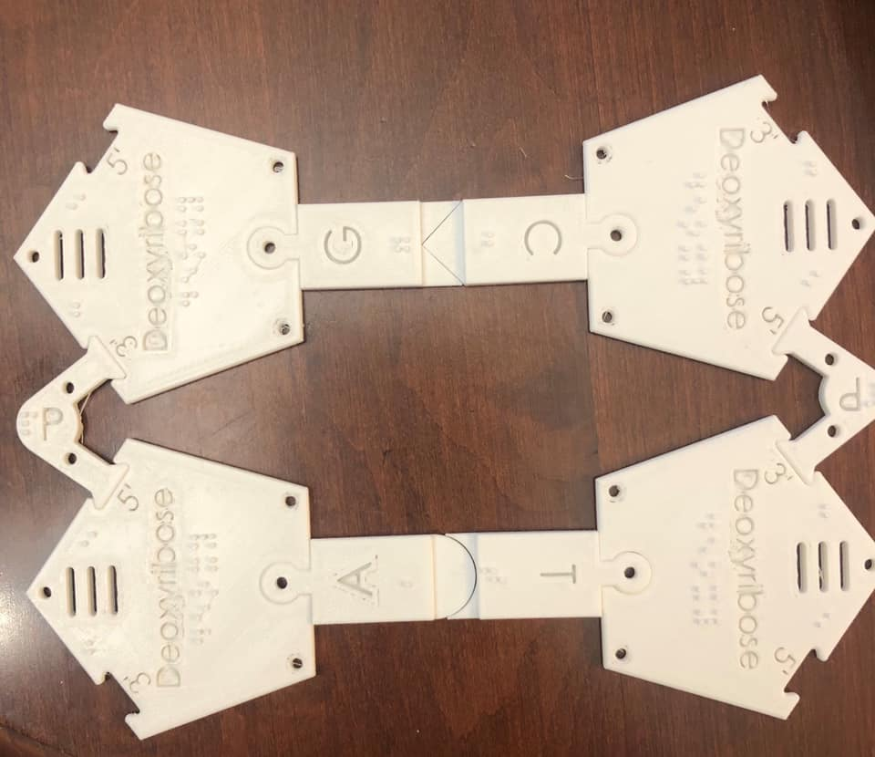
Ian is keen to partner with ANZAGG.
ACTIONS:
- Leona to share her OpenSCAD files and process for braille labels
- Ian may have some ideas for the European project on what information needs to be included in a good database of 3D prints
- Look out for a Lakers Makers Thingivers account, coming soon.

5. Other Business

5.1 TactileImages project and research
https://associationsnow.com/2021/01/new-partnership-lets-the-blind-experience-pictures-through-touch/
”As part of the initiative, a survey of more than 50,000 members of the blind community revealed what photography and art they wanted to experience first. The top three people respondents wanted to experience with the tactile images were Louis Braille, Martin Luther King Jr., and Albert Einstein. The places they wanted to experience were the White House, the Grand Canyon, and the Statue of Liberty. And the events were the moon landing, the civil rights movement, and the September 11, 2001, terror attacks.”
It would be good to do a similar survey here.
Note that some of the models mentioned are already available to 3D print e.g.
- Albert Einstein https://www.thingiverse.com/thing:966908
- Martin Luther King https://www.thingiverse.com/thing:282337
- Grand Canyon https://www.thingiverse.com/thing:409877
- the Statue of Liberty https://www.thingiverse.com/thing:2445539
- New York skyline with twin towers, etc.
In fact, these subjects might lend themselves better to 3D printing than the Tactile Images relief-style graphics.

5.2 SPEVI Conference
Nav Virdi and Leona Holloway presented on 3D printing for education.
Matt Butler and Leona Holloway presented on the ARC Project investigating 3D printing for touch readers.

5.3 3D4VIP Project, Europe
The project held its first meeting in January. Wendy Voorn will lead the project. Their first target outputs are:
- Identify or create the ideal database for sharing 3D print files for touch readers. It should be WCAG compliant and give enough information so that VI students can search for models themselves.
- Guidelines for designers of models for touch readers
- Identify a “top 20” list of models to illustrate the value of 3D printing for touch readers, to be distributed widely to students throughout Europe.

5.4 Nonscriptum
The next 5 lessons on teaching geometry with 3D prints are now available from the nonscriptum website at http://www.nonscriptum.com/geometry. They cover slicing 3D shapes, volume of 3D shapes, conic sections, surface areas and nets

5.5 Certificate in Access Technology
Melissa Fanshawe (University of Queensland) is creating a TAFE level certificate of Access Technology for BLV students from year 10 upwards, with a range of units to choose from. We are aiming to produce two units on 3D printing – why it is important for accessibility and how students who are blind or have low vision can do their own 3D design and printing.

6. Next Meeting
Wednesday 17 March 2021, 11.30am AEST

