ANZAGG 3D Meeting Minutes

Wednesday 18 November 2020

1. Roll call
Meeting chaired by Leona Holloway, Monash University
14 attendees from Monash University, BLENNZ, Sonokids, SASVI, NSW Department of Education, …

2. Icebreaker - What have you been designing/printing in the last month?
A member printed a small white cane but it broke. Some tips for strength:
- Print lengthways so that 3D printed layers are perpendicular to the potential breaking point
- ABS is stronger than PLA
- Increase infill
Another member designed, printed and shared a model of Tower Hill volcanic crater using Terrain2STL.
Some members have met with a group of Occupational Therapy students who looking at designing materials for sex education for students who are blind or have low vision.

3. Draft Guidelines
Link: http://printdisability.org/about-us/accessible-graphics/3d-printing/ for published ANZAGG guidelines on 3D printing for people who are blind or have low vision.
The section on 3D printing by people who are blind or have low vision was updated (again).
Now working on guidelines on software:
- TouchMapper – updated
- Terrain2STL – updated
- 3D face reconstruction – Leona has been testing. Processing is very slow. It may only work with low resolution images.
- df3D - updated
- OpenSCAD – done and checked
- TinkerCAD – done. Checking needed
- SketchUp – done and checked.
- Fusion360 – done and checked. Another member to add an image.
- Netfabb – started. Who can assist with this section?
- Blender - started. Who can assist with this section?
- ZBrush – started. Who can assist with this section?

4. Previous action items

4.3 Hex game
All files from Ian Matty now stored in Teams in the 3D prints > Hex Game file folder. Please consider printing and providing feedback. The game has been designed to encourage inclusion as they are suitable for sighted and blind children to use together. The pieces are designed to make interesting noises as the marble moves.

5. Feature topic: ARC Linkage project on 3D printing
Special guests Matt Butler, Chief Investigator, Monash University and Ruth Nagassa, PhD student
Slides and associated research papers will be made available in Teams. Information and updates on the project can also be found at https://accessiblegraphics.org/research/3dprints/arc/
One member suggested that we research using a key, and people remembering the label and find the texture on a map, or identify the texture.
Another member asked “is there a plan to have the textures stored by category like a library? Where will the recommendations of what to use for what be available?”. Yes, the plan is to recommend a series of textures that can be easily distinguished and recommended uses. The textures will be distributed through TinkerCAD (and other software?), labelled appropriately and described in Round Table guidelines. One member adds textures after printing, e.g. paint with sand or felt glued on. Another member puts real objects in containers, e.g. water in a pond, scrunched up paper in a rubbish bin.
A member asked “Regarding the audio files for the solar system, do you record your own audio, or find it somewhere? Also, are the files stored locally on the Raspberry Pi, or stored online and fetched when needed?” Both approaches have been used – pre-recorded audio stored on the Raspberry Pi or automated audio fetched when needed. There was discussion about the best interface for touch points.
A lot of pre-teaching is required for concept building before 3D models can be used in NAPLAN tests. Currently, these questions are omitted for blind students.

6. Other Business

6.1 Update from DIAGRAM 3D group
Visio in the Netherlands have produced materials for teaching concepts from 3D to 2D, using the perspective of “William Wisenose”. The booklet is in Dutch only.
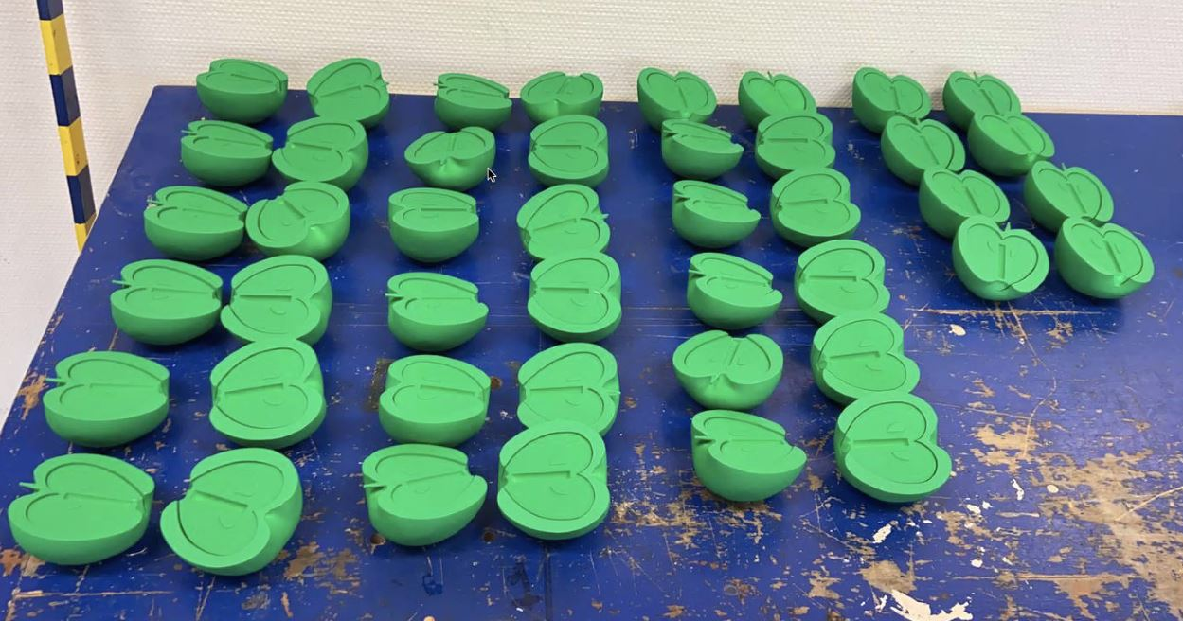
The UBIS website is unlikely to go live as there is no further funding for the project.
ACTION: Leona to contact Visio to find out what other materials were planned to be shared on the UBIS website and request access to any that might be of interest.

7. Next Meeting
Wednesday December 16 at 11.30am AEST.
Feature topic: What to design/print for the curriculum

