ANZAGG 3D Meeting Minutes
Wednesday 15 July 2020

1 Roll call
Meeting chaired by Leona Holloway
13 people in attendance from Monash University, SASVI, BLENNZ, TSBVI, ACT Department of Educaiton, NSW Department of Education, Sonokids

2. Icebreaker - What have you been designing/printing in the last month?

Topographic maps
Lots of people have been printing topographic maps.
- Topographic models and landmarks, e.g. Blue Mountains, Three Sisters, Sydney Opera House, Sydney Harbour Bridge
- Australian topographic map
- Topographic map of the Adelaide Hills. Recently acquired a new 3D printer.
Topographic maps can be rough to touch. Tips?
- Try printing on the side.
- One member has printed with ABS and smoothed with acetone bath but you lose detail

Street maps
Leona and Jim have been working on elements in TinkerCAD to create street crossings.
TinkerCAD collaboration only lasts for 2 weeks, however TinkerCAD classroom can be used to collaborate on projects.
Another member has tried designing road crossings too for O&M purposes.

Other
One member ran a project with year 5 students to design 3D models for VI students
A 3D model of a guillotine was requested by a teacher.
Perkins Brailler finger guide requested by an Occupational Therapist.

3. Special guest - Jim Allan, Texas School for the Blind and Vision Impaired & DIAGRAM 3D working group
DIAGRAM Center is a subsidiary of Benetech, working on accessible graphics. Jim chairs the 3D working group, which is a forum for information sharing and development of standards for 3D printing for accessibility. See http://diagramcenter.org/3d-printing.html. The group meets fortnightly and all are welcome to join. Shared documents are stored on a Google drive – Jim has sent an email inviting ANZAGG 3D members to collaborate.
One of DIAGRAM’s projects is ImageShare, a repository to share 2.5D and 3D files with tags, accompanying lesson plans, grade level, teacher comments, etc. It is not yet ready for public use but they are taking submissions. See https://imageshare.benetech.org/topic/new/.

4. Draft Guidelines
A member provided a document that they produced for inclusion in the ANZAGG guidelines. Leona to check through and add anything new to the shared guidelines. Thank you!

4.1 When to use 3D printing & Where to find 3D printing designs
These two sections published on the ANZAGG website. However, they should be treated as living documents, with further input still welcome.

4.2 Labelling - further testing of touchsee.me
Further testing has been done. Touchsee.me gives good braille dots, including contractions but the base is very thin. You need to add extra base if printing on the side.

4.3 UBIS guidelines
Universal information containers for Blind and Visually impaired Students – funded by Erasmus with participation by Blista Marburg (Germany), Bundes (Austria), CDV (Luxembourg), Visio (Netherlands) and LVR (Germany) http://www.ubis-project.eu/
Wendy Voorn shared the UBIS guidelines with the DIAGRAM group. They can be found in the DIAGRAM 3D google drive. There are a lot of similarities with our guidelines. Some minor ideas from UBIS have been incorporated into ANZAGG guidelines. The main point of interest is their labelling solution: they designed five symbols to serve as both key and “this way up”, to be used in combination with a QR code on the “Basement” – a swell paper graphic with labels, outline of the model base and QR code. The UBIS website will include 3D models with accompanying basements.
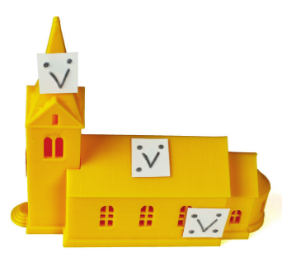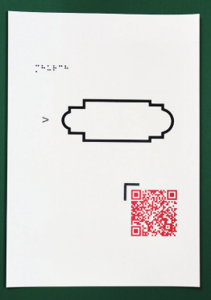
A member asked whether these guidelines are universal? We would need to evaluate the guidelines and make a decision to adopt (or adapt) them for use in Australia and New Zealand. The DIAGRAM group to do the same for the US.
A member showed some models that they have been producing. Students preferred labels to be in braille on the model, however this only works for short text and models with relatively flat areas.
A member asked how to put braille labels on curved surfaces?
- One member uses braille on dymo label that is then stuck onto the 3D model.
- Another member uses Fusion 360 to place braille on curved surfaces. However, every dot needs to be moved individually so it is time-consuming. Also, if the curve is too complex (for example on a model of the brain or heart), it become too hard to read the braille. He added that Fusion 360 is difficult to learn but worth the effort.
One member has produced some 3D printed sheets similar to the UBIS basements with the outline of the 3D model and braille labels around the outside.

5. Other Business
None.

6. Next Meeting
Monday 17 August
Topic for discussion – Distribution and feedback for (interactive?) 3D models for education

