(Accessibly) Mapping the Werribee Mansion and Gardens
Round Table Conference, 2023
Werribee Park is Melbourne’s most significant tourism destination on the western side of Melbourne and is part of a major tourist precinct. Werribee Park Mansion is of architectural significance for the number of intact buildings and features constructed during the late 19th century, under the ownership of the Chirnside family. The mansion, with its fine interiors and some original furniture, is one of Australia’s grandest and most finely designed English country houses. Since its construction in the 1870s, little has been altered internally and externally.
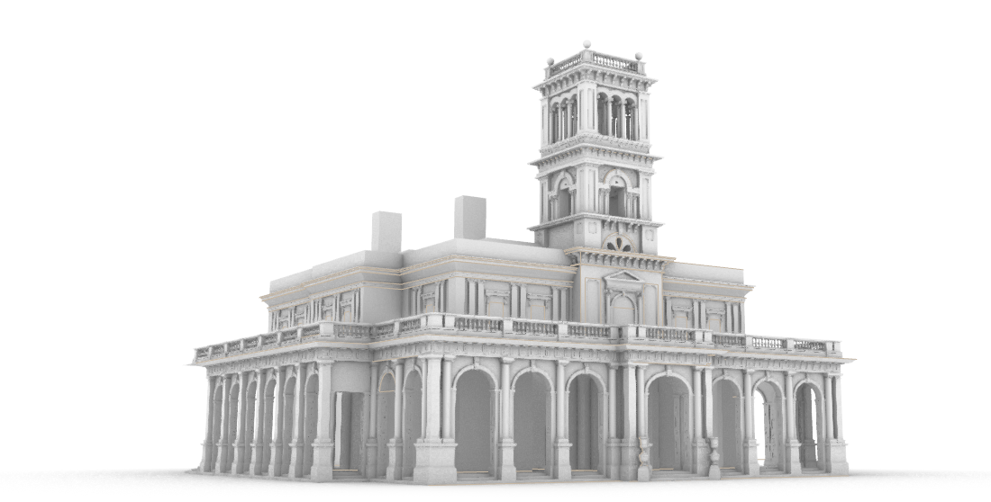
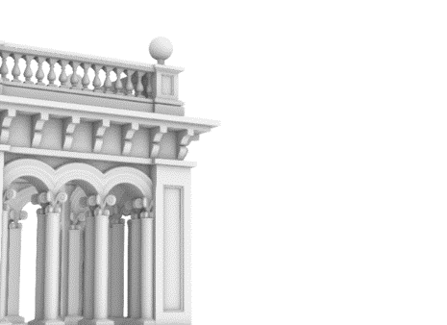
A range of multisensory experiences are already available for visitors to Werribee Mansion who are blind or have low vision. Weekly guided touch tours offer visitors the opportunity to experience a descriptive tour of the mansion. Blind and low vision visitors have the opportunity of hands-on access to the mansion’s many historic items, such as beaded foot stools in the Drawing Room and a unique moustache cup in the library.
In a partnership between Parks Victoria, Monash University and the University of Sydney, we are developing a multimedia map of the mansion and park for display in the main foyer, for inclusive use by all visitors including those who are blind or have low vision. The map will use a combination of print, braille, 3D models, 3D icons and audio touch buttons to provide an overview of the grounds and its many offerings. The map will be accompanied by a larger model of the Mansion to enable touch access to its architectural features. These new materials will provide a welcome supplement to Werribee Mansion's existing attractions for visitors who are blind or have low vision.
The aims of the project are:
- To provide visitors who are blind or have low vision learn more about the architecture and grounds;
- To support the guided touch tours for people who are blind or have low vision;
- To provide an inclusive experience for all visitors;
- To demonstrate that Werribee Mansion is committed to providing an inclusive experience for all visitors
This project builds on the work of the ARC Linkage Project investigating 3D printing for accessibility, which was supported by Round Table and other partners. This work provided evidence that 3D maps are easier to understand than equivalent tactile graphics [1], that accessible public 3D maps are helpful and appealing to both sighted and blind visitors, and that many tactile icons can be understood without reference to a key [2,3]. It also builds on our prior work into the aesthetics of touch materials created using modern maker technologies [4,5,6]. All of these strategies will be brought together in the Werribee Mansion mapping project as a best practice example of accessibility for inclusion at a popular tourist destination.
Round Table members are invited to touch, listen and look at prototype materials to provide feedback to help shape the final product. In particular, we are interested in exploring the balance between accessibility and aesthetics through materiality.
For further information, please contact:
- Leona Holloway, Inclusive Technologies, Monash University: leona.holloway@monash.edu
- Dagmar Reinhardt, Architecture, Design and Planning, University of Sydney: dagmar.reinhardt@sydney.edu.au
- Robyn Dean, Customer Service, Parks Victoria: robyn.dean@parks.vic.gov.au

References
[1] Holloway, L., Butler, M., & Marriott, K. (2018). Accessible Maps for the Blind: Comparing 3D Printed Models with Tactile Graphics. CHI Conference on Human Factors in Computing Systems, Montreal, Canada. https://doi.org/10.1145/3173574.3173772
[2] Holloway, L., Marriott, K., Butler, M., & Reinders, S. (2019). 3D printed maps and icons for inclusion: Testing in the wild by people who are blind or have low vision. The 21st International ACM SIGACCESS Conference on Computers and Accessibility, Pittsburgh, PA, USA. https://doi.org/10.1145/3308561.3353790
[3] Holloway, L., Butler, M., & Marriott, K. (2023). TactIcons: Designing 3D Printed Map Icons for People who are Blind or have Low Vision. CHI Conference on Human Factors in Computing Systems, Hamburg, Germany. https://doi.org/10.1145/3544548.3581359
[4] Holloway, L., Marriott, K., Butler, M., & Borning, A. (2019). Making Sense of Art: Access for Gallery Visitors with Vision Impairments. CHI Conference on Human Factors in Computing Systems Glasgow, Scotland, UK. https://doi.org/10.1145/3290605.3300250
[5] Reinhardt, D., Sonne-Frederiksen, P. F., Solberg, T., Sarfelt, L. J., Christensen, B., & Biagi, M. (2019). Reading with your Hands: Robotic Braille and Tactile Narratives. The Architecture School, Aarhus, Denmark.
[6] Reinhardt, D., Holloway, L., Larkin, N., & Silveira, S. (2022). Tactile Oceans – Enabling Inclusive Access To Ocean Pools For Blind And Low Vision Communities. CAADRIA 2022 International Conference for The Association for Computer-Aided Architectural Design Research in Asia, Sydney, Australia. https://caadria2022.org/wp-content/uploads/2022/04/85-1.pdf

