Round Table Conference 2022 Workshop 4:
Techniques for creating accessible graphics
Australia and New Zealand Accessible Graphics Group (ANZAGG)
Workshop notes

Workshop outline
Tactile graphics
- Dynamic Tactile Display - Greg Stilson (APH)
- Magnatab - Leona Holloway (Monash University)
- Tactplus embosser - Peter Cracknell (Quantum RLV)
- DIY maps - Angela Reynolds (Guide Dogs NSW)
- Thermographic technique - Bob Marek (Hungry Fingers) & Marcin Matys (TEXTURE)
- Braille embossing powder - Leona Holloway (Monash University)
- CNC milling - Nick D’Souza & Sam Boswell (NextSense)
Description and audio labels
- Invicta - Rajat Prakash & K. Sriram (Continual Engine)
- Creating QR codes - Leona Holloway (Monash University)

Housekeeping
- Please ask questions
- But don’t use the chat
- Have your supplies ready:
  - Blindfold
  - Shoe box or A4 piece of paper
  - Cardboard cutout shapes (squares, triangles, circles, rectangles)
  - Small containers (matchbox, pill bottle, pill container)
  - Scissors
  - Sticky tape
  - O&M Talking Compass (iPhone)
  - Smartphone with QR code reader
  - Printer

Dynamic Tactile Device – Greg Stilson, American Printing House for the Blind (APH)
Email: gstilson@aph.org
APH has partnered with HumanWare to develop the DTD and DOT INC to provide the tactile technology.
The Dynamic Tactile Device will be the first device capable of displaying multiple lines of standard braille and tactile graphics on the same surface.
Goals:
- greatly reduce time to fingertips for textbooks
- provide a consistent impromptu learning option
- improve spatial understanding
- create a medium for STEM content access
- introduce a new, reduced cost refreshable braille tech
Where are we now and where are we going?
- Initial design UX sessions have been completed
- Design underway
- Software development has started
- More UX testing will happen regionally in 2022
- Hope to have product ready by end of 2023

Magnatab magnetic drawing board – Leona Holloway, ANZAGG
Contact: leona.holloway@monash.edu
- Affordable, light, easy to use
- Encourages tactile drawing
- Suggested for teachers & O&Ms
- Search for “magnatab” or “magnetic tablet” to buy online
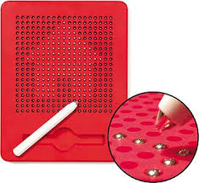

Tactplus – Peter Cracknell, Quantum RLV
Emboss Braille and images directly from your computer onto Thermal Technology and Capsule Paper. By heating the paper, Braille and graphics can be produced with only 1 step.
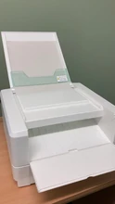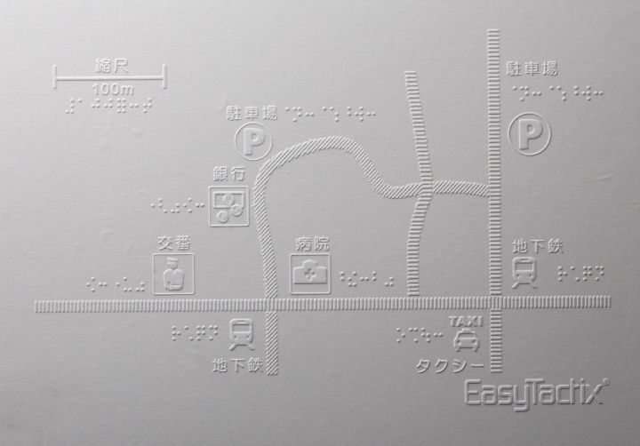
https://www.quantumrlv.com.au/collections/tactile-graphics/products/tactplus-braille-and-graphics-embosser

DIY Maps – Angela Reynolds, Guide Dogs NSW/ACT
Goal: To make a tactile map of your bedroom under blindfold.
Materials list for activity at home:
- A blindfold (scarf, sleep shades, or beanie) Or just close your eyes, but try to keep them shut.
- An empty shoe box or A4 piece of paper
- Cardboard cutout shapes - small squares x 3 (4x 4 cm), rectangle x 1 6 x 4cm, 2 circles (4 x 4 cm), 2 x triangles 4 x 4 cm)
- 2 o r 3 small containers such as match box, medication bottle, packet of panadol,
- A pair of scissors
- Sticky tape
- O&M Talking Compass (iPhone)
To create a simple tactile map of a bedroom start by determining cardinal directions so each wall can be labelled. Use the O&M talking compass to determine north, east, south & west.
Use a variety of shapes with different textures - each shape and texture can then represent a particular piece of furniture in a room.

Thermography – The power of thermographic powder - Bogusław ‘Bob’ Marek - Hungry Fingers & Marcin Matys – TEXTURE, Poland
Edward Anczurowski developed Braille thermographic powder designed specifically for tactual exploration of graphics.

Why (bother with) tactile graphics?
Given the chance, appropriate tools and training, congenitally blind children and adults can make tactile drawings for leisure and use it in education.

2. What is available?
Some more popular methods for producing tactile graphics include swell paper, braille embossers, UV printing, thermoforming and 2.5D printing.
Other methods include die stamping (embossing / debossing).

3. What is thermography?

4. Thermographic printing – the process
The principles of thermography are extremely simple. Thermographic powder is applied to the surface of a printed sheet and the surplus is removed, with the powder adhering only to the wet ink. Thermographic powder has the characteristic, when heated, of melting and expanding in volume slightly to form a raised texture or lines, very similar to that produced by embossing.

5. Thermographic powders. Different options for different effects
Thermographic powders differ in their characteristics.
a. Granulation size:
highest grade (coarse) - for higher raise
finest grade – for minimal raise and extra thin lines
b. Colour or colourless
c. Accept additives for special effects e.g. glitter

6. Thermographic printing vs other technologies. Feedback from blind users
Thermographic printing can achieve a high quality but it is not widely used. the method is economically justified only for production of tactile graphics on a larger scale, not single copies.
Advantages:
- Excellent quality
- Clear lines, textures
- Clear Braille
- Durable
- Pleasant to touch
- Possibility of passing graphics through Braille embossers
Weaknesses, things to be careful about:
- One height of all lines and textures
- Braille – labels rather than long texts
- Caution and experience needed during production with thermographer (control of parameters – choice of paper, temperature, humidity, speed of conveyer belt)

Further references and contact details
The authors would like to thank:
- Powderarts www.powderarts.com
- Faust Thermographic Inc. http://www.faustusa.com
- Carlo Gasperini www.gasperini.it
- Sunraise Inc. https://sunraise.com
for permission to use materials from their websites in our presentation.
If you would like to ask some questions or send comments, please write to: forblindkids@gmail.com
For information about introducing learners with congenital blindness to tactile graphics please visit www.hungryfingers.com.

Braille embossing powder – Leona Holloway, ANZAGG
Braille embossing powder offers a manual method for gaining a similar result to thermography.
Purchase braille embossing powder along with an embossing pen.
- Trace the lines or braille dots that you want to emboss with the pen.
- Sprinkle on the embossing powder. Shake off any excess powder and collect it for your next use.
- Heat gently with a heat gun.
Other tactile line-making tools to try at home:
- Pen pressed firmly on paper (with soft backing)
- Pen pressed firmly on plastic sheet protector (with soft backing)
- Dressmaker’s tracing wheel
- String soaked in glue
- PVA glue (mixed with flour, baked on low heat)
- Wiki stix - commercial or make your own by soaking string in melted crayons
- …
Which is easiest to use? Which gives the best result?

CNC machining – Nick D’Souza and Sam Boswell, NextSense
Rapid prototyping and manufacturing is very accessible for people and organisations now as machines are getting cheaper and knowledge is more accessible.

What is CNC machining?
CNC stands for Computer numerical control, a way to pre-program a machine to carry out a set of instructions.
3D printers and CNC machines use G-Code to program movements and other instructions.
CNC is subtractive manufacturing, so material is being removed from a stock piece to produce a final product. You can find machines that use a variety of different tools to achieve this: mills, lathes, plasma cutters, water jets, etc. You can produce objects from a variety of materials, including, timber, plastic, metals, foams etc.

CNC milling process
- Design done usually in CAD (3D) or vector graphic (2D) software.
- CAM software is used to produce G-Code
- Machine software uses G-Code to control tool movement.

CNC milling versus 3D printing
CNC milling | 3D printing
Subtractive manufacturing | Additive manufacturing
High waste | Low waste
Wide range of materials | Limited materials (unless using expensive machines)
High barrier to entry | Relatively low barrier to entry
Large format | Smaller format
Overhangs not possible (unless using specialist machines) | Overhangs possible (and other complex shapes)

Applications for people who are blind or have low vision
- Topographic maps
- Tactile game board
- Tactile signs

Invicta: An AI-powered platform for Image Accessibility – Rajat Prakash and K. Sriram

What Accessibility Problem Does Invicta™ Solve?
- STEM content is largely inaccessible for a billion people who have visual impairments or learning disabilities
- 90%+ of students with visual disabilities stop pursuing STEM disciplines after junior school
- Despite availability of screen readers, STEM content accessibility is an expensive and manual effort
- Making one STEM textbook accessible costs between $20k to $150K, and takes anywhere from 1 to 6 months to complete
- Increasing regulations regarding accessibility compliance make this a priority for businesses
Invicta™ is an innovative world-class Vision platform that automates image accessibility by leveraging a spectrum of AI techniques.

Automating High Quality Image Alt Text with AI + Expert-In-The-Loop
Image to Alt Text: AI-powered engine that automatically generates high-quality alternative text (alt text)
Diverse Discipline and Images: Deep expertise in a wide range of discipline including Chemistry, Physics, Math, Engineering, Life Science, Computer Science, Accounting, and other diverse images across many disciplines
Section 508/WCAG Compliant: Trained on a multitude of images, InvictaTM offers a reliable alt text authoring platform in full compliance with Section 508 and WCAG accessibility guidelines
Expert-in-the Loop: Enables the accessibility expert or faculty play the role of a reviewer, and make custom changes

Chemistry examples
The figure illustrates a chemical reaction containing 2 reactants and 1 product. The first reactant is a carbon chain with the following structure: C H 3 C H 2 C, double bond, C H 2. The third carbon atom is single bonded to C H 3. The second reactant is H B r. The reaction takes place in presence of peroxide. The product is a carbon chain with the following structure: C H 3 C H 2 C H C H 2 B r. The third carbon atom is single bonded to C H 3. There is a callout states an asymmetric center.
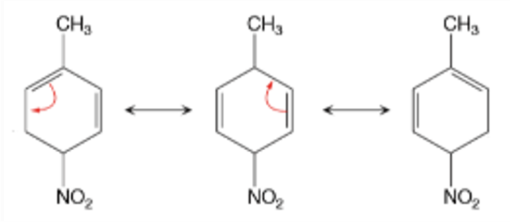
The figure illustrates 3 resonance structures of a molecule. The first structure is as follows: a 6-carbon ring in a vertical orientation. A double bond is present between C 2 and C 3, C 6 and C 1. C 1 is single bonded to C H 3. C 4 is single bonded to N O 2. There is a curved arrow from double bond between C 6 and C 1 to single bond between C 4 and C 5. The second structure is as follows: a 6-carbon ring in a vertical orientation. A double bond is present between C 2 and C 3, C 5 and C 6. C 1 is single bonded to C H 3. C 4 is single bonded to N O 2. There is a curved arrow from double bond between C 2 and C 3 to single bond between C 1 and C 2. The third structure is as follows: a 6-carbon ring in a vertical orientation. A double bond is present between C 1 and C 2, C 5 and C 6. C 1 is single bonded to C H 3. C 4 is single bonded to N O 2.

Physics examples
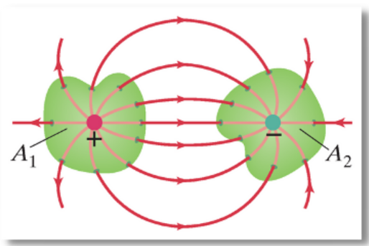
The 2 surfaces are placed side by side at a distance from each other. The surface on the left has an area labeled A subscript 1 and has a positive point charge at the center. The surface on the right has an area labeled A subscript 2 and has a negative point charge at the center. Electric field lines go out radially left to right from the positive point charge positive and come in radially on the negative point charge.
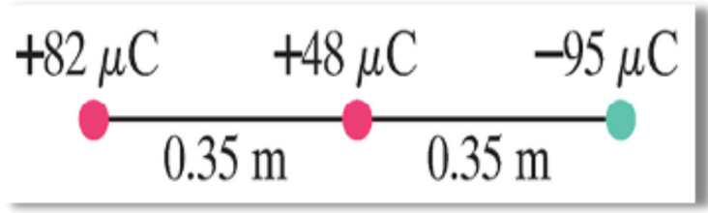
The positive charge labeled 82 mu C is present on the left. The positive charge labeled 48 mu C is present at the same horizontal level as positive charge labeled 82 mu C and at a distance of 0.35 m from the positive charge labeled 82 mu C. The negative charge labeled negative 95 mu C is placed on the right of positive charge labeled 48 mu C and at a distance of 0.35 m from the positive charge labeled positive 48 mu C.

Engineering example
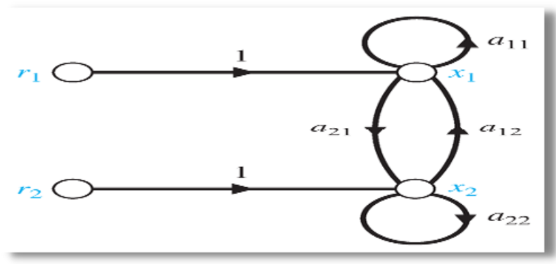
4 summing points are present. Input 1 is given as 'R subscript 1'. An arrow labeled '1' from summing point 1 points to summing point 2. An arrow labeled 'a subscript 11' from summing point 2 points to itself. Output 1 is given as 'x subscript 1'. Input 2 is given as 'R subscript 2'. An arrow labeled '1' from summing point 3 points to summing point 4. An arrow labeled 'a subscript 22' from summing point 4 points to itself. Output 2 is given as 'x subscript 2'. An arrow labeled 'a subscript 21' from summing point 2 points to summing point 4. An arrow labeled 'a subscript 12' from summing point 4 points to summing point 2.

Mathematics example
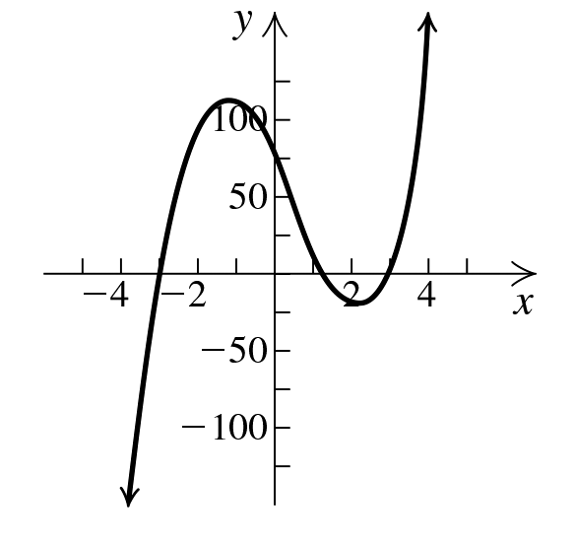
The horizontal axis is labeled as x and ranges from negative 6.0 to 6.0 in increments of 1.0 unit. The vertical axis is labeled as y and ranges from negative 150.0 to 150.0 in increments of 25.0 units. The curve enters the viewing window at approximately (negative 4.2, negative 150.0) and rises to intersect the x axis at approximately (negative 3.1, 0). The curve further rises to a maximum at approximately (negative 1.4, 121.2). The curve drops to intersect the y axis at approximately (0, 80.4). The curve further drops to intersect the x axis at approximately (1.4, 0). The curve continues to drop to a minimum at approximately (2.4, negative 27.8). The curve rises to intersect the x axis at approximately (3.2, 0). The curve further rises till it exits the viewing window at approximately (4.4, 169.6). The equation of the curve is y equals 5 x cubed minus 7 x squared minus 52 x plus 72.

Table example
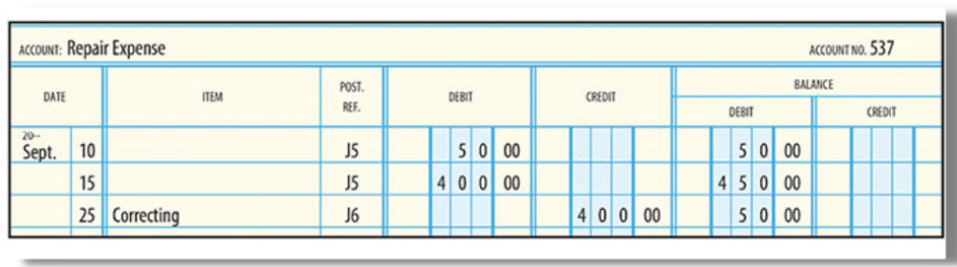
HTML
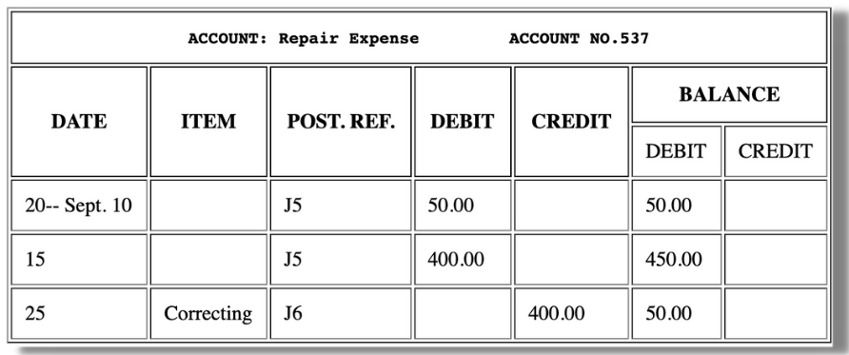
Alt text:
Statement 1. This statement shows ACCOUNT: Repair Expense, on the left hand side of the statement. ACCOUNT NO. 537, on the right hand side of the statement. The statement consists of 6 columns and 3 rows. The headings of the columns, from left to right are as follows: DATE, ITEM, POST. REF., DEBIT, CREDIT, BALANCE. The Date column is subdivided into two columns. The BALANCE column is subdivided into two columns, namely DEBIT and CREDIT. The entries are as follows: Row 1. Date First column, 20-- Sept. Second column, 10. POST. REF., J5. DEBIT, 50.00. BALANCE DEBIT column, 50.00. Row 2. Date Second column, 15. POST. REF., J5. DEBIT, 400.00. BALANCE DEBIT column, 450.00. Row 3. Date Second column, 25. ITEM, Correcting. POST. REF., J6. CREDIT, 400.00. BALANCE DEBIT column, 50.00.

Our current clients and services model
We work with 3 of the top 4 global publishers including Pearson and Macmillan, and leading US higher education institutions (universities and colleges).
Clients can partner with us in two ways:
- Invicta™ Alt Text Services (rates provided per image along with volume-based discounts)
- Invicta™ API subscriptions (Chemistry, Mathematics & Accounting/Finance table Images)
Email us at contact@continualengine.com to learn more about Invicta™ or visit invicta.continualengine.com.

Creating a QR code activity
- Copy a web address that you would like to link to
e.g. Wikipedia page, Google doc, https://printdisability.org/
- Go to https://www.the-qrcode-generator.com/
- Paste the URL
- Test - scan the QR code with your smartphone QR reader
(optional)
- Download or copy the QR code
- Print
- Cut and paste onto a tactile graphic or 3D model

Let’s continue the conversation!
Australia and New Zealand Accessible Graphics Group (ANZAGG)
http://printdisability.org/about-us/accessible-graphics/
Listserv http://www.freelists.org/list/accessiblegraphics
Facebook group https://www.facebook.com/groups/ANZAGG

