Braille and Large Print Services
2022 Round Table Conference
3D Printing for Inclusive Services
Kim Barber
Leanne Tucker
Navkaran Virdi

What is Braille and Large Print Services?
Braille and Large Print Services (BLPS) is an alternate format production library within the NSW Department of Education creating accessible resources for students with vision impairment.
BLPS also supply students with equipment essential in assisting them to produce classwork and examinations. We have several different types of Braillers:
- Regular manual brailler
- Soft Touch brailler – reduces key force requirements and is useful for younger students and those with limited hand strength and dexterity
- Unimanual brailler – gives students the ability to produce Braille with only one hand
- Brailler with extension keys – used to reduce the required keyboard hand span from 7" to 4" and useful for students with limited hand strength and dexterity
- Electric brailler – reduces key force requirements allowing a student with limited hand strength and dexterity to braille quickly and more comfortably.
In addition, we also supply Tactile Drawing Kits, Braille Rulers and Protractors and Bold Line Exercise books in a variety of sizes for students with low vision.

Who are our clients?
BLPS provides resources for 1200 students with vision impairment across the state of New South Wales and is one of the largest producers of alternate format materials in the Southern Hemisphere.
File resources are also shared with external organisations such as Catholic Education and independent schools.
25 Vision Teams comprising of 225 Itinerant Support Teacher-Vision (ISTVs) access Oliver, the online library, to borrow books for students. We currently have 550 borrowers registered on our Library site.

Alternate Formats

The Braille Production Team
The Braille Production Team consists of 10 transcribers, 2 proof readers and a Coordinator of Braille Services.
The Team produces a range of literary and technical curriculum texts in Braille including text books – primary and secondary, novels and early readers.
They also produce tactile graphics by analysing individual graphics for adaptation and incorporating modifications to ensure easy and accurate interpretation by students.

Primary Textbook
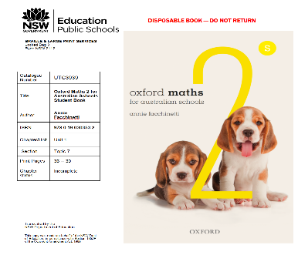
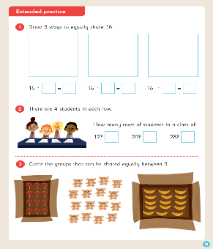
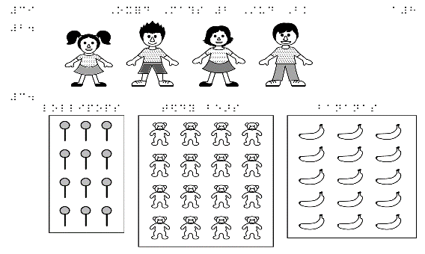

Secondary Textbook
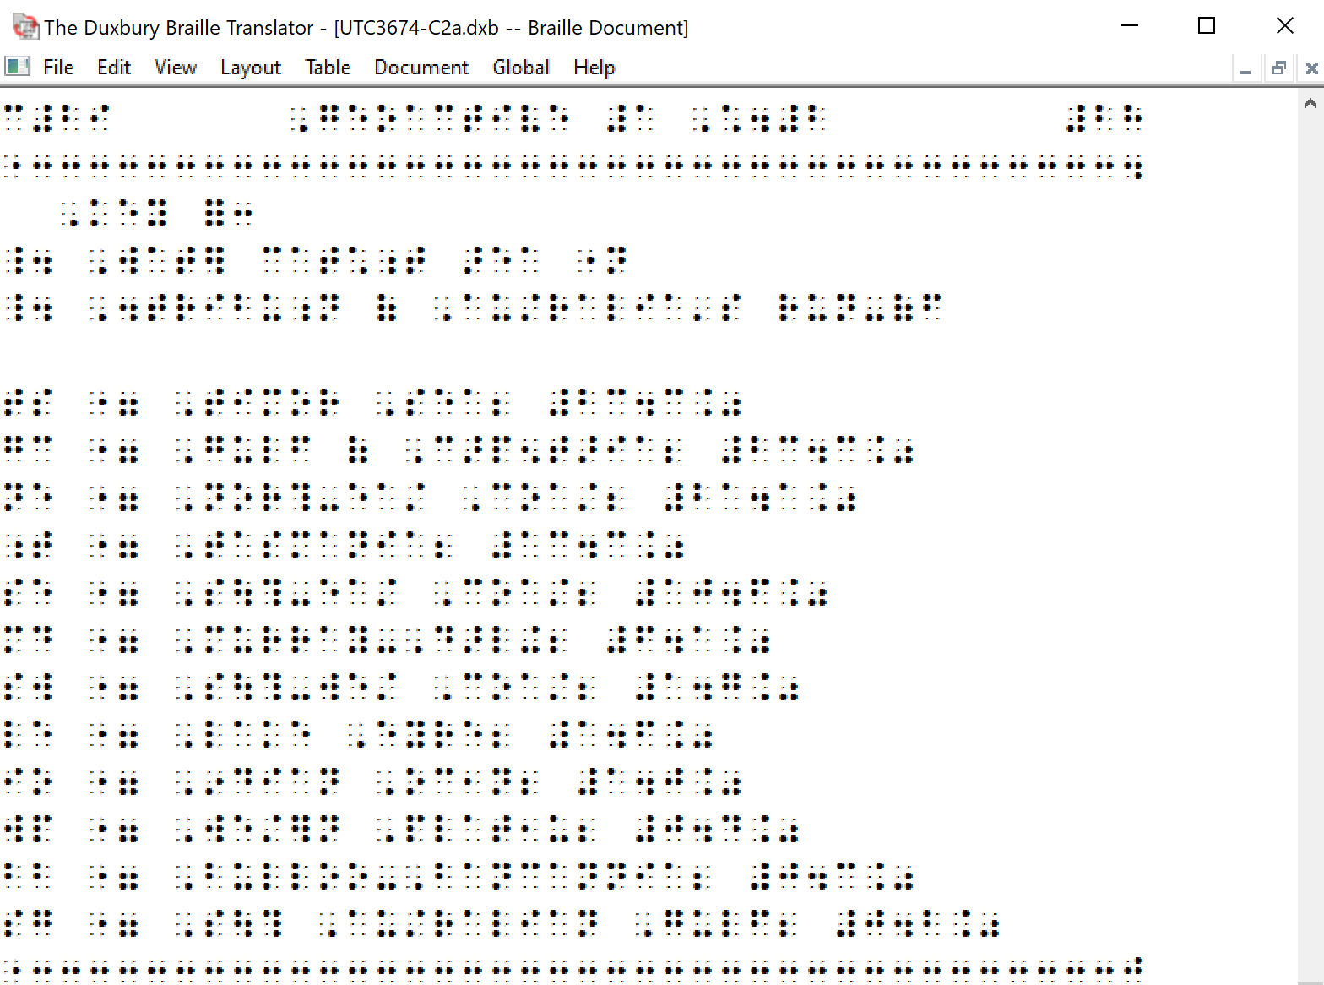
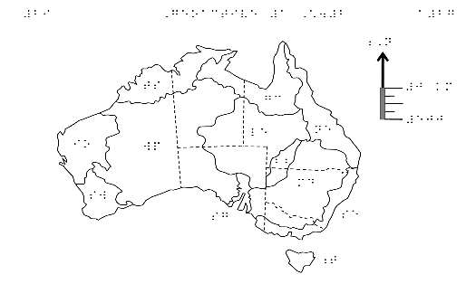
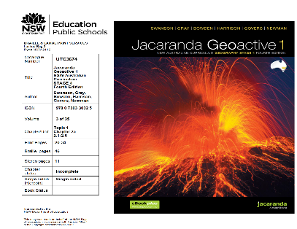
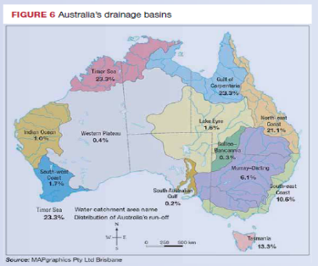

Novel
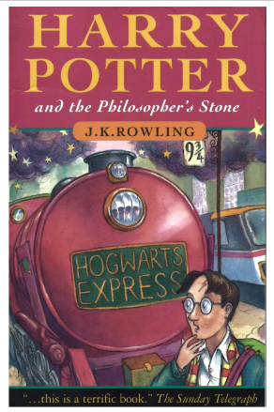
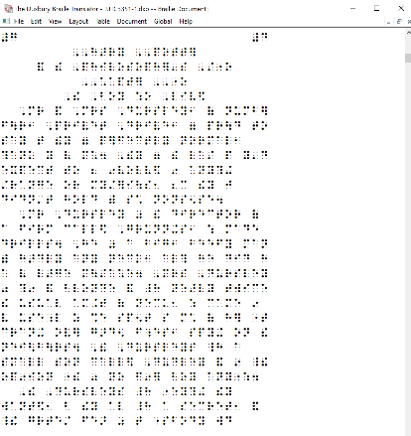

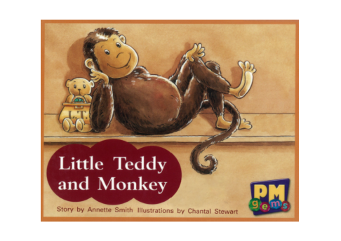
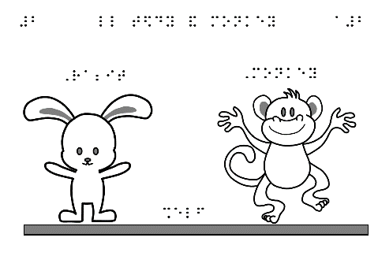
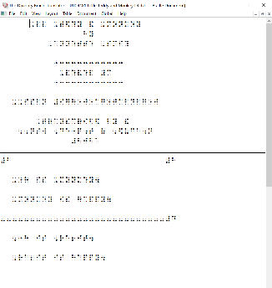
Early Reader

Braille texts are produced in a number of formats which fit the requirements of students:
- Early Readers are produced in A5 size with double line spacing
- Novels are produced in A4 size in single sided or interpoint braille depending on the development of the student
- Textbooks are produced in either Braille Size or A4 to accommodate differing amounts of text

New Developments

Accessible MS Word documents with Alt Text
As well as being braille transcribers and graphic artists, the Braille Team added the creation of accessible MS Word documents with companion Graphics Booklets to their repertoire last year in response to developing student needs.
The advent of the 2019 pandemic saw a massive shift in the delivery of education in NSW with an emphasis on remote learning and BLPS has moved with that shift with the introduction of accessible Word documents that can be easily read by screen readers. The electronic files are shared with teachers and students and contain Alt Text for graphics with a description and reference to corresponding pages in the companion Graphics Booklet.
Students were able to be supported during home learning by parents/carers as the Word documents were accessible to all.
The start of 2022 has seen a large increase in the number of accessible Word orders as students embrace the new format and carry it over into the school setting.
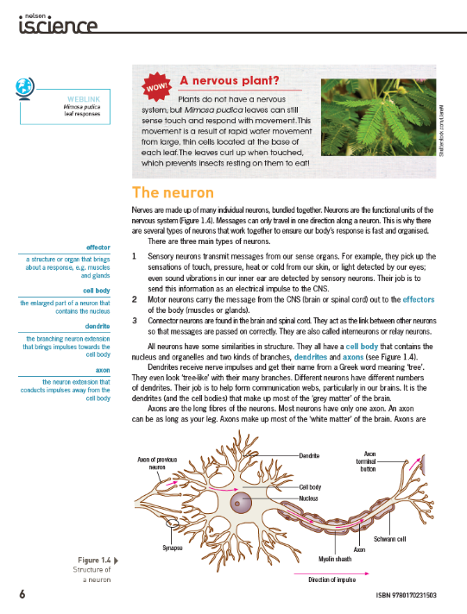
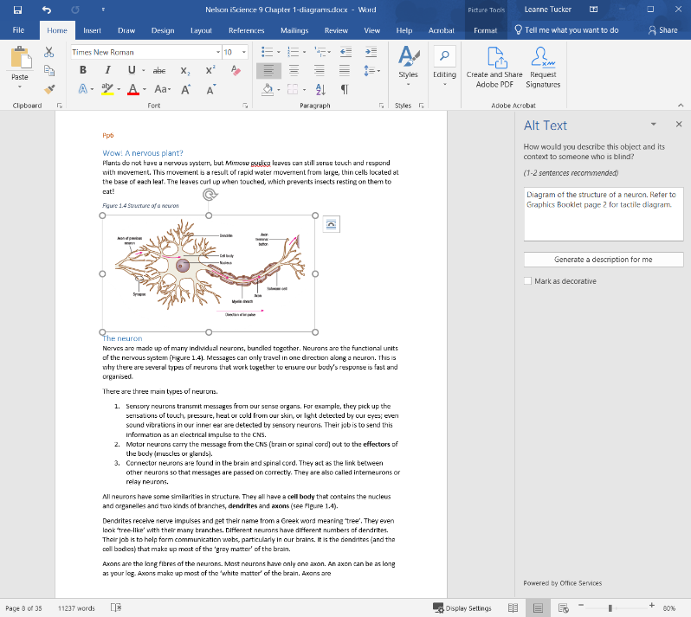

MS Publisher Patterns
Recognising the restrictions that the limited amount of pattern fills in MS Publisher placed on the production of tactile graphics, the Braille Team has developed their own bespoke patterns which fit the criteria for effective tactile reading.
The pattern fills were trailed and tested by students and feedback received from them fine tuned the creation of a Publisher Pattern Library.

New Patterns Fills

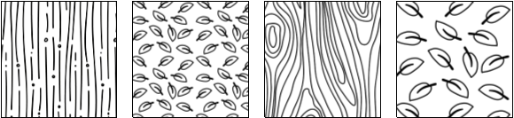
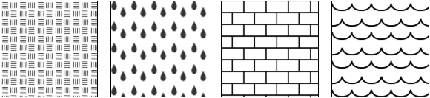
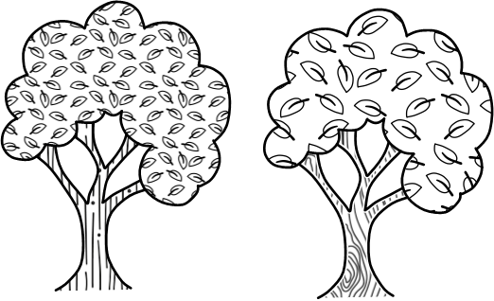
Training and Development

BLPS has an ongoing commitment to the training and professional development of vision support staff at all levels within the NSW Department of Education.

Training in the production of braille, tactile graphics and accessible Word documents is provided within the unit in the form of individual training in the Duxbury Braille Translation Program and MS Publisher.

Pre-production meetings for the planning of formatting of texts and review of graphics with the Coordinator and Senior Braille Transcribers develop the skills and contribute to the learning of team members.

In house guidelines for braille formatting and graphics production have been developed to assist transcribers and ensure continuity within the team.

Training programs for Braille Outpost Operators can be accessed and include small workshops at BLPS and individual instruction and mentoring by the Braille Team and other experienced Outpost Operators.

BLPS also supports the training and development of Itinerant Support Teachers – Vision and offer a variety of in-house and external options.

BLPS SharePoint Site

The development and introduction of the BLPS SharePoint Site has added another aspect to our commitment to supporting students by support those who work most closely with them.

NSW DoE staff have access to this site which provides a wide range of information and services all in one place including the Graphics Library and 3D Print Library.
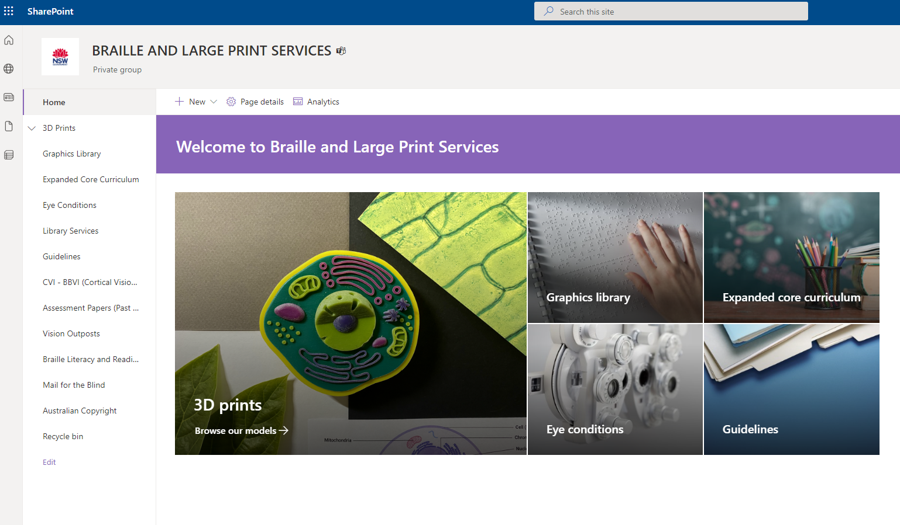

3D Prints - What can teachers borrow?
The BLPS 3D print project creates resources that align with the state curriculum.
Anatomy prints have been incredibly popular amongst teachers and students due to their complexity. A number of prints have been produced in this space from organs such as the heart and lungs, to the skeletal system. These prints can have Braille embedded on them, or are accompanied with a Braille key. Raised elements and different textures assist with tactile exploration. The organs are also printed with a low density rubber-like resin, making it soft and lifelike.
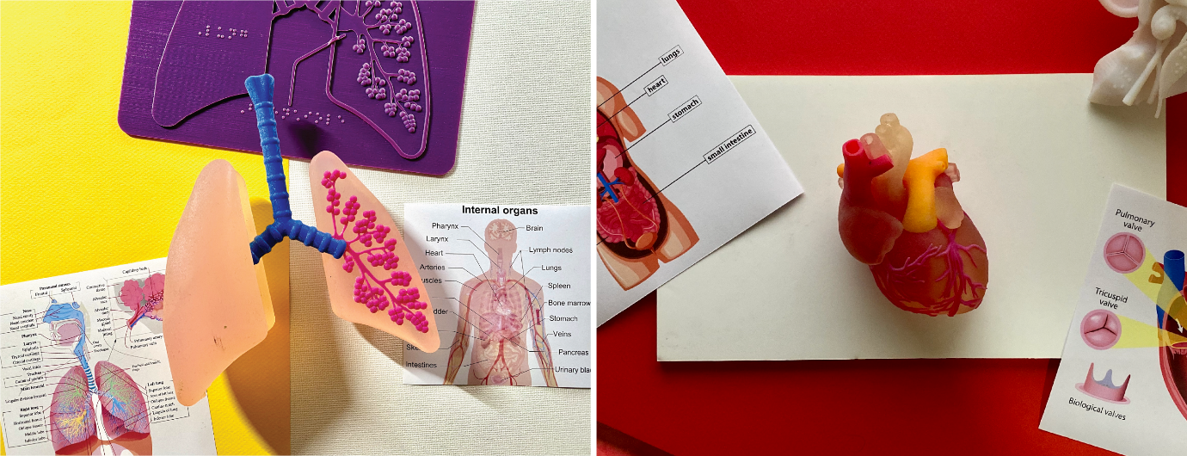
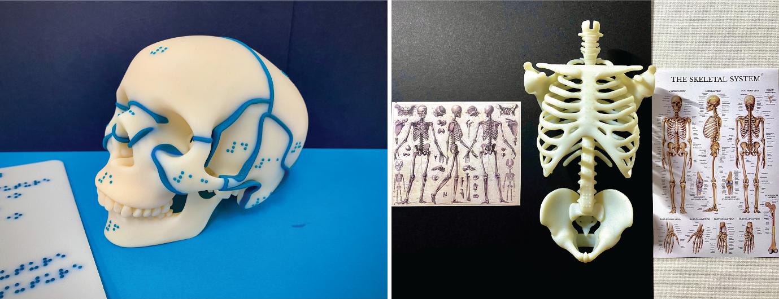
Teaching history to students with vision impairment can be quite difficult because a lot of it is based on primary resources. When a student use 3D prints in a classroom, other students and the teacher engage with them as well. This leads to a discussion based learning environment in which students and teachers bounce ideas off each other and come to insights and conclusions they would not have otherwise.
The prints BLPS has produced in this space covers topics like Ancient Egypt, Ancient Rome, Pompeii and Herculaneum, and Antiquity. These prints use grainy and gritty textures to mimic the feel of the real things. Accentuating textures like this has proved to be extremely beneficial and fun to BVI students. One of BLPS’s driving beliefs for this project is to create resources that are essential for some, but useful for all. When these resources are used in a classroom, everyone benefits.

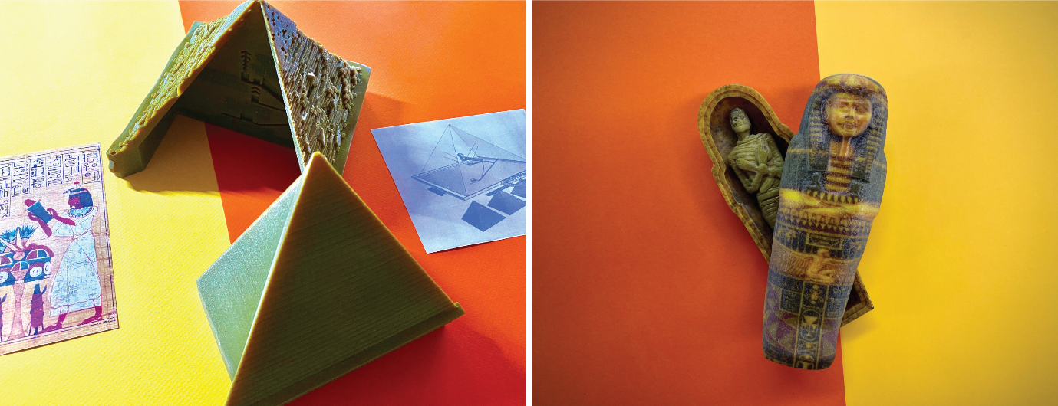
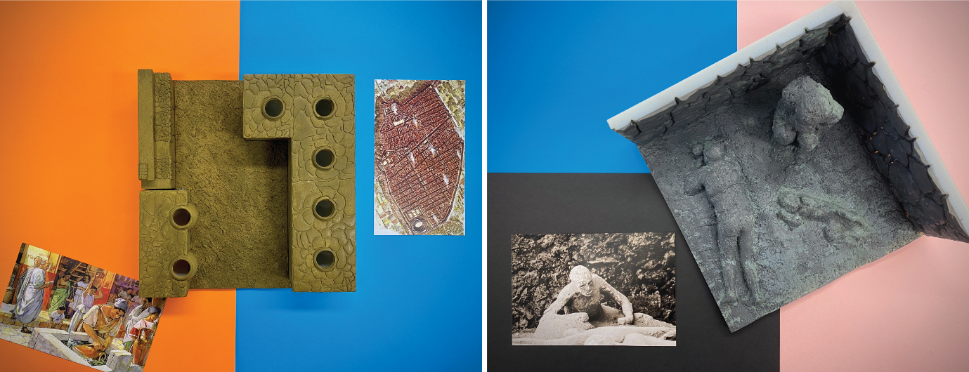
BLPS has also worked closely with curriculum teams in the department to create a catalogue of resources that have been useful to teachers and students. One of BLPS’s most popular 3D print, a tactile globe with raised continents and Braille labels, was produced through this method. This method also revealed that interactive prints should be explored, so a puzzle showing the continents of Earth was produced, among other interactive geography prints.
BLPS also produces Australia-specific prints. These resources are instrumental in assisting students fill gaps in knowledge about historically and culturally important landmarks. Prints of the Sydney Harbour Bridge, Sydney Opera House, Uluru/Ayers Rock, the Three Sisters, the Great Barrier Reef, and many others have been produced and used in the classroom.
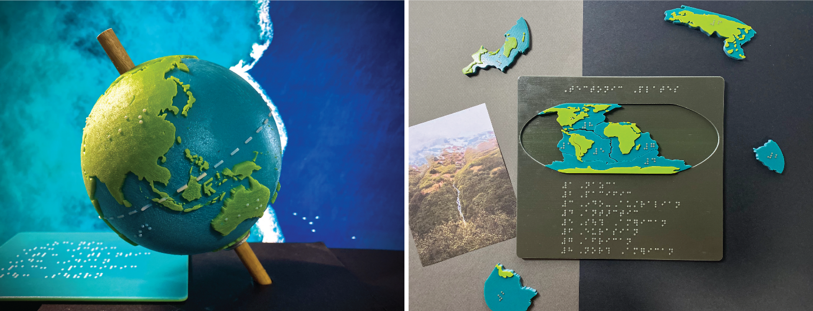
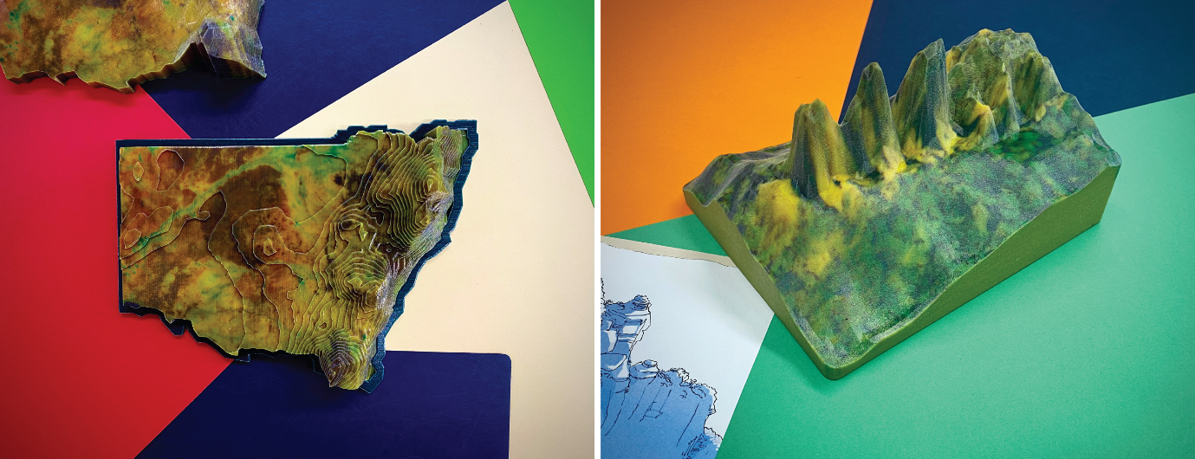

3D Prints - Teacher and student feedback
With almost every 3D print, BLPS include a feedback form asking teachers about why they ordered the print, whether they’ve tried teaching this topic with traditional resources in the past, how students responded to the prints, and other print specific questions. BLPS also call teachers for feedback, and sometimes teachers call or email BLPS to talk about prints.
When BLPS sent the globe out to a year 3 student mid last year, we had to follow up where it was because it was over two months overdue. The teacher told us that her student loved it so much, that she would play with it every night after school, and she did not want to return it.
Another teacher told us that the anatomy prints made teaching biology easier compared to using traditional resources. They said this is because biology diagrams show a lot of body parts encased in other parts, making it difficult to use raised line diagrams. The 3D prints allowed him to show his students how the brain sits inside the skull as these prints are made in the same scale.
A teacher told us that her student could make a very clear picture of Pompeii and Herculaneum using the 3D prints alongside raised line drawings. The student and teacher used raised line drawings to gain a wide picture of the cities – showing maps with roads, buildings, places of interest, proximity to Mt Vesuvius, etc. and then used the 3D prints to hone in on specifics within the city.
Another teacher told BLPS that the textures and colours made learning really fun for the student. He ordered a number of astronomy prints – the surface of the moon, the Mars Curiosity rover, and a 3D representation of a black hole – and the students found the different textures – from gritty surfaces to smooth panels – exciting and engaging.
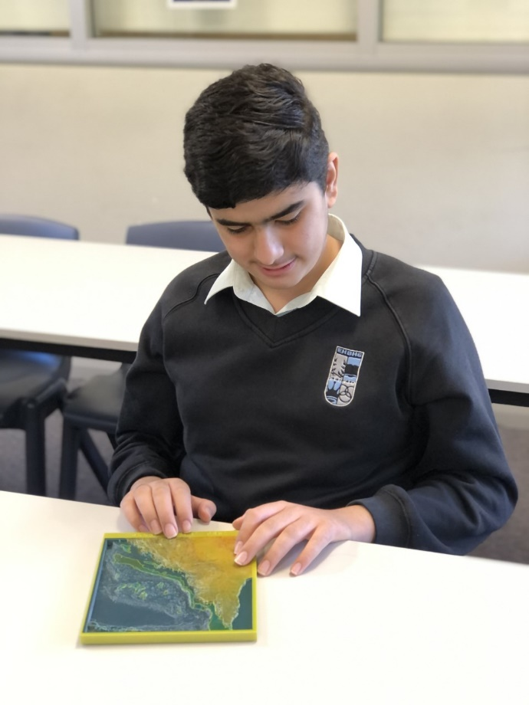
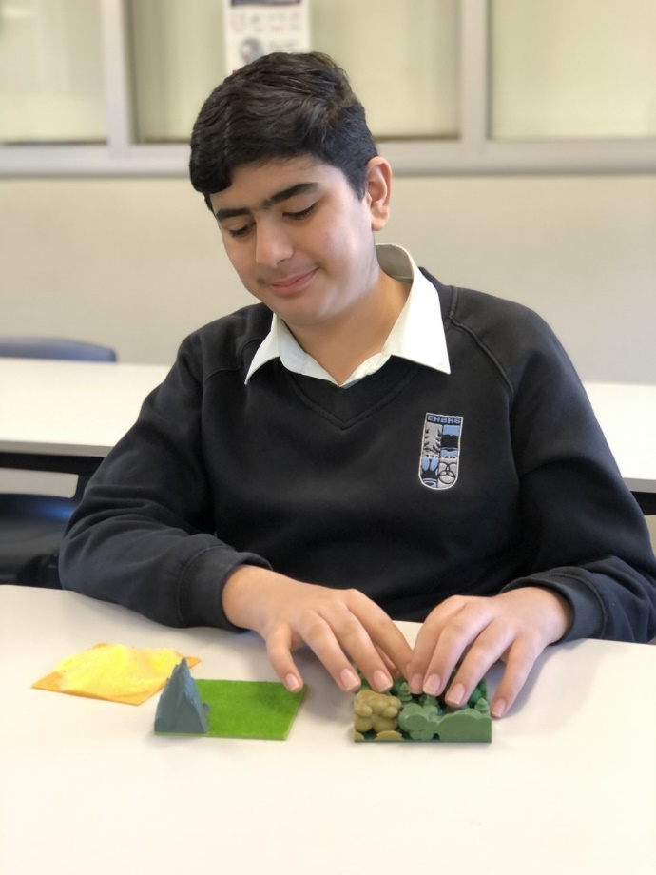
A teacher ordered a number of interactive prints – the continents puzzle, and an interactive dataset of Arctic ice – and told BLPS that her student loved the hands-on approach of these prints. She loved that she could take these prints apart and put them back together as this allowed her to learn independently and learn at her own pace.
Finally, another teacher told us that he’s had students drop subjects in the past because the traditional resources made teaching and learning some concepts too challenging. This teacher ordered a number of geography prints including the elevation maps of NSW, and was excited to use these prints with his students because showing this type of information in a raised line diagram was not clear in the past. These resources help open new avenues for BVI students and make the teachers’ jobs easier.

New ways to access
As of 2022, all the design files created by BLPS can be downloaded by anyone with a NSW Department of Education email address. This means any public school staff member or student can download these files to modify and print at their own convenience. BLPS uses a mentality of “essential for some, but useful to all” when designing these prints, and this access will allow these designs to reach thousands of students across the state.
With several schools already having access to 3D printers within their STEM or Art departments, students and teachers will be able to download, modify, and print the files as they see fit. If a school does not have access to 3D printers, a kit with detailed use instructions can be loaned from the stem.T4L team.
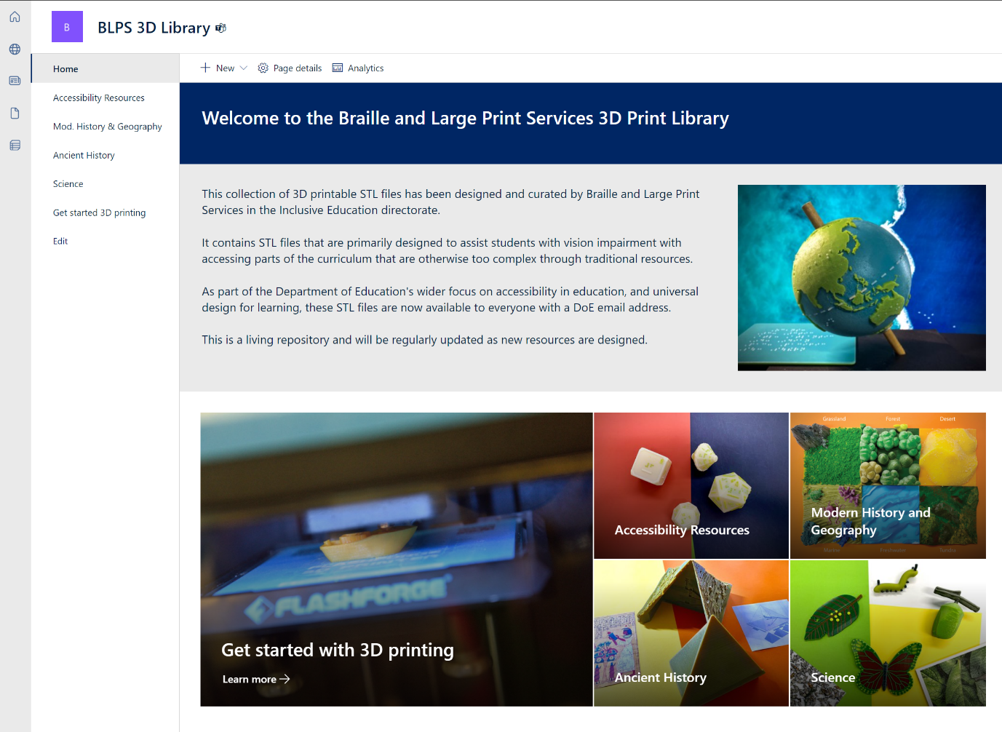
To download these files, please visit: edu.nsw.link/3DBraille.

