VisiCalc for Braille:

How Canute enables better use of spreadsheets with refreshable Braille
Ed Rogers, Bristol Braille Technology CIC, for the 2021 Round Table on Information Access for People with Print Disabilities
20th of April, 2021
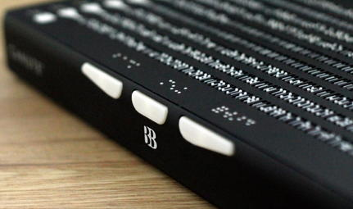
Fig: Close up of the Canute 360

Abstract
Bristol Braille Technology CIC is a not-for-profit hardware manufacturer, co-operating with software developers around the world, to make the world's only multiline Braille spreadsheet. We will be combining the power of modern spreadsheets with Canute 360, the nine line Braille display, to do for digital Braille what VisCalc did for the personal computer.

Overview
Digital Braille has always been single line. This is not particularly useful for spacial, two dimensional information, such as tables, mathematics, bar charts and other graphs. Meanwhile people and organisations are looking to move away from the limits of paper Braille.
In many parts of the world the rate of employment amongst blind people is around one in four, significantly lower than that of the population as a whole. Use of Braille is associated with double the likelihood of being employed. And yet their use is critically limited by only showing one line of text, negating much of the point of special information contained in spreadsheets and other tabular forms.
Spreadsheet software–in particular Microsoft Excel, Google Sheets and LibreOffice Writer–are one of the most common and important forms of productivity software, generally considered essential in almost every office job, including those that have no obvious financial or data-driven aspect to the role.
And yet, when navigated with text-to-speech or single line Braille displays, spreadsheets are usually navigated one cell at a time, stripped of all context. Spreadsheets are not designed to be understood one cell at a time. Space is king; it's simply not the same medium without both horizontal and vertical context.
Our product, Canute 360, is the only affordable multiline Braille display, costing less than £2,000 Sterling, with 360 cells rather than 12-80. As such at Bristol Braille we have been experimenting with the benefits of combining multiline Braille displays with spreadsheets. This has required us to reimagine the spreadsheet to fit into the more limited space and stylistic options available for Braille.
So far we have used recent BRLTTY support for Canute to demonstrate that Excel files can be shown and navigated on a Canute 360 connected to a Windows 10 PC, with dynamic resizing of columns. This allows Braillists to pan around and zoom in and out of spreadsheets like their sighted colleagues, without any specialist training required beyond an understanding of standard Braille tables.
We have also demonstrated bar charts and special graphs, derived from the same spreadsheets, on Canute 360s. This uses an easy to understand form of tactile graphics we call "special Braille graphics", requiring no special knowledge or experience of tactile graphics, only of Grade One Braille.
Next step is achieve proper integration with the major spreadsheet packages and screen readers. For this we are working with external partners with relevant experience, while BBT provides the multiline hardware experience.
We are looking forward to designing this revolution in Braille productivity in the same way we always do, working community groups to trial prototypes and design the interfaces. Therefore we invite anyone with an interest in this subject to get in contact with the project.
We believe there will be huge benefits to Braille readers' careers from integrating the productivity of spreadsheets with the world's only page-view Braille display. This is why we believe that multiline Braille spreadsheets could be a breakthrough equivalent, for Braille readers, to the original VisiCalc.
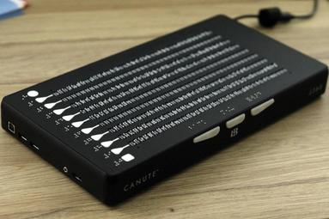
Fig: Full image of Canute 360

Experimentation with Excel-to-Canute
BBT have successfully tested the concept of integrating a multiline Braille display with spreadsheets by using a Canute as a display to navigate around and dynamically resize Excel files, using a simple Python script and BRLTTY.
We start with the BANA / ICEB standards for representing Braille tables, then we use OpenPyXL library to load data from Excel sheet from the file system into that table. The table automatically resizes columns to fit the most readable information possible on the 360 characters of Braille space.
As one moves around the table the output is dynamically resized to fit the data in the current view-port, always keeping the (user definable) header line visible. This method disregards styling information in the sheet in order to retain identical cell-by-cell special formatting.
This approach is to take the special data from the spreadsheet and represent it exactly, but to disregard the per-cell stylistic information in favour of maximising readability across the whole view-port. This in our view gives a majority of the benefit of viewing spreadsheets in page-view digital Braille. However it is only a first step and other view-types will be necessary, plus the ability to edit.
The experimental script is under 150 lines, demonstrating the ease of adapting this new Braille technology to new mediums, like multiline Braille spreadsheets. This relies on the excellent work done by BRLTTY in integrating support for Canute in the latest releases of the BRLTTY terminal screen reader.

Next steps and the proposed method of integration
The next step, for representing full per-cell information, including style, inspired by the work done by Duxbury and transcribers over the years to represent tables in Braille, is either:
1. To be modal. So a user zooms in on a cell, which then takes up as much of the display as it needs to, retaining a minimum of context of the columns left and right, and the rows above and below. This mode would include in-line stylistic information.
2. Or to have the ninth line of the Canute always show the full textual info of the currently selected cell, with in-line style info, which a user can scroll back and forth on. This is most similar to the conventional visual display of a spreadsheet.
This functionality could be integrated into the spreadsheet package itself, thus tying it to that product. This may improve integration. Or it could be done in a genericised fashion that equally suits users of various different spreadsheets, with one of the free desktop screen readers, such as NVDA, Narrator, or ChromeVox.
At this stage we are open to either or both approaches and are working with a number of partners to explore how best to test this integration in a real world prototype. We look forward to hearing from anyone with an interest in this field, either as a developer or a user.
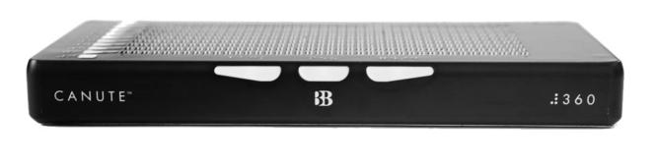
Fig: Front view of Canute 360

Tactile graphics
As we have all seen, the fundamentally different technical requirements of tactile graphics and Braille, and the huge difference in resolution, are often given too
little attention in digital display concepts and prototypes that tackle tactile graphics.
Take even a large, as-yet unavailable, 40 cell by 25 line Braille tablet, with evenly spaced vertical dots (i.e. four extra dots under each cell): This would have a 2-bit ("black and white") resolution of 80 × 135, roughly equivalent to a Nokia 1100 and significantly lower than the output of many modern Braille embossers. This compares with a minimum of 32-bit 640 × 480 for most images on the web.
There has been a common assumption that the correct way to represent graphics on digital technology designed for Braille is to break down the cells into the constituent dots, the better to emulate visual bitmap graphics. Break a Braille cell down to dots and you have just six points of data on your tactile graphic, in service of visual assumptions. By comparison a cell holds up to 63 possible meanings to any Braille reader, regardless of familiarity with visual or tactile graphics.

Special Braille graphics: Bar charts and other graphs
Development of Canute has afforded the opportunity to experiment with ways of representing productivity-focused tactile graphics in a way that works well with the integration of spreadsheets and multiline Braille. It works with Braille's strengths and uses people's prior knowledge of Braille, without assuming prior knowledge of tactile graphics. We refer to this as "special Braille graphics".
We have therefore worked on a form of tactile graphics specifically intended to be used for bar charts and other graphs within or derived from spreadsheets. Rather than using the bitmap output of the graph, we use the source data to redraw it with Braille assumptions rather than visual assumptions. These include never using any of the cells (or any dots of those cells) in the tactile graphic for something other than a valid alphabetical Braille character, which can be looked up on a key that is always on the left of every tactile graphic.
To date we have created a variety of well received demonstrations on the Canute 360, generated uses simple shell scripts from a variety of sources, including the spreadsheet transfer format Comma Separated Value.
The Canute's integration with spreadsheets is therefore intended to be accompanied by the ability to present the most useful forms of bar charts and other graphs as special Braille graphics. We hope that this feature will also improve Braille readers' productivity, comprehension of source information, and parity at work with sighted colleagues.

About Canute 360 and Bristol Braille
● Bristol Braille Technology CIC is a not-for-profit Community Interest Company based in Bristol, United Kingdom. We also manufacture the Canute 360 in the United Kingdom.
● The Canute 360 has won a variety of awards, including:
- The National Federation of the Blind's Dr Jacob Bolotin Award for: Breaking down barriers facing blind people in an innovative way; Changing negative perceptions of blindness and blind people; Pushing past existing boundaries to inspire blind people to achieve new heights.

- National Braille Press's Touch of
Genius Prize for: The most innovative
idea in the field of Braille and tactile
literacy.
● Fully CB, CE & FCC certified for sale in the UK, Europe, Australia, America and elsewhere.
● Launched 2020: First 100 Canutes sold and shipped to a dozen countries on four continents.
● Production paused over the pandemic but restarted in April 2021.
● With Canute we've already achieved real and affordable multi-line Braille displays. We are now moving away from simple e-book reading functionality, on to making the most of this new medium.
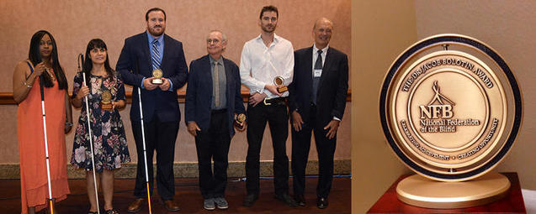
Fig: Dr Jacob Bolotin Award
Contact details
e: ed.rogers@bristolbraille.org
t: +44 (0) 117 325 30 22
a: BBT, G11, BV Studios, 37 Philip St, Bristol, BS3 4EA

