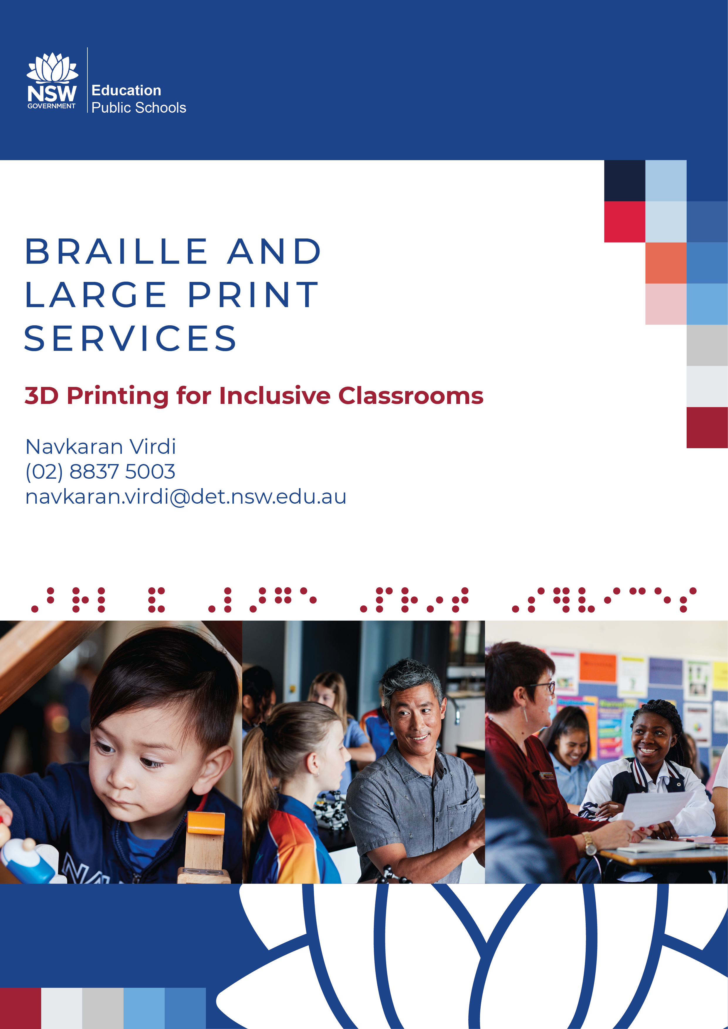

3D Printing for Inclusive Classroom
Navkaran Virdi
NSW Department of Education
Braille and Large Print Services

Contents
3D Printing for Inclusive Classroom 2
Introduction 3
Why are 3D prints important? 3
What can teachers borrow? 4
Teacher and student feedback 8
How to use 3D prints with BVI students 10
How to order 3D prints and contact BLPS 11

Introduction
This paper accompanies a presentation given at the 2021 Round Table Conference on the 18th of May.
The presentation looks at why 3D prints are important, what prints are being produced at NSW Department of Education’s Braille and Large Print Services (BLPS), teacher and student feedback, how teachers can introduce and use 3D prints with students with vision impairment, and how to order 3D prints and how to contact BLPS.

Why are 3D prints important?
Existing evidence relating to the use of 3D prints with students with vision impairments yields positive results.
Thomas Politzer from the Neuro-Optometric Rehabilitation Association in New Jersey said that “80 to 85% of our perception, learning, cognition, and brain activity is stimulated and mediated through visual cues.” In a classroom, where teachers use mixed media from presentation to videos and documentaries, to excursions, and much more, students that cannot use these resources are unfortunately at a disadvantage.
In a paper titled Improvement of Space and Text Memorisation in Visually Impaired Students by Erhel and Jamet, the two researchers found that “[BVI students] showed an improvement of memorisation and comprehension, as well as a decrease in perceived cognitive load when using multimodal resources.” They were able to deduce that when BVI students used physical resources – whether they were 3D prints or handmade models, they were able to learn more with less effort. Their research also found that having a combination of resources yielded the best results.
In a 2016 paper by Buehler et al, researchers found that “3D design and printing performs three functions in special education: (1) STEM engagement, (2) creation of educational aids for accessible curriculum content, and (3) making custom adaptive devices.” The project at BLPS has focused on points one and two, and we have seen an amazing response from students and teachers engaging in subjects they otherwise would not have been able to with traditional resources.

What can teachers borrow?
All 3D prints produced by BLPS are available to loan by Itinerant Support Teachers – Vision (ISTVs) and Assistant Principals – Vision (APVs) in New South Wales.
Prior to printing anything, BLPS surveyed vision support teachers to find what they needed.
Anatomy models were overwhelmingly requested, with some teachers saying their science department did not have access to them, they were too expensive to purchase from other sources, and that teaching anatomy with raised line diagrams was too difficult. BLPS have produced a set of human lungs showing a whole lung on one side and a cross-section on the other. This ability to show what would have needed multiple diagrams on one print reduces resource burden for students and teachers. A human heart with raised veins and different colours for different valves has also been produced for students with low vision. Both prints use mixed density resins to create squishy textures that mimic real organs.
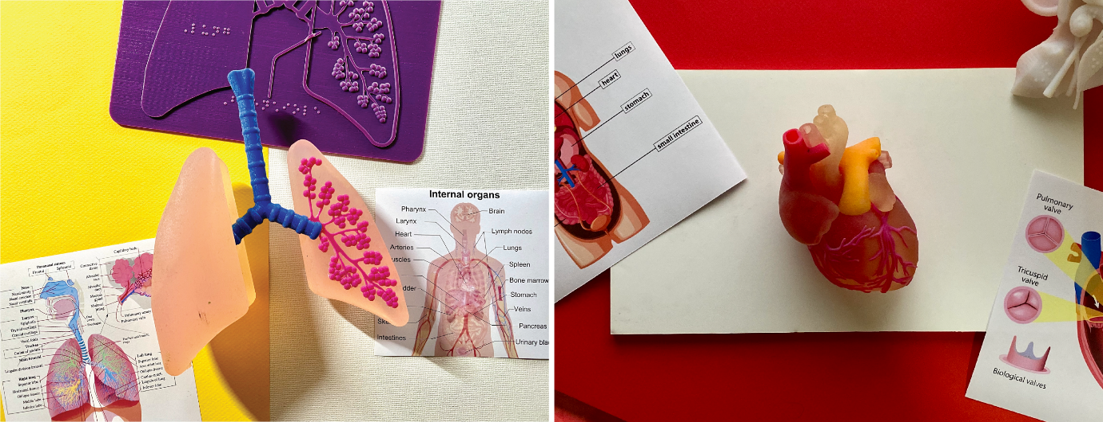
Teachers also requested parts of the skeletal structure. BLPS produced a 3D printed human skull with blue lines to show different sections, and a print of a spine, ribcage and pelvis. While models like this can be purchased, designing them with blind and visually impaired (BVI) students in mind allowed BLPS to integrate accessible design features in the creation process, rather than as an afterthought. Braille labels are found across the models, colour contrast is used, articulating parts have tough, large hinges to withstand numerous uses, some sections are adjusted to be bigger, thicker, longer, etc. to highlight them for students with vision impairment.
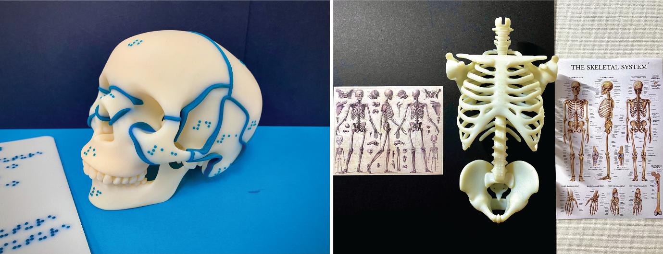
Teachers also requested historical artefacts and this has been an area where BLPS have seen a lot of interest over the years. Among others, a print of the Pyramid of Giza was produced. The print splits in half to show internal chambers and features. An Egyptian mummy inside a sarcophagus was also produced. The sarcophagus has detailed colours and patterns on it so it can be accessed by all students in a classroom to encourage group discussion and collaborative learning. Teaching history to students with vision impairment can be quite difficult because a lot of it is based on primary resources. When a student uses these prints in a classroom, other students and the teacher engage with them as well. This leads to a discussion based learning environment in which students and teachers bounce ideas off each other and come to insights and conclusions they would not have otherwise.
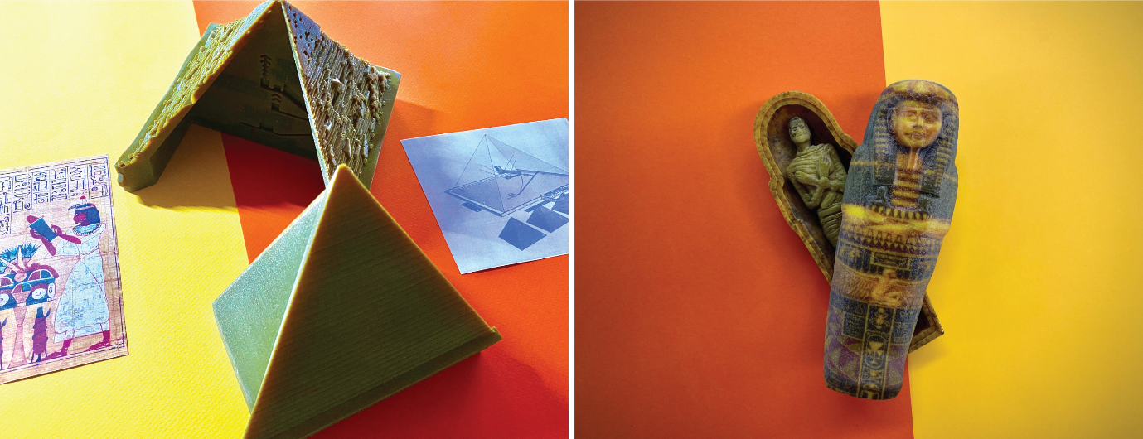
3D prints of primary resources from the eruption of Mount Vesuvius in 79AD have also been produced as this is a core curriculum element of Stage 7 Ancient History in NSW. A print of a Thermopolium from Herculaneum and a scene of preserved remains from Pompeii were produced, among other resources. These prints use grainy and gritty textures to mimic the feel of the real things. Accentuating textures like this has proved to be extremely beneficial and fun to BVI students. One of BLPS’s driving beliefs for this project is to create resources that are essential for some, but useful for all. When these resources are used in a classroom, everyone benefits.
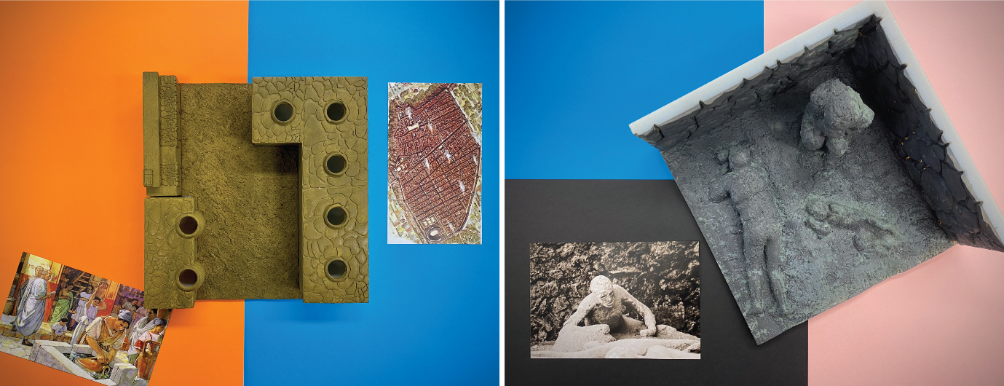
BLPS has also worked closely with curriculum teams in the department to create a catalogue of resources that we believe will be useful to teachers and students. The decision making process for these resources comes from a wealth of experience from teachers, support staff, policy makers, creators, and tinkerers. Geography resources were an area where we have used 3D printing extensively to provide resources for teachers they may not have thought about. One of BLPS’s most popular 3D print, a tactile globe with raised continents and Braille labels, was produced through this method. This method also revealed that interactive prints should be explored, so a puzzle showing the continents of Earth was produced, among other interactive geography prints. We have heard back from students saying these prints have sparked a love of geography and their teachers have put in orders for more geography resources for their students.
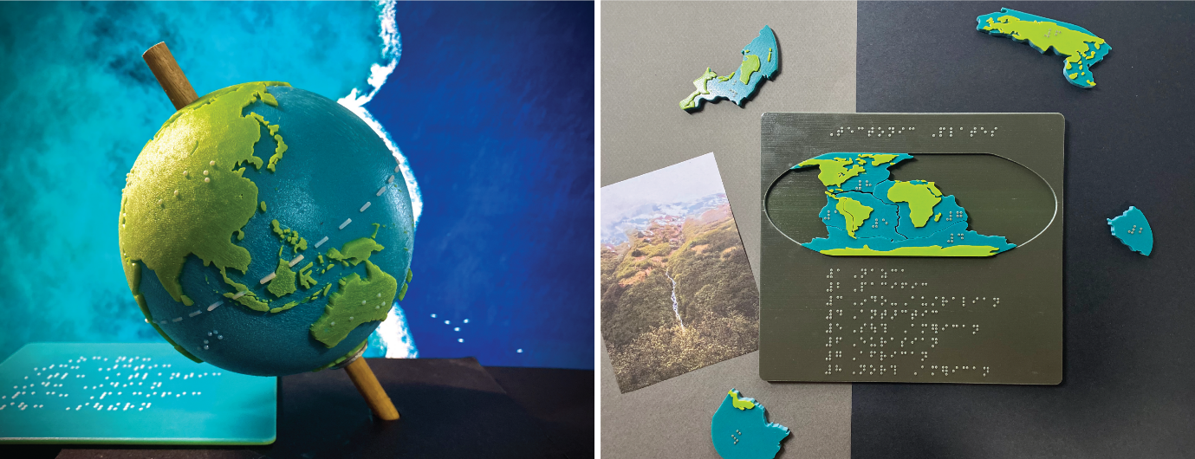
BLPS can also create Australia-specific resources that cannot be purchased anywhere. These resources are instrumental in assisting students fill gaps in knowledge about historically and culturally important landmarks. Prints of the Sydney Harbour Bridge, Sydney Opera House, Uluru/Ayers Rock, the Three Sisters, the Great Barrier Reef, and many others have been produced and used in the classroom.
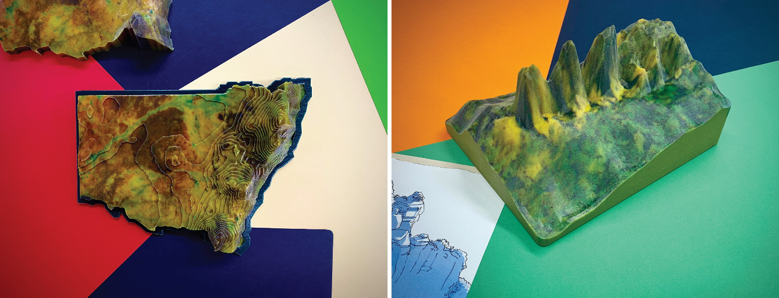
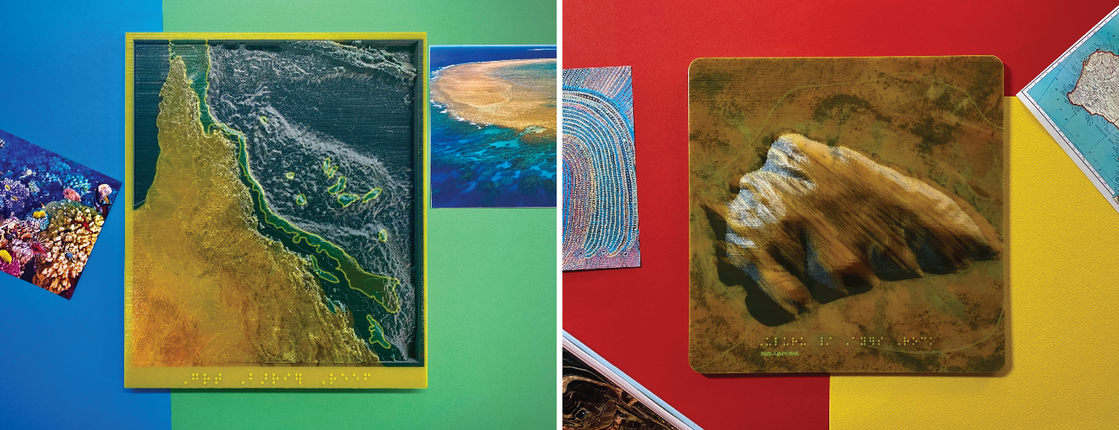
While BLPS are primarily focusing on curriculum based resources, we have produced Braille specific teaching aids at times. These include swing cells, and Braille alphabet tiles. BLPS have also produced Brailler finger guides, pattern and texture recognition kits, and Braille dice to assist students.
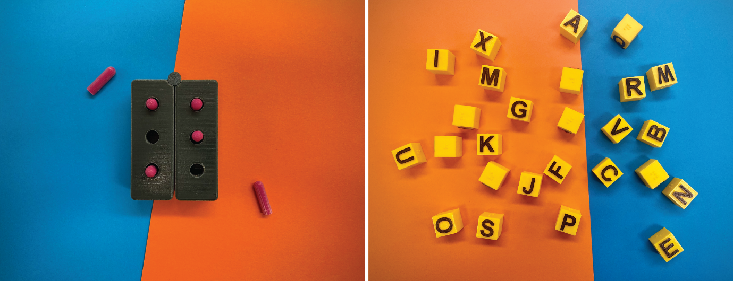

Teacher and student feedback
With almost every 3D print, BLPS include a feedback form asking teachers about why they ordered the print, whether they’ve tried teaching this topic with traditional resources in the past, how students responded to the prints, and other print specific questions. BLPS also call teachers for feedback, and sometimes teachers call or email BLPS to talk about prints.
When BLPS sent the globe out to a year 3 student mid last year, we had to follow up where it was because it was over two months overdue. The teacher told us that her student loved it so much, that she would play with it every night after school, and she did not want to return it.
Another teacher told us that the anatomy prints made teaching biology easier compared to using traditional resources. They said this is because biology diagrams show a lot of body parts encased in other parts, making it difficult to use raised line diagrams. The 3D prints allowed him to show his students how the brain sits inside the skull as these prints are made in the same scale.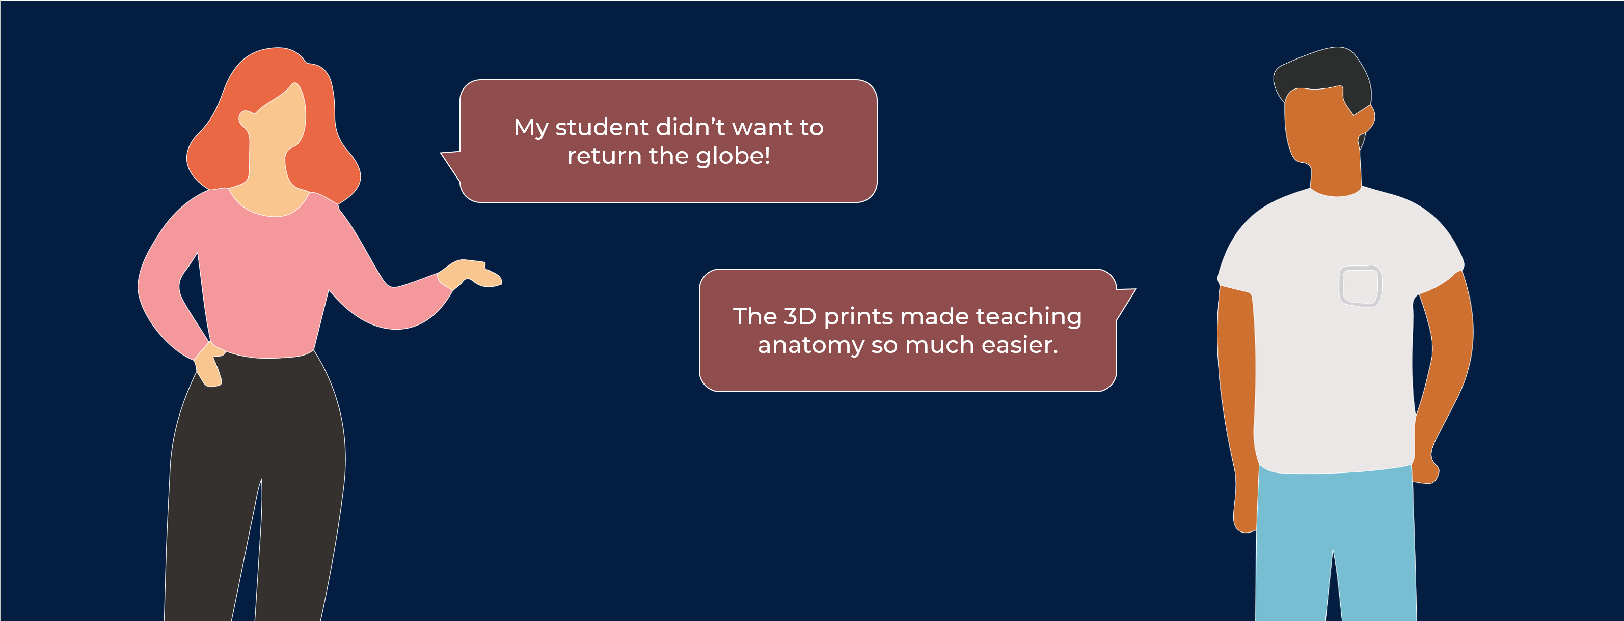
A teacher told us that her student could make a very clear picture of Pompeii and Herculaneum using the 3D prints alongside raised line drawings. The student and teacher used raised line drawings to gain a wide picture of the cities – showing maps with roads, buildings, places of interest, proximity to Mt Vesuvius, etc. and then used the 3D prints to hone in on specifics within the city.
Another teacher told BLPS that the textures and colours made learning really fun for the student. He ordered a number of astronomy prints – the surface of the moon, the Mars Curiosity rover, and a 3D representation of a black hole – and the students found the different textures – from gritty surfaces to smooth panels – exciting and engaging.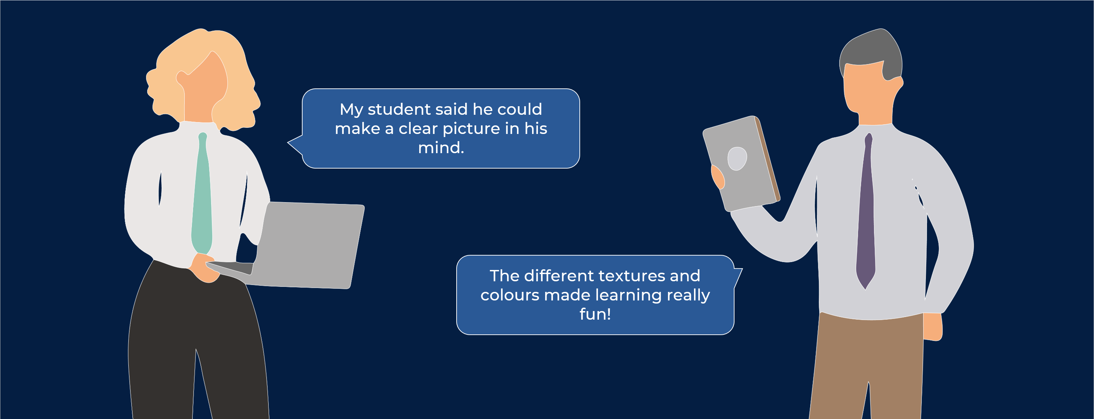
A teacher ordered a number of interactive prints – the continents puzzle, and an interactive dataset of Arctic ice – and told BLPS that her student loved the hands-on approach of these prints. She loved that she could take these prints apart and put them back together as this allowed her to learn independently and learn at her own pace.
Finally, another teacher told us that he’s had students drop subjects in the past because the traditional resources made teaching and learning some concepts too challenging. This teacher ordered a number of geography prints including the elevation maps of NSW, and was excited to use these prints with his students because showing this type of information in a raised line diagram was not clear in the past. These resources help open new avenues for BVI students and make the teachers’ jobs easier.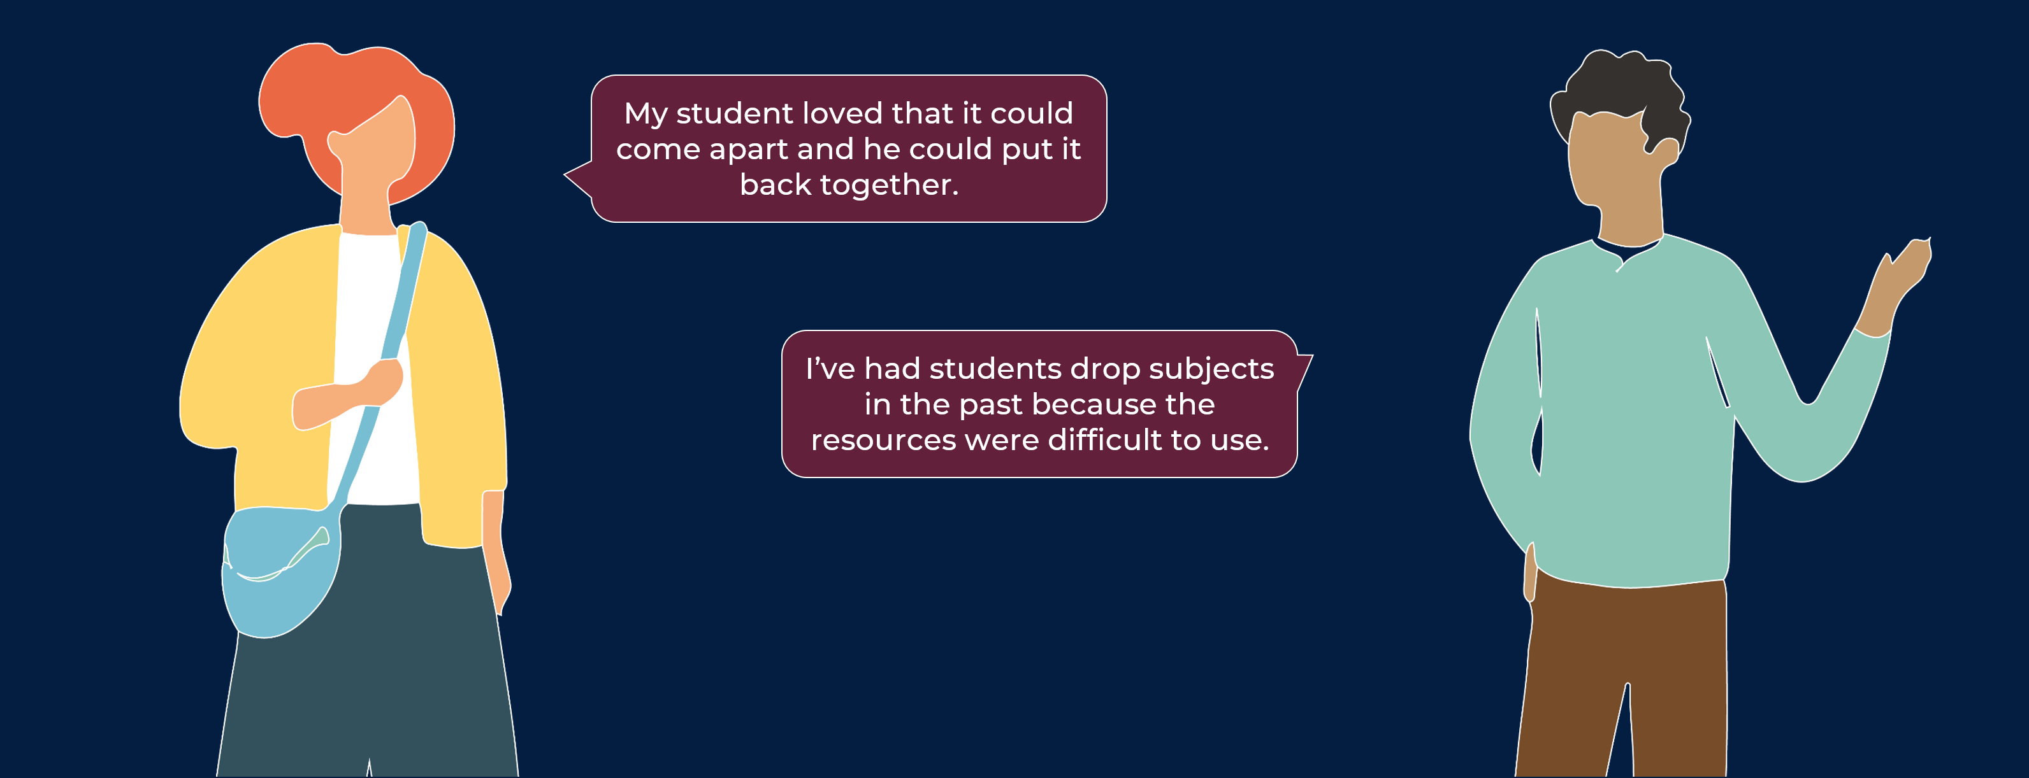

How to use 3D prints with BVI students
Useful tips for using 3D prints in the classroom.
First and foremost – don’t get students to guess what the print is. This can be frustrating and embarrassing for them. Always provide context before giving your student the print.
If your student needs encouragement, use techniques like hand-under-hand or hand-over-hand to guide them. And focus on extremities – look out for edges, sides, corners and encourage students to investigate these areas.
Focus on the size of the print, discuss the print in three dimensions and talk about the height, length, and width of the print.
Discuss Braille labels if the print has them. Some have full labels on the print, others use a key, and others have a Braille description on a flat surface on the print. Go through these with students.
Encourage students to go over the entire print and look out for different textures. As mentioned earlier, some prints have squishy sections, others have gritty surfaces, others have model-making fake grass applied them, and others use felt or sandpaper to mimic real features.
Let the students manipulate the print. Some of them like the skull have an articulating jaw, the globe spins on an axis, the Pyramid of Giza comes apart, and the Mars Rover’s wheels spin. Let students explore these moving parts.
Take advantage of opportunities in the environment and in the classroom to look at how things that don’t seem alike have similarities. Discuss the differences between the print and the real world object as some prints can provide an overall idea of a concept, but can’t replicate real textures of features.
Assist student in linking prior knowledge to the 3D prints. If you’ve covered this topic in the past with tactile diagrams, build upon that knowledge with 3D prints. As mentioned earlier – tactile diagrams provide dense information, and 3D prints help contextualise this information.
And lastly – give your student plenty of time to explore. Let them be independent and learn at their own pace, and encourage them to ask questions.

How to order 3D prints and contact BLPS
For now, these prints are only available to ISTVs and APVs at the NSW Department of Education.
All ISTVs and APVs have access to BLPS’s Oliver library where they can see what prints are available and what new prints have been priced. Teachers can look up print availability on Oliver and then submit an order form like they do for our Braille books and large prints books.
BLPS has also started using SharePoint to showcase new prints, upload any presentation recordings, research documents, tips and tricks, and sharing useful links. Offline PDF catalogues can also be downloaded from here. ISTVs and APVs should already have access to the SharePoint – please contact BLPS if you do not have access.
For all 3D print related questions and enquiries, please contact Navkaran Virdi (Nav) via email (navkaran.virdi@det.nsw.edu.au) or phone (02 8837 5003).

