Documenting Tactile Graphicacy
Written by Louise Curtin, Leona Holloway and Debra Lewis

Introduction
International interest in tactile literacy for blind and low vision children has flourished over the last 15 years, with growing recognition of its importance. This document is based on the approaches being taken in Australia and New Zealand with children from birth to the completion of their secondary schooling.

While a number of organisations have written guidelines for the production of tactile graphics^{[2, 9, 10, 11]}, far less attention has been given to how the foundations of tactile literacy are reached. In this paper we intend to outline the importance of tactile graphicacy (section 1), how the skills are achieved (section 2) and provide some guidelines for the production of tactile graphics to support this learning (section 3).

This document has been produced as the result of the work of the Australian and New Zealand Accessible Graphics Group (ANZAGG) with the aim of sharing the expertise and practices among families, educators and producers supporting children who are blind or have low vision.

1. What is tactile graphicacy and why is it important?

Tactile literacy and tactile graphicacy
Literacy is the ability to decode and produce a written language. It usually refers to a written script such as print or braille, but can equally apply to graphics. In order to be literate, you must first be able to perceive the written language, understand its conventions (for example, reading from left to right), recognise its symbols and decode its meaning. The conventions for achieving tactile literacy are tied also to language understanding and tactual comprehension that is built up from birth to mid secondary years. Haptic and kinaesthetic skills are primary methods of developing tactile literacy.

Tactile graphicacy in particular refers to the ability to read, interpret and produce tactile graphics or raised line drawings. This skill is an extension of tactile literacy, requiring explicit attention.

The importance of tactile literacy
For people who are blind or have very low vision, tactile literacy is the means to successful access to literacy, education, information and independence. Among blind adults, braille reading ability is linked to better employment rates, education levels, financial self-sufficiency, self-esteem and life satisfaction^{[4, 22, 24]}. "Braille holds a special place of honor in the lives of those of us who use it—not only as a tool for true literacy but also as a tool for personal dignity, privacy, and independence"^{[7]}. Exploring tactile picture books is the first step towards braille literacy.

There is a direct link to being tactile literate and achieving at late secondary and tertiary levels because curriculums are now so visually presented. Our students who are blind or have low vision need to be able to read graphs and all tactile diagrams effectively. Tactile literacy and braille literacy support each other in a myriad of ways as skill development in both areas are complementary.

There is evidence that practice and exposure to tactile stimuli such as braille and tactile patterns can aid brain development of touch perception^{[23]}. Early success in exploring and interpreting tactile pictures is vital for confidence and interest in tactile graphics at a later age, and ultimately to ensure that a wide range of study and career options are attainable. In a recent study of university and TAFE students in Australia with vision impairments, half reported that they had avoided a potential study area or career due to concerns about access to graphics in that field, and there was an under-representation of these students in the STEM disciplines^{[5]}. We must work to ensure that future students can overcome such barriers through tactile literacy and self-advocacy skills^{[17]}.

The role of tactile pictures
If children who have vision loss are to have equitable access to books and stories then “feely pictures” are essential. Consider a child at story time in a preschool centre, sitting with their sighted peer who describes what they see in the picture book about the seaside. The blind or low vision child has their own tactile book and says, “I see a shell in my book”. “I see a shell on the beach too, in my book!” says the sighted child. Such experiences empower children in their early experiences of sharing books.

For the very young, tactile symbols are used to convey meaning, usually associated with a story book or a rhyme. Tactile song cards are popular in child care and kindergartens to allow a child with vision loss to learn and sing popular rhymes like “Round and round the garden” or “Twinkle twinkle little star”. These cards are a potent method in teaching concepts. Once such simple concepts are established in a child’s tactile lexicon, they are able to use them for interpreting other tactile graphics. It has been found that tactile graphics assist a child to retain information and the more active the searching of the tactual information, the greater the understanding of the text^{[6]}. If a child has a tactile card with a tracking circle shape embedded in it for “Teddy Bear, Teddy Bear, turn around” this this can then also be used in conjunction with others for “Here we go round the mulberry bush”, “Here’s a ball for baby” and “The wheels on the bus”. Then the child can begin to absorb the concept of round in many settings.

Parents report that children are attracted to tactile books when the print version is being read to them. This is usually the case when parents reinforce ideas about the story and the tactile picture they are feeling. Just as pictures are used to engage sighted children, if families reinforce how the tactile graphics relate to a story, a child who is blind or has low vision will remain focused on the story telling^{[25]} and better retain memory of the story or rhyme. Children who are blind and have low vision also use these small tactile books to tell their own story based on the symbols they are feeling. This activity assists language development and early understanding of causality in story-telling.

Children naturally use two hands to investigate the “feely” books, which is good practice for future braille reading. It also helps to develop pincer grip, finger strength and scanning techniques. Book handling skills grow as children learn to turn the sturdy handbook pages and the orientation of a page by the left binding of all books, just like print and braille books.

2. Tactile graphicacy skills development
In order to develop a child’s independence in using tactile graphics, many hands-on experiences of the world must be provided in the early years and continue through to latter years. The first exposure to tactile books can never begin too early.

In practical terms, there are specific skills that are needed for tactile readers, as described in the sections below. These are the skills that we aim to establish in our children who are blind or have low vision by the time they reach mid primary school years. They are definitely skills required to be able to use 2D tactile representations. They do not need to be learned sequentially, and many are generalised skills needed for multiple developmental areas.

Resources:
- SQUID Tactile Activities Magazine
- Touch and Learn Tactile Activity Book
- On the Way to Literacy sets

Motor Skills
Children first need to develop the requisite motor skills to achieve effective tactile exploration of the page. Touch perception relies on movement^{[12]} and different manual exploratory motions are required according to the object being felt and the information being sought^{[18]}. Instruction and training on optimal movements and strategies for tactile exploration improves tactile reading performance^{[14]}. This is particularly important for children who are born blind, as they do not spontaneously explore with their hands unless actively encouraged.
A. Book handling skills like turning pages, and orienting front and back.

B. Searching tactually on a page to find a picture and text, and to systematically explore all parts of a picture^{[27]}.

C. Line tracing. Children should first be taught how to trace a straight line from left to right. Later, curved lines and zigzag lines can be introduced^{[3, 19, 27]}.

D. Fine motor skills^{[27]}. This can be encouraged by providing small objects that need to be manipulated, for example wooden jigsaw puzzles, playdough and Lego. Some suggestions for adding manipulatives to tactile graphics are given in section 3 of this document.

Haptic discrimination skills
Haptic discrimination skills are the ability to differentiate between different features by touch. There is evidence that practice can improve touch perception through brain plasticity^{[23]}.

A. Texture discrimination^{[3, 19]}. Each texture or symbol must be identifiable and meaningful in the context of which it is used^{[15]}. Often, materials are used that are too similar and can confuse a young learner, so look for textures that are clearly different and support the learning with language and connections with real-life experiences.

B. Shape discrimination^{[3, 19]}. It is recommended to use solid objects to start. Once these have become established for a child they can start to absorb these forms in their everyday experiences, for example an ice cream cone; a wand with a star on top; a football.

C. Size discrimination^{[19]}. Again, start with everyday objects. Nesting tables, nesting saucepans, or nesting measuring cups are a good start. Then move to raised tactile images of big, small and in-between. Having an early understanding of size discrimination is important to grasp the meaning of many fairy tales such as “Goldilocks and the three bears”. Further, it is the grounding for early mathematical concepts.

Cognitive Skills
A. Spatial awareness^{[3, 27]}. This begins with awareness of one’s own body in space then orientation of objects in space and orientation to page layout^{[19]}. Children must understand concepts such as close, far, over, under, in front, behind, top, bottom, left, right, etc.

B. Understanding of object permanence^{[27]}, i.e. understanding that an object continues to exist even when it cannot be perceived (seen or felt)^{[20]}.

C. Short-term memory. This includes memory for location^{[27]} and memory of what has already been scanned but is not currently under the fingers.

D. Part-to-whole assembly^{[27]}. Children who have vision will look at an overall picture and then look for the detail. However, children who are blind or have low vision can access only a small piece of the picture at a time. This is why very young children benefit from the use of a simple feature to represent a whole. The parent or educator should support understanding with verbal explanations, by labelling the whole and linking the graphic to the story or the child’s experiences.

Tactile concepts
A. Book concepts such as book orientation^{[27]}, pages, the front cover, reading from beginning to end, and page numbering.
Consistency of presentation is important to assist in learning about the orientation of a book. SVRC always have an orientation marker for loose pages, that is, having the top right corner snipped off. Feelix Library tactile books are bound with soft cord on the left hand side and have a carrying loop in the top left hand corner at the front of the book. Other organisations use a piece of ribbon along the bottom of each page. Book page numbers are not used in preschool but all school books have page number in the top right corner in Australia^{[16]} and bottom right corner in New Zealand^{[1]}. Vision Australia’s Feelix library run tactile book workshops for parents teachers and preschools and these constants are explained, to allow for fluidity in transfer of information.

B. Language of line needs to be developed to allow concepts of straight, curved, wavy, solid, dashed and circular patterns.

C. Similarly, just like sighted children, the tactual reader must develop an understanding of geometric shapes, beginning with simple forms such as the square, rectangle, circle, triangle, etc^{[15]}.

D. Children need to have a tactile lexicon to assist them in interpreting symbols^{[27]}. Concepts such as rough, smooth, scratchy, spiky, sticky etc will assist the child to describe and classify. Parents and educators need to be specific about the tactual qualities of the symbol; for example, “That’s an echidna. Feel how spiky it is.”

Concept development
Concept development is the process of gaining an understanding of the world, including the self, others, objects, categories and the environment. Without access to the visual world, children who are blind or have severe low vision require additional support to build up concepts, beginning with concrete experiences with the real world before moving on to pictorial representations. Children must be able to reference previous experience in order to make sense of a tactile picture. “It is essential that the child’s tactile (and other sensory) experience should be as rich as possible from the earliest years”^{[15]}. It is always advised that meaningful experiences scaffold the understanding of the tactile symbols. Conversely, once the basics have been understood, tactile pictures can be used to further build on knowledge of important concepts. Immersion in tactile graphics at an early age creates a solid foundation for future concepts^{[13]}.

For example, a child may first learn about horses through smelling, hearing, or touching (a small part of) a real horse; by touching a toy horse; and understand the size of a horse in relation to their own height or the height of objects around them. Their learning can then be furthered by listening to a story about a horse accompanied by a simple tactile diagram that relates to one aspect of a horse, for example its bridle or its mane. An older child may expand their learning using a series of tactile graphics showing the horse standing, trotting and galloping.

Language skills
Language skills are the basic building blocks for tactual integration of meaning. Real life objects and tactile presentations promote the development of vocabulary and concepts. Parents and educators must therefore constantly verbalise the experiences that the blind or low vision child is engaged in. This language will support the child in literacy and tactile interpretation^{[8, 27]}. For example, in the story “Alexander’s Outing” by Pamela Allen, a couple are having a picnic in the park. On the tactile page is a small woollen square of fabric for the picnic blanket and a small woven basket. The parent or educator can support these ideas by saying, “Find the basket and the picnic rug. What do you think they will have for their picnic?”

Tactile symbols
The first tactile picture books often avoid use of symbols, instead featuring real objects attached to the page. Story boxes, bags or boards can also be used to collect a variety of objects all relating to a concept or story.

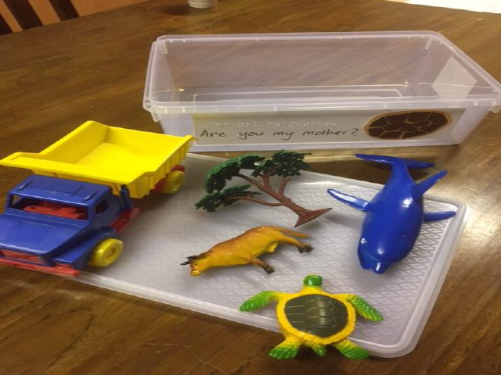
Story box
Photo credit: Mary McPherson
“Are you my mother?” by P. D. Eastman

When introducing symbols and representation using tactile graphics, move from the concrete to the abstract. Begin with real-world objects, the same objects attached inside a book, the same object thermoformed, then represented with collage, followed by more abstract representations.

By school age, basic shape concepts like square, circle, triangle and rectangle are needed so that early maths concepts can be presented in tactile graphics, but hands-on 3D examples must be available as well.

3D shapes to be matched to
tactile pictures
Photo credit: National Institution for the Blind, Visually Impaired and Deafblind, Iceland

Older children will require an understanding of the conventions used in different types of diagrams, for example thick lines for axes and dashed lines for grids on graphs; and standard symbols used in maps.

See also:
- Storybox Ideas from Norma Drissel, Paths to Literacy, http://www.pathstoliteracy.org/storybox-ideas-norma-drissel
- Ozzie Dots illustrated book series to introduce braille and tactile graphics
- Touchdown Sheepville: How to Read Tactile Maps by C.P. Gilbert on behalf of TABMAP, introducing mapping conventions. Available from Vision Australia Library

Drawing
All children love to draw, whether they are sighted or not. Creating your own marks is an essential aspect of literacy as it enables two-way communication^{[3]} and reinforces understanding of language conventions through active learning. Children love to draw with raised line kits and when asked to draw their impression of a solid object that they have held they are very able to produce a 2D image of the object^{[21]}. The language they use when doing this indicates very good conceptual understanding. This supports the early theory that experiential learning informs all interpretation of tactile graphics. It also suggests that children may gain great satisfaction from illustrating their own stories tactually. Some methods for children to create their own tactile drawings include tracing, colouring within raised lines, Wikki Stix, mylar film, tactile drawing boards, a Perkins brailler, collage materials, magnetic shapes, Lego, a cork board with pins and rubber bands, and so on.

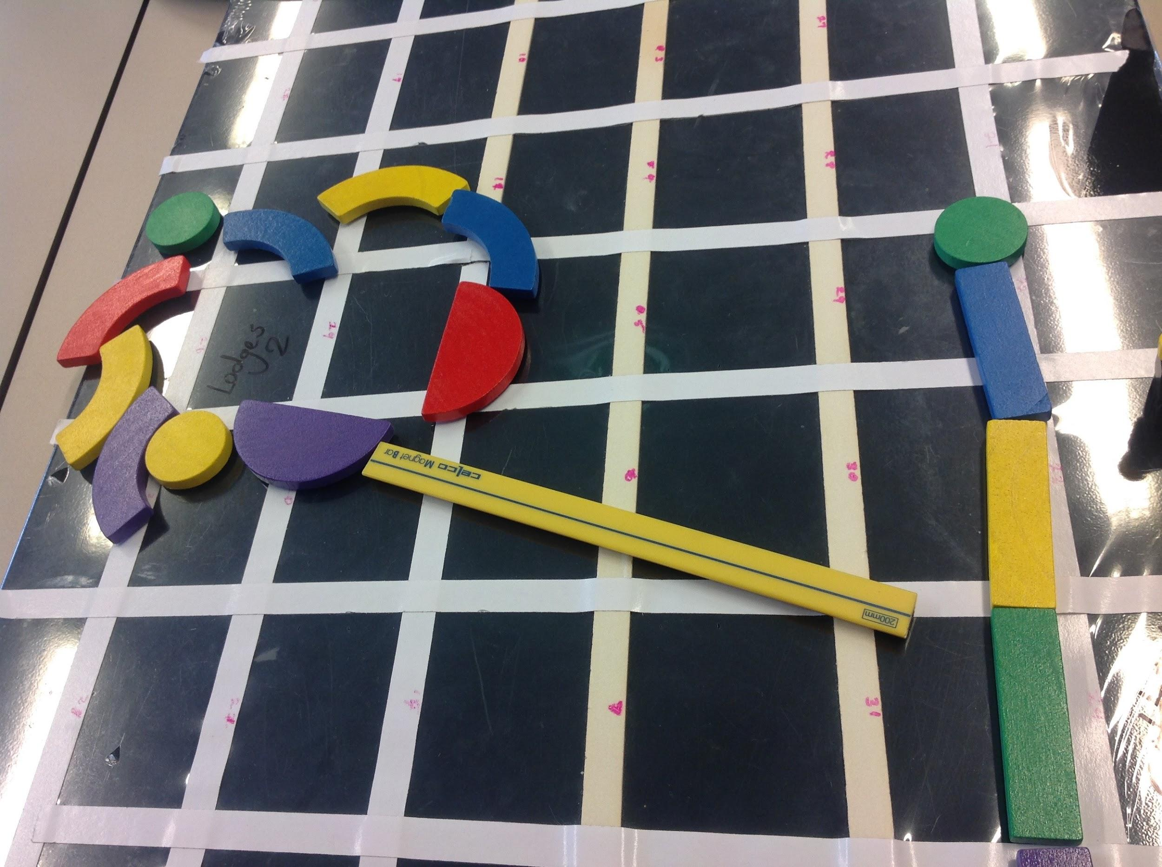
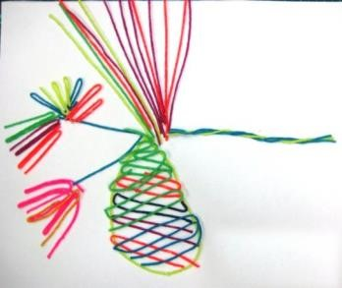
Drawings by children with vision impairments: (1) A simple classroom map constructed with wooden shapes and (2) A pinecone created with wikki stix.
Photo credits: (1) Kerri Weaver, Eyes and Independence
(2) Michael Donnelly, SVRC Support Skills Program

See also:
- So What About Drawing? Instructions for Drawing Using a Braille Writer
- Sensational BlackBoard for creating raised line drawings with pen and paper
- Wikki Stix re-usable tacky yarn for creating tactile drawings

3. Production considerations
Tactile pictures for young readers should be designed specifically with the touch reader in mind. A simple translation of the original print graphic is almost never suitable. Instead, consider the skills that the child already has, what skills and concepts need to be developed, and how the tactile picture feels rather than how it looks.

Creating tactile picture books for young children

- Keep graphics at a reasonable and meaningful size for two hands to investigate. Large tactile pictures are too difficult to explore and interpret.

- Simplify. A single object or concept on each page is usually sufficient.

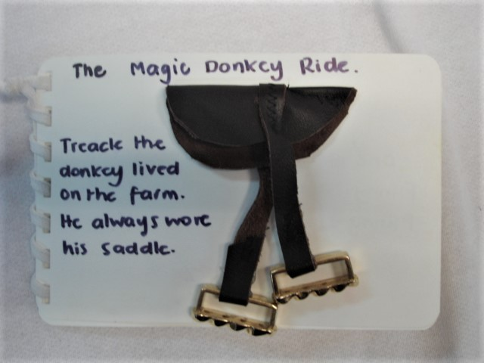
Tactile book page depicting only a single object.
Photo credit: Feelix Library
“The Magic Donkey Ride” by Giles Andreae

- Use real-life objects if possible and appropriate. Items that can’t easily be adhered to a page can instead be put in fine gauze bags and then attached to the page. Rocks, weighted items and sand can be included in this way.

- Consistency. If using symbols or textures, keep them consistent throughout the book or series.

- Contrast. The foreground and background should be very different in terms of feel and appearance. Use contrasting textures, heights, colours and brightness. For this reason, collage is ideal for young children. A variety of different lines can be created using Perkins brailler, spur wheels, glued string, hot glue, or even just running a pen across the back of the page.

- Use filled shapes rather than outlines. Raised line drawings are generally difficult to interpret, with filled shapes much easier to understand^{[26]}.

- Depict the story or the object from left to right to reinforce reading direction. For example, animals should be placed with the head on the left and the tail on the right.

- Avoid visual conventions such as 3D shapes or obstructed views. Separate objects so they can be shown in full and show all legs on animals.

Vision Australia’s Feelix Library lends tactile story books based on picture books to families throughout Australia. The tactile symbols are usually collage pictures and simple braille pictures. PIAF illustrations are only used occasionally. Regular symbols are used for recurring items in Feelix tactile books so that a child recognises the symbols easily. These symbols are designed to be simple, tactually distinct and tactually meaningful. For example, elephants are symbolised by a sewn leather trunk, pigs by a curly leather tail, lambs and sheep by a piece of lambswool, the sea by three wavy lines of braille, and so on. Once a child has borrowed several Feelix kits they will come to recognise the recurrence of these tactile symbols, which aids them in remembering the story.

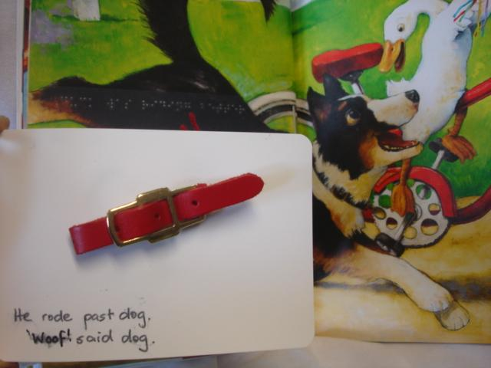
Dog collar used as a symbol for a dog.
Photo credit: Feelix Library.
“Duck on a Bike” by David Shannon

See also:
- Telling Stories Through Touch (2005) by Neil Johnston, ClearVision – principles for clear, meaningful tactile representations
- Making a Fabric Book by Marion Ripley, ClearVision – materials and techniques for sewing a fabric book
- Guide to Designing Tactile Illustrations for Children’s Books (2008) by Suzette Wright, American Printing House for the Blind (APH)
- The Typhlo and Tactus guide to children’s books with tactile illustrations (2008) by Phillipe Claudet and Patricia Richard (eds.)

Creating tactile graphics for school children
In primary and secondary school tactile materials are often computerised rather than hand-made due to time and volume restraints. The PIAF machine is popular as is the Tiger embosser and, now more rarely, the thermoform machine.

- Outlines can be introduced if careful approaches have been used in preschool years to learn the basics of the language of line.
The Statewide Vision Resource Centre has produced a very successful group of readers called Ozzie Dots that use embossed diagrams with dotted outlines.
Slob the dog, as illustrated in the Ozzie Dots books
Image credit: Statewide Vision Resource Centre

- Precede diagrams with a meaningful title or text.

- It is often helpful to include a brief description of the graphic in braille to assist in interpretation. For example, it may include the type of diagram (bar chart, concept map, etc), the direction in which the diagram should be read and the main features to look for.

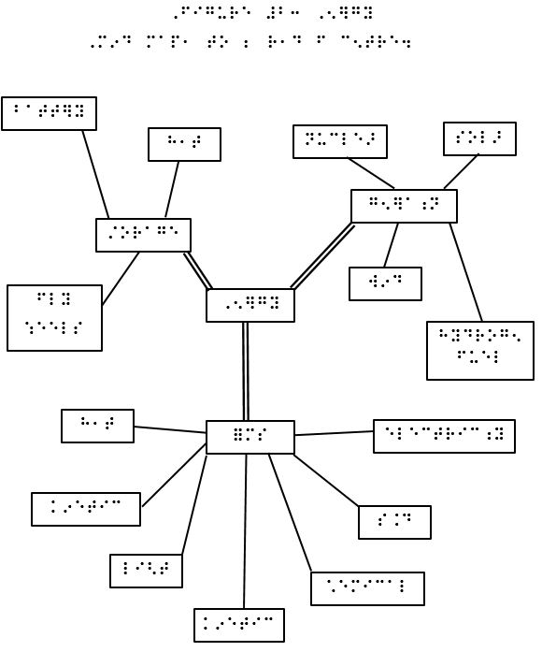
Diagram with description for type of graphic (mind map)
and reading order (from center).

- Consistency of presentation will allow students to more quickly navigate and understand a tactile graphic. Follow the ABA Rules and Guidelines for Formatting Braille^{[16]} or the BANZAT Essentials of Braille Formatting^{[1]} i.e.:
  - Always include the page number in the top right corner of the page in Australia or the bottom right corner of the page in New Zealand.
  - The diagram title and caption should be kept together and given before the tactile diagram or description.
  - If a key is required, it should be given before the tactile graphic.
  - Avoid the need to flip pages, for example by using facing or fold-out pages.

- Thoughtful use of braille labels
  - Avoid the use of vertical braille labels
  - Use a key if braille labels will not fit on the graphic. Braille key items should consist of two braille cells representative of the word and with dots in the upper and lower cells, for example vc (vc) for vacuum cleaner.

- Continue to simplify.
  - If necessary, split a graphic into its most important components and spread them across multiple pages.
  - Separate objects for clarity. For example add space between the bars in a bar chart and add white space around the most prominent lines whenever two lines intersect.

See also:
- Guidelines on Conveying Visual Information (2005), Round Table on Information Access for People with Print Disabilities Inc.
- Guidelines and Standards for Tactile Graphics (2012), Braille Authority of North America
- Tactile Accessibility Guidelines (2012), Smarter Balanced Assessment Consortium

Adding interaction
Kinaesthetic learners will be advantaged by having moving parts in their tactile pictures like an interactive button and buttonhole sequence for a book about dressing, or a moving bead along an elastic for a travelling story. There needs to be a commitment to offer a range of experiences tactually to allow variety in interpretive play to occur and extract meaning.

Simple collage items
A number of simple collage items can be added to a tactile picture to provide sounds and interactions that encourage more active exploration.
- Simple ways to provide audio feedback for a young child in early tactile books include bells, squeakers, bear growlers and noise buttons that play tunes like a lullaby.

- Characters or objects attached to the page with elastic, string or velcro can be moved in/out, up/down, over/under or to illustrate the story as it is told.

“Two little dickie birds” attached with Velcro so they can “fly away” and “come back”
Photo credit: SensiLab

- Things like buttons, zippers and lacing boards are great for encouraging manual dexterity and are especially suited to stories about getting dressed.

- Flaps or doors that can be opened and closed to reveal items underneath.

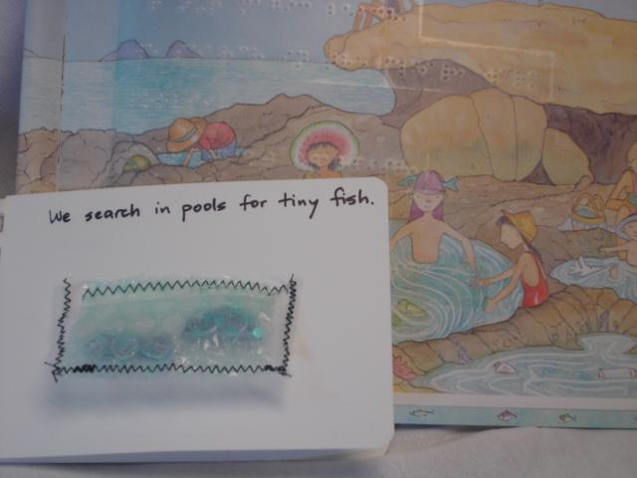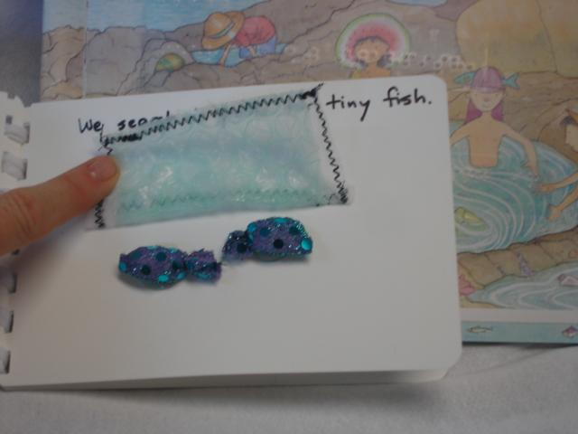
A simple flap to hide fish that are being searched for in the story.
Photo credit: Feelix Library version of “Magic Beach” by Alison Lester

- Sealed laminating pouches or sewn channels can be filled with objects like marbles and stones that can then be moved around inside the page.

- Cellophane enclosed in a fabric pocket is ideal for crinkly leaves or wrapping paper.

For school students, embossed or swell paper diagrams can be enhanced simply with moveable additions attached with string, split pins, etc. This has the added advantage of making the diagrams re-usable for a range of different questions and tasks.

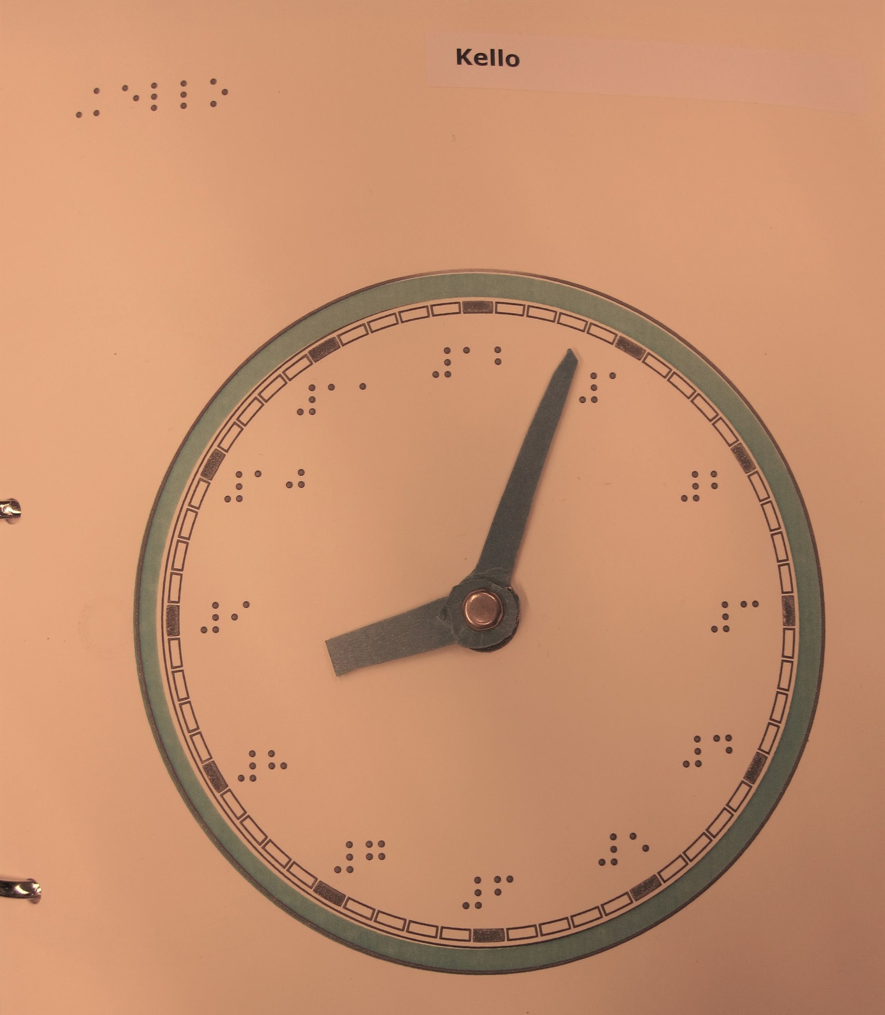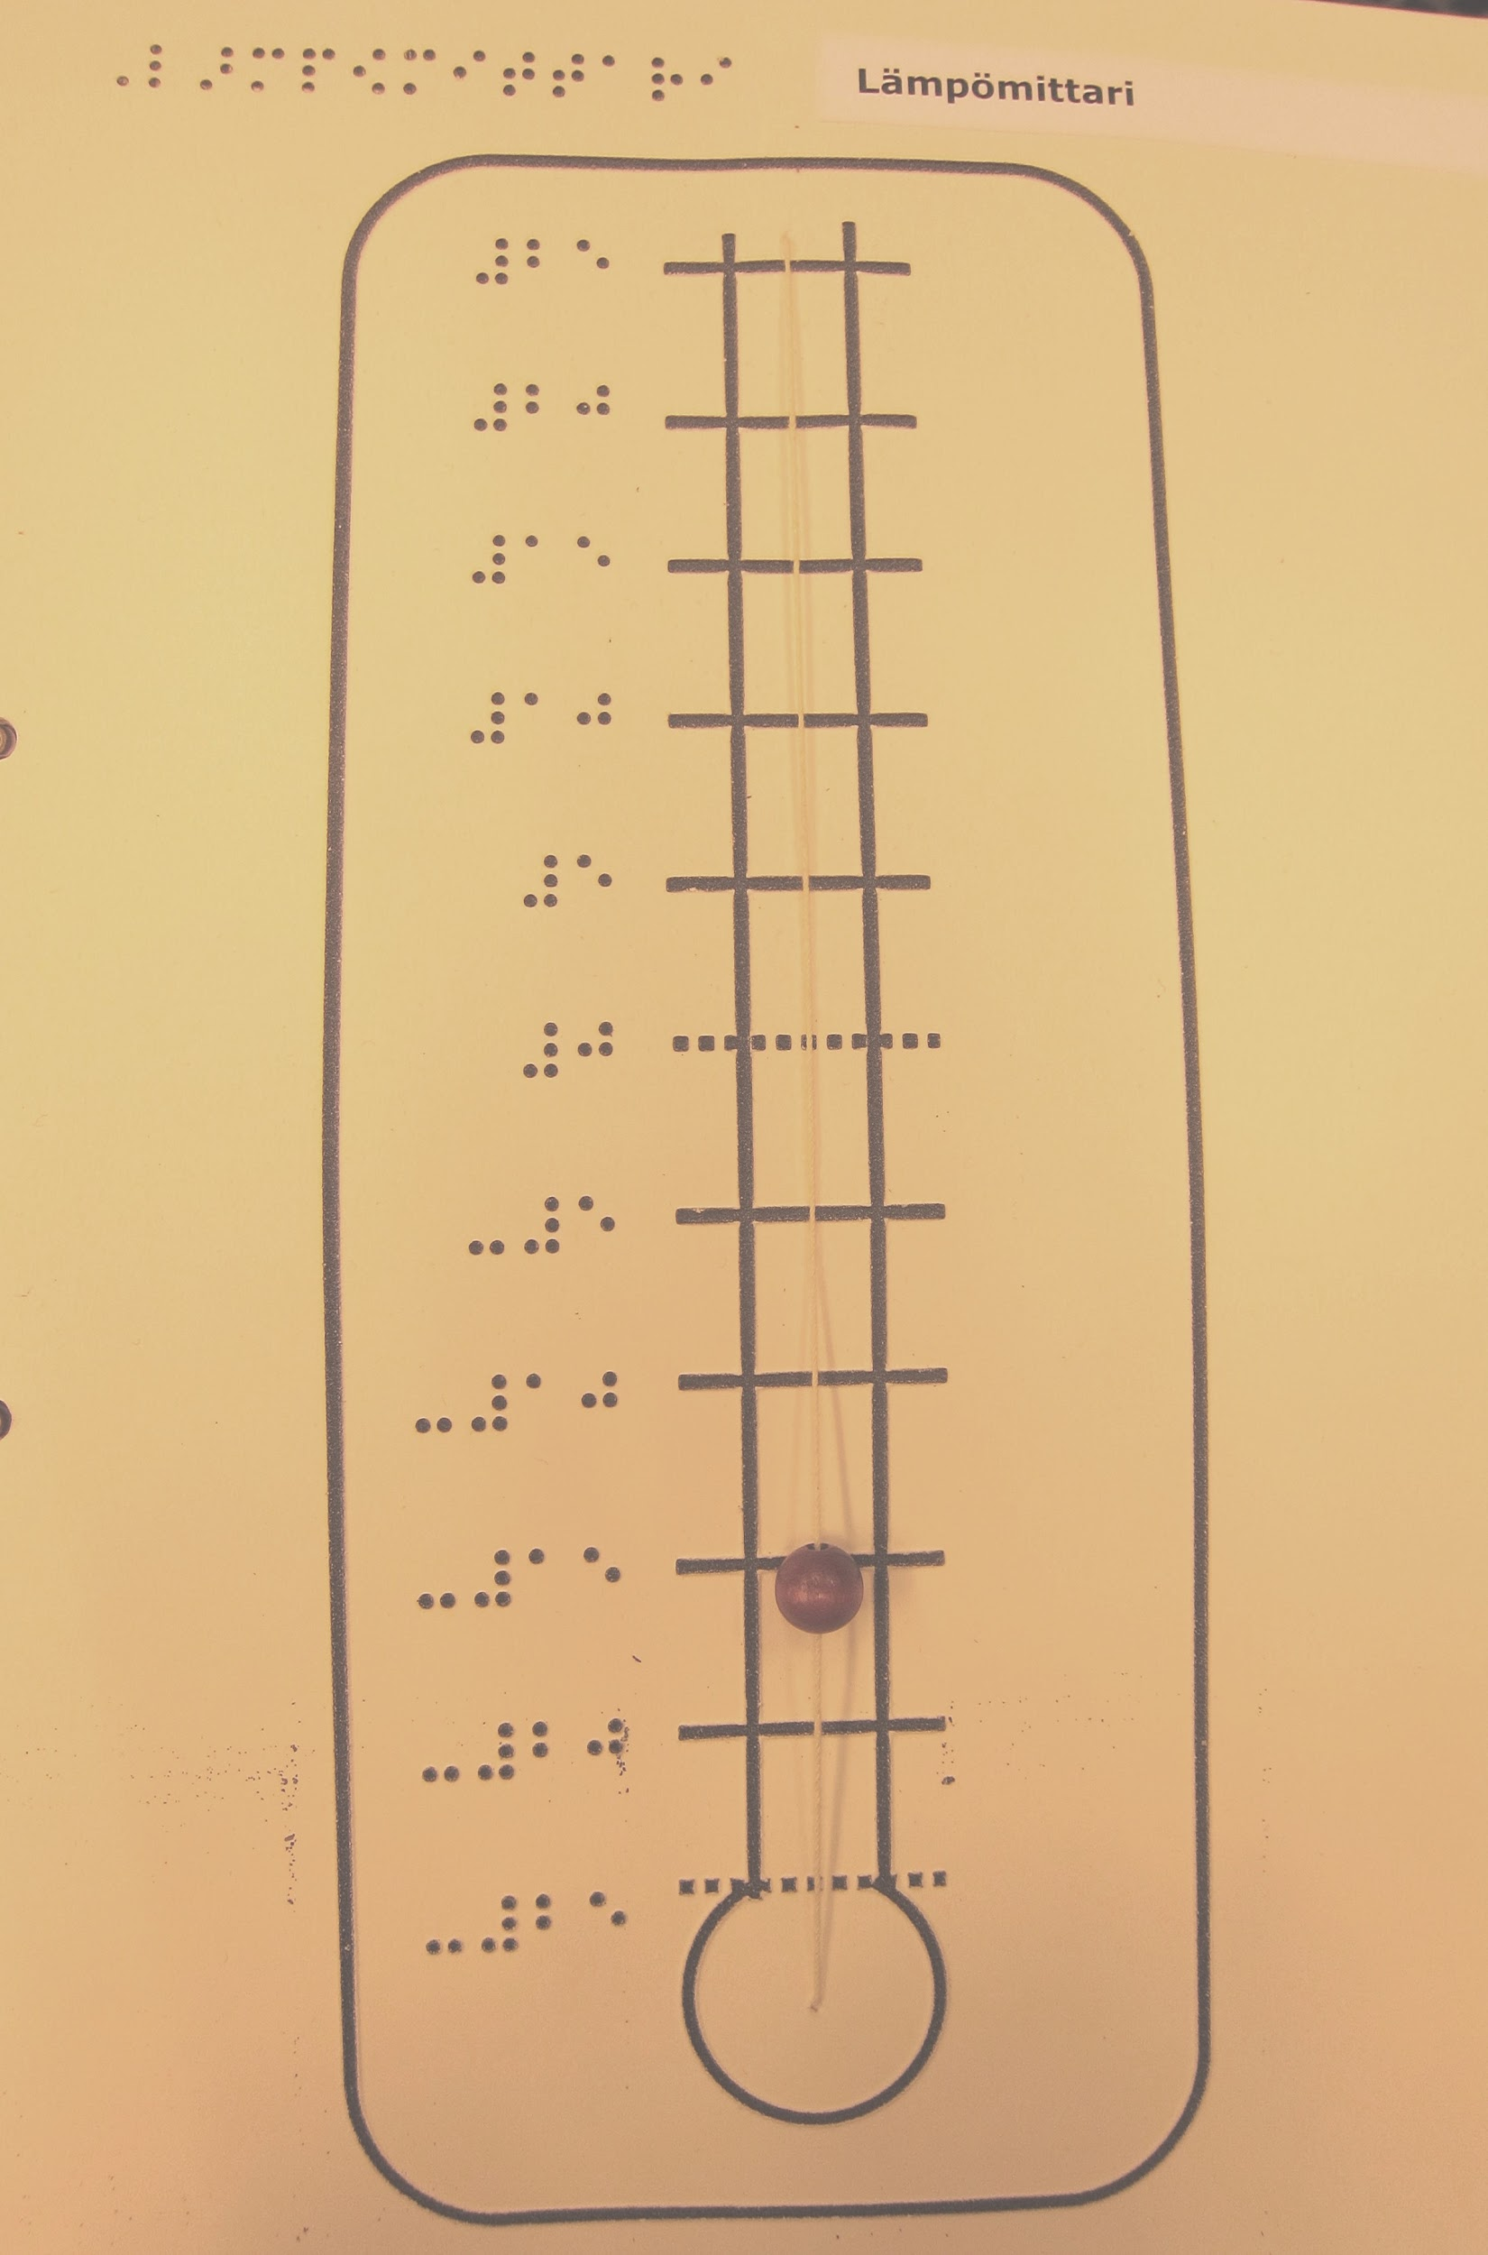
- Clock with added hands attached with a split pin and (2) Thermometer with bead on a string that can slide up and down to indicate the temperature.
Photo credit: Valteri Center for Learning and Consulting (Finland)

Audio labels
Some children’s books come with embedded sounds or audio labels and can be adapted with the addition of braille labels and some simple collage. Audio labels can also be created simply using talking tins, talking labels and similar commercial products allowing simple audio recording and playback. Pen friend and other similar commercial products use a small sticker that activates an audio label using a hand-held device. QR codes are a free option that can be used with a mobile phone. Audio labels can also be helpful for older students when lengthy labels are required.

See also:
- https://www.talkingproducts.com for a variety of recordable talking label products

eTextiles
eTextiles are a new maker technology using electrical circuits to generate sensorimotor experiences. Buzzers can provide small reverberating sensations combined with a tactile cue above it, or small lights can shine from a hole in a tactile cue. A buzzer under a bell will also provide sound. For added interaction, the circuit can include a switch that the child activates by manipulating the graphic, for example patting a cat or moving the hands on a clock. Such pages could be included in a tactile book or used as individual story mats. There is no doubt that children with vision loss crave to experience story through as many modalities as possible and these sensorimotor examples have evidenced this.

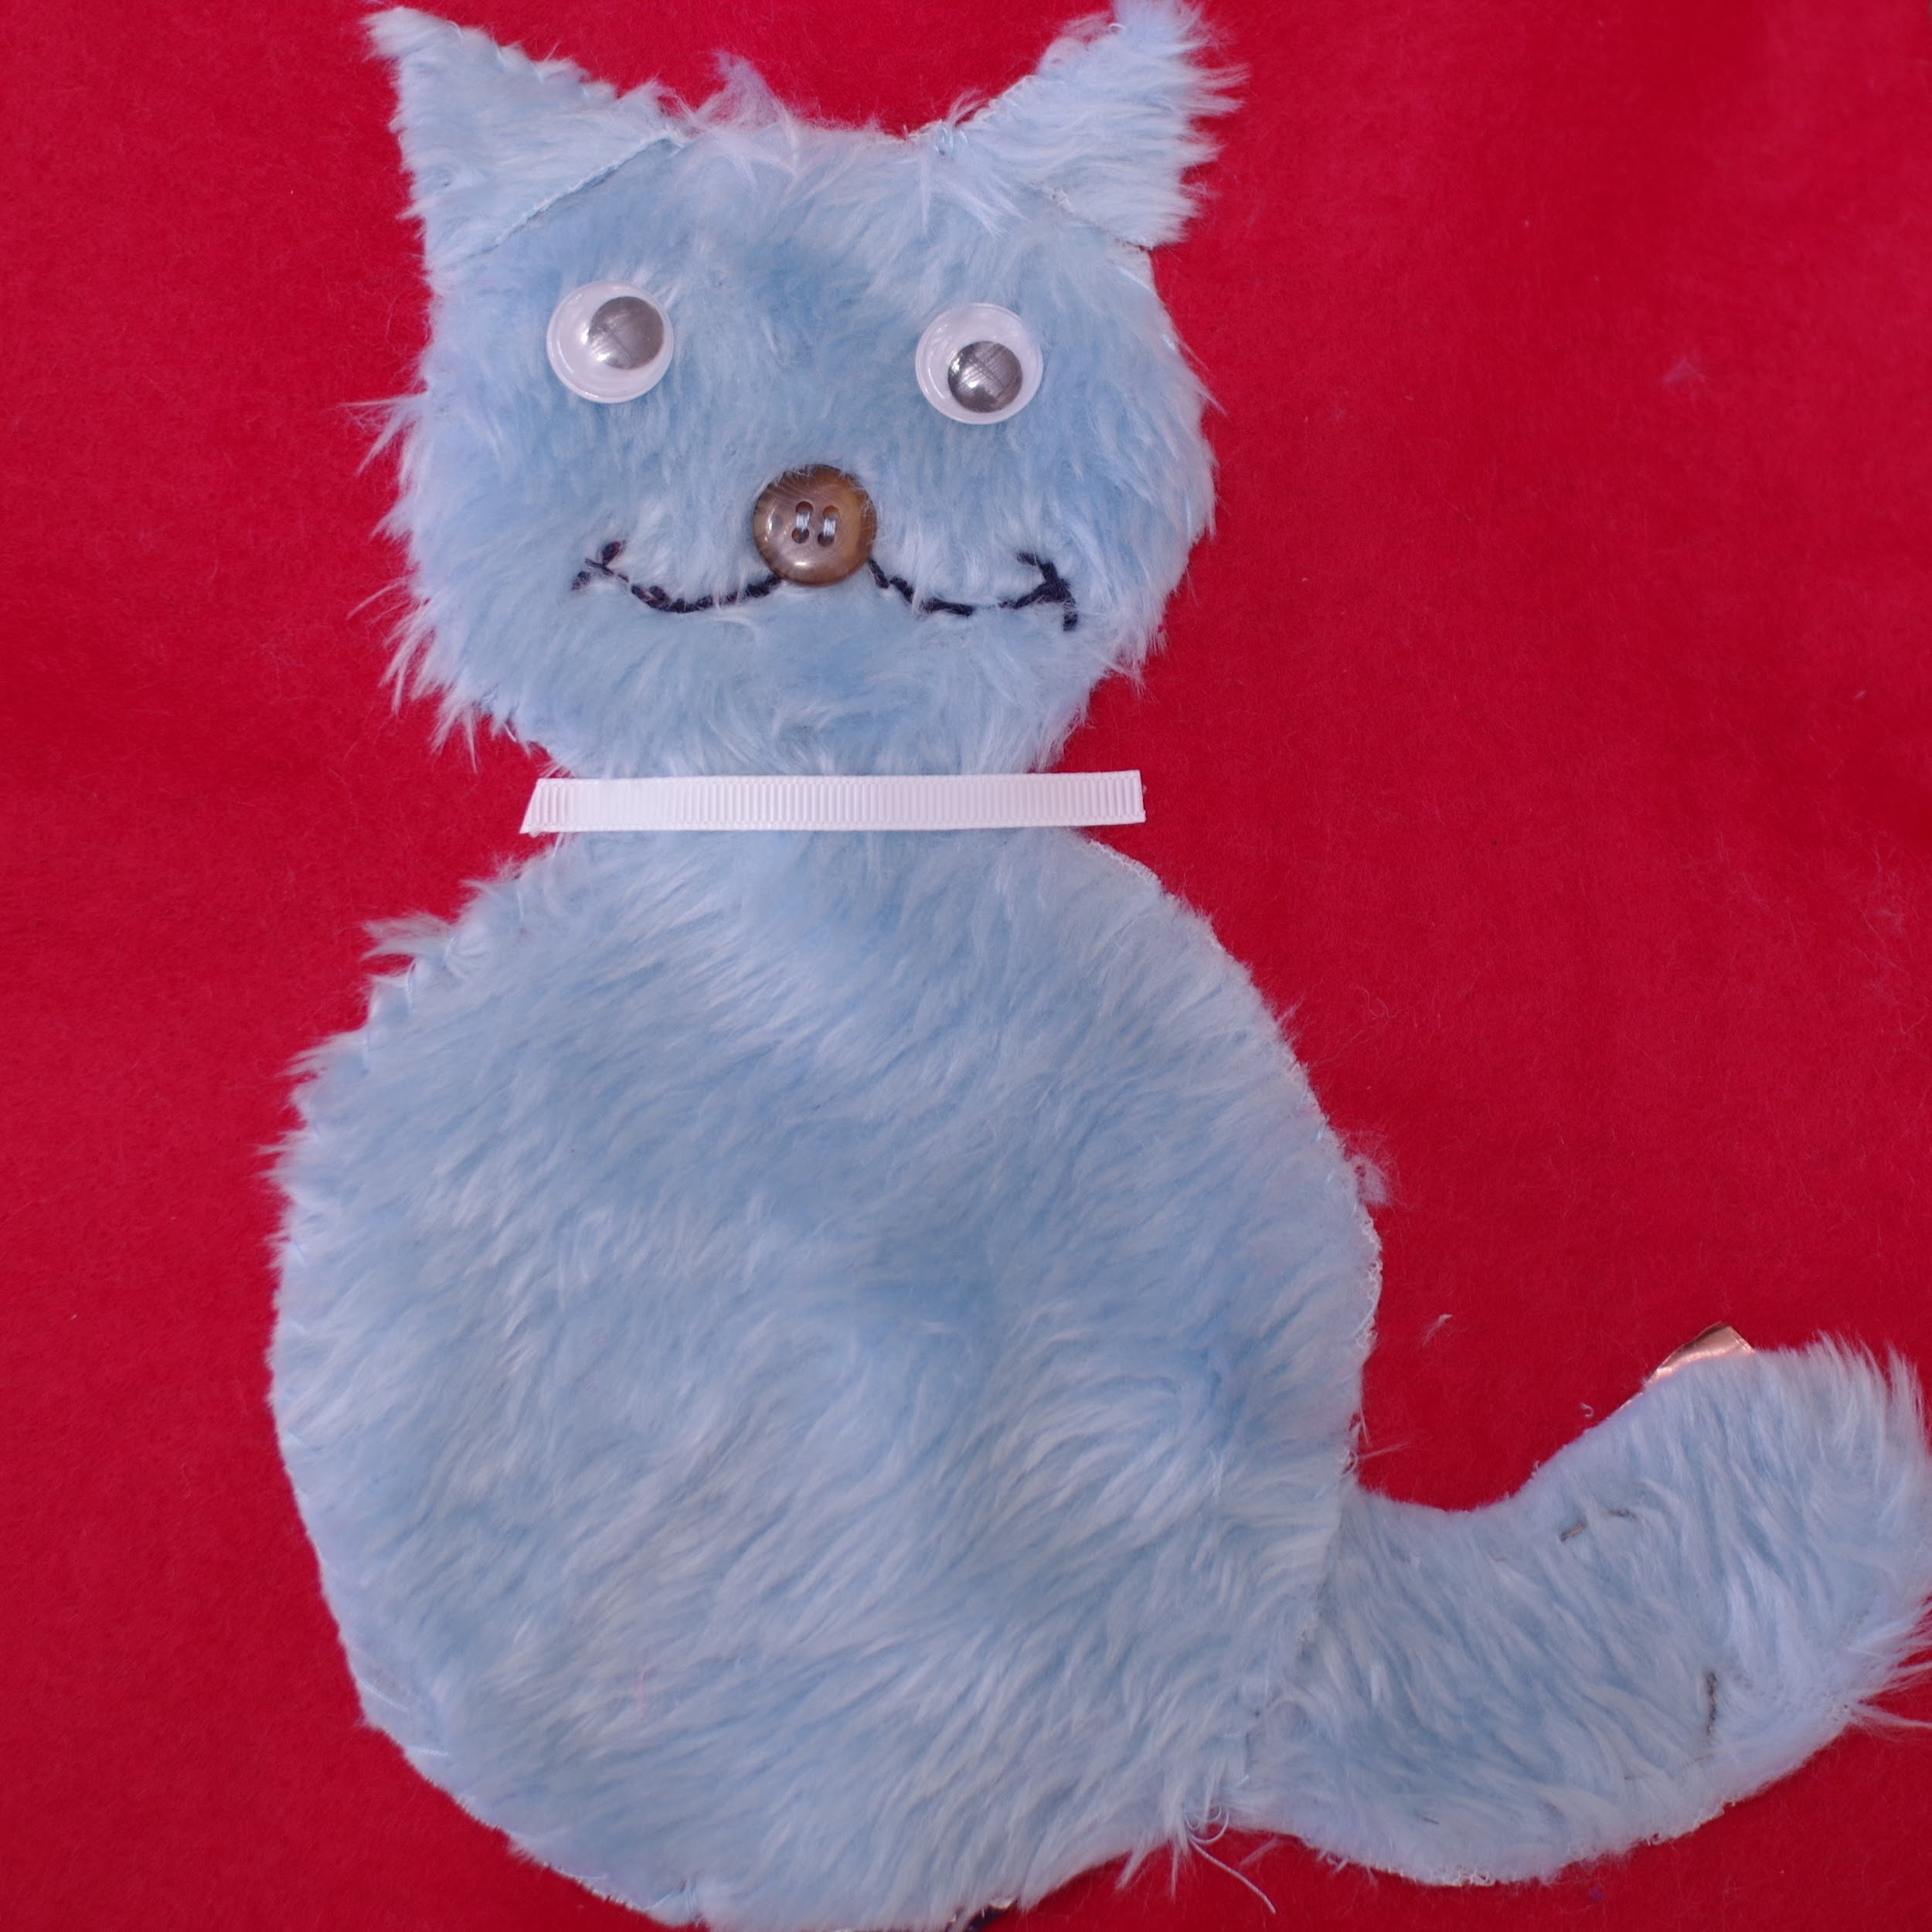
Furry cat with eTextiles circuit.
When the tail is patted down it completes the circuit and the cat “purrs” via a buzzer under its collar.
Photo credit: SensiLab

See also:
- https://sensilab.monash.edu/news-events/creating-tactile-stories/ for tips on using eTextiles for accessible story book pages

References

[1] (2014). Essentials of Braille Formatting, Braille Authority of New Zealand Aotearoa Trust.

[2] (2012). Guidelines and Standards for Tactile Graphics, The Braille Authority of North America.

[3] Aldrich, F., Sheppard L. & Hindle Y. (2002). "First steps towards a model of tactile graphicacy." British Journal of Vision Impairment 20(2): 62-67.

[4] Bell, E. C., & Mino, N. M. (2013). “Blind and visually impaired adult rehabilitation and employment survey: Final results.” Journal of Blindness Innovation and Research, 3(1).

[5] Butler, M., Holloway, L., Marriott, K. & Goncu, C. (2017). "Understanding the graphical challenges faced by vision-impaired students in Australian universities." Higher Education Research and Development 36(1): 59-72.

[6] Chen, D. & Downing, J. E. (2006) Tactile Strategies for Children who have Visual Impairments and Multiple Disabilities. New York, American Foundation for the Blind. pp163-164.

[7] Dixon, J. M. (ed.) (2000). Braille: Into the Next Millennium. National Library Service for the Blind and Physically Handicapped, Washington D. C.

[8] Erickson, K. A. and Hatton, D. (2007). "Expanding understanding of emergent literacy: empirical support for a new framework." Journal of Visual Impairment & Blindness 101(5): 261-277.

[9] Frankel, L. (2012). Tactile Accessibility Guidelines. Smarter Balanced Assessment Consortium.

[10] Gale, G. (ed.) (2005). Guidelines on Conveying Visual Information, Round Table on Information Access for People with Print Disabilities Inc.

[11] Gardiner, A. & Perkins, C. (2002). Best practice guidelines for the design, production and presentation of vacuum formed tactile maps, Tactile Book Advancement Group (TBAG).

[12] Gibson, J. J. (1962). "Observations on active touch." Psychological Review 69(6).

[13] Gool, G. (2015). Tactile Graphics. Premier's IOOF Centre for Educational and Medical Research Itinerant Support Teacher (Vision) Scholarship.

[14] Hatwell, Y. (2003). “Manual exploratory procedures in children and adults. Touching for knowing.” Cognitive psychology of haptic manual perception. Y. Hatwell, A. Streri & E. Gentaz (eds), Amsterdam, John Benjamins Publishing Company.

[15] Hinton, R. A. (1991). "First introduction to tactiles." British Journal of Visual Impairment 9:79-82.

[16] Holloway, L. (ed.) (2016). Australian Braille Authority Rules and Guidelines for Formatting Braille. Round Table on Information Access for People with Print Disabilities Inc.

[17] Holloway, L. & Lewis, D. (2018). “Preparing for higher education: Readiness of vision impaired students for access to materials.” Journal of the South Pacific Educators in Vision Impairment 11(1):12-25

[18] Lederman, S. J. and R. J. Klatzky (1987). "Hand movements: A window into haptic object recognition." Cognitive Psychology 19: 342-368.

[19] Mazella, A., Labardin, M., Mesnieres, S., Albaret, J. & Picard, Delphine (2014). "Construction of a 2D haptic tests battery for use with children and adolescents with and without visual impairment." Terra Haptica International Journal of Visual Disability and Inclusive Practices 4: 65-73.

[20] Piaget, J. (1954). “The development of object concept.” The Construction of Reality in the Child. New York, Basic Books.

[21] Picard, D. & Lebaz, S. (2012). "Identifying raised-line drawings by touch: A hard but not impossible task." Journal of Visual Impairment & Blindness 106(7): 427-431.

[22] Ryles, R. (1996). "The impact of braille reading skills on employment rates, reading habits, education levels and financial self-sufficiency of visually impaired adults." Journal of Visual Impairment & Blindness 90: 219-226.

[23] Sathian, K. (2000). “Practice makes perfect: Sharper tactile perception in the blind.” Neurology 54(12): 2203-2204.

[24] Silverman, A. M. & Bell, E. C. (2018). "The association between braille reading history and well-being for blind adults." Journal of Blindness Innovation and Research 8(1).

[25] Theurel, A., Polato, E., Caldironi, P., Lanners, J., Claudet, P., Caldin, R., Gentaz, E. (2010). "The effect of joint reading on the tactile comprehension of a tact-illustrated book by early blind children." Terra Haptica International Journal of Visual Disability and Inclusive Practices 1.

[26] Thompson, L. J., Chronicle, E. P. & Collins, A. F. (2006). "Enhancing 2-D tactile picture design from knowledge of 3-D haptic object recognition." European Psychologist 11: 110-118.

[27] Wilkinson, D. & Hasty, L. (2012). “Teaching tactile graphicacy: Reading more than words.” ATIA Orlando 2012. Orlando, Florida, USA. www.tactilegraphics.org/teachingtgs.html

Glossary of terms
Concept development – Gaining a basic understanding of the world, beginning with the self then others, objects, the environment and abstract ideas.
Mylar film – Thin plastic sheets that pucker up and form a raised image on the drawing side when placed on a rubber mat and drawn firmly with a stylus or ball-point pen. Also known as German film or plastic embossing film.
Perkins brailler – Manual braille typewriter with six keys.
PIAF – “Picture In a Flash” machine used to heat and raise graphics on microcapsule/swell paper. Also known as a stereocopy machine.
Raised line drawings – illustrations made to be interpreted by touch.
Swell paper – Specialised paper for tactile graphics production that contains microcapsules of a chemical that swells when exposed to carbon and heated. Production of the diagram can be achieved quickly by hand or with printed computer graphics but the paper is quite expensive, at around $3 per sheet. Also known as microcapsule paper.
Tactile drawing boards - Can be used with ordinary paper to form raised lines on the drawing side using a ball-point pen. For example, the Sensational BlackBoard available from http://www.sensationalbooks.com/products.html#blackboard.
Tactile graphicacy – The ability to explore, understand and interpret tactile graphics and models.
Tactile literacy – The ability to effectively read (braille and tactile graphics) by touch.
Thermoform – A method of reproducing tactile graphics onto plastic sheets (braillon) by heating and vacuum forming. The original diagrams can be produced by any number of techniques and can be up to 5cm in height if using extra heavy braillon.
Tiger embosser – An embosser designed for the production of tactile diagrams. The dots can be raised to five different heights and can be closer together than using a traditional braille embosser.
Wikki stix – Re-usable wax-coated string that can be pressed onto the page to create straight and curved tactile lines. Available for purchase through http://www.wikki-stix.com.au or you can make your own.

